Traffic Sign Recognition System
System Requirement Specification (SRS)

Project work Phase 1 (EAI753)
Degree
BACHELOR OF TECHNOLOGY (CSE)(AI)

PROJECT GUIDE:  Dr. Saurabh Pathak | SUBMITTED BY:  Subham Jain  (TCA1959008)

Dec, 2022



FACULTY OF ENGINEERING & COMPUTING SCIENCES
TEERTHANKER MAHAVEER UNIVERSITY, MORADABAD

Table of Contents
1 Introduction 3
1.1 Problem Statement 3
1.2 Scope of the project 4
1.3 Definitions, Acronyms, and Abbreviations 4
1.4 References 6
2 Project Description 6
2.1 Scope of the work 6
2.2 Project Modules 7
2.3 User Characteristics 9
2.4 Constraints of project 10
2.5 Assumptions and Dependencies 11
3 Specific Requirements 12
3.1 External Interfaces 12
3.2 Functions 13
3.3 Performance Requirements 14
3.4 Logical Database Requirements 14
3.5 Design Constraints 14
3.6 Standards Compliance(diagram) 15
3.7 Software and Hardware Requirements 16

Introduction
There are several different types of traffic signs like speed limits, no entry, traffic signals, turn left or right, children crossing, no passing of heavy vehicles, etc. Traffic signs classification is the process of identifying which class a traffic sign belongs to . we have made an attempt to help automotive companies detect and recognize traffic signs in video sequences recorded by on-board vehicle camera. Traffic Sign Recognition (TSR) is used to display the speed limit signs. Here, OpenCV is used for image processing. OpenCV is an Open source Computer Vision library designed for computational efficiency with a strong focus on real time applications

Problem Statement
In current traffic management systems, there is a high probability that the driver may miss some of the traffic signs on the road because of overcrowding due to neighbouring vehicles. With the continuous growth of vehicle numbers in urban agglomerations around the world, this problem is only expected to grow worse. A visual-based traffic sign recognition system can be implemented on the automobile with an aim of detecting and recognizing all emerging traffic signs. The same would be displayed to the driver with alarm-triggering features if the driver refuses to follow the traffic signs.

Scope of the project

Traffic signs can be analyzed using forward-facing cameras in many modern cars, vehicles and trucks. One of the basic use cases of a traffic-sign recognition system is for speed limits. Most of the GPS data would procure speed information, but additional speed limit traffic signs can also be used to extract information and display it in the dashboard of the car to alert the driver about the road sign.
In the world of Artificial Intelligence and advancement in technologies, many researchers and big companies like Tesla, Uber, Google, Mercedes-Benz, Toyota, Ford, Audi, etc. are working on autonomous vehicles and self-driving cars. So, for achieving accuracy in this technology, the vehicles should be able to interpret traffic signs and make decisions accordingly

Definitions, Acronyms, and Abbreviations

Software Platform
- Anaconda
Anaconda is a distribution of the python and R programming language for scientific computing (Data Science, Machine Learning application , large scale data processing , predictive analysis etc.)

Tools
- Python
Programming language
- Keras
it is written in Python and is used to make the implementation of neural networks easy. It also supports multiple backend neural network computation.
- Matplotlib
Matplotlib is complete package for data visualization data can be acquired , elaborate and plot easily using this tool.
- Scikit – learn
Use for train and test dataset
- Pandas
Use for preprocessing the data
- Opencv
OpenCV is a python library that is used to solve computer vision problems. Computer vision include understanding and analyzing digital images by the computers and process the image or provide relevant data after analyzing the image.
- GUI
Python Django.
Django is a free and open-source, Python-based web framework that follows the model–template–views architectural pattern. It is maintained by the Django Software Foundation.

References
- https://www.kaggle.com/datasets/meowmeowmeowmeowmeow/gtsrb-german-traffic-sign
- https://www.javatpoint.com/machine-learning
- https://www.javatpoint.com/deep-learning

Project Description

Scope of the work
Important information can be provided to the drivers by the signs on the road like safety, warning and navigation, thus computer based system for automatic recognition and detection of road sign grow popular these days. Designing a traffic sign detection and recognition use computer capabilities to aid the transportation systems can be very useful, it is also possible to add robotic assistance like cameras that are equipped with an auto detection system for traffic signs on the road. Traffic signs play a vital role in transportation system. Many road accidents occur due to lack of traffic signs. Detecting and classifying different group of traffic signs can save our lives as well as resources.

Project Modules
- Explore the dataset
- Build a CNN model
- Train and validate the model
- Test the model with test dataset
- Deployment phase

- Explore the dataset
Our ‘train’ folder contains 43 folders each representing a different class. The range of the folder is from 0 to 42. With the help of the OS module, we iterate over all the classes and append images and their respective labels in the data and labels list Finally, we have stored all the images and their labels into lists (data and labels)
- The PIL library is used to open image content into an array
- We need to convert the list into Numpy arrays for feeding to the model.
- The shape of data is (39209, 30, 30, 3) which means that there are 39,209 images of size 30×30 pixels and the last 3 means the data contains colored images (RGB value).
- With the sklearn package, we use the train_test_split() method to split training and testing data.
- From the keras.utils package, we use to_categorical method to convert the labels present in y_train and t_test into one-hot encoding.

- Build a CNN model
To classify the images into their respective categories, we will build a CNN model . CNN is best for image classification purposes.
The architecture of our model is:
- 2 Conv2D layer (filter=32, kernel_size=(5,5), activation=”relu”)
- MaxPool2D layer ( pool_size=(2,2))
- Dropout layer (rate=0.25)
- 2 Conv2D layer (filter=64, kernel_size=(3,3), activation=”relu”)
- MaxPool2D layer ( pool_size=(2,2))
- Dropout layer (rate=0.25)
- Flatten layer to squeeze the layers into 1 dimension
- Dense Fully connected layer (256 nodes, activation=”relu”)
- Dropout layer (rate=0.5)
- Dense layer (43 nodes, activation=”softmax”)
We compile the model with Adam optimizer which performs well and loss is “categorical crossentropy ” because we have multiple classes to categorise

- Train and validate the model
After building the model architecture, we then train the model using model.fit(). I tried with batch size 32 and 64. Our model performed better with 64 batch size. And after 15 epochs the accuracy was stable.
Our model got a 95% accuracy on the training dataset. With matplotlib, we plot the graph for accuracy and the loss

- Test the model with the dataset
Our dataset contains a test folder and in a test.csv file, we have the details related to the image path and their respective class labels. We extract the image path and labels using pandas. Then to predict the model, we have to resize our images to 30×30 pixels and make a numpy array containing all image data. From the sklearn.metrics, we imported the accuracy_score and observed how our model predicted the actual labels. We achieved a 95% accuracy in this model

User Characteristics

Detection

Image

The use will need to upload a image for detection

Real time

To detect in real time the use can click on a device camera .
User characteristics includes the physical characteristic of driver like power of vision, hearing and reaction time of the driver shown during a traffic situation

Constraints of project
- video source(video camera):- recognition depends on quality of an image sensor (CMOS/CCD chips) and output format of an image. It can be used color or gray cameras with various resolutions, settings, compression rates etc. Is-sues can arise not only by settings of a camera but also if the camera is not correct fixed in a vehicle so vibration and blurring can be appeared on the video sequences. Another problem is causing by autofocus. We can therefore recom-mend autofocus mode switch off and focus set to infinity.

- Lighting conditions – there are differences in acquiring images by daylight and night, or by influencing of source oflight. Thus shade of colors of objects can be seen differently by the illumination changes. Issues cause also a reflection from any light source such as sun in daylight or street light-ing in night. Shape based approach for traffic sign detection seems to be a good choice for solving this problem

Weather conditions – captured image is influenced by raining, snowing or occurrence of a fog. For example, traffic signs can be shrouded by snow or be poorly visible in a fog.
Damage – traffic signs can be damaged not only by sunshine, but also by vandalism or weather over time (strong breeze, storm, raining). They can be then dirty, scribbled

Assumptions and Dependencies

The uploaded image must contain traffic sign

The system will detect sign in real time only if the device camera is on
- Blurring and vibration by a moving vehicle, therefore thecamera must be fixed properly.

Specific Requirements

External Interfaces

Traffic Recognition System will have a Graphical user interface which build in Python Django .

Functionality of Graphical User Interface:

file choose option for image input

Button for execute the model on image

Output label

Functions

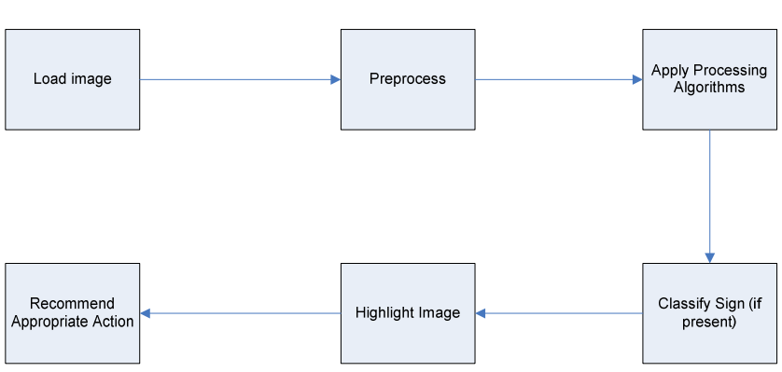

Input to the system will be an image loaded from the computer's hard drive. Preprocessing including contrast, brightness, clarity will then be performed. The actual image processing including color detection and edge detection will be applied next, and the software will then attempt to determine if a sign is present. If present, the sign will be classified and highlighted. To allow for future expansion, action will be recommended to a hypothetical vehicle based on the nature of the sign observed.

Performance Requirements
- Good Camera for quality image input
- System for fast response
- Weather Condition

Logical Database Requirements

Database of image dataset should be connected while execute model.

Design Constraints

Image preprocessing

Integration with automobile

Budget

Standards Compliance(diagrams)

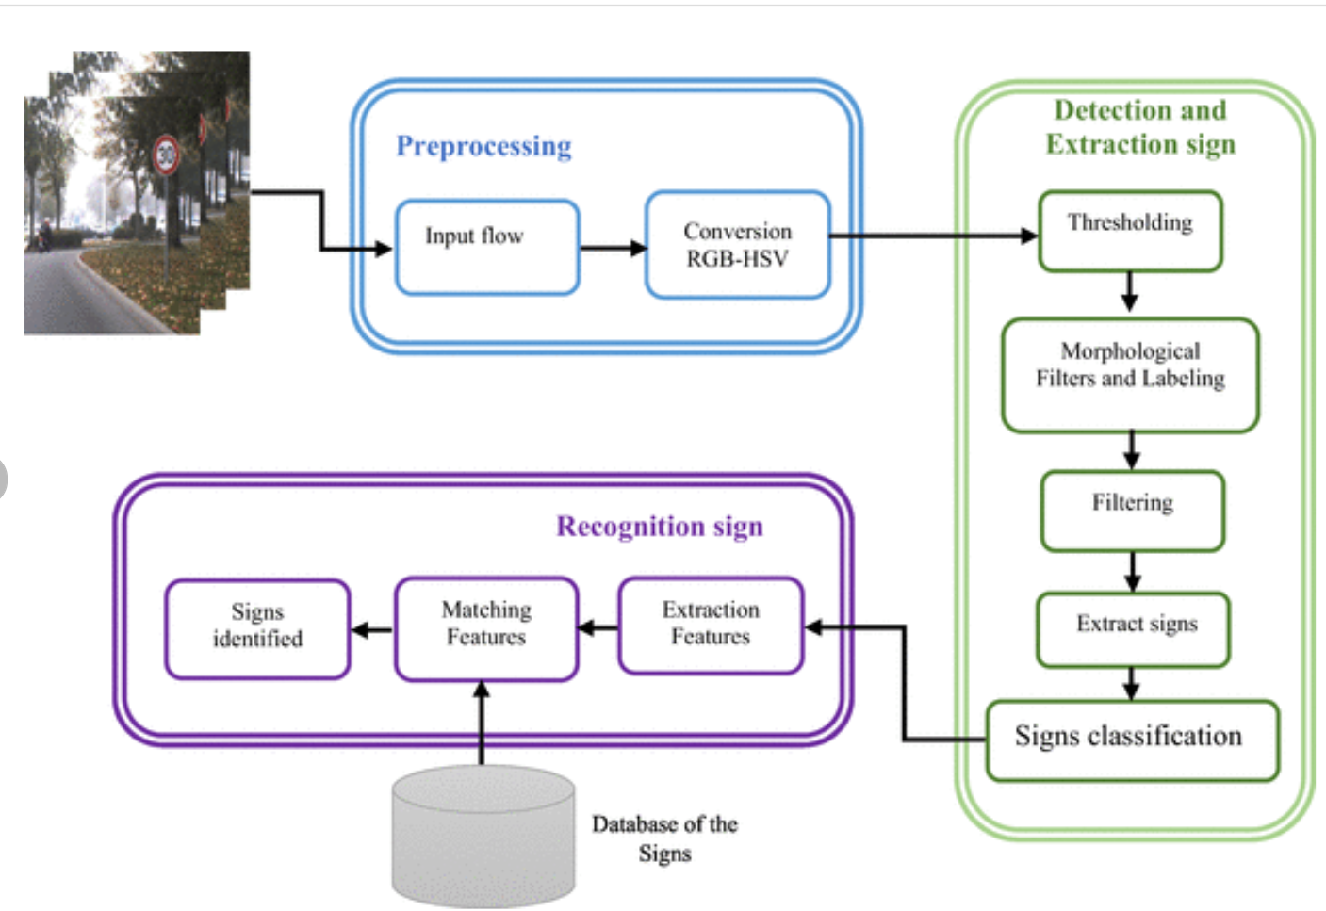

Software and Hardware Requirements
Software
- Programming language: Python
- Operating system: Window 7 or above
- Platform used : Anaconda Spyder
Hardware
- Ram : 4GB
- CPU: intel Core i3 or above
- Disk: 1TB
- Camera and Speaker

