**Xtreme Carz!**

21CSS101J – Programming for Problem Solving

Mini Project Report

Submitted by

Shubham Sahu RA2211003010533

Nishce RA2211003010533



School Of Computing

College of Engineering and Technology

SRM Institute of Science and Technology

(Under Section 3 of UGC Act, 1956)

S.R.M. Nagar, Kattankulathur – 603 203

Kancheepuram District

**December 2022**

**Table of Contents**

|  |  |  |
| --- | --- | --- |
| **Chapter No.** | **Title** | **Page No.** |
| 1. | Problem Statement | 3 |
| 2. | Methodology/Procedure | 3 |
| 3. | Coding (Python) | 3 - 8 |
| 4. | Results | 8 |
| 5. | Conclusion | 9 |
| 6. | Bibliography | 9 |

**Problem Statement**

The goal is to make a retro looking car game like old Nokia games. It should have a working “Main menu” and “pause menu”, include music and keyboard inputs and different screens to show the crashing of the car. Add a functioning score monitoring system. Make sure the car is within bounds of the screen. Detect the crashing of the car. Increase the speed of the oncoming cars to keep the game challenging.

**Methodology/Procedure**

1. the user executes the program.

2. the user either clicks on the rules button to read the rules or start button to start the game.

3.the goal of the game is to avoid as many oncoming cars and get a higher score each time.

4. The score is equivalent to the number of the number of cars dodged.

5. The game ends when the user presses ‘esc’ or when the user clicks on the pause3 button and clicks exit.

6. The game can be restarted using the ‘space’ key.

**Coding (Python)**

Basic Structure of the Project

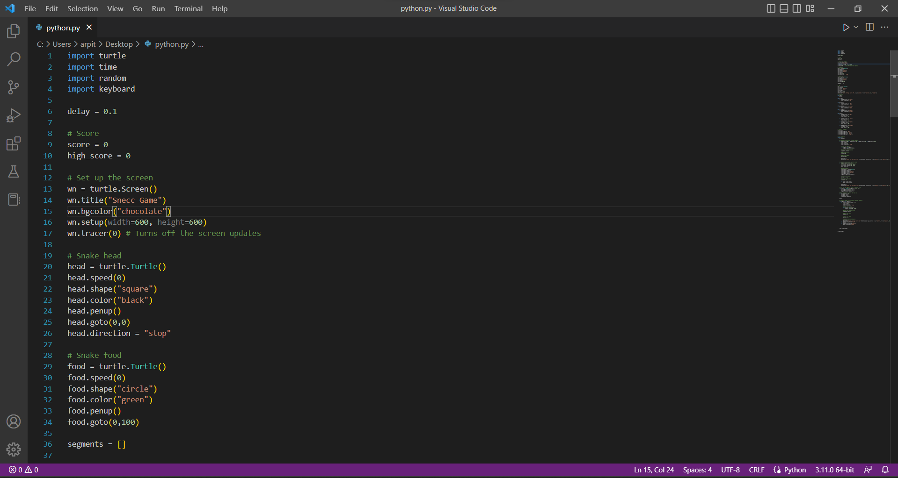

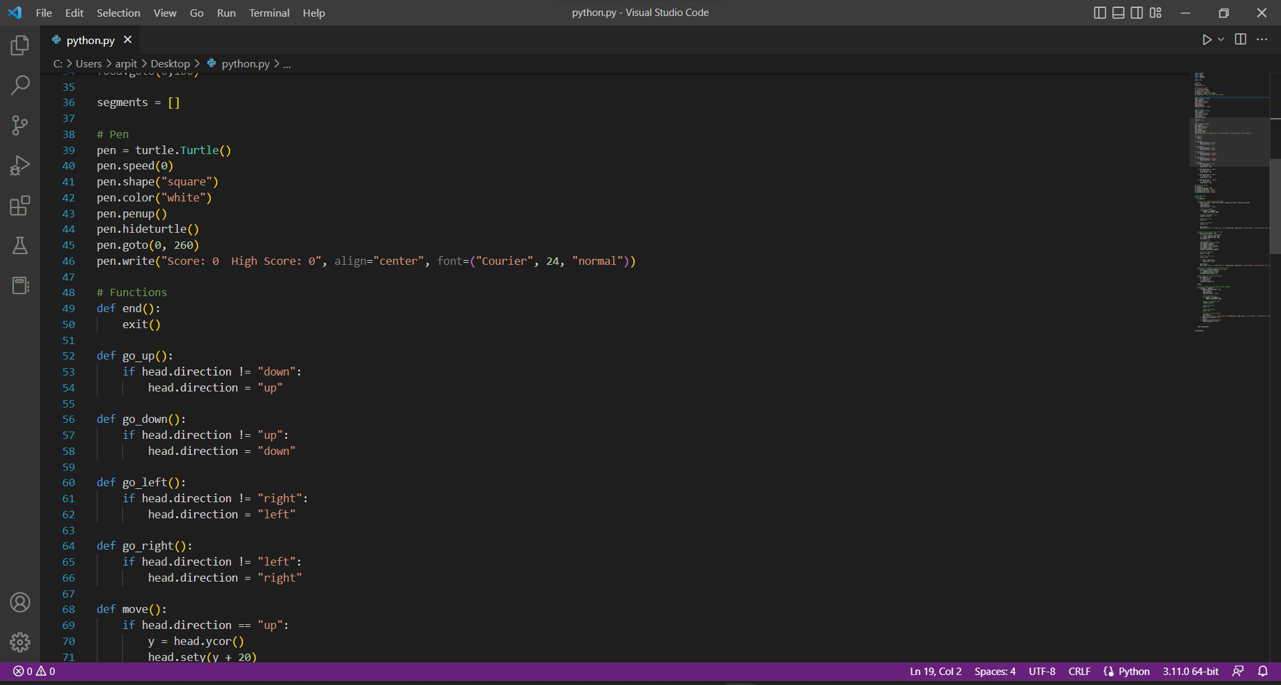

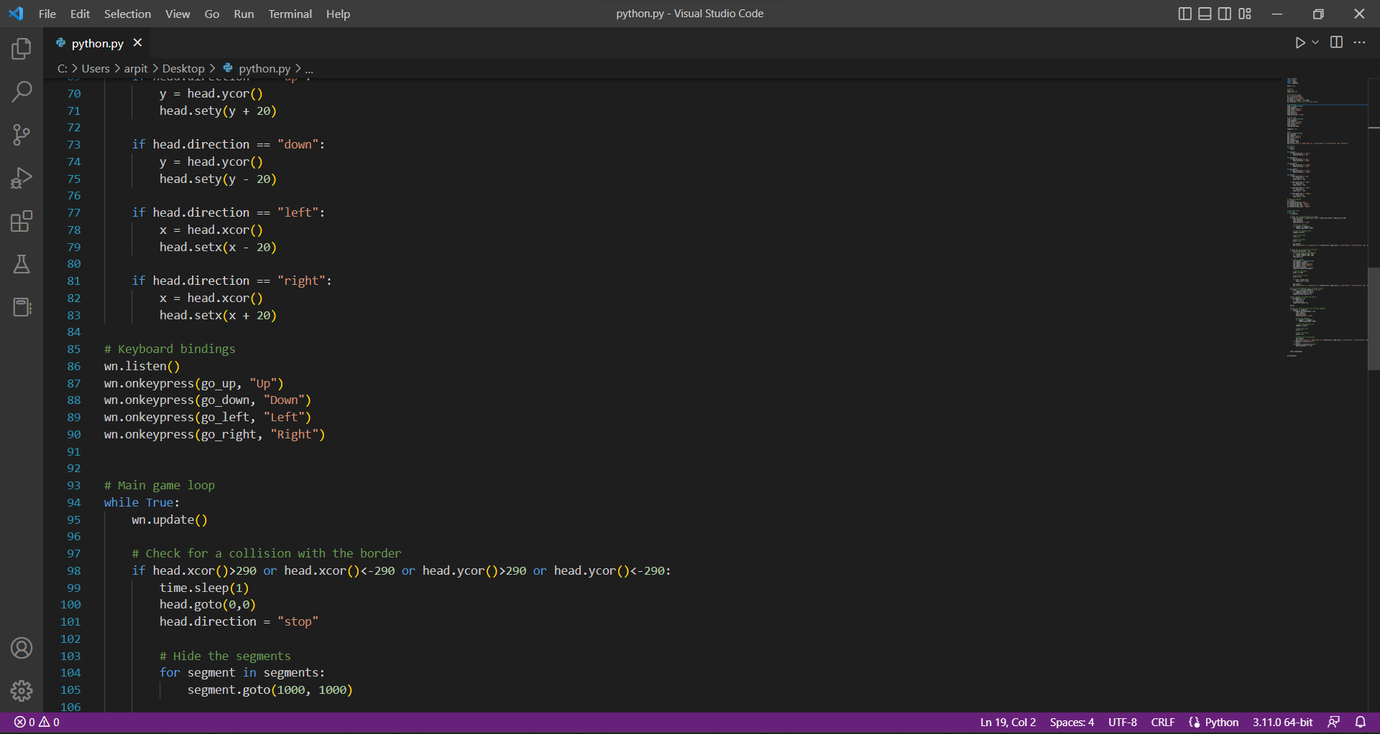

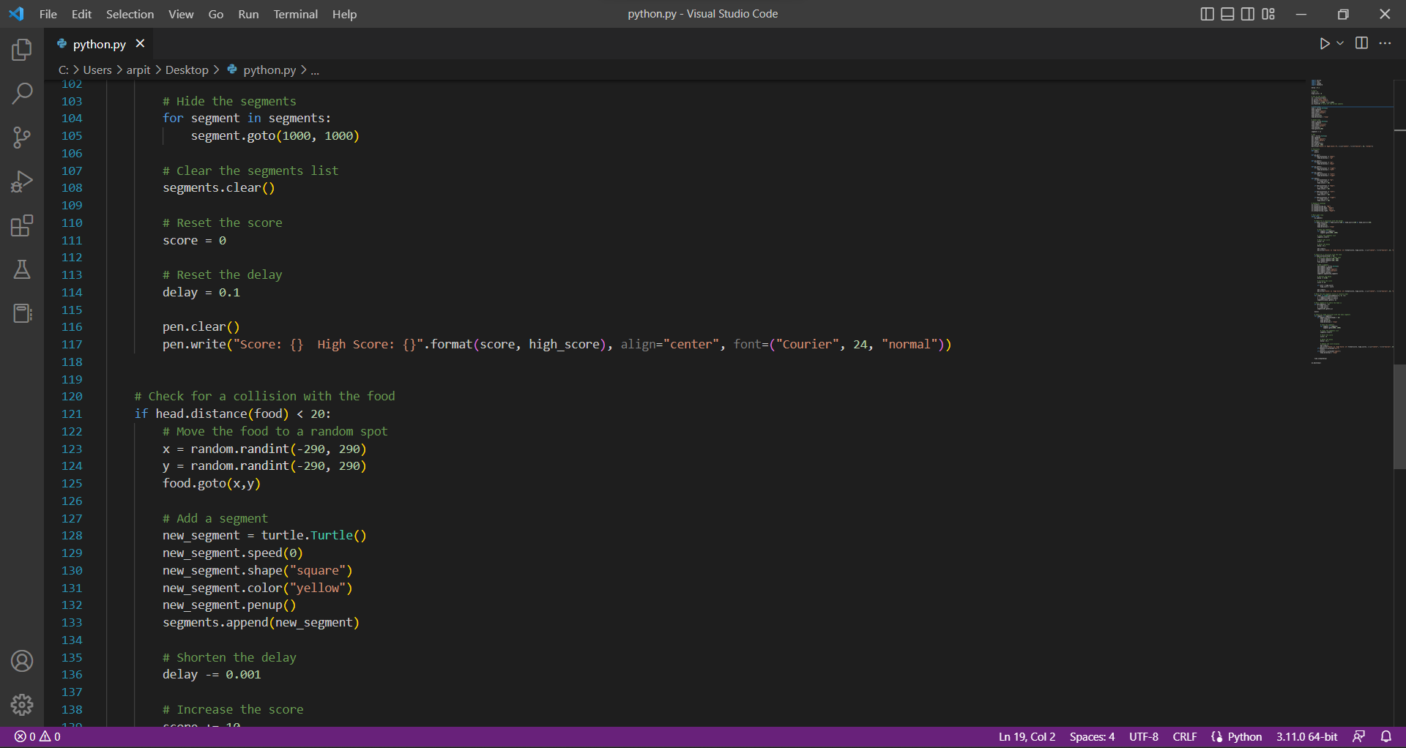

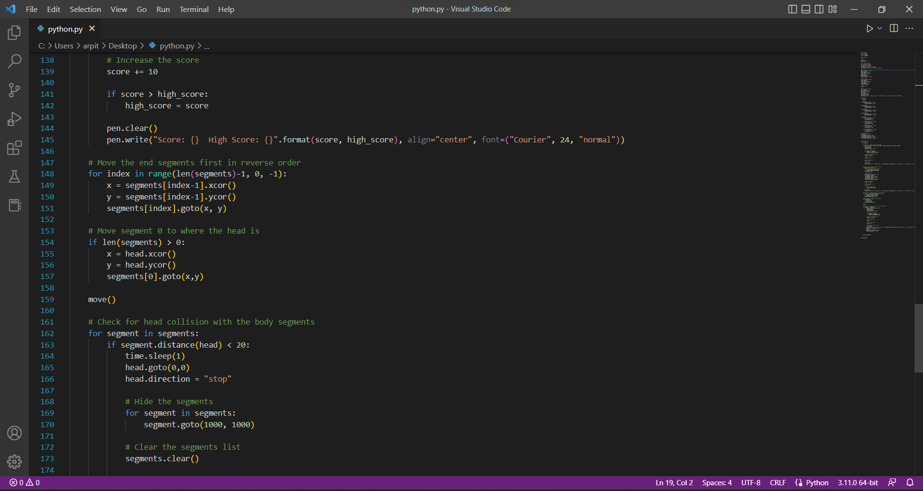

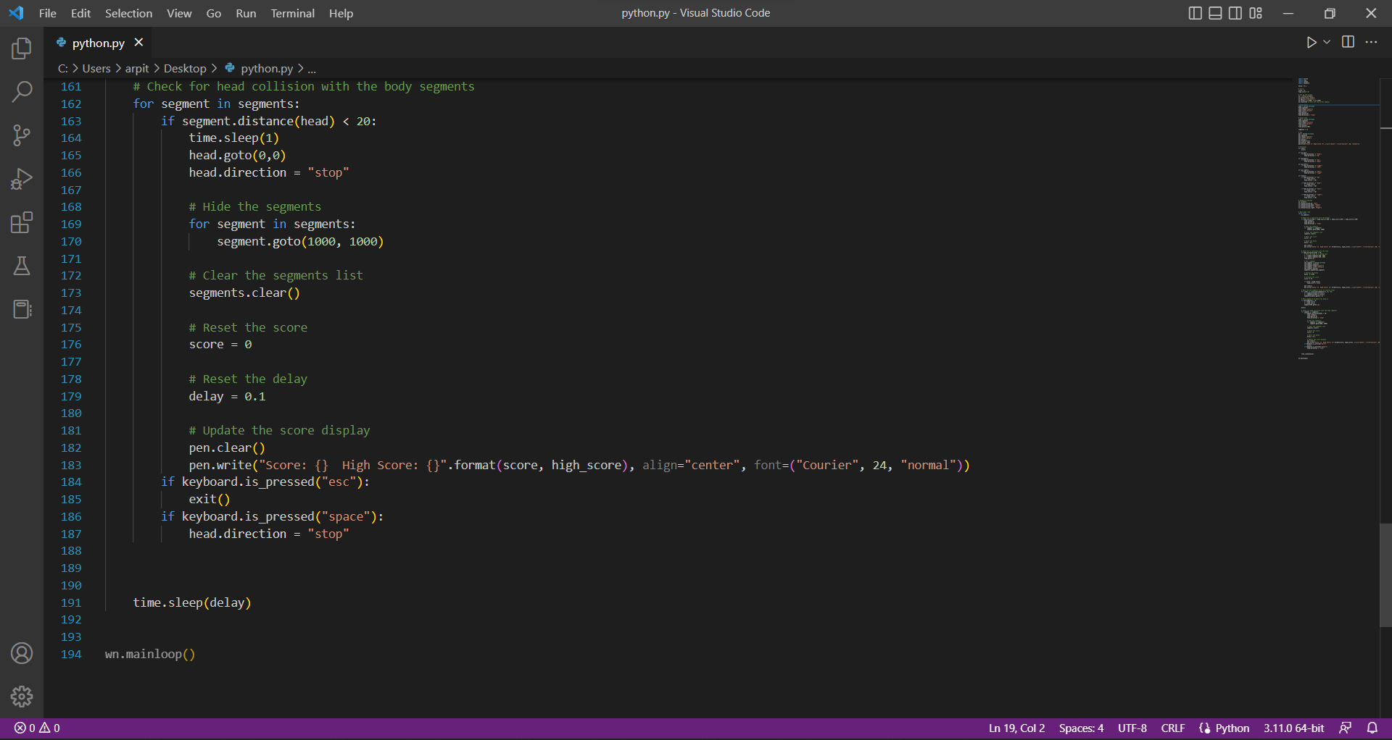

**Results**

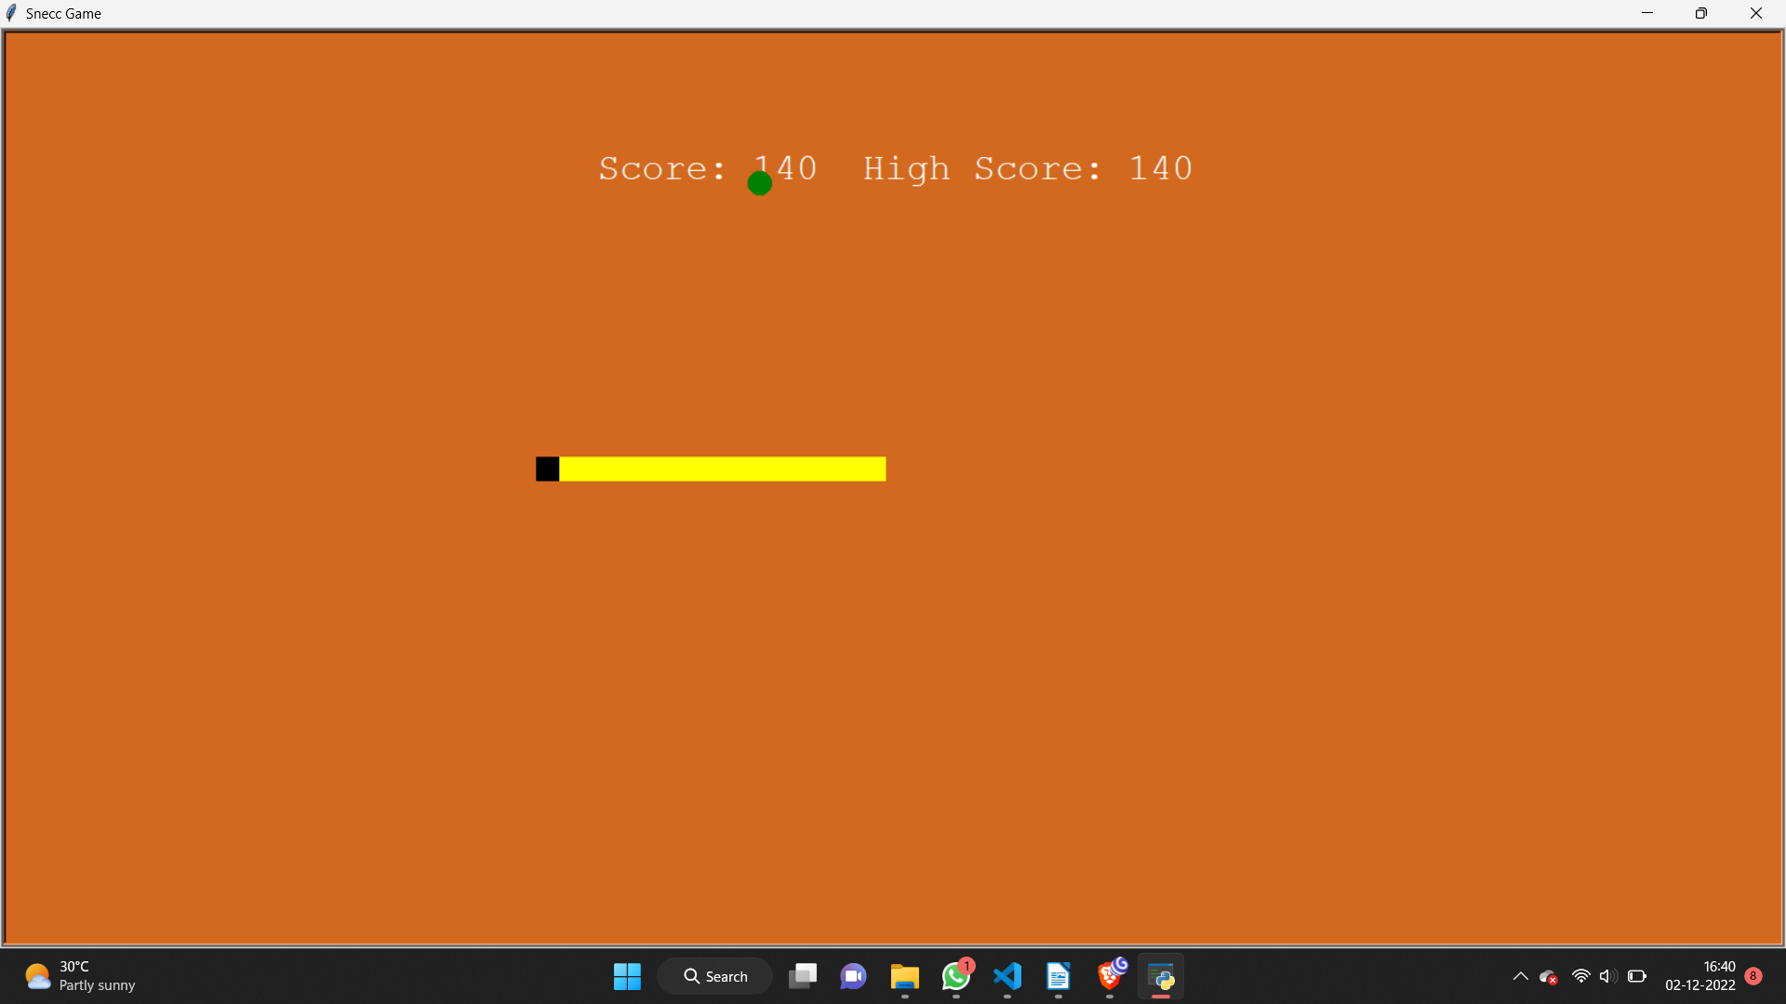

**Conclusion**

A program of sneec game was successfully written (in Python) and executed.

**Bibliography**

1. [www.python.org](http://www.python.org/)
2. [www.geeksforgeeks.org/](http://www.geeksforgeeks.org/)
3. [www.w3schools.com](http://www.w3schools.com/)
4. [www.github.com](http://www.github.com/)
5. [www.programiz.com](http://www.programiz.com/)