Chapter 12 - Let's Build our Store

Theory:

* useContext vs Redux.
* Advantage of using Redux Toolkit over Redux.
* Explain Dispatcher.
* Explain Reducer.
* Explain slice.
* Explain selector.
* Explain createSlice and the configuration it takes.

Coding:

* Practice making a store, slices and do read and write operations using Redux Store
* 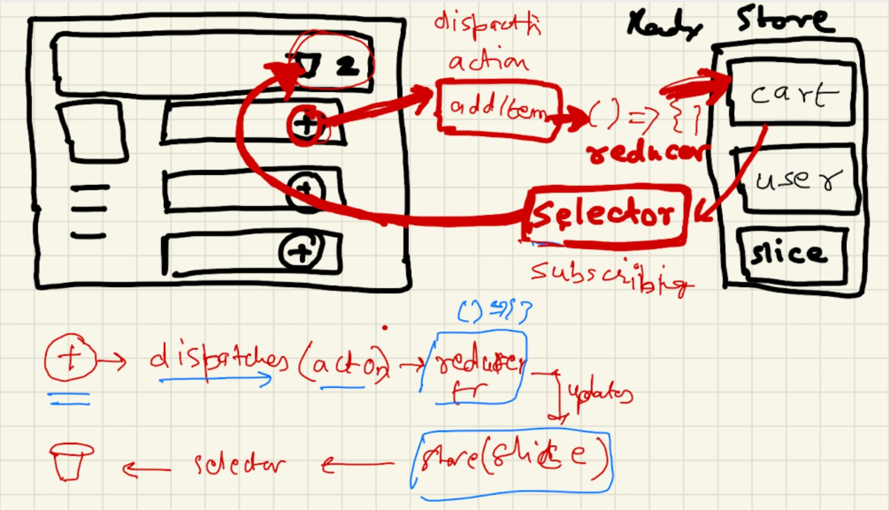Build Cart Flow using Redux Store