**Checking of the below done as per your mail dated 27/08/18, Please check the comment in Green for completion & Blue to be rectified**

**From Student's Perspective - Rectifications As on 14/08/2018**

**1. Registration form**

Student view

1. Mobile Number should be maximum 10 digit with no country code or the field should be alphanumeric. **- Done**

2. Educational Qualifications: - Edit and Delete should be disabled **– Done but now the Add button for educational Qualification is missing**

3. View profile should not show add and update in work ex **- Done**

4. Student View is showing the tabs of add new students as it creates confusion. with add new students tab the student is able to open a new registration page **– Done**

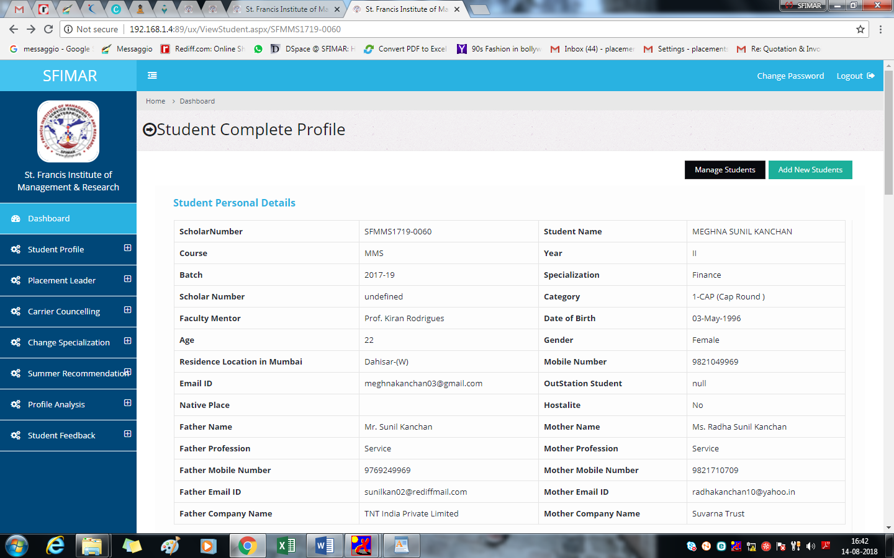

5. Freeze summer internship details. **I could not check this, since the summer Internship details in my login are not seen which I had entered, nor is it allowing me to save it through admin login thus giving me error 3 as below**

6. Declaration should be seen in view form although buttons can be disabled.

**Newly as on 27/08/18**

#### It is allowing edit of Data of field Siblings Working With

#### The declaration is not yet seen by the student as above screenshot

#### 

#### After adding the Summer details and while saving the file it gives error as per the attachment in Admin.

#### 