**ASSIGNMENT NUMBER: A4**

**Title**

Connectivity of Raspberry Pi/Beagle board circuit with temperature sensor

**Problem Statement**

Write an application to read the environment temperature. If temperature crosses a threshold value, the application indicated user using LEDSs

**Objective**

Understanding the connectivity of Raspberry Pi /Beagle board circuit with temperature sensor

**Outcomes**

I will be able to connect Raspberry Pi board circuit with temperature sensor

**Software & Hardware Requirements**

* Raspberry pi board/ BBB
* DTH-11 temperature sensor
* LED
* Raspbian (OS)
* Adafruit_DTH Library

**Theory**

**Raspberry** **Pi**

**Introduction**

The Raspberry Pi is a series of credit card-sized single-board computers developed in the United Kingdom by the Raspberry Pi Foundation to promote the teaching of basic computer science in schools and in developing countries. It is a capable little computer which can be used in electronics projects, and for many of the things that your desktop PC does, like spreadsheets, word processing, browsing the internet, and playing games. It also plays high definition video.

The Raspberry Pi is open hardware, with the exception of the primary chip on the Raspberry Pi, the Broadcom SoC (System on a Chip), which runs many of the main components of the board–CPU, graphics, memory, the USB controller, etc. Many of the projects made with a Raspberry Pi are open and well-documented as well and are things you can build and modify yourself.

The Raspberry Pi was designed for the Linux operating system, and many Linux distributions now have a version optimized for the Raspberry Pi.

One powerful feature of the Raspberry Pi is the row of GPIO (general purpose input/output) pins along the top edge of the board. These pins are a physical interface between the Pi and the outside world. At the simplest level, you can think of them as switches that you can turn on or off (input) or that the Pi can turn on or off (output). Of the 40 pins, 26 are GPIO pins and the others are power or ground pins (plus two ID EEPROM pins which you should not play with unless you know your stuff!)

You can program the pins to interact in amazing ways with the real world. Inputs don't have to come from a physical switch; it could be input from a sensor or a signal from another computer or device, for example. The output can also do anything, from turning on an LED to sending a signal or data to another device. If the Raspberry Pi is on a network, you can control devices that are attached to it from anywhere and those devices can send data back. Connectivity and control of physical devices over the internet is a powerful and exciting thing, and the Raspberry Pi is ideal for this.

**Raspberry Pi Board with GPIO:**

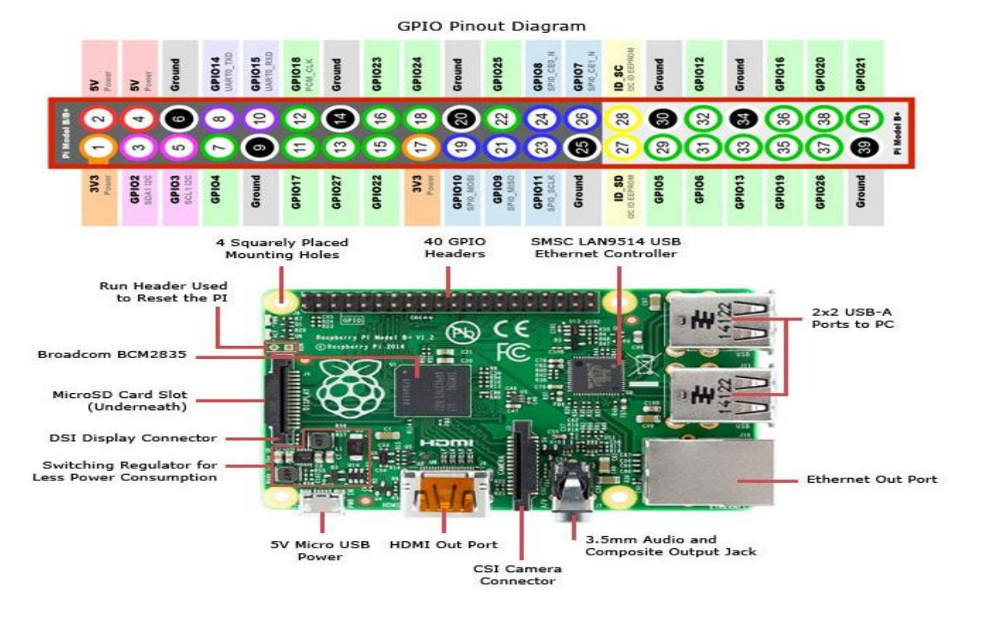

**Technical Specification**

* Broadcom BC M28 37 64bit AR Mv7 Quad Core Processor powered Single Board
* Computer running at 1.2GHz
* 1GB RAM
* BCM43143 WiFi on board
* Bluetooth Low Energy (BLE) on board
* 40pin extended GPIO
* 4 x USB 2 ports
* 4 pole Stereo output and Composite video port
* Full size HDMI
* CSI camera port for connecting the Raspberry Pi camera
* DSI display port for connecting the Raspberry Pi touch screen display
* Micro SD port for loading your operating system and storing data
* Upgraded switched Micro USB power source (now supports up to 2.4 Amps)
* Expected to have the same form factor has the Pi 2 Model B, however the LEDs will Change position

**DTH Sensor**

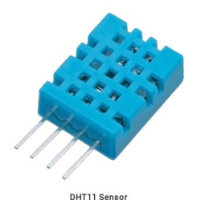

**Introduction**

DHT11 is a single wire digital humidity and temperature sensor, which provides humidity and temperature values serially. It can measure relative humidity in percentage (20 to 90% RH) and temperature in degree Celsius in the range of 0 to 50°C. It has 4 pins of which 2 pins are used for supply, 1 is not used and the last one is used for data. The data pin is the only pin used for communication. Pulses of different TON and TOFF are decoded as logic 1 or logic 0 or start pulse or end of the frame. For more information about DHT11 sensor and how to use it, refer the topic DHT11 sensor in the sensors and modules topic.

**Interfacing Diagram**

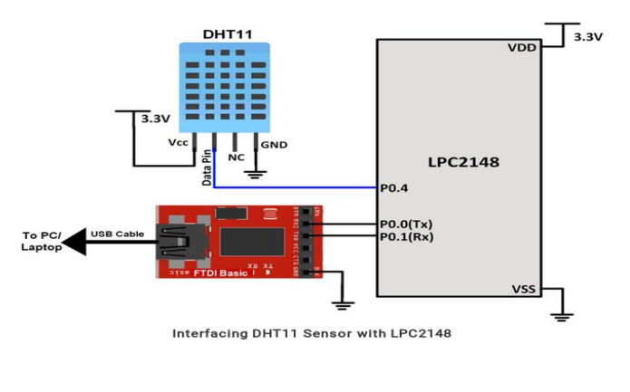

**Python Code**

import time

import board

import adafruit_dht

# Initial the dht device, with data pin connected to:

dhtDevice = adafruit_dht.DHT11(board.D18)

while True:

try:

# Print the values to the serial port

temperature_c = dhtDevice.temperature

temperature_f = temperature_c * (9 / 5) + 32

humidity = dhtDevice.humidity

print(

"Temp: {:.1f} F / {:.1f} C Humidity: {}% ".format(

temperature_f, temperature_c, humidity

)

)

except RuntimeError as error:

# Errors happen fairly often, DHT's are hard to read, just keep going

print(error.args[0])

time.sleep(2.0)

**Conclusion**

Thus we have successfully established an interface between Raspberry Pi and Temperature Sensor.