**ASSIGNMENT NUMBER: B3**

**Title**

Write a network application for communication between two devices using Zigbee.

**Problem Statement**

Understanding and connectivity of Raspberry-Pi /Beagle board with a Zigbee module. Write a network application for communication between two devices using Zigbee.

**Objective**

To understand functionalities of various single board embedded platforms fundamentals.Develop application for Communication between more raspberry pi hardware.

**Outcomes**

I will be able to create a network application for communication between two devices using Zigbee.

**Software & Hardware Requirements**

* Two Raspberry pi board/ BBB
* Raspbian (OS)
* Python
* Zigbee device,
* Latest Version of 64 bit
* Operating Systems,Open Source Fedora-GHz. 8 G.B. RAM, 500 G.B.
* HDD, 15"Color Monitor, Keyboard, Mouse

**Theory**

**Raspberry** **Pi**

**Introduction**

The Raspberry Pi is a series of credit card-sized single-board computers developed in the United Kingdom by the Raspberry Pi Foundation to promote the teaching of basic computer science in schools and in developing countries. It is a capable little computer which can be used in electronics projects, and for many of the things that your desktop PC does, like spreadsheets, word processing, browsing the internet, and playing games. It also plays high definition video.

The Raspberry Pi is open hardware, with the exception of the primary chip on the Raspberry Pi, the Broadcom SoC (System on a Chip), which runs many of the main components of the board–CPU, graphics, memory, the USB controller, etc. Many of the projects made with a Raspberry Pi are open and well-documented as well and are things you can build and modify yourself.

The Raspberry Pi was designed for the Linux operating system, and many Linux distributions now have a version optimized for the Raspberry Pi.

One powerful feature of the Raspberry Pi is the row of GPIO (general purpose input/output) pins along the top edge of the board. These pins are a physical interface between the Pi and the outside world. At the simplest level, you can think of them as switches that you can turn on or off (input) or that the Pi can turn on or off (output). Of the 40 pins, 26 are GPIO pins and the others are power or ground pins (plus two ID EEPROM pins which you should not play with unless you know your stuff!)

You can program the pins to interact in amazing ways with the real world. Inputs don't have to come from a physical switch; it could be input from a sensor or a signal from another computer or device, for example. The output can also do anything, from turning on an LED to sending a signal or data to another device. If the Raspberry Pi is on a network, you can control devices that are attached to it from anywhere and those devices can send data back. Connectivity and control of physical devices over the internet is a powerful and exciting thing, and the Raspberry Pi is ideal for this.

**Raspberry Pi Board with GPIO**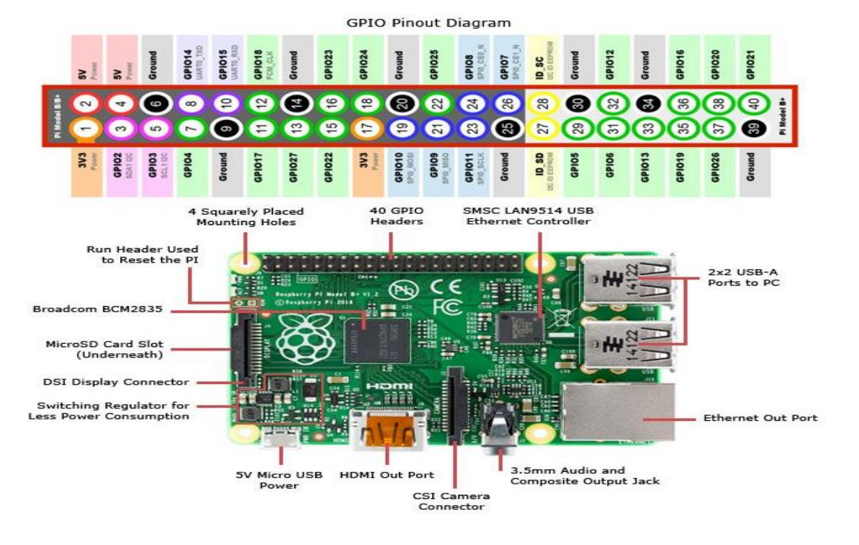

**Technical Specification**

* Broadcom BC M28 37 64bit AR Mv7 Quad Core Processor powered Single Board
* Computer running at 1.2GHz
* 1GB RAM
* BCM43143 WiFi on board
* Bluetooth Low Energy (BLE) on board
* 40pin extended GPIO
* 4 x USB 2 ports
* 4 pole Stereo output and Composite video port
* Full size HDMI
* CSI camera port for connecting the Raspberry Pi camera
* DSI display port for connecting the Raspberry Pi touch screen display
* Micro SD port for loading your operating system and storing data
* Upgraded switched Micro USB power source (now supports up to 2.4 Amps)
* Expected to have the same form factor has the Pi 2 Model B, however the LEDs will Change position

**Zigbee**

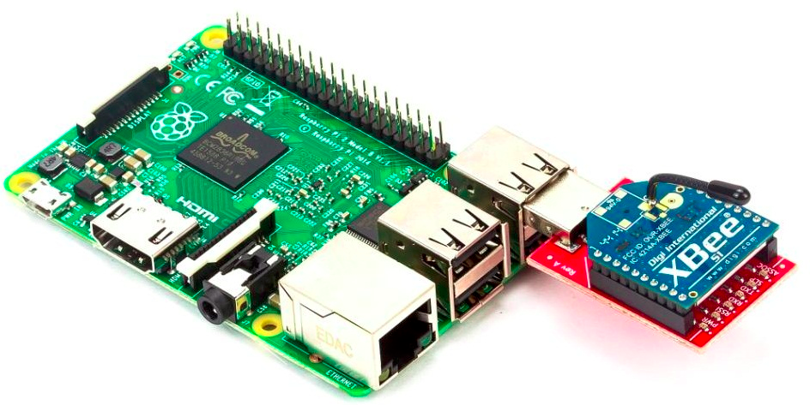

**Introduction**

ZigBee Communication Using Raspberry Pi ZigBee is a communication device used for the data transfer between the controllers,computers, systems, really anything with a serial port. As it works with low power consumption, the transmission distance is limited to 10–100 meters line-of-sight.ZigBeedevices can transmit data over long distances by passing data through a mesh network of intermediate devices to reach more distant ones. ZigBee is typically used in low data rate applications that require long battery life and secure networking. Its main applications are in the field of wireless sensor network based on industries as it requires short-range low-rate wireless data transfer. The technology defined by the ZigBee specification is intended to be simpler and less expensive than other wireless networks.

Zigbee communication is specially built for control and sensor networks on IEEE 802.15.4 standard for wireless personal area networks (WPANs), and it is the product from Zigbee alliance. This communication standard defines physical and Media Access Control (MAC) layers to handle many devices at low-data rates. These Zigbee‟s WPANs operate at 868 MHz, 902-928MHz and 2.4 GHz frequencies. The date rate of 250 kbps is best suited for periodic as well as intermediate two way transmission of data between sensors and controllers.

Zigbee is low-cost and low-powered mesh network widely deployed for controlling and monitoring applications where it covers 10-100 meters within the range. This communication system is less expensive and simpler than the other proprietary short-range wireless sensor networks as Bluetooth and Wi-Fi. Zigbee supports different network configurations for master to master or master to slave communications. And also, it can be operated in different modes as a result the battery power is conserved. Zigbee networks are extendable with the use of routers and allow many nodes to interconnect with each other for building a wider area network

**Zigbee Architecture**

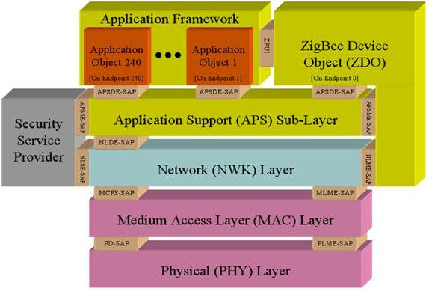

Zigbee system structure consists of three different types of devices such as Zigbee coordinator, Router and End device. Every Zigbee network must consist of at least one coordinator which acts as a root and bridge of the network. The coordinator is responsible for handling and storing the information while performing receiving and transmitting data operations.Zigbee routers act as intermediary devices that permit data to pass to and fro through them to other devices. End devices have limited functionality to communicate with the parent nodes such that the battery power is saved as shown in the figure. The number of routers, coordinators and end devices depends on the type of network such as star, tree and mesh networks.Zigbee protocol architecture consists of a stack of various layers where IEEE 802.15.4 is defined by physical and MAC layers while this protocol is completed by accumulating Zigbee‟s own network and application layers.

Zigbee Topology

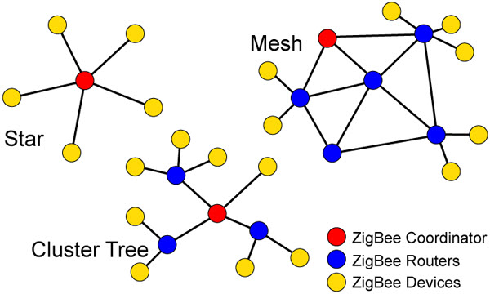

Zigbee two way data is transferred in two modes: Non-beacon mode and Beacon mode. In a beacon mode, the coordinators and routers continuously monitor active state of incoming data hence more power is consumed. In this mode, the routers and coordinators do not sleep because at any time any node can wake up and communicate. However, it requires more power supply and its overall power consumption is low because most of the devices are in an inactive state for over long periods in the network.

In a beacon mode, when there is no data communication from end devices, then the routers and coordinators enter into sleep state. Periodically this coordinator wakes up and transmits the beacons to the routers in the network. These beacon networks are work for time slots which means, they operate when the communication needed results in lower duty cycles and

longer battery usage. These beacon and non-beacon modes of Zigbee can manage periodic (sensors data), intermittent (Light switches) and repetitive data types.

**Python Code**

**Zigbee transmitter code:**

Import serial

Port=serial.Serial(“/dev/ttyUSB0”,baudrate=9600,timeout=3.0)

While True:

X=raw_input(„pass your data‟)

Port.write(x)

Rcv=port.read(1)

Print(„received data:‟,rcv)

**Zigbee receiver code:**

Import serial

Import time

Port=serial.Serial(“/dev/ttyUSB0”, baudrate=9600,timeout=0.1)

While= True:

#x=raw_input(“pass your input”)

#port.write(x)

Rev=port.read(1)

Print(rev)

#time.sleep(1)

If(rev!=‟‟):

F=open(“log.txt”,‟a‟)

f.write(rev)

f.close()

)

**Conclusion**

Thus the communication between two devices using Zigbee are successfully done.