**Assignment No. E1**

**Title:**

Develop a Real time application.

**Problem Statement**

Develop a Real time application like smart home with following requirements: When user enters into house the required appliances like fan, light should be switched ON. Appliances should also get controlled remotely by a suitable web interface. The objective of this application is student should construct complete Smart application in group.

**S/W and H/W:**

1. Raspberry Pi
2. Memory card 8 or 16GB running Raspbian Jessie
3. 5v Relays
4. 2n222 transistors
5. Diodes, Jumper Wires
6. Connection Blocks
7. LEDs to test
8. AC lamp to Test
9. Breadboard and jumper cables
10. 220 or 100 ohms resistor
11. Python

**Learning Objectives:**

* To develop comprehensive approach towards building small low cost embedded IoT system.
* To understand different sensory inputs.
* To develop real time IoT based application

**Learning Outcomes:**

The students will be able to :

* Implement an architectural design for IoT for specified requirement
* Solve the given societal challenge using IoT

**Theory:**

Automatic Room Light Control When we enter a room, as a habitual tendency, we often search for a switch to turn the light on, and if we are new to the room, we often find it difficult to locate the switch. Most of the times, many of us forget to switch off the lights while leaving the room in which we stay most of the time. This results in unnecessary power wastage. Therefore, an automatic room-light controller automatically turns on the lights when a person enters into a room, and turns off the lights when the person leaves the room. This automatic room controller can be implemented by using a simple microcontroller and wireless IR technologies. INTRODUCTION

Home automation is the control of any or all electrical devices in our home or office. There are many different types of home automation system available. These systems are typically designed and purchased for different purposes. In fact, one of the major problems in the area is that these different systems are neither interoperable nor interconnected. There are number of issues involve when designing a home automation system. It should also provide a user friendly interface on the host side, so that the devices can be easily setup, monitored and controlled In smart home systems, the internet is also use to ensure remote control. For years, the internet has been widely use for the processes such as surfing on the pages, searching information, chatting, downloading and installation. By the rapid developments of new technologies, monitoring, controlling services have been started to be served along with internet as an instrument providing interaction with machinery and devices. The system can be use in several places like banks, hospital, labs and other sophisticated automated system, which dramatically reduced the hazards of unauthorized entry. The main reason to develop this system is to save time and man power along with maintaining security and convenience.

* **DIAGRAM OF BASIC H/W and S/W LINKAGE**

**WITH EACH OTHER**

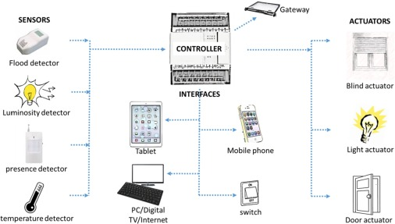

**Home Appliances Control using a Remote Control:**

The lights, fans can be automatically turned on/off with the help of a remote where there will be a sensor instead of going near to a switch board and putting on/off the switch. Companies like Legrand and Gold Medal already started these kinds of control system and they are at present available in the market.

**Home Appliances Control using DTMF:**

In this method, the control of home appliances can be done even though when we are elsewhere just by using the DTMF tone generated when the user pushes mobile phone keypad buttons or when the user pushes mobilephone keypad buttons or when connected to a remote mobile.

**Home Appliance Control Using Free Hand Gesture:**

This is a type of home appliance control system where the person must be present in sight to the appliance that is needed to be controlled and a predefined gesture must be used to turn on the device and another gesture must be used by us to turnoff the device. The performance of the proposed system is done with a hardware embedded in that particular device.

**Home Appliance Control Using Internet and Radio Connection:**

In this system, the control of home appliances can be done from a remote are with an option from a local server, using the Internet and radio connection. This system is accomplished by personal computers, interface cards, radio.

* **BLOCK DIAGRAM FOR HOME AUTOMATION**

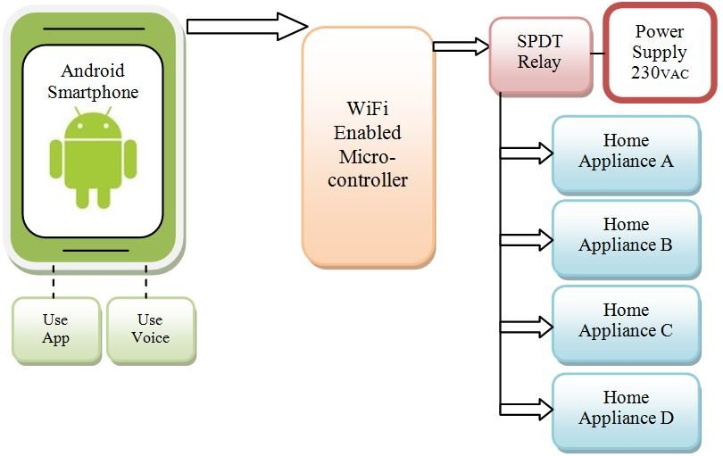

**Conclusion:**

Hence, we implemented a real time application for smart home irrigation. This application turns on the basic appliances like fan, lights when the use enter the room. A simple interface to remotely control the appliances was built.