**Title:**

Hospital Management System

**Abstract:**

Hospitals currently use a manual system for the management and maintenance of critical information. The current system requires numerous paper forms, with data stores spread throughout the hospital management infrastructure. Often information (on forms) is incomplete, or does not follow management standards. Forms are often lost in transit between departments requiring a comprehensive auditing process to ensure that no vital information is lost. Multiple copies of the same information exist in the hospital and may lead to inconsistencies in data in various data stores.

A significant part of the operation of any hospital involves the acquisition, management and timely retrieval of great volumes of information. This information typically involves; patient personal information and medical history, staff information, room and ward scheduling, staff scheduling, operating theater scheduling and various facilities waiting lists. All of this information must be managed in an efficient and cost wise fashion so that an institution's resources may be effectively utilized HMS will automate the management of the hospital making it more efficient and error free. It aims at standardizing data, consolidating data ensuring data integrity and reducing inconsistencies.

**Introduction:**

**Purpose**

• The Software is for the automation of Hospital Management.

• It maintains two levels of users :

1. Administrator Level
2. Doctor Level
3. Receptionist Level

• The Software includes:-

1. Maintaining Patient details.
2. Maintaining Patient Appointments Records
3. Maintaining Doctor Details.
4. Maintaining Doctor Appointments.

**Scope**

It can be used in any Hospital, Clinic, Dispensary or Pathology labs for maintaining patient details.

**Problem Definition**

To implement a system to store and manage the Details of patients, doctors, admins and receptionists of a Particular Hospital.

**Learning Objectives**

This project is being undertaken by the students for them to:

* Understand Database connectivity to the frontend of an application
* Understand Database concepts an actual application
* Understand how backend and frontend work in tandem to make an application function

**Learning Outcomes**

After completion of this project, the students will be able to:

* Connect Database to the frontend of an application
* Implement Database concepts an actual application

**Theory**

**JDBC**

JDBC stands for Java Database Connectivity. JDBC is a Java API to connect and execute the query with the database. It is a part of JavaSE (Java Standard Edition). JDBC API uses JDBC drivers to connect with the database. There are four types of JDBC drivers:

* JDBC-ODBC Bridge Driver,
* Native Driver,
* Network Protocol Driver, and
* Thin Driver

We can use JDBC API to handle database using Java program and can perform the following activities:

1. Connect to the database
2. Execute queries and update statements to the database
3. Retrieve the result received from the database.

**JDBC-ODBC bridge driver**

|  |
| --- |
| The JDBC-ODBC bridge driver uses ODBC driver to connect to the database. The JDBC-ODBC bridge driver converts JDBC method  calls into the ODBC function calls. |

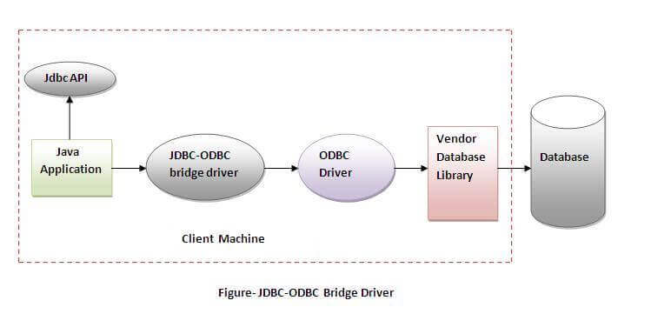

Advantages:

* easy to use.
* can be easily connected to any database.

Disadvantages:

* Performance degraded because JDBC method call is converted into the ODBC function calls.
* The ODBC driver needs to be installed on the client machine.

 The **java.sql** package contains classes and interfaces for JDBC API. A list of popular *interfaces* of JDBC API are given below:

* Driver interface
* Connection interface
* Statement interface
* PreparedStatement interface
* CallableStatement interface
* ResultSet interface
* ResultSetMetaData interface
* DatabaseMetaData interface
* RowSet interface

To connect Java application with the MySQL database, we need to follow following steps.

1. **Driver class:**The driver class for the mysql database is **com.mysql.jdbc.Driver**.
2. **Connection URL:**The connection URL for the mysql database is **jdbc:mysql://localhost:3306/db_hospital** where jdbc is the API, mysql is the database, localhost is the server name on which mysql is running, we may also use IP address, 3306 is the port number and sono is the database name. We may use any database, in such case, we need to replace the sono with our database name.
3. **Username:**The default username for the mysql database is **root**.
4. **Password:**It is the password given by the user at the time of installing the mysql database. In this example, we are going to use **root** as the password.

**Java Swing tutorial** is a part of Java Foundation Classes (JFC) that is used to create window-based applications. It is built on the top of AWT (Abstract Windowing Toolkit) API and entirely written in java.Unlike AWT, Java Swing provides platform-independent and lightweight components.The javax.swing package provides classes for java swing API such as JButton, JTextField, JTextArea, JRadioButton, JCheckbox, JMenu, JColorChooser etc.

The class **JFrame** is an extended version of **java.awt.Frame** that adds support for the JFC/Swing component architecture.

JFrame works like the main window where components like labels, buttons, textfields are added to create a GUI.

Unlike Frame, JFrame has the option to hide or close the window with the help of setDefaultCloseOperation(int) method.

**Class Diagram/ER Diagram**

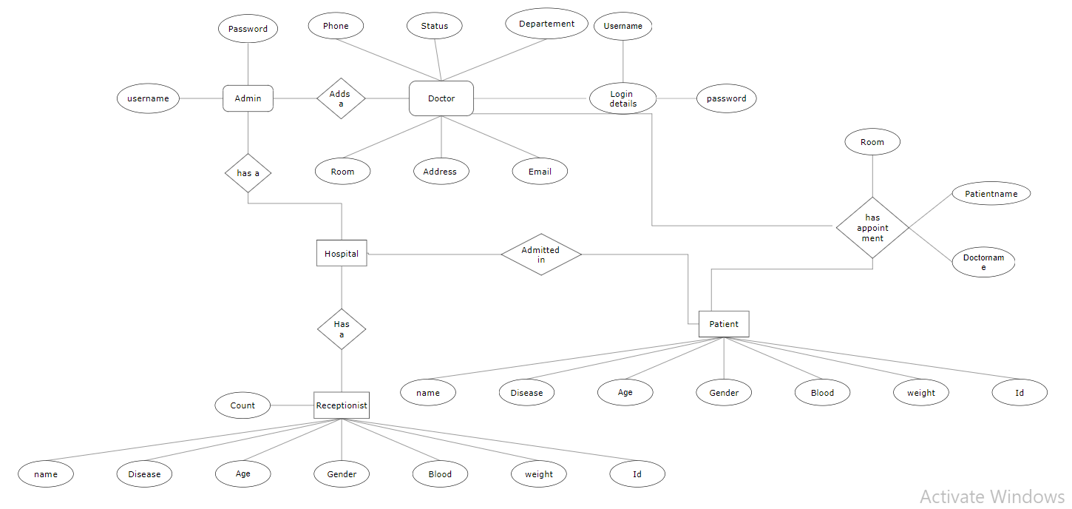

**Relational Schema:**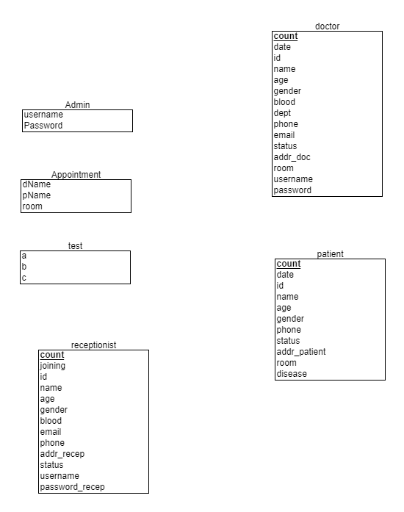

**Output (SNAPSHOTS):**

**Fig.1) Main Portal**

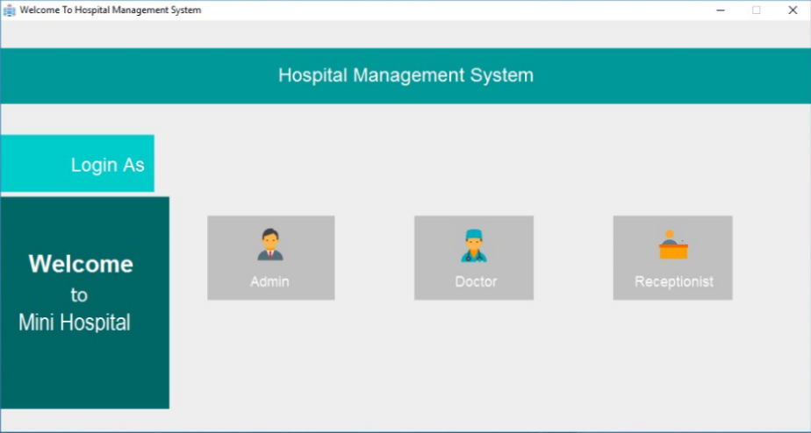

**Fig.2) Admin Login**

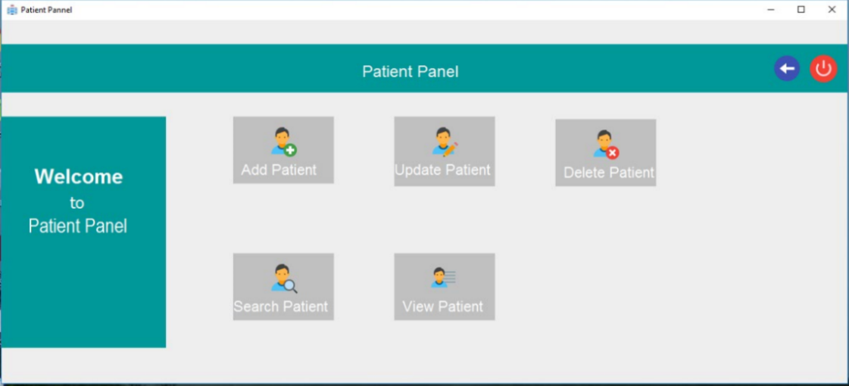

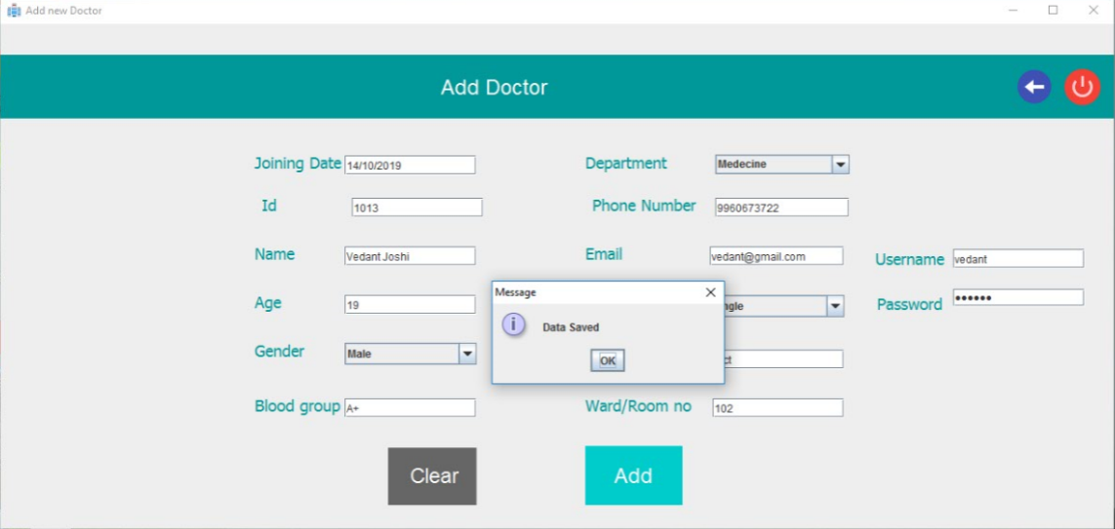

**Fig.3) Add Doctor**

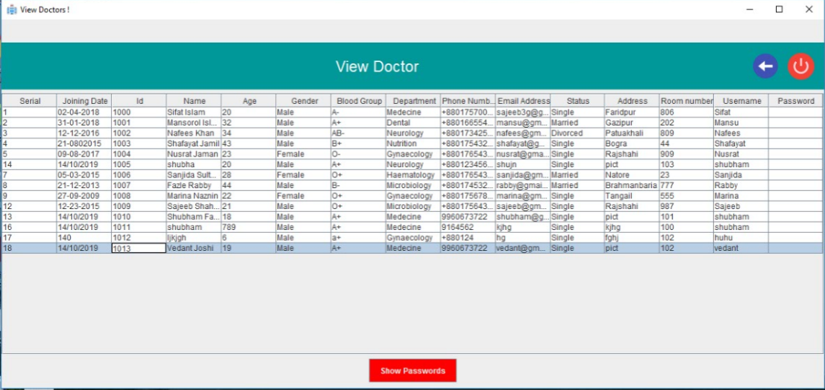

**Fig.4) View Doctors**

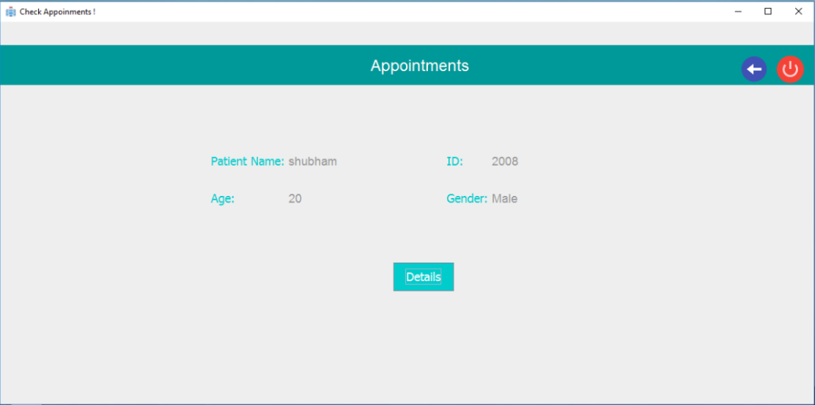

**Fig.5) View Appointments**

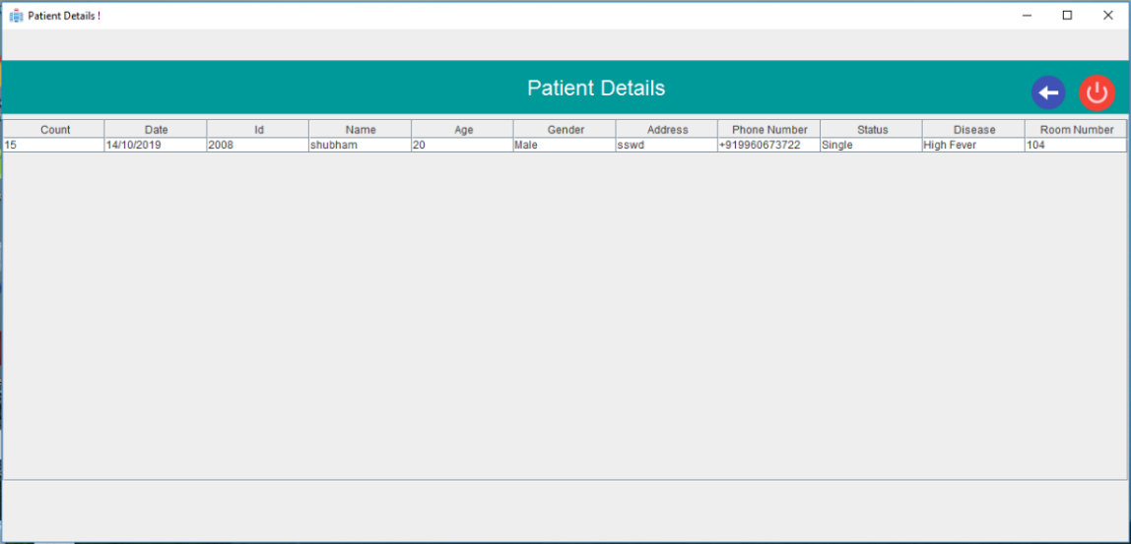

**Fig.6) View Patient**

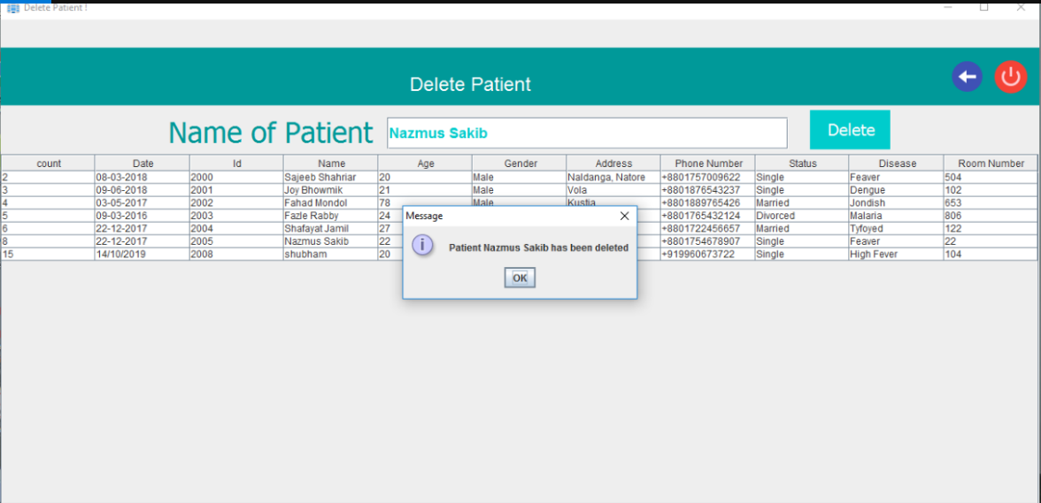

**Fig.7) Delete Patient**

**Source Codes:**

**1. JDBC Connectivity**

public class Connector {

public static void main(String[] args) {

ConnectDb();

}

public static Connection ConnectDb() {

Connection connection = null;

try {

Class.forName("com.mysql.jdbc.Driver");

connection = DriverManager.getConnection("jdbc:mysql://localhost:3306/db_hospital", "root", "root")

return connection;

} catch (ClassNotFoundException | SQLException ex) {

JOptionPane.showMessageDialog(null, ex);

}

return connection;

}

}

**2.Login Validation**

private void dLoginBtnActionPerformed(java.awt.event.ActionEvent evt) {

connection = Connector.ConnectDb();

String user = dUserField.getText();

String pass = String.valueOf(dPassField.getPassword());

try {

String sql = "select username, password from doctor where username='" + user + "'";

prp = connection.prepareStatement(sql);

result = prp.executeQuery();

result.first();

userName = user;

if (pass.equals(result.getString("password"))) {

doctorActivity dActivity = new doctorActivity(userName);

dActivity.setVisible(true);

JOptionPane.showMessageDialog(null, "Login Succesful", "Welcome " + user, JOptionPane.INFORMATION_MESSAGE);

dispose();

connection.close();

} else {

JOptionPane.showMessageDialog(null, "Login Failed", "Error", JOptionPane.WARNING_MESSAGE);

}

} catch (HeadlessException | SQLException e) {

JOptionPane.showMessageDialog(null, "User or Password wrong."); }

**3.Add Doctor**

connection = Connector.ConnectDb();

if (connection != null) {

String date = rDateField.getText();

String id = rIdField.getText();

String name = rNameField.getText();

int age = Integer.parseInt(rAgeField.getText());

String gender = (String) rGenderField.getSelectedItem();

String rblood = rBloodField.getText();

String email = rEmailField.getText();

String phone = rPhoneField.getText();

String address = rAddressField.getText();

String status = (String) rStatusField.getSelectedItem();

String user = rUserField.getText();

String pass = String.valueOf(rPassField.getPassword());

String sql = "insert into receptionist(joining,id,name,age,gender,blood,email,phone,address,status,username,password) values (?,?,?,?,?,?,?,?,?,?,?,?)";

try {

prp = connection.prepareStatement(sql);

prp.setString(1, date);

prp.setString(2, id);

prp.setString(3, name);

prp.setInt(4, age);

prp.setString(5, gender);

prp.setString(6, rblood);

prp.setString(7, email);

prp.setString(8, phone);

prp.setString(9, address);

prp.setString(10, status);

prp.setString(11, user);

prp.setString(12, pass);

prp.execute();

JOptionPane.showMessageDialog(null, "Data Saved");

ReceptionistManagement rm = new ReceptionistManagement();

rm.setVisible(true);

dispose();

} catch (SQLException e) {

}

**4.Delete Receptionist**

connection = Connector.ConnectDb();

String search = rDeleteField.getText();

String sql = "Delete from receptionist where name ='" + search + "'";

try {

ps = connection.prepareStatement(sql);

ps.execute();

JOptionPane.showMessageDialog(null, "Patient " + search + " has been deleted");

defaultTableModel.getDataVector().removeAllElements();

defaultTableModel.fireTableDataChanged();

loadData();

connection.close();

} catch (SQLException e) {

JOptionPane.showMessageDialog(null, "patient named " + search + " not found");

}

**5.Update Patient**

connection = Connector.ConnectDb();

String sql = "Update patient set date = '" + date + "', id = '" + id + "', name = '" + name + "', age = '" + age + "', gender = '" + gender + "', address = '" + address + "', phone = '" + phone + "', status = '" + status + "', disease = '" + disease + "', room = '" + room + "' where count = '" + count + "'";

try {

ps = connection.prepareStatement(sql);

ps.execute();

defaultTableModel.getDataVector().removeAllElements();

defaultTableModel.fireTableDataChanged();

loadData();

JOptionPane.showMessageDialog(null, "Data Updated");

} catch (HeadlessException | SQLException e) {

JOptionPane.showMessageDialog(null, e);

}

**6.Set Appointment**

int row = pSTable.getSelectedRow();

String pname = (pSTable.getValueAt(row, 2).toString());

connection = Connector.ConnectDb();

String sql = "insert into appointment(dName,pName,room) values (?,?,?)";

try {

ps = connection.prepareStatement(sql);

ps.setString(1, dName);

ps.setString(2, pname);

ps.setInt(3, droom);

ps.execute();

JOptionPane.showMessageDialog(null, "PATIENT " + pname + " Appointment set with DOCTOR " + dName + " at room no " + droom);

} catch (HeadlessException | SQLException e) {

}

**Test cases**

|  |  |  |  |
| --- | --- | --- | --- |
| **INPUT** | **EXPECTED OUTPUT** | **ACTUAL OUTPUT** | **RESULT** |
| **Add Patient**  Name : Shubham  Disease : Cancer  Age: 20  Date: 14/10/2019  Gender: Male  Ward No: 102  Phone:9977442255 | Patient Added | Patient Added | **Pass** |
| **Login Patient**  Name : Shubham  Password : 12345 | Login Unsuccessful | Login Unsuccessful | **Pass** |
| **Login Admin**  Name : admin  Password : admin | Login Successful | Login Successful | **Pass** |
| **Set Appointment**  Department: Nutrition  Patient Name: Shubham | Patient Appointment Set with doctor | Patient Appointment Set with doctor | **Pass** |

**Features:**

* 1. **Improved Processes**: It helps to optimize the user experience. Medical specialists, patients, and hospital authorities can interact online, make the appointments and exchange information.
  2. **Digital medical records:** The hospital database includes all the necessary patient data. The disease history, test results, prescribed treatment can be accessed by doctors without much delay in order to make an accurate diagnosis and monitor the patient’s health. It enables lower risks of mistakes**.**
  3. **Facility management**: Hospitals authorities are able to manage their available resources, analyze staff work, reduce the equipment downtime, optimize the supply chain, etc. Another fact to mention is that hospital staff deal with the digital data instead of endless paperwork.
  4. **Better customer experience:** Since the clinic management system is patient-oriented, the treatment process can be less stressful. Doctors have more time for the examination and interaction with patients. In addition, all the requested information can be received online.

**Data Modelling:**

Receptionist information

Patient Information

Doctor Information

Appointments

**Conclusion:**

The project Hospital Management System is for computerizing the working in a hospital. It is a great improvement over the manual system. This system is thoroughly checked and tested with dummy data and thus is found very reliable. Thus, we have successfully implemented Hospital Management System using SQL queries and Java Swing for the Frontend.