**Project Name: “Ayurveda”**

**Project Member:**

**Shubham Gadhave 210543181026**

**Ahire Juhi Arun 210543181003**

**Pooja Belsare 210543181073**

**Tausif Bholukha 210543181112**

**Abstract:**

Ayurveda is a system of medicine with historical roots in the Indian subcontinent. Globalized and modernized practices derived from Ayurveda traditions are a type of alternative medicine. Online facility to take an appointment with the doctor. Providing communication through online system.

In these we can create a general awareness about diseases and their homemade therapy with their effectiveness cure and ayurvedic properties.

* Admin Module

The admin will have control over the entire system. There is no registration for him but he should have username and password to login into the system to provide security. He can view everyone's profiles associated with the ayurvedic clinic.

* Doctor Module

Doctor can be accessible to their portal through their credentials. They can have access the calendar controller in which they can select their holidays or leaves whenever they are not available on desired dates.

So that patient can have an idea about availability of doctor on desired days.

* Patient Module

Patient can able to take an appointment on desired dates for their diseases with online available specialists. They can take an appointment by themselves when doctor is available.

They can have search functionality of nearby doctor to their place.

* Technology: Java, SpringBoot,Hibernate, MySQL, Bootstrap.

**Implementation Technologies:**

1. **Spring Framework:**

Spring Framework is a Java platform that provides comprehensive infrastructure support for developing Java applications. Spring handles the infrastructure so you can focus on your application.

Spring enables you to build applications from “plain old Java objects” (POJOs) and to apply enterprise services non-invasively to POJOs. This capability applies to the Java SE programming model and to full and partial Java EE.

**1.1 Features of Spring Framework:**

**1. Lightweight**

Spring is modular lightweight framework which allows you to selectively use any of its modules on the top of Spring Core.

**2. Inversion of Control (IOC)**

This is another top feature of Spring framework where application dependencies are satisfied by the framework itself. Framework creates the object in runtime and satisfies application dependencies.

**3. Aspect Oriented Programming (AOP)**

Aspect Oriented Programming (AOP) is very popular in programming world and in Spring it is well implemented. Developer can use Aspect Oriented Programming (AOP feature of Spring to develop application in which business logic is separated from system services.

**4. Container**

Spring provides their own container for managing the bean lifecycle.

**5. MVC Framework**

Spring MVC Framework is used for developing MVC based web applications.

**6. Transaction Management**

Spring framework provides generic Transaction Management layer which can be used with or without J2EE(JEE) environment.

**7. JDBC Exception Handling**

Spring provides their own abstraction of JDBC exception which further simplifies the exception handling in program.

**1.2 Advantages of Spring Framework:**

**1. Solving difficulties of Enterprise application development**

Spring is solving the difficulties of development of complex applications, it provides Spring Core, Spring IoC and Spring AOP for integrating various components of business applications.

**2. Support Enterprise application development through POJOs**

Spring supports development of Enterprise application development using the POJO classes which removes the need of importing heavy Enterprise container during development. This makes application testing much easier.

**3. Easy integration other frameworks**

Spring designed to be used with all other frameworks of Java, you can use ORM, Struts, Hibernate and other frameworks of Java together. Spring framework do not impose any restriction on the frameworks to be used together.

**4. Application Testing**

Spring Container can be used to develop and run test cases outside enterprise container which makes testing much easier.

**5. Modularity**

Spring framework is modular framework and it comes with many modules such as Spring MVC, Spring ORM, Spring JDBC, Spring Transactions etc. which can used as per application requirement in modular fashion.

**6. Spring Transaction Management**

Spring Transaction Management interface is very flexible it can configure to use local transactions in small application which can be scaled to JTA for global transactions.

1. **Spring Boot:**

Spring Boot helps you to create stand-alone, production-grade Spring-based applications that you can run. We take an opinionated view of the Spring platform and third-party libraries, so that you can get started with minimum fuss. Most Spring Boot applications need very little Spring configuration.

You can use Spring Boot to create Java applications that can be started by using java -jar or more traditional war deployments. We also provide a command line tool that runs “spring scripts”.

Our primary goals are:

* Provide a radically faster and widely accessible getting-started experience for all Spring development.
* Be opinionated out of the box but get out of the way quickly as requirements start to diverge from the defaults.
* Provide a range of non-functional features that are common to large classes of projects (such as embedded servers, security, metrics, health checks, and externalized configuration).
* Absolutely no code generation and no requirement for XML configuration.

**3. Hibernate:**

Hibernate is a Java framework that simplifies the development of Java application to interact with the database. It is an open source, lightweight, ORM (Object Relational Mapping) tool. Hibernate implements the specifications of JPA (Java Persistence API) for data persistence.

* 1. **ORM Tool:**

An ORM tool simplifies the data creation, data manipulation and data access. It is a programming technique that maps the object to the data stored in the database.

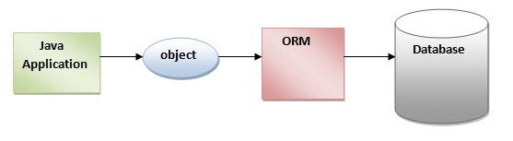

The ORM tool internally uses the JDBC API to interact with the database.

**4. MySQL**

MySQL, the most popular Open Source SQL database management system, is developed, distributed, and supported by Oracle Corporation.

**Features of MySQL:**

* **MySQL is a database management system.**

A database is a structured collection of data. It may be anything from a simple shopping list to a picture gallery or the vast amounts of information in a corporate network. To add, access, and process data stored in a computer database, you need a database management system such as MySQL Server. Since computers are very good at handling large amounts of data, database management systems play a central role in computing, as standalone utilities, or as parts of other applications.

* **MySQL databases are relational.**

A relational database stores data in separate tables rather than putting all the data in one big storeroom. The database structures are organized into physical files optimized for speed. The logical model, with objects such as databases, tables, views, rows, and columns, offers a flexible programming environment.

* **MySQL software is Open Source.**

Open Source means that it is possible for anyone to use and modify the software. Anybody can download the MySQL software from the Internet and use it without paying anything.

* **The MySQL Database Server is very fast, reliable, scalable, and easy to use.**

MySQL Server was originally developed to handle large databases much faster than existing solutions and has been successfully used in highly demanding production environments for several years. Although under constant development, MySQL Server today offers a rich and useful set of functions. Its connectivity, speed, and security make MySQL Server highly suited for accessing databases on the Internet.

* **MySQL Server works in client/server or embedded systems.**

The MySQL Database Software is a client/server system that consists of a multithreaded SQL server that supports different back ends, several different client programs and libraries, administrative tools, and a wide range of application programming interfaces (APIs).

1. **Hardware and Software Requirements (Minimum):**

**Hardware:**

1. Intel i5 processor 10th generation

2. 2 GB RAM.

3. Windows 10 Home edition.

4. 200 GB Data HDD Space

5. Data Connection 200 kbps

**Software:**

1. Eclipse IDE for Enterprise Java Developers
2. MySQL 5.7 with Workbench 8.0
3. Google Chrome version 93.0
4. Apache Tomcat Server 8.5
5. Maven Dependencies
6. **ER Diagram:**

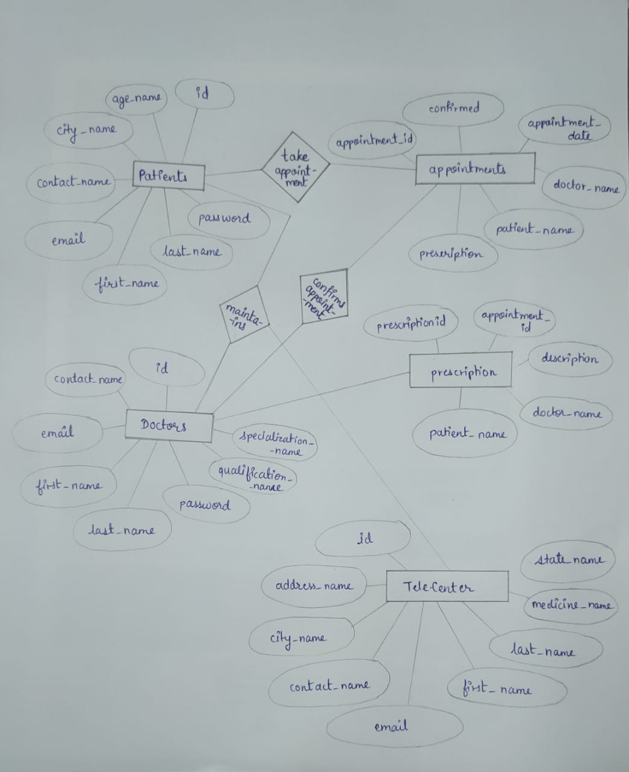

Figure 1: ER Diagram

1. **Table Structures:**

**1.Table:users**  
  
**Columns:**

|  |  |
| --- | --- |
| **id** | bigint AI PK |
| age_name | varchar(20) |
| city_name | varchar(20) |
| contact_name | varchar(20) |
| **email** | varchar(45) |
| first_name | varchar(20) |
| last_name | varchar(20) |
| password | varchar(64) |

**2.Table:usersdoctor**  
  
**Columns:**

|  |  |
| --- | --- |
| **id** | bigint AI PK |
| contact_name | varchar(20) |
| **email** | varchar(45) |
| first_name | varchar(20) |
| last_name | varchar(20) |
| password | varchar(64) |
| qualification_name | varchar(20) |
| specialization_name | varchar(20) |

**3.Table:appointment**  
  
**Columns:**

|  |  |
| --- | --- |
| **appointment_id** | int AI PK |
| confirmed | varchar(50) |
| appointment_date | varchar(50) |
| doctor_name | varchar(50) |
| patient_name | varchar(50) |
| prescription | varchar(50) |
|  |  |

**4.Table:userstelecenter**  
  
**Columns:**

|  |  |
| --- | --- |
| **id** | bigint AI PK |
| address_name | varchar(20) |
| city_name | varchar(20) |
| contact_name | varchar(20) |
| **email** | varchar(45) |
| first_name | varchar(20) |
| last_name | varchar(20) |
| medicine_name | varchar(20) |
| state_name | varchar(20) |
| 5. **Table:prescription**  **Columns:**   |  |  | | --- | --- | | **prescriptionid** | int AI PK | | appointmentid | int | | description | varchar(255) | | doctor_name | varchar(255) | | patient_name | varchar(255) | |  |

6. **Table:admin**  
  
**Columns:**

|  |  |
| --- | --- |
| **id** | bigint AI PK |
| **email** | varchar(45) |
| password | varchar(64) |

1. **UML Diagrams:**

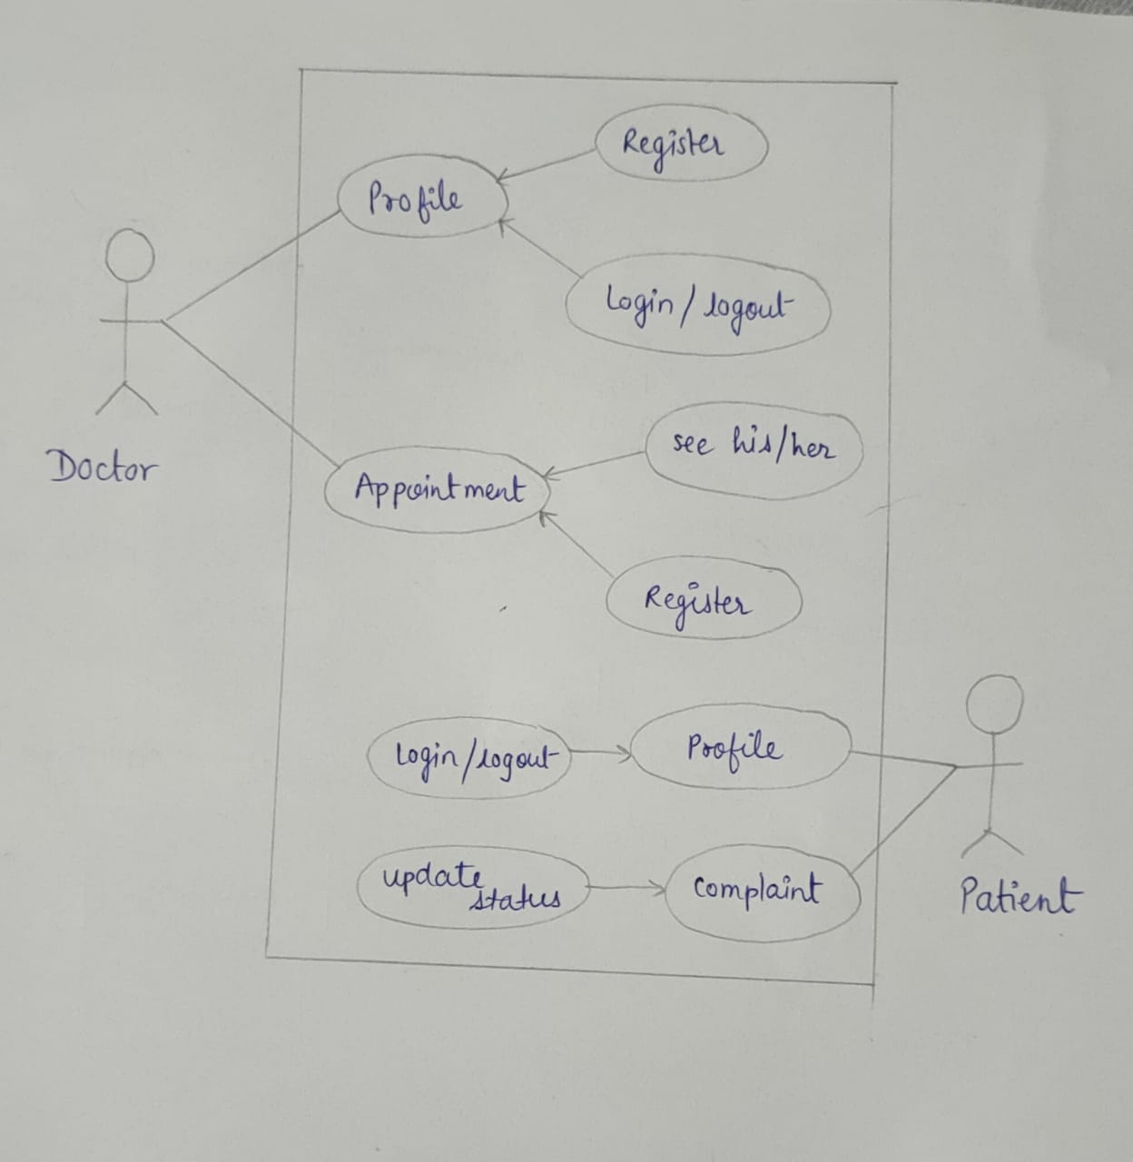

Figure 2: Use Case

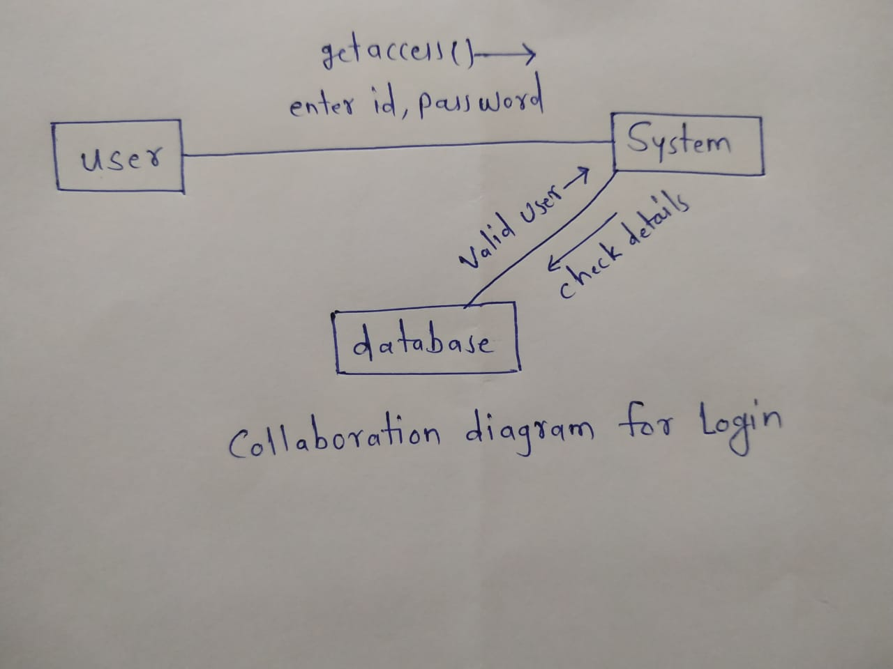

Figure 3: Collaboration Diagram

**Login :**

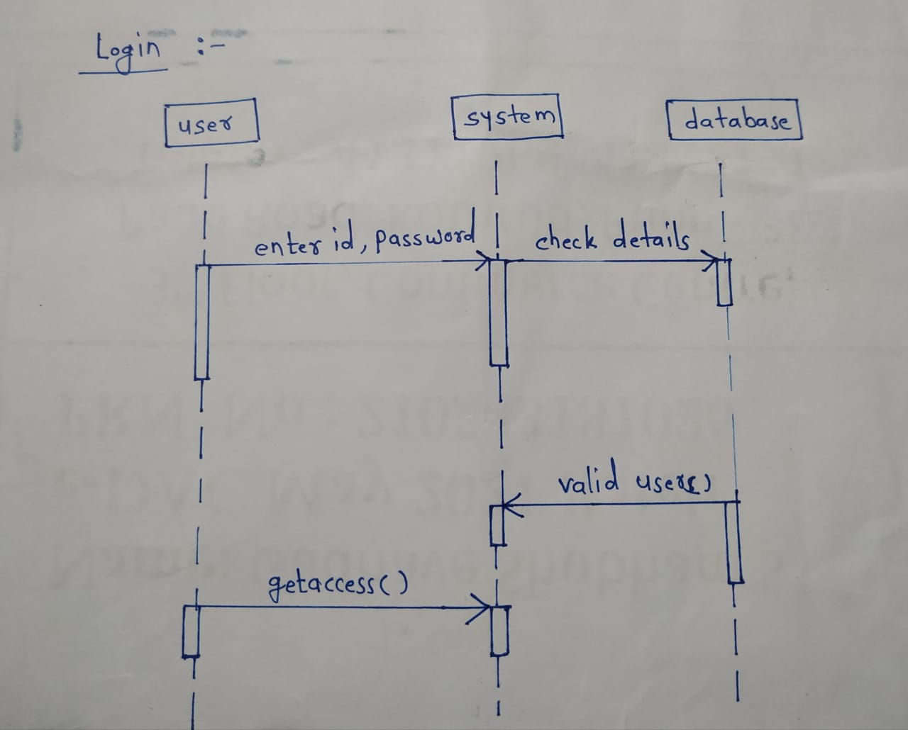

Patient Information :

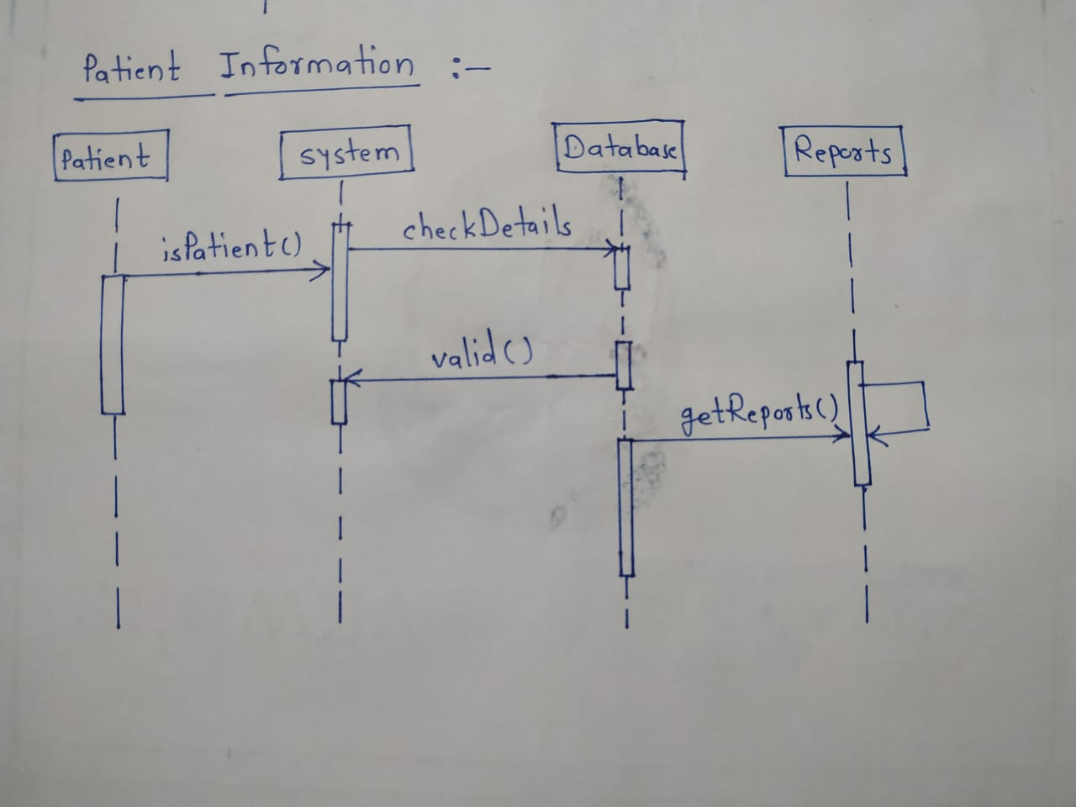

**Take Appointments :**

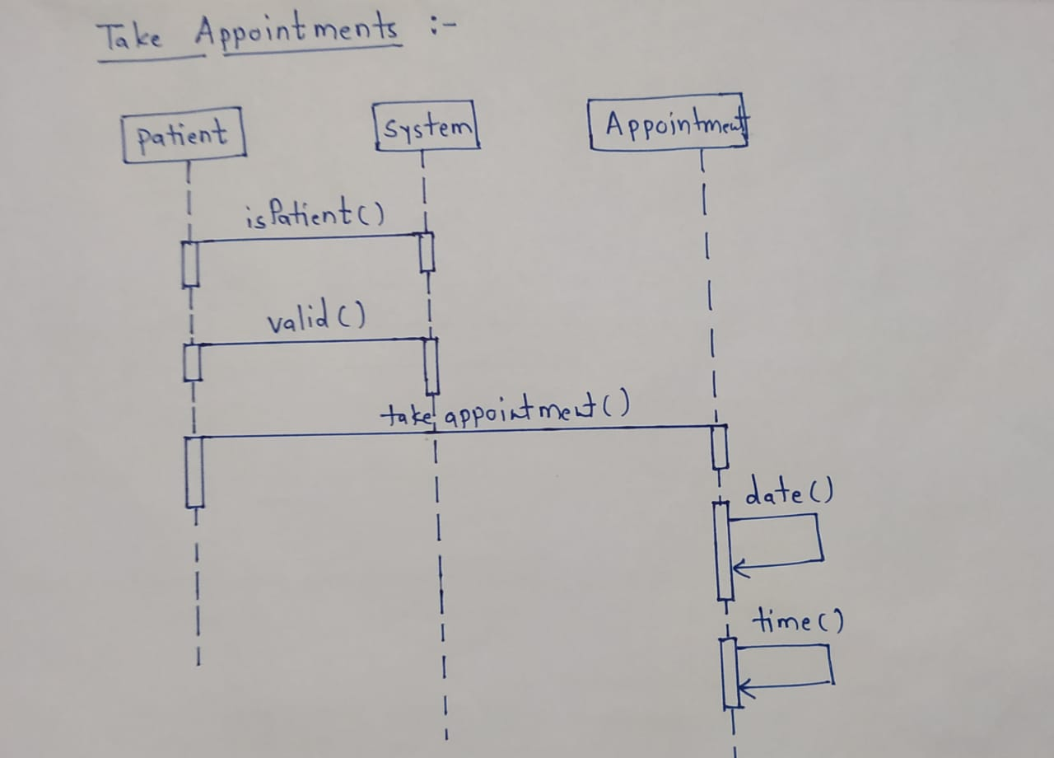

Figure 4: Sequence Diagram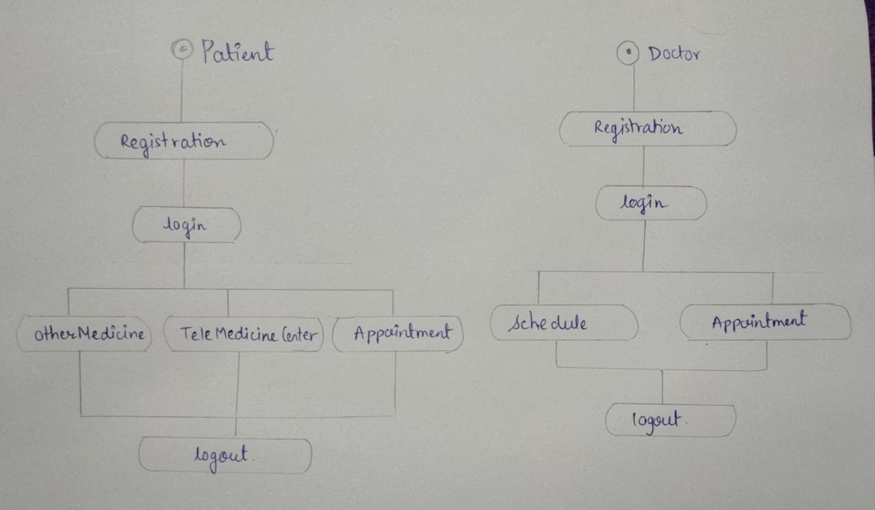Figure 5: State Diagram

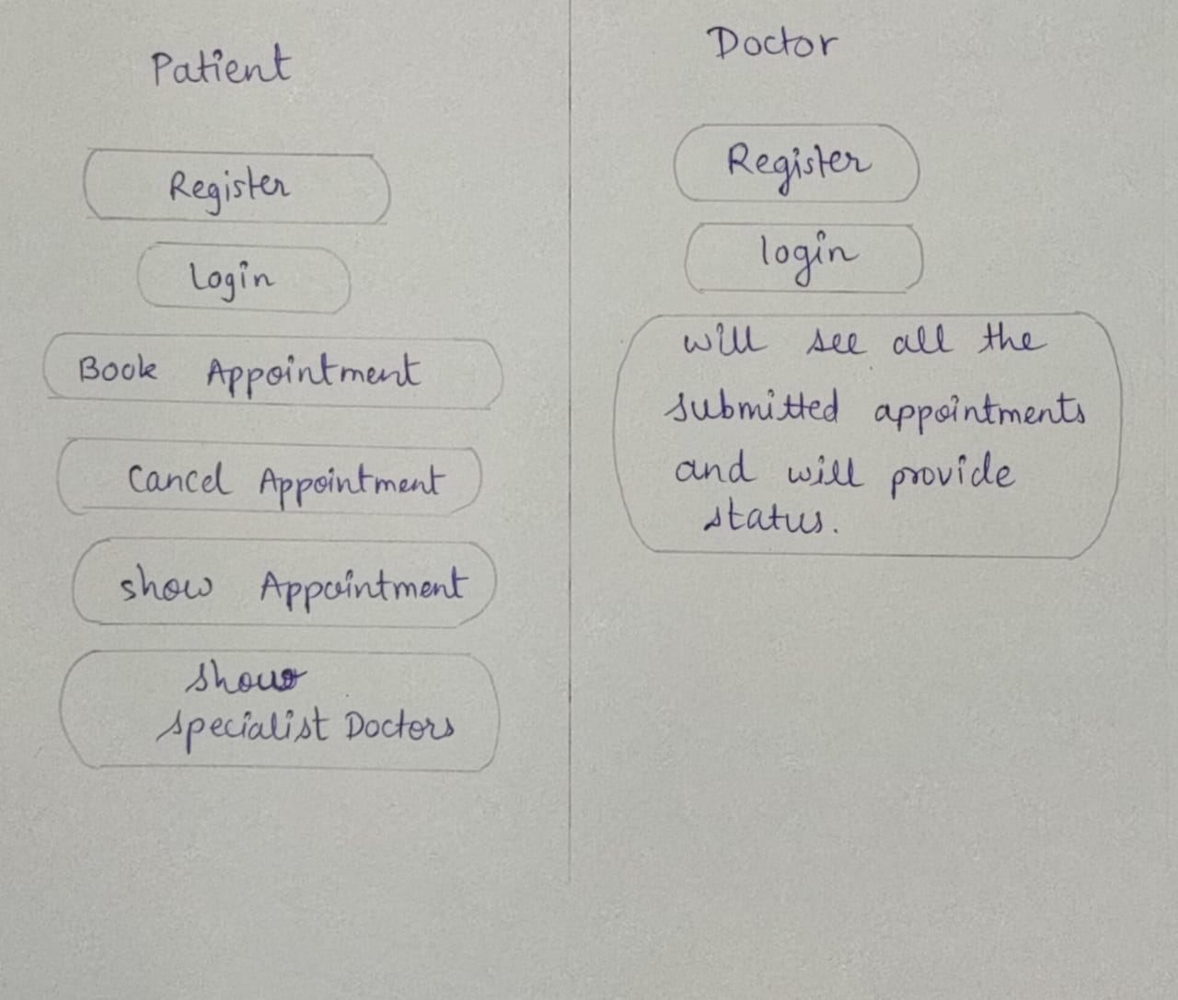

Figure 6: Activity Diagram

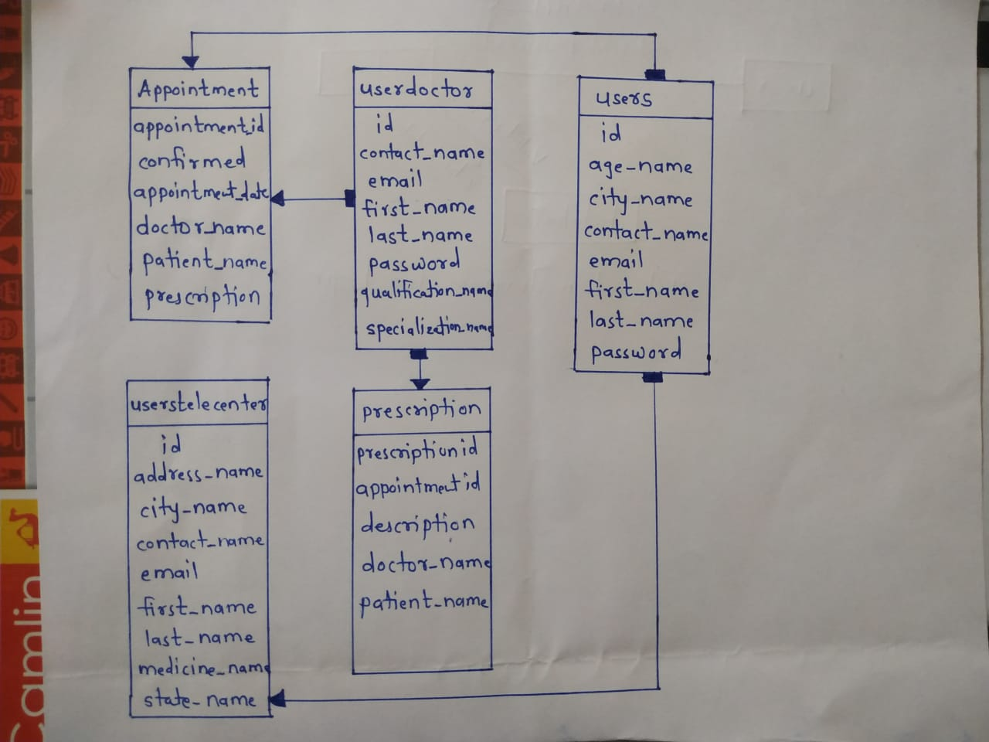

Figure 7: Class Diagram

1. **End to End Flow of Application:**

**Patient:**

**Login:**

**Step 1:** User should have valid username and password to login to the system.

a. Make Login page of Ayurveda

b. Enter username and password

c. Click on login button and then shows welcome page.

**Step 2:** If invalid user login to the system then it shows invalid username and password so he should get register first.

**Registration:**

**Step 1:** Registration for new patients.

a. If the patient is a new user then first he should get registered.

b. Then click on the Register button.

c. Fill all the required details and click on register button.

d. After the patient registration Now the patient can login and use the services.

**Appointment:**

a. Patients can take online appointments from the doctors.

b. Fill all the details in complaint form and click on Booking button.

c. Patients can view doctor’s prescriptions.

**Doctor:**

**Step 1:** The doctors should also get registered and the Admin registers the new doctors.

a. Login as Admin to the system.

b. Click on Add Doctor and the following register form appears.

c. Fill all the details and the doctor gets registered.

**Step 2:**

a. After the doctor registration login as Doctor.

b. The doctor should give online appointments.

c. Based on the Date of availability of doctor, the doctor sends Schedule and the appointment is given to the patient.

**OtherMedicine:**

User and patient can purchased/ordered medicines by filling the required information.

1. **Future Scope Of Project:**

**The Ayurveda has good potential to grow since it provides specialty health care to the remote hospitals. The growth could be the connectivity between**

* Improve online facilities of district hospitals/ health centres and super-specialty hospitals in the cities.

* Community Health Centres at block level and district hospital.

* Provide convenient consultation through video conferencing.

**Thank You!**