<https://drive.google.com/drive/folders/1rOAFRMzN_ZepTI4zOWnT7lmgB_saC0F-?usp=sharing>

There are three output images attach below

Output_01 :--

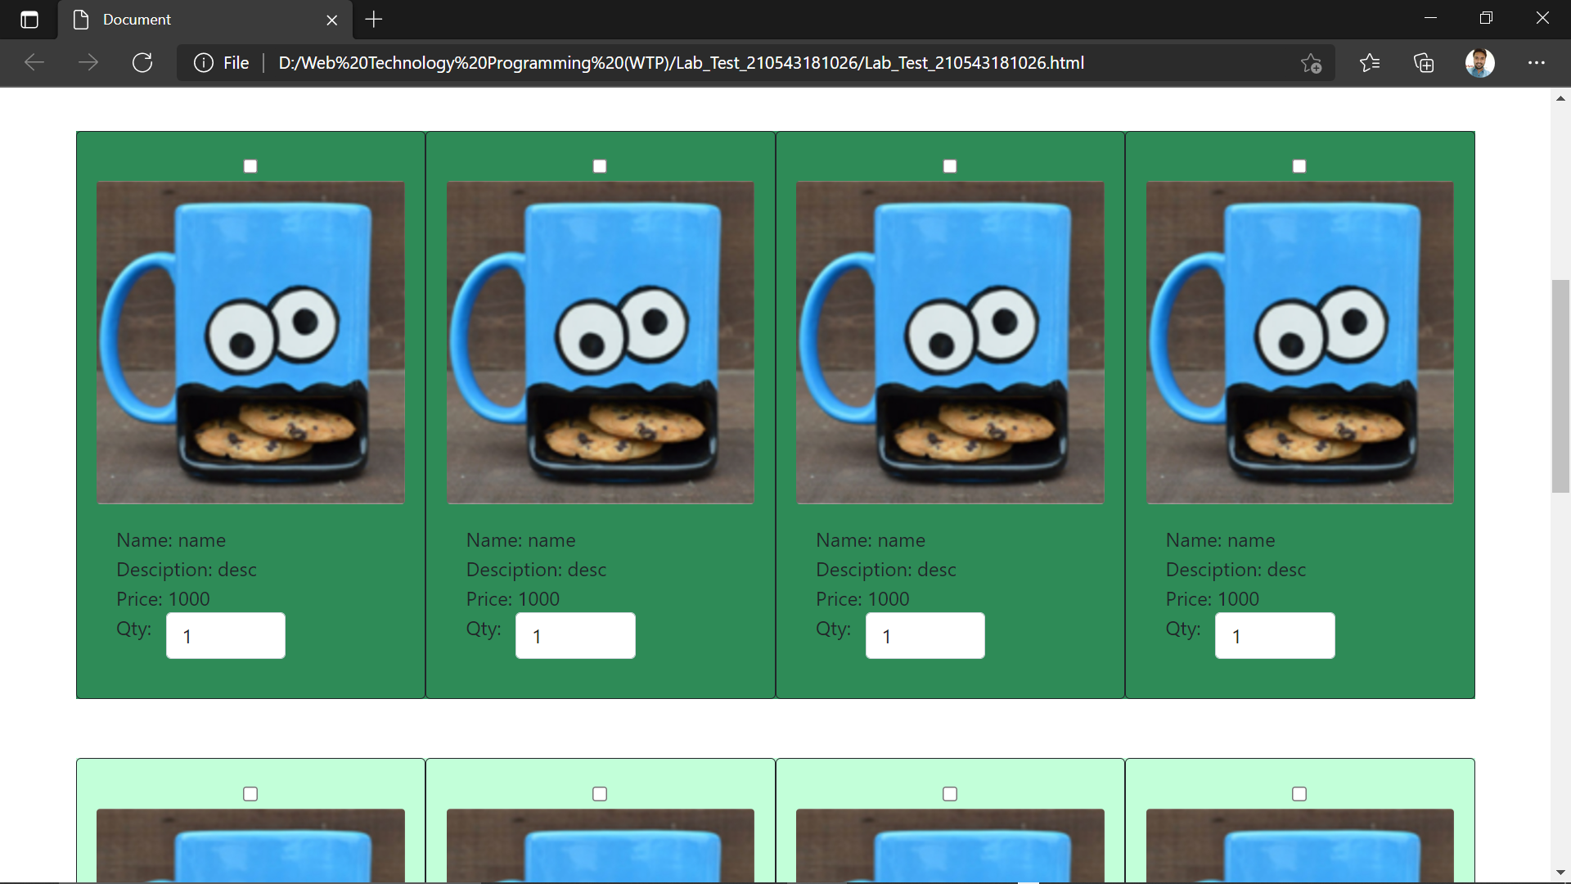

Output_02 :--

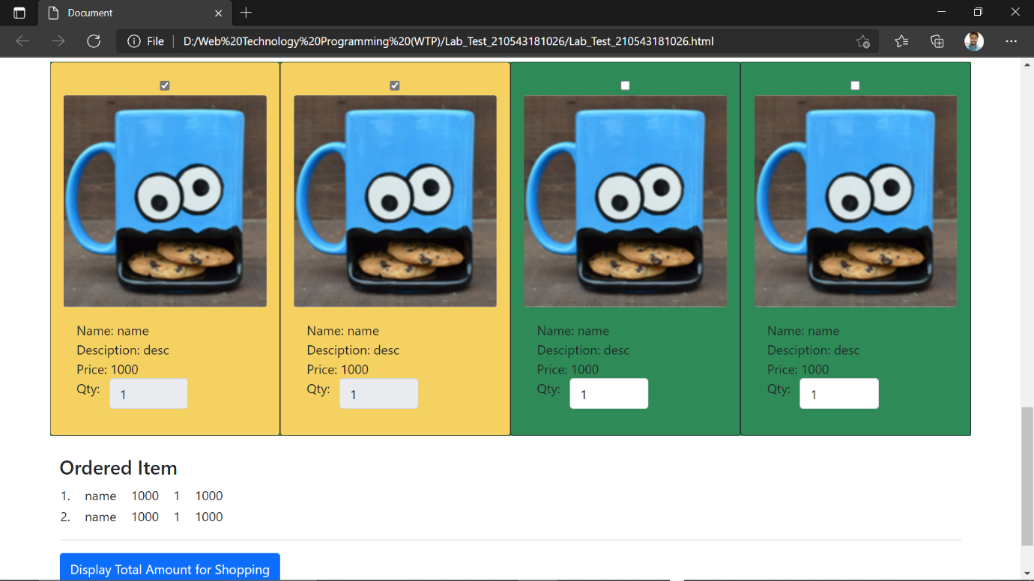

Output_03 :--

