DMT mai
1.
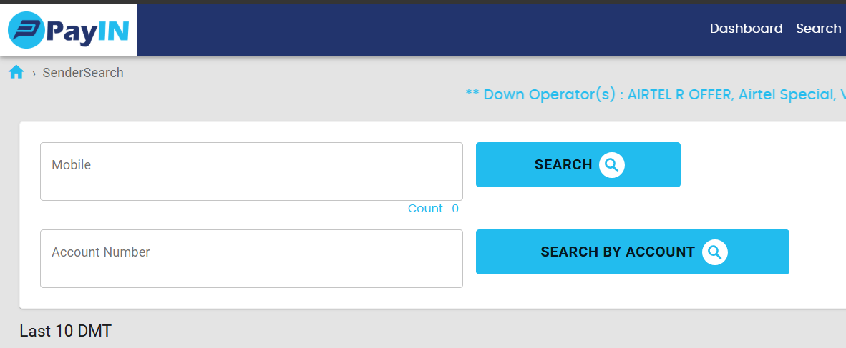
ya tho mobile number se search kare yafir account se .
2. Isme kya ho raha hai ki mobileer number dalne ke baad 2 page open honge .
2.1.ager Sender ka Details Add nahi hai tho registration page.
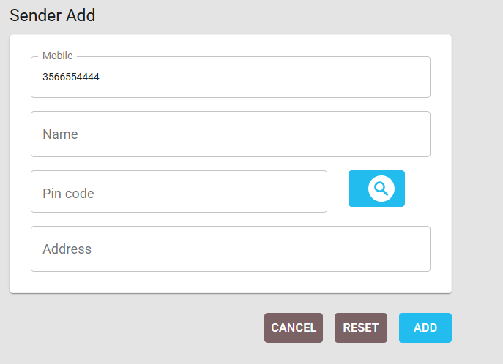
add button pe click kiya tho otp jata hai . vefition hoga fir submit success hoga
2.2ager sender add hoga tho next page
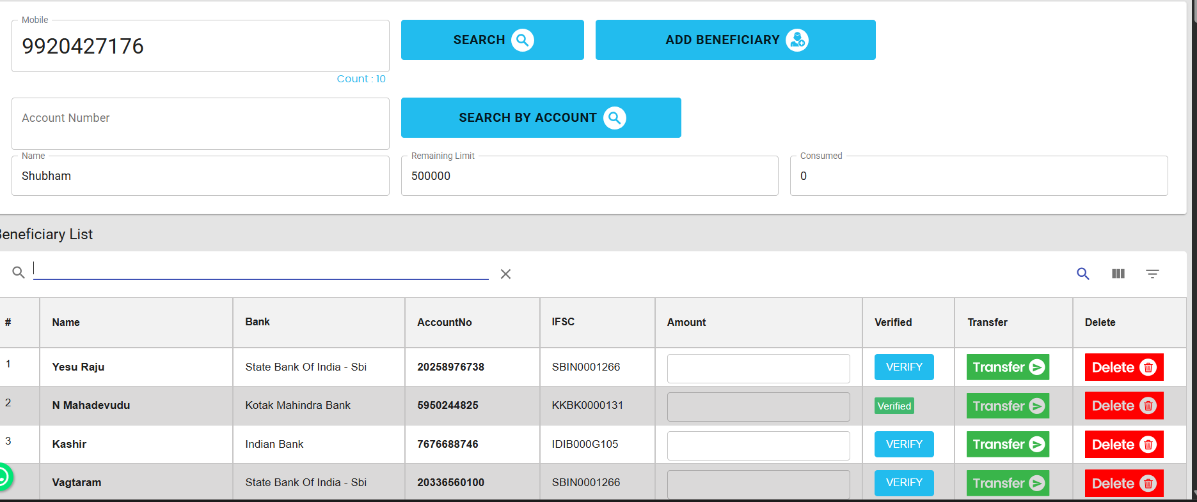
add beneficiary Karega tho
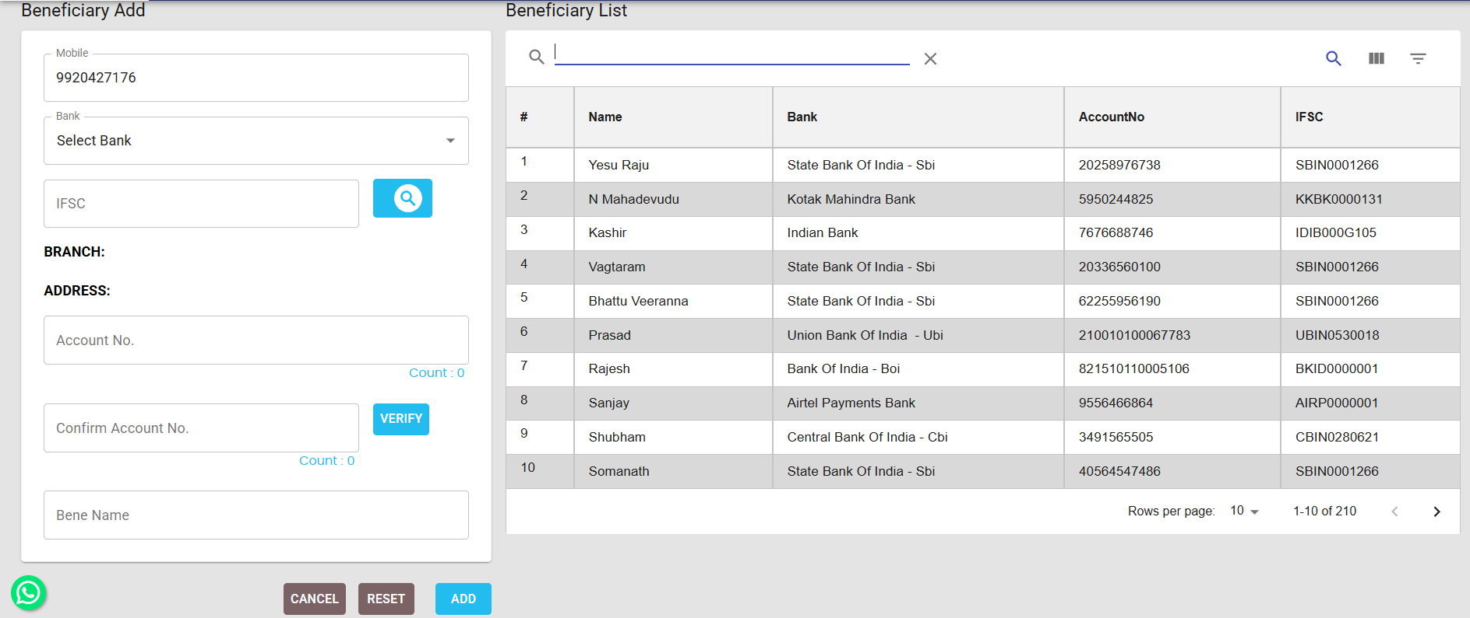
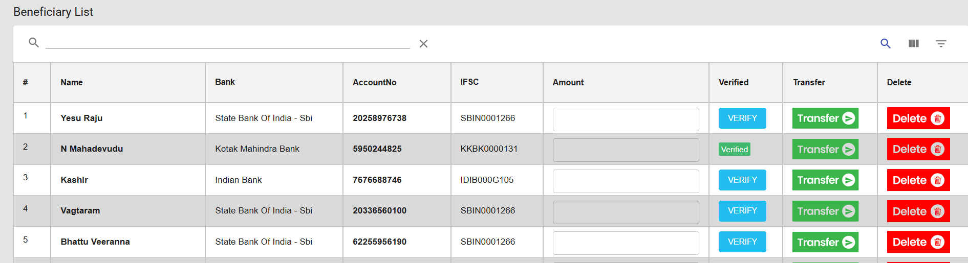
1rs hai wo veification ko jata hai .


