Maine sample ke liye ek data liya hu ek wo dekho chqno hai wo apne Bank_Statement mai narration mai dundna hai (CHQ PAID-MICR CTS-MU-RUSHABH SURGICALS 0000000000002562)
ye mathc Karega .
tho hume system_update mai waha ek or Date Columne “Date “ hai ,waha cheque date dalo “Type” mai Chq likho , ChequeNo mai WAHA DALO ,”priouvus pending “ ka meaning mujhetakeover 290may-2025 mai diya hai par bank statement uske pehle ka bhi bill diya hai tho hum 29-may-2025 ke bill ke pehle amount calculate karo or lihko “Privious Pending” 29-May ke baad ka amount likho. Jo mai higliht kiya wo likhna .
or system_Puchare mai Vou.No. mai id or PURCH mai id same hoge tho wahja likh

Exel

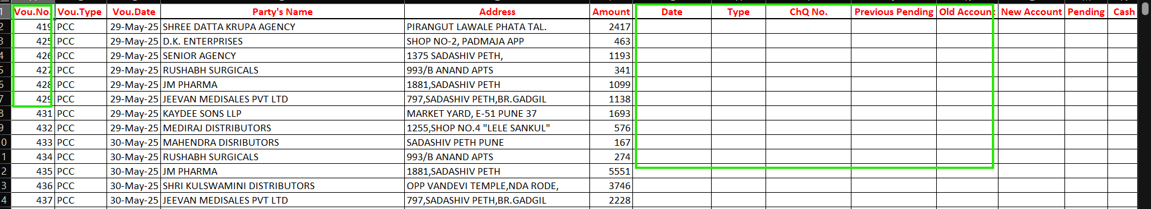
ACCount -
