SHOPKART E-COMMERCE BUSINESS ANALYTICS

SQL Pro Project
Student Name: Shubham Kumar
Course: B.Tech CSE (Data Analytics)
University: SAGE University, Bhopal
Submission Date: 31st March 2026

Table of Contents
- Project Overview
- Objectives
- Database Structure
- SQL Concepts Used
- Key Business Queries
- Insights
- Challenges Faced
- Solutions & Approach
- Learning Outcomes
- Future Improvements
- Output Screenshots
- Conclusion

1. Project Overview
This project focuses on analyzing e-commerce business data from ShopKart using SQL. The objective is to extract meaningful insights about customers, products, orders, and overall business performance.
The dataset includes multiple tables such as Customers, Orders, Products, Categories, and Order_Items.

2. Objectives
- Perform data analysis using SQL queries
- Understand customer purchasing behavior
- Identify top-performing products and categories
- Analyze revenue, profit, and order trends
- Solve real-world business problems using SQL

3. Database Structure
The project consists of the following tables:
- Customers
- Orders
- Products
- Categories
- Order_Items
These tables are connected using primary and foreign keys.

4. SQL Concepts Used
- SELECT, WHERE
- ORDER BY, LIMIT
- GROUP BY, HAVING
- INNER JOIN
- AGGREGATE FUNCTIONS (SUM, COUNT, AVG, MAX)
- SUBQUERIES

5. Key Business Queries
Some important business questions solved in this project include:
- Customers from a specific city
- Top expensive products
- Latest orders
- Total orders and quantities
- Revenue generated by city
- Most profitable product
- Repeat customers
- Cancelled order percentage
- Monthly order trends

6. Insights
- Identified top-performing products based on sales
- Found the most profitable categories
- Analyzed customer purchasing patterns
- Determined revenue contribution by city
- Evaluated order trends over time

7. Challenges Faced
While working on this project, I faced several challenges:
- Understanding complex joins between multiple tables
- Writing accurate aggregation queries
- Handling grouping and filtering conditions
- Avoiding logical mistakes in subqueries
- Interpreting business requirements into SQL queries

8. Solutions & Approach
To overcome these challenges:
- Broke down complex queries into smaller steps
- Practiced SQL concepts step-by-step
- Verified outputs using query execution
- Focused on understanding logic before coding
- Improved query structure for better readability

9. Learning Outcomes
- Gained strong understanding of SQL fundamentals
- Learned how to solve real-world business problems
- Improved logical thinking and analytical skills
- Gained hands-on experience in data analysis

10. Future Improvements
- Create dashboards using Power BI or Tableau
- Work with larger datasets
- Optimize SQL queries
- Perform advanced analytics

11. Output Screenshots
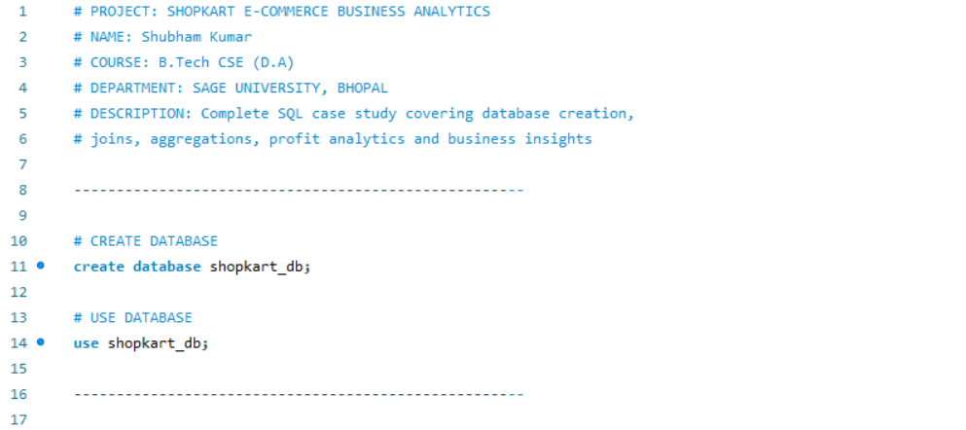
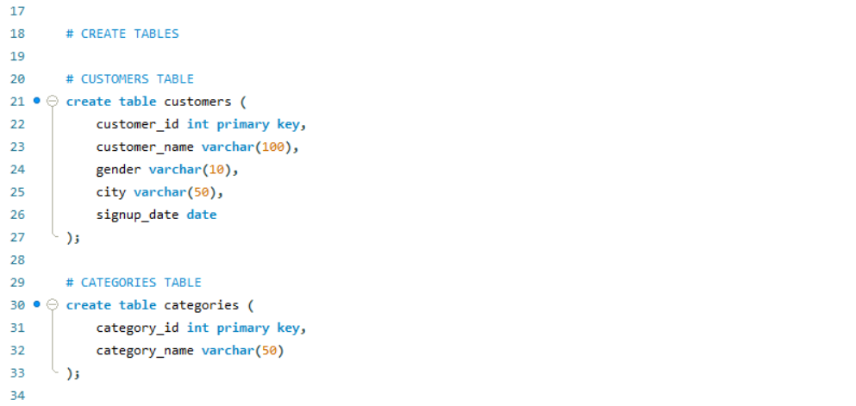
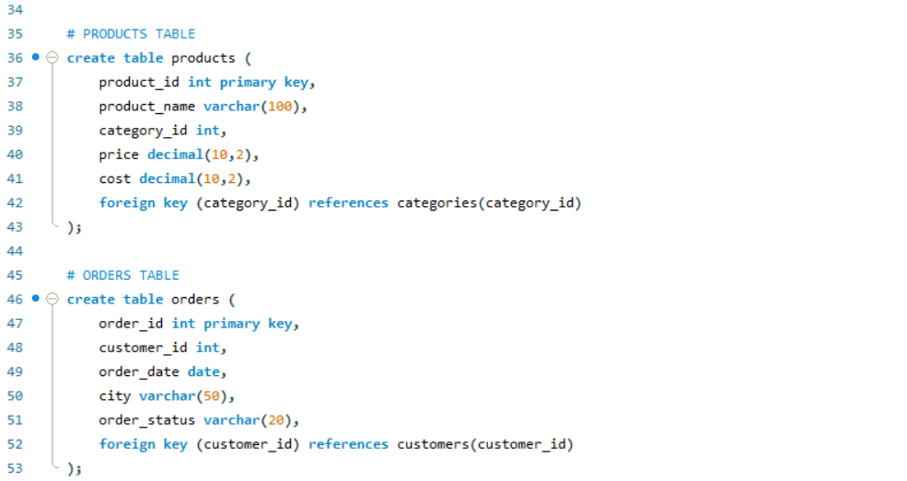
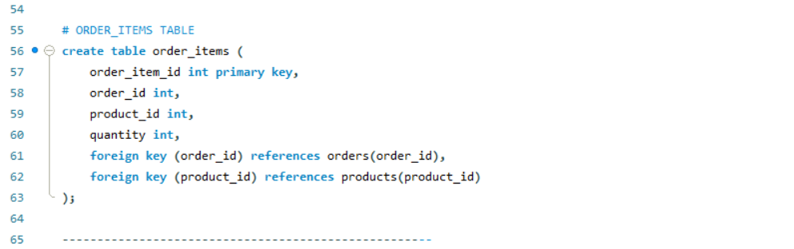
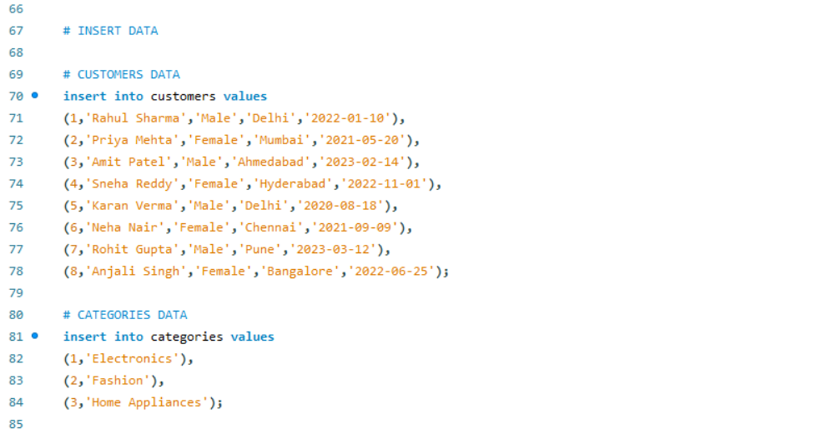
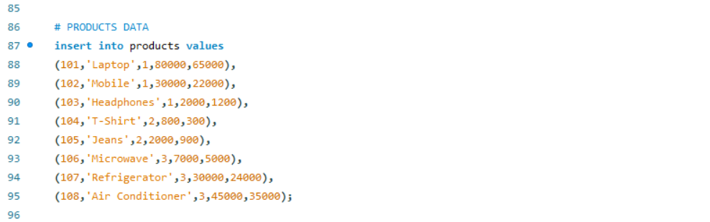
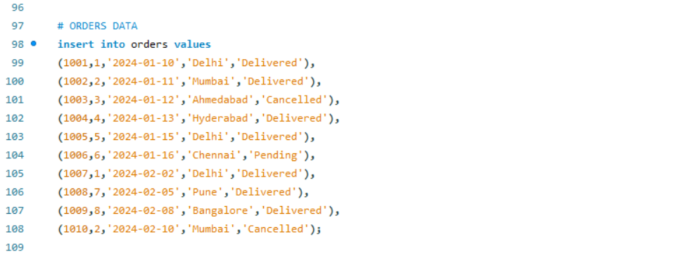
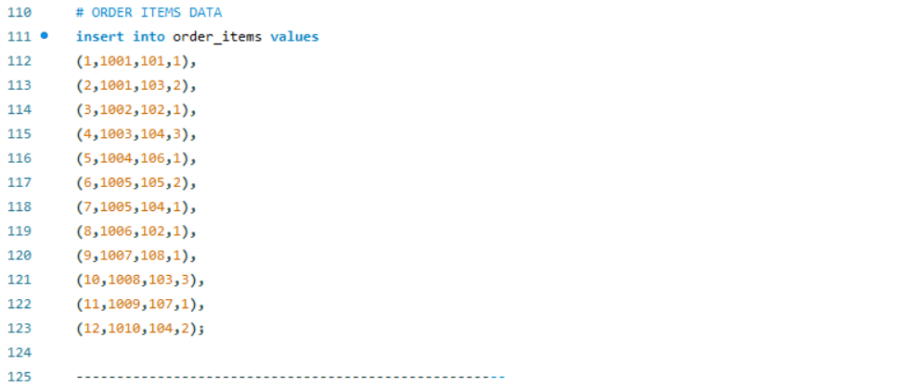
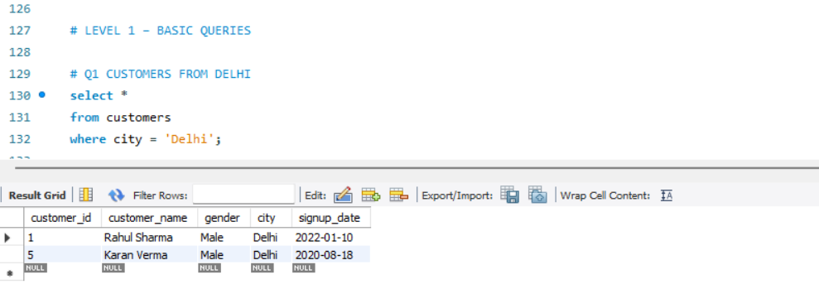
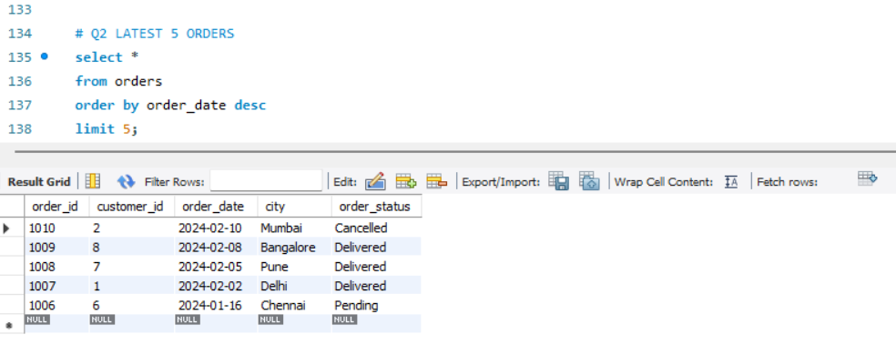
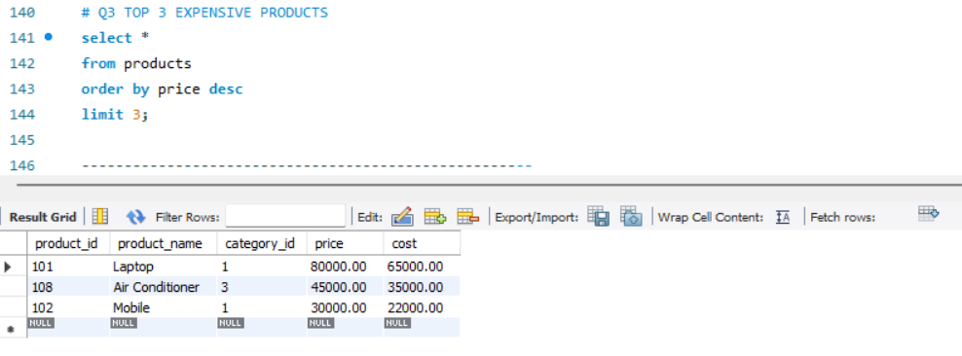
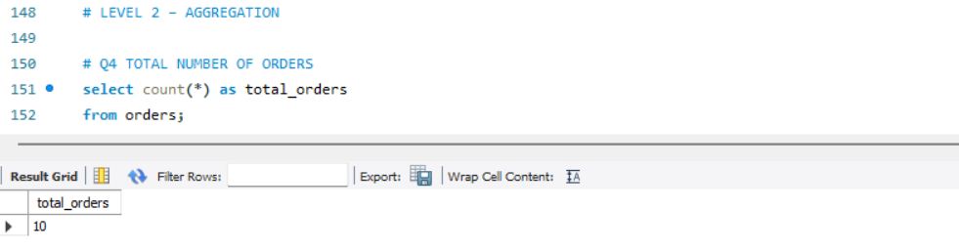
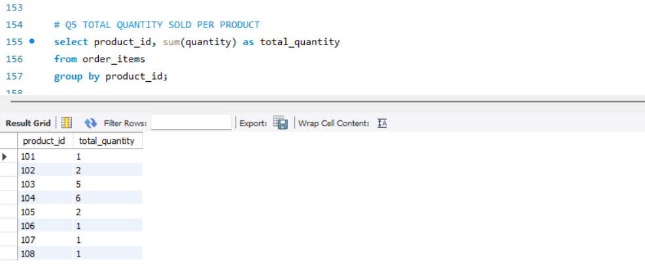
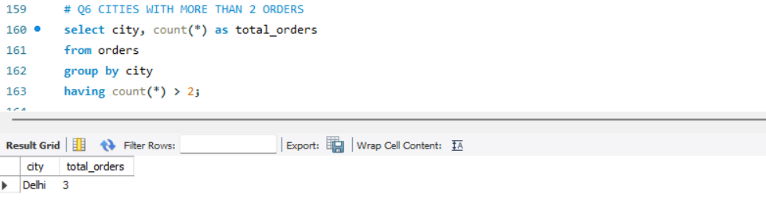
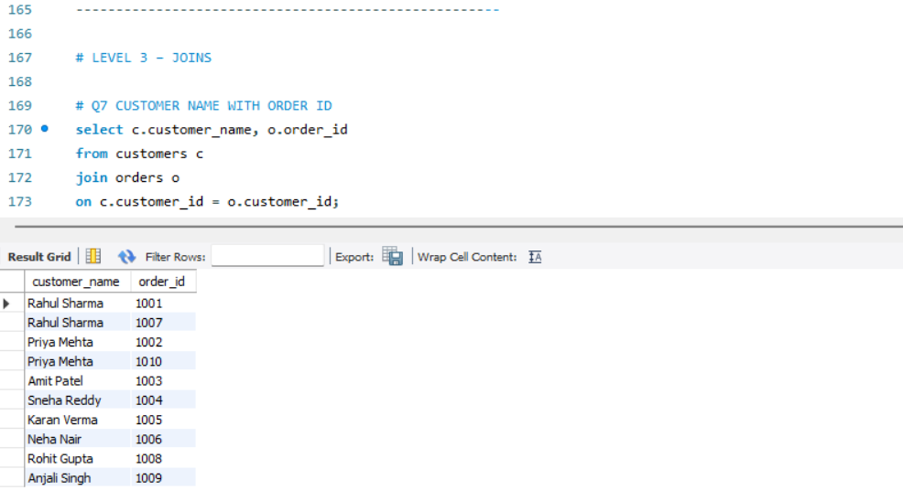
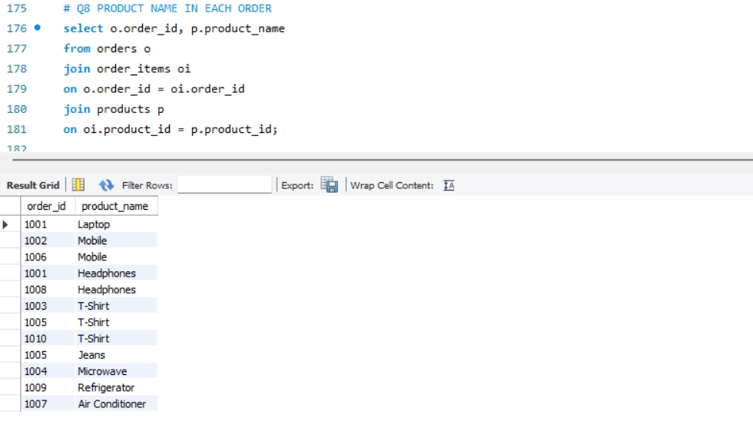

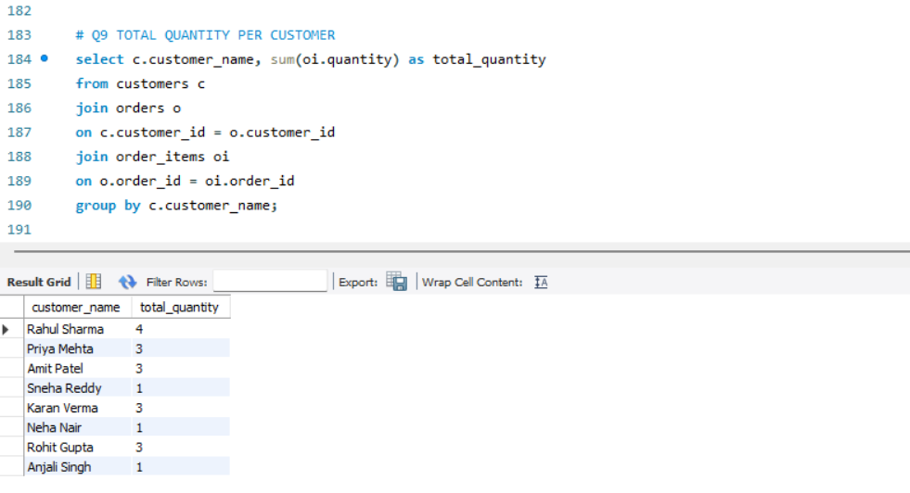
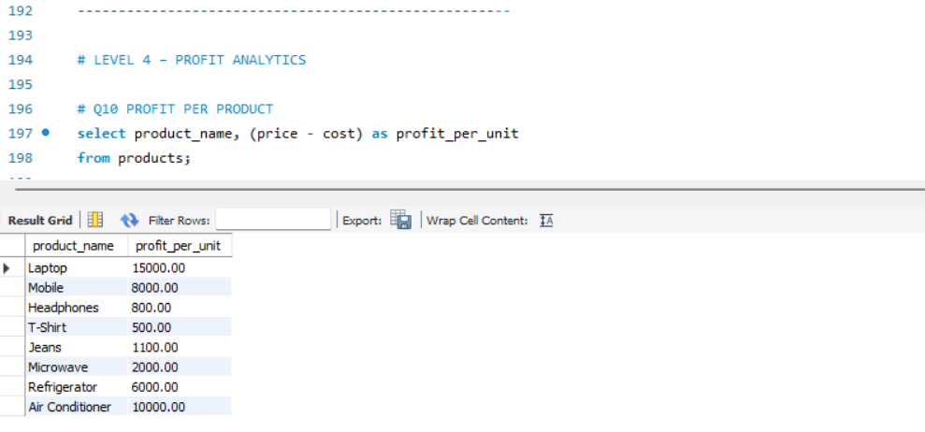
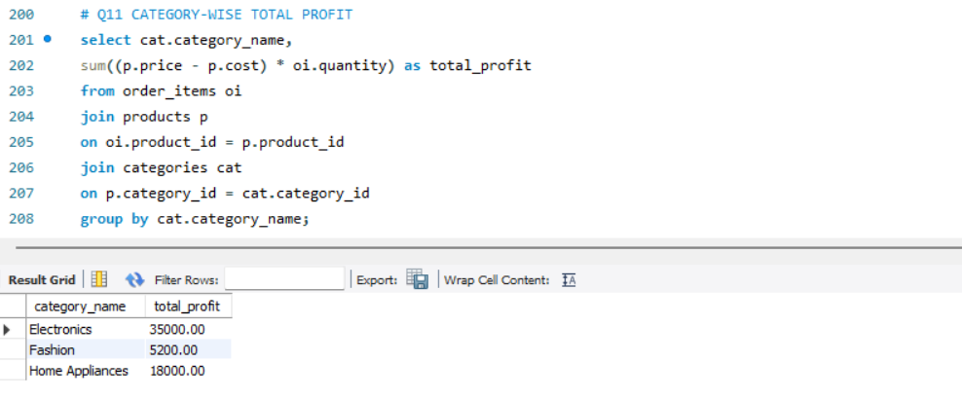
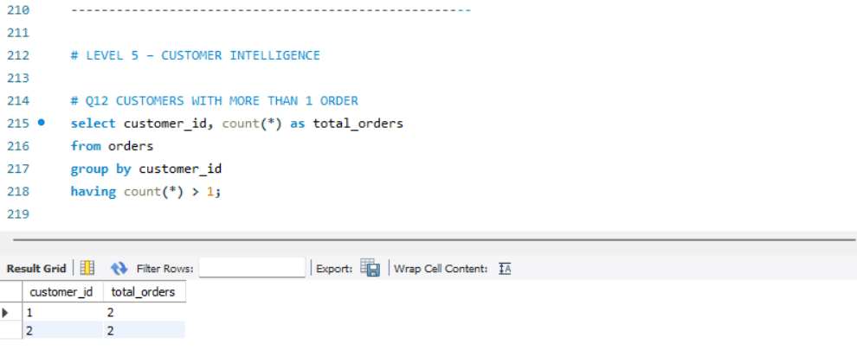

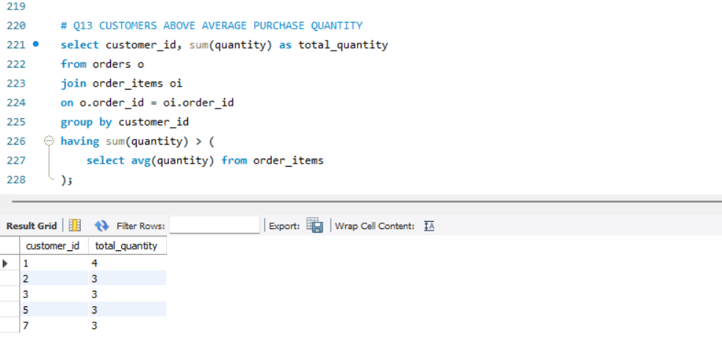

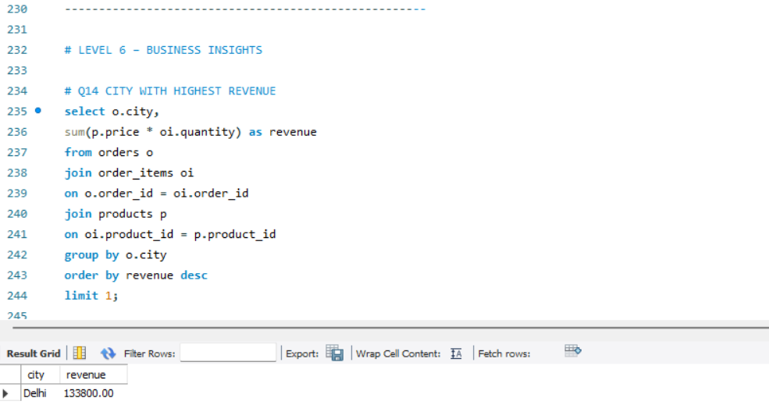
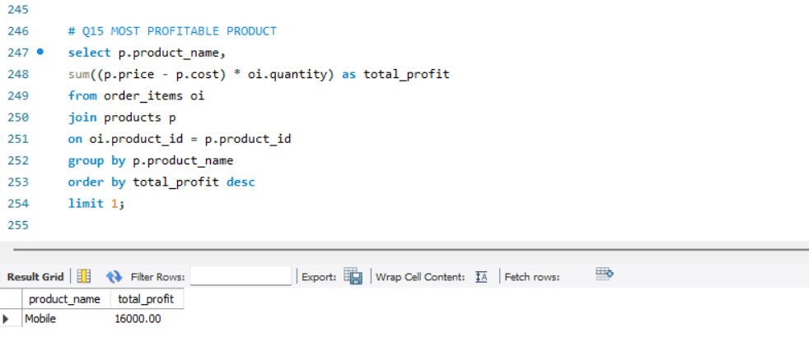
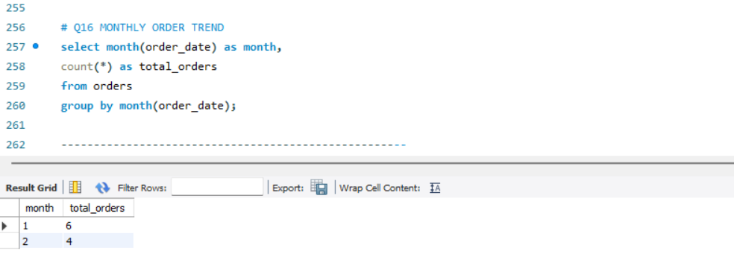
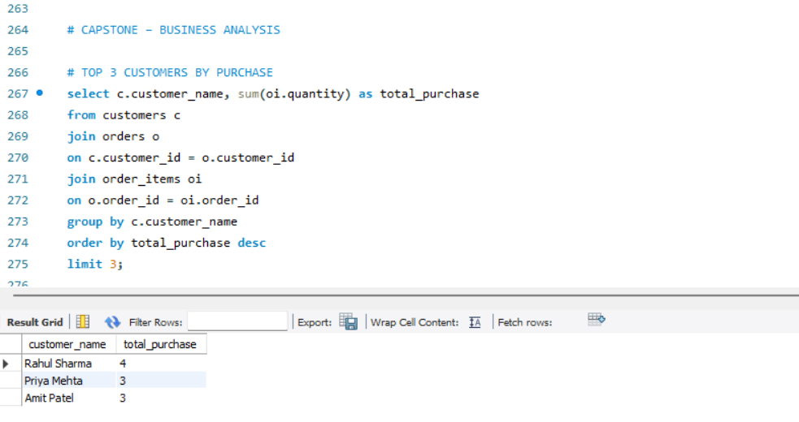
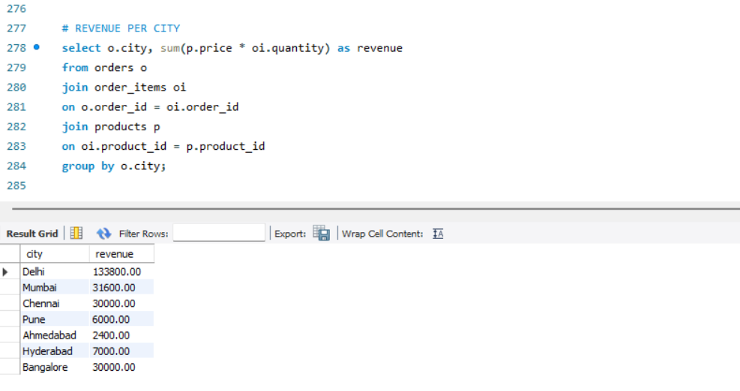
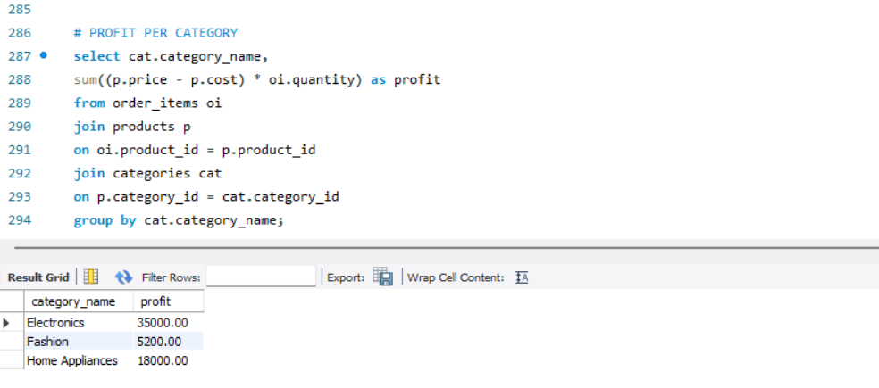
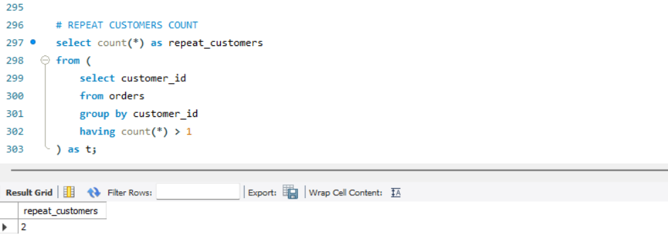
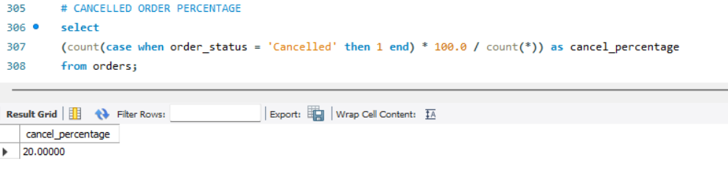
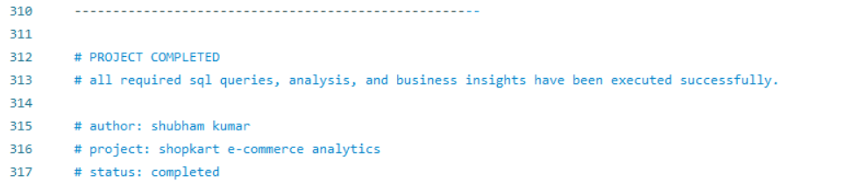
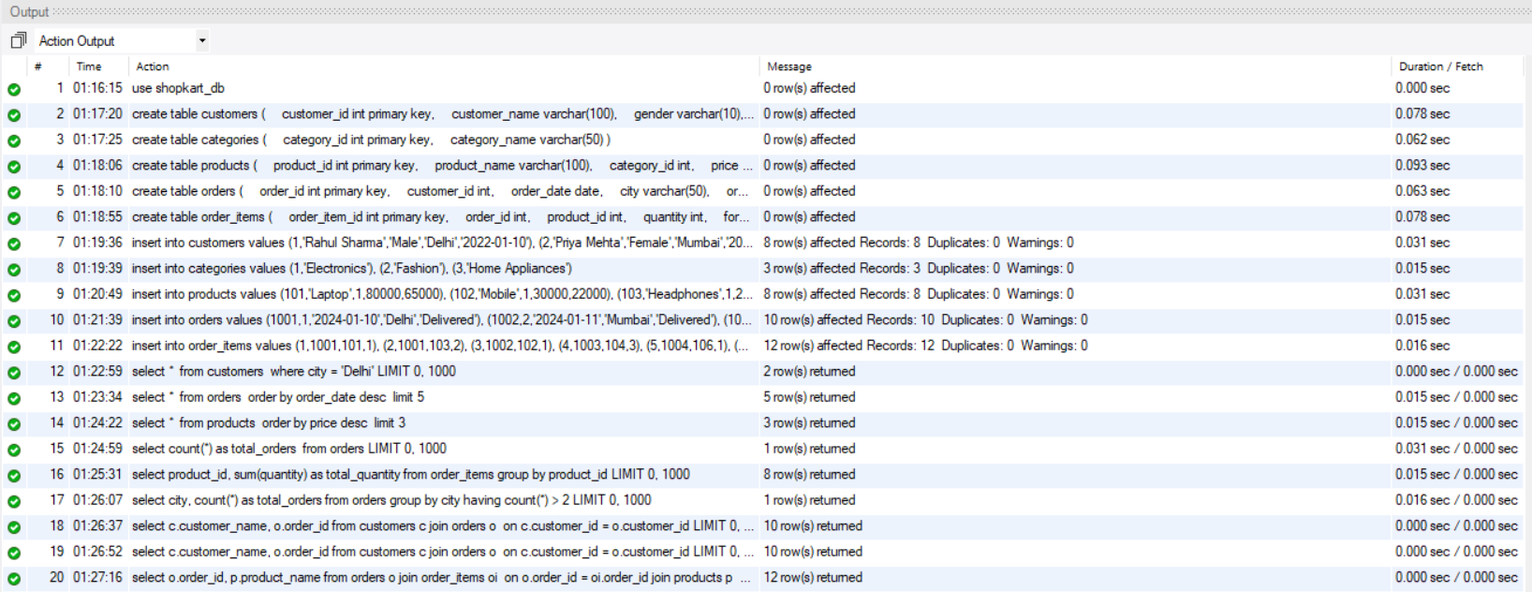
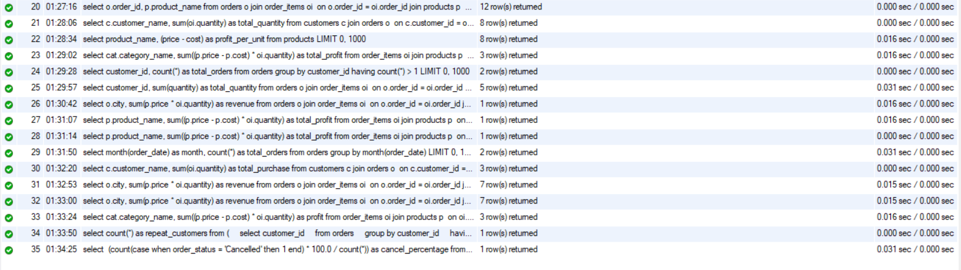

12. Conclusion
This project helped me understand how SQL can be used for business analytics.
I successfully executed all required queries and generated meaningful insights from the dataset.
Project Status:
- Completed Successfully
- All Queries Executed
- Outputs Verified

