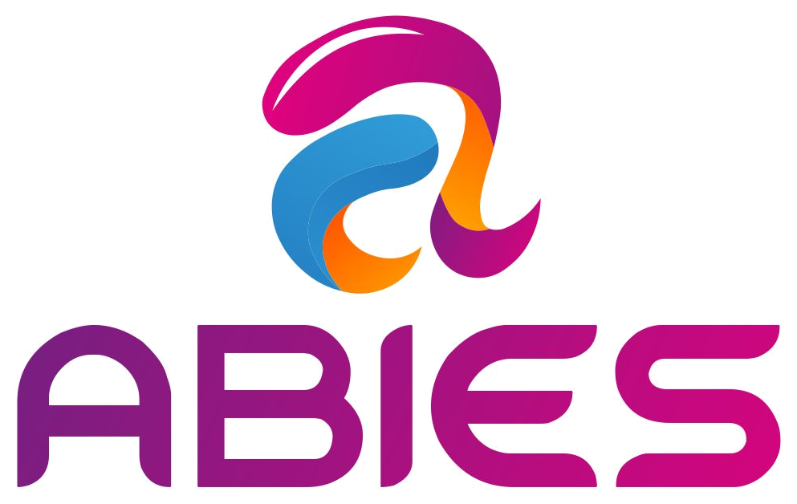
AYURVEDA
INTEGRATED CARE PLATFORM
Enhanced Product Blueprint, Journeys, Operations Model & Development Sprint Plan
Prepared for ABIES
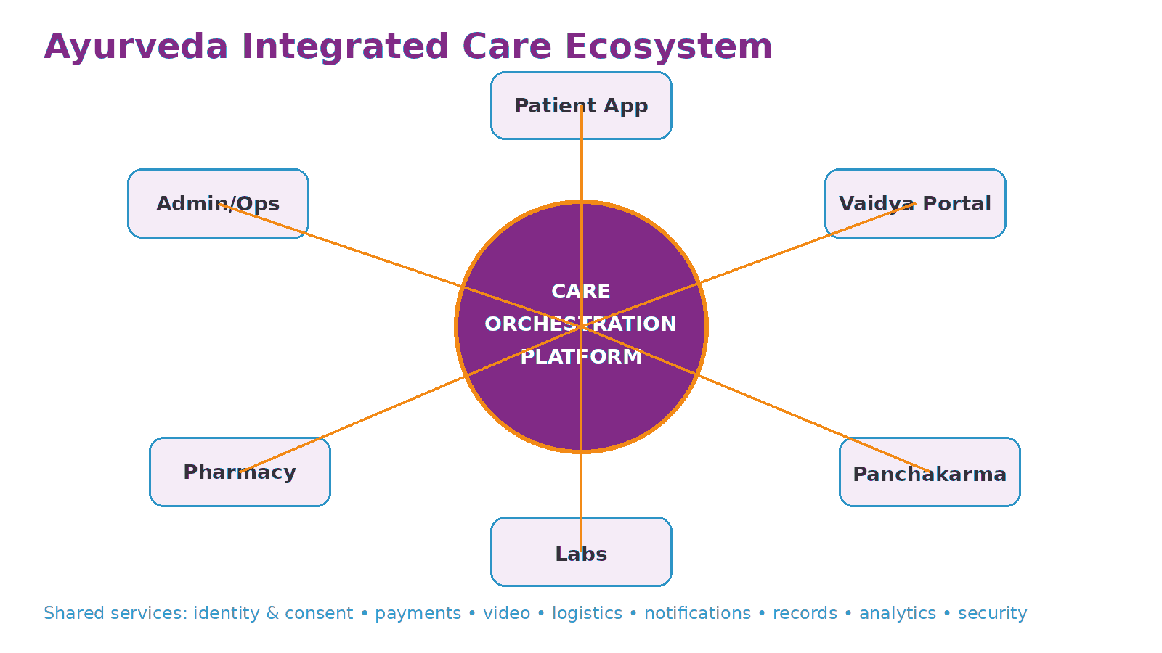
Working positioning
A trusted digital care network that connects patients, verified Ayurveda practitioners, diagnostics, medicines and Panchakarma services through one coordinated treatment journey.

Prepared for ABIES as a product, operating-model and technical-design foundation

Document Purpose
A foundation that can be used for product discovery, investor discussions, UX design, software estimation and partner onboarding.
This blueprint describes a proposed digital Ayurveda care platform. It is intentionally broader than a doctor-booking or medicine-commerce application: the core product is a longitudinal care orchestration layer connecting consultation, diagnostics, prescription fulfilment, Panchakarma/therapy and follow-up.
Important note
This is a product and business design document, not medical or legal advice. Clinical protocols, telemedicine practices, pharmacy/medicine fulfilment, diagnostics, facility requirements, advertising claims and data-processing controls must be validated with qualified clinical, legal, regulatory and security professionals before launch.

How to use this document
- Founders: define the business scope, launch sequence and partner model.
- Product managers: convert capabilities into epics, stories and acceptance criteria.
- UX teams: use the journeys and screen inventory to design prototypes.
- Engineering teams: use the reference architecture, domain model and integrations as a starting point.
- Clinical and compliance teams: review the points explicitly marked for policy, clinical or regulatory validation.
Table of contents
1. Executive Summary
2. Product Vision & Market Positioning
3. Problem Definition & Design Principles
4. Ecosystem & Personas
5. Patient Journey
6. Doctor / Vaidya Journey
7. Panchakarma Centre Journey
8. Diagnostic Lab Journey
9. Pharmacy Journey
10. Admin & Operations Journey
11. Application Modules & Screen Inventory
12. Care Plan Engine
13. Core Workflows
14. Trust, Quality & Credential Verification
15. Data, Consent, ABDM & Security
16. AI & Automation
17. Business Model & Commercial Mechanics
18. Reference Technical Architecture
19. Data Model & Integrations
20. MVP and Release Roadmap
21. Operating Model & KPIs
22. Risks & Mitigations
23. Competitive Positioning
24. Example End-to-End Scenario
25. Launch Plan
26. References
27. Customer Support, Sales & Technical Operations
28. Support, Sales and Tech Journeys
29. Development Sprint Plan
30. Delivery Governance & Release Gates
1. Executive Summary
The product is a care network, not a single-service marketplace.
The proposed platform unifies the fragmented Ayurveda treatment journey into one digital experience. Patients can discover and consult verified practitioners, receive structured treatment plans, book clinically appropriate diagnostic tests, obtain prescribed medicines, schedule Panchakarma or other supported therapies, and remain connected through follow-up and outcome tracking.
Dimension | Blueprint decision
Primary promise | Trusted, coordinated Ayurveda care from consultation to follow-up.
Core differentiator | A longitudinal Care Plan that connects multiple providers around one patient journey.
Primary users | Patients/families, registered Ayurveda practitioners, clinics, Panchakarma centres, labs, pharmacies and platform operations.
Business model | Marketplace + SaaS + fulfilment/service fees, while protecting clinical independence.
Launch strategy | Start with consultation + records + prescription + medicine fulfilment; add diagnostics and Panchakarma in controlled phases.
Technology direction | Modular API-first platform with consent, audit, identity, workflow and interoperable health-record capabilities.
Trust strategy | Credential verification, partner quality controls, traceable orders, complaint management and explicit clinical ownership.

North-star concept
One patient. One treatment timeline. Multiple verified providers. A single coordinated care plan.

2. Product Vision & Market Positioning
Vision
Create India’s trusted digital infrastructure for Ayurveda care, enabling independent practitioners and verified service partners to deliver a connected, transparent and measurable patient experience.
What the platform is
- A patient-facing care marketplace and health journey application.
- A practitioner clinical workflow and clinic operating system.
- A referral and session-management network for Panchakarma facilities.
- A fulfilment layer for prescribed Ayurveda medicines.
- A diagnostic-order and result-routing layer where tests are clinically appropriate.
- A trust, consent, records and payments layer across all participants.
What the platform should not become
- A marketplace that ranks providers only by commission paid.
- An AI system that diagnoses or prescribes without an accountable qualified practitioner.
- A supplement shop disguised as a medical consultation product.
- A lead-generation portal that loses visibility once the appointment is booked.
- A data silo that prevents patients from accessing or controlling their records.
3. Problem Definition & Product Principles
Current friction | Platform response
Patients search separately for doctors, medicines, labs and therapy centres. | Coordinate services through a single Care Plan.
Records are scattered across paper, WhatsApp and multiple providers. | Create a structured longitudinal health timeline with patient-controlled sharing.
Provider credentials and facility quality can be difficult to judge. | Build verification and quality workflows into onboarding.
Doctors have limited visibility into whether treatment, tests or therapy sessions were completed. | Provide adherence, referral and follow-up status to the treating practitioner.
Patients often drop off between consultation and follow-up. | Use reminders, care coordinators and outcome checkpoints.
Independent practitioners lack integrated digital operations. | Offer scheduling, records, treatment plans, billing, communication and analytics.

Design principles
- Clinical authority stays with qualified practitioners.
- Consent before data sharing; minimum necessary access.
- Marketplace incentives must not distort clinical decisions.
- Every important action must be auditable.
- Make complex Ayurveda terminology understandable without oversimplifying clinical records.
- Support multilingual patient communication while preserving a canonical structured record.
- Design for Tier-2 and Tier-3 operations: low bandwidth, WhatsApp/SMS fallback, assisted onboarding and variable partner maturity.
4. Ecosystem & Personas

Primary personas
Persona | Primary goals | Platform value
Patient / family caregiver | Find trustworthy care, understand plan, complete treatment, keep records. | One coordinated journey and transparent status.
Ayurveda practitioner / Vaidya | Consult efficiently, document assessment, prescribe, refer and follow up. | Clinical workflow + digital practice operations.
Panchakarma centre manager | Receive appropriate referrals, schedule resources, document sessions. | Qualified demand + operational workflow.
Diagnostic lab | Receive orders, manage collections and deliver results. | Integrated referrals and report delivery.
Pharmacy / fulfilment partner | Receive valid orders, manage stock, invoice and deliver. | Demand and digital order integration.
Care coordinator | Help patients complete the plan and resolve exceptions. | Unified patient timeline and work queue.
Platform admin / quality team | Verify partners, manage catalogues, disputes, SLAs and settlements. | Central governance and analytics.

5. Patient Journey
The patient journey should feel like a guided care programme rather than a set of disconnected transactions.
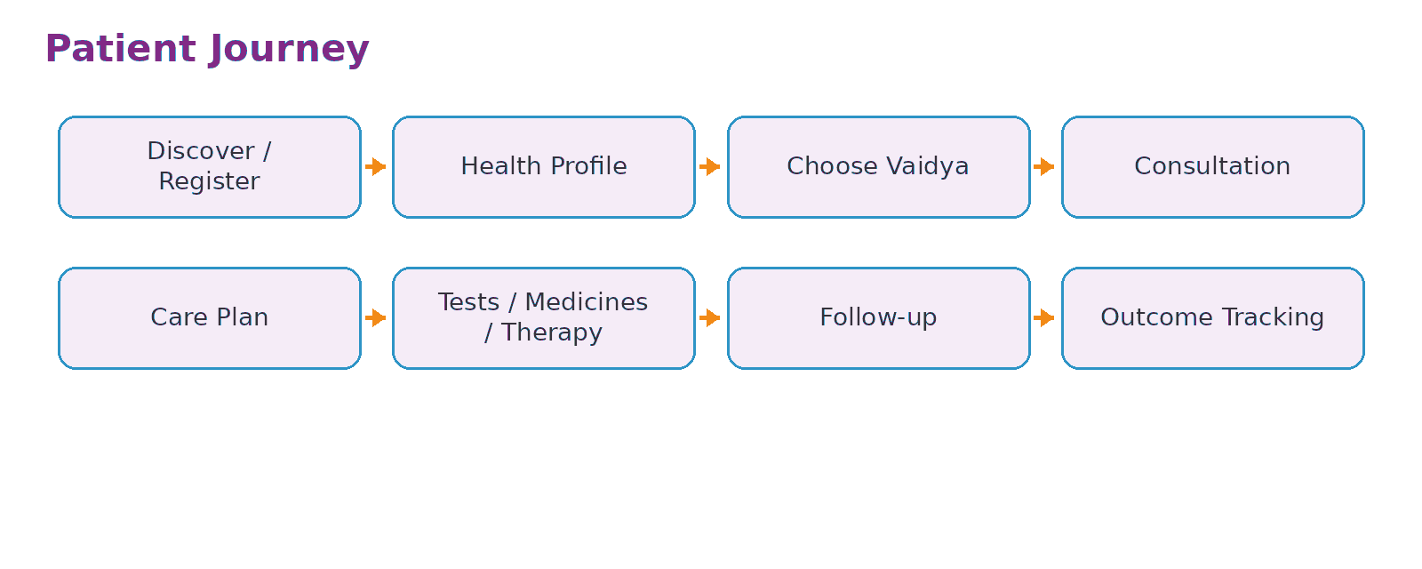
- Entry points: symptom/health-goal search, doctor profile, referral link, clinic QR, campaign, partner referral or repeat visit.
- Registration: mobile OTP, consent notices, optional ABHA linking when implemented, language preference and family profiles.
- Health profile: concerns, history, current medicines, allergies, reports and goals; emergency/red-flag messaging must route users to appropriate care rather than delay urgent treatment.
- Discovery: filter practitioners by language, consultation mode, location, experience, areas of practice and verified credentials.
- Consultation: appointment, payment, pre-consultation questionnaire, document upload, video/clinic visit and structured summary.
- Care Plan: practitioner-owned plan containing medicines, investigations, diet/lifestyle instructions, therapies, follow-up dates and patient tasks.
- Fulfilment: patient chooses eligible partner for medicine/test/therapy, sees price and availability, and tracks fulfilment.
- Follow-up: reminders, progress questions, outcome measures, adverse-event escalation and next consultation.
- Retention: family records, recurring plans, refill reminders and continuity across cities/providers subject to consent.

6. Doctor / Vaidya Journey
The practitioner experience is the platform’s clinical backbone and should work for both marketplace doctors and independent clinics.
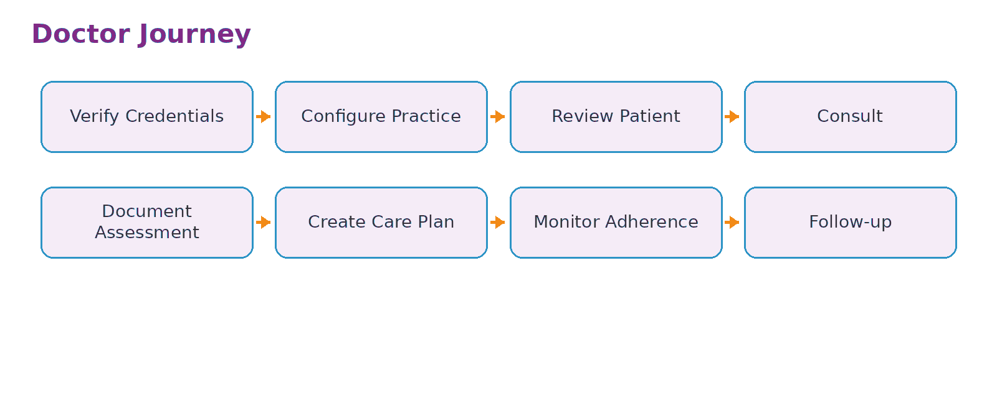
- Credential onboarding: identity, qualification, registration details, state/national register validation where applicable, bank and tax details, practice locations and specialties/areas of practice.
- Availability: configure online/clinic slots, buffers, consultation duration, leave and emergency closures.
- Patient review: history, uploaded records, previous care plans, adherence and prior partner activity visible only when authorised.
- Clinical encounter: history, findings, Ayurveda-specific assessment fields, relevant conventional history and report review.
- Decision support: templates and safety reminders may assist documentation but must not replace clinical judgement.
- Care Plan authoring: medicines, dose/instructions, diagnostic orders, therapy referrals, diet/lifestyle advice, duration and follow-up.
- Referral: select eligible lab/pharmacy/centre without hidden commercial prioritisation.
- Monitoring: see whether tests, medicine delivery and therapy sessions were completed, then review outcomes at follow-up.
- Practice operations: appointments, invoices, communications, team roles, analytics and patient recall.

7. Panchakarma Centre Journey
Panchakarma is treated as a supervised clinical service with referral, facility capability and session documentation.
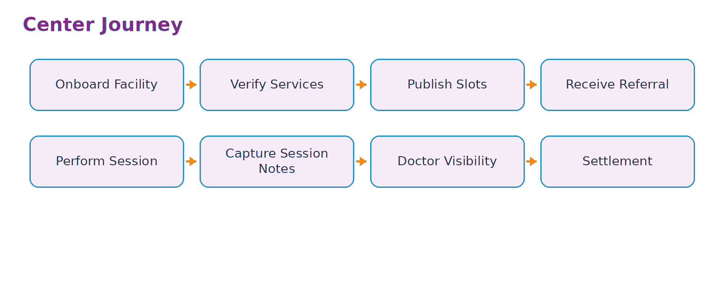
- Facility onboarding: ownership, location, clinical supervision, practitioners/therapists, available procedures, rooms, equipment, hygiene processes and required licences/registrations.
- Service catalogue: therapy type, duration, prerequisites, contraindication prompts, price, capacity and required supervision.
- Referral receipt: centre receives only the information necessary to fulfil the practitioner’s referral and patient consent.
- Pre-session check: confirm patient, referral, preparation instructions and any practitioner-defined restrictions.
- Session execution: attendance, start/end, therapist, procedure notes, observations and exceptions.
- Escalation: defined process when patient condition requires practitioner review or urgent medical attention.
- Completion: update referring practitioner and patient timeline; issue invoice and next-session guidance.
- Quality: cancellations, complaints, safety events, facility audits and satisfaction metrics feed partner governance.

8. Diagnostic Lab Journey
Diagnostics are integrated as practitioner-ordered services, not as indiscriminate test-selling.
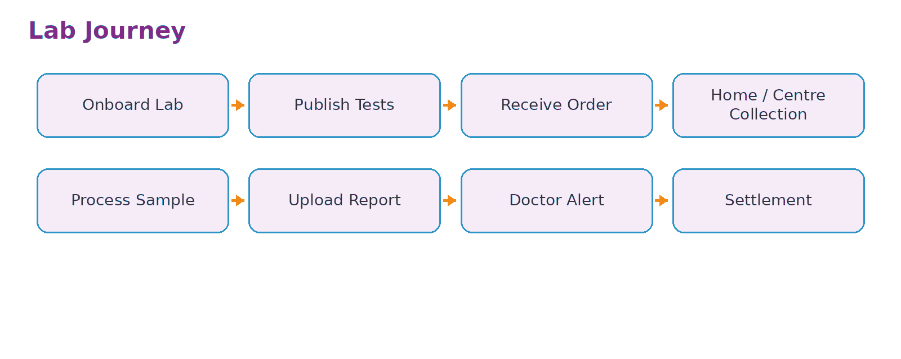
- Partner onboarding: lab identity, service locations, accreditation/licensing evidence as applicable, collection coverage, test catalogue and turnaround times.
- Order intake: receive test order, patient contact details and minimum relevant clinical context after consent.
- Booking: home collection or centre visit; slot, phlebotomist/collector assignment and preparation instructions.
- Sample lifecycle: collected, received, processing, quality exception, completed.
- Report delivery: structured result where possible plus signed report document; notify patient and ordering practitioner.
- Critical-result process: configure lab and clinician escalation workflow appropriate to the service.
- Settlement and reconciliation: order amount, discounts, refunds and partner payout recorded against a unique transaction.

9. Pharmacy & Medicine Fulfilment Journey
Medicine commerce remains prescription-led where required and traceable from order to delivery.
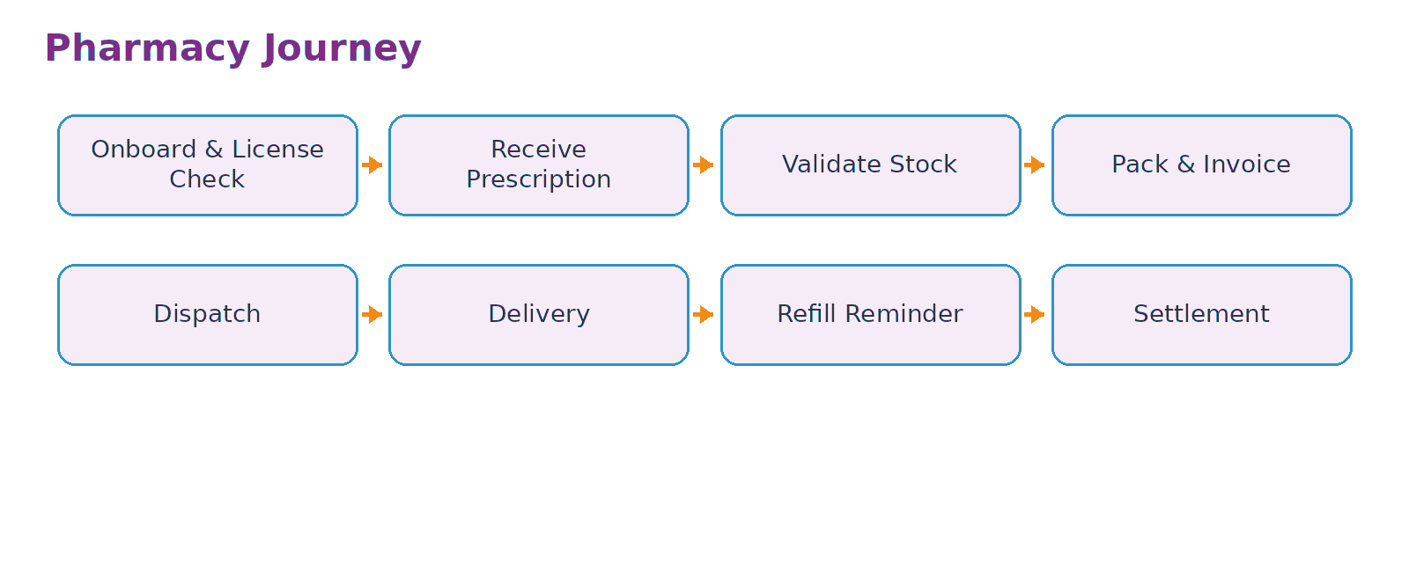
- Partner onboarding: business identity, applicable licences, locations, fulfilment radius, brands/categories, inventory-feed capability and return policy.
- Order: prescription-linked item list, patient delivery details and fulfilment option.
- Validation: check product, quantity, stock, batch/expiry controls and whether pharmacist review is required.
- Substitution: no silent substitution; any allowed alternative process must follow applicable rules and practitioner/patient approval requirements.
- Pack and invoice: create itemised invoice, batch/expiry capture where feasible and tamper-evident dispatch controls.
- Delivery: logistics tracking, proof of delivery and exception management.
- Refill: remind patient based on practitioner plan, not purely commercial repurchase logic.
- Quality: recall handling, damaged product, counterfeit concern and adverse-event reporting channel.

10. Admin & Operations Journey
Operations teams keep the network trustworthy, financially reconciled and clinically neutral.
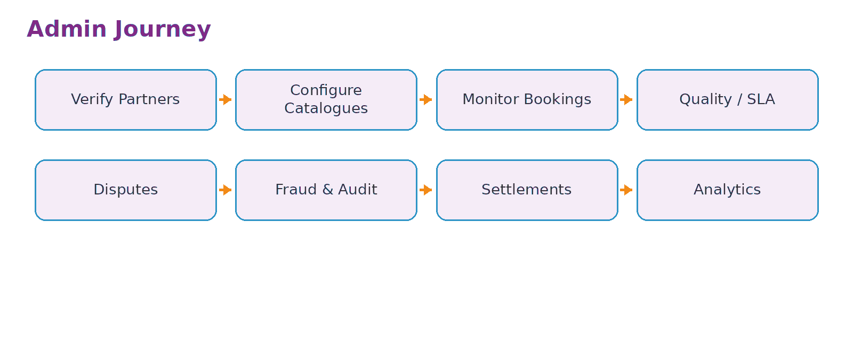
- Partner verification and approval queues with maker-checker controls.
- Provider/facility master data, service catalogue and geography management.
- Booking, order and care-plan exception dashboards.
- Care coordination work queues for missed follow-ups, failed deliveries and incomplete referrals.
- Complaint, refund, dispute and safety-event case management.
- Quality scoring based on objective operational metrics, not pay-to-rank.
- Fraud and abuse monitoring: fake credentials, self-referral anomalies, duplicate orders, coupon abuse and suspicious payouts.
- Settlement, commissions, invoices, tax documentation and reconciliation.
- Role-based access, audit log review, consent support and data-subject request operations.

11. Application Modules & Screen Inventory
A practical inventory for UX prototyping and software estimation.
Patient application
Module | Representative screens
Access & profile | OTP login, consent, language, personal profile, family members, addresses, preferences.
Home & discovery | Search, health concerns, doctors, clinics, programmes, recent plan, upcoming task.
Practitioner discovery | Results, filters, profile, credentials, fees, availability, consultation mode, reviews policy.
Appointments | Slot selection, reason, upload records, payment, confirmation, reschedule/cancel, waiting room.
Consultation | Pre-consult questionnaire, video launch, notes/summary, prescription, documents.
Care Plan | Timeline, medicines, tests, therapies, diet/lifestyle, tasks, progress, follow-up.
Diagnostics | Test order, partner/slot, preparation, collection status, reports.
Medicines | Prescription cart, partner selection, order, invoice, delivery tracking, refill.
Panchakarma | Referral, eligible centres, service details, package/session schedule, preparation, attendance.
Records | Consultations, prescriptions, reports, invoices, uploaded documents, consented sharing.
Support | Chat/call, complaint, refund status, safety issue, FAQs.
Account | Payments, privacy/consent, notifications, connected records, language, delete/request controls.

Doctor portal
Module | Capabilities
Dashboard | Today’s appointments, follow-ups, unread reports, care-plan exceptions, tasks.
Schedule | Online/clinic calendar, leave, availability, team calendars.
Patient chart | Demographics, history, allergies, current medicines, reports, encounters, consent.
Clinical note | History, examination/findings, Ayurveda assessment, diagnosis/assessment, plan.
Prescription | Medicine selection, instructions, duration, warnings, signed prescription.
Diagnostics | Order tests, preferred criteria, result review and acknowledgement.
Therapy referral | Panchakarma/therapy recommendation, prerequisites, session count, instructions.
Care Plan | Goals, tasks, interventions, milestones, adherence, outcomes, follow-up.
Communication | Approved patient messages, education material, reminders, care-coordinator handoff.
Practice admin | Fees, invoices, staff access, locations, integrations, analytics.

Partner portals
Partner | Core screens
Panchakarma centre | Dashboard, referrals, patient check-in, schedule, session charting, incidents, invoices, payouts, quality.
Diagnostic lab | Orders, slots, collection, sample status, report upload/API, exceptions, payouts.
Pharmacy | Orders, prescription view, stock, pack/dispatch, returns, invoice, payouts, recall handling.
Admin | Verification queues, masters/catalogues, transaction console, support cases, safety cases, settlements, audit, analytics.

12. Care Plan Engine
The central product object connecting clinical intent with patient action.
Every care journey should be represented as a practitioner-owned plan with structured interventions and milestones. The platform orchestrates execution but does not independently alter clinical instructions.
Care Plan element | Examples
Clinical owner | Treating Vaidya / authorised practitioner.
Goals | Symptom improvement, adherence, follow-up objective, lifestyle goal.
Medicines | Product/formulation, dose, timing, duration, special instruction.
Diagnostics | Test, clinical reason/notes, target completion date, result status.
Therapies | Procedure/referral, sessions, centre requirements, preparation, completion.
Diet & lifestyle | Practitioner-approved instructions, education content, avoid/encourage list.
Tasks | Upload report, take medicine, prepare for therapy, questionnaire, follow-up.
Milestones | Week 2 review, therapy completion, repeat report, final review.
Outcomes | Patient-reported measures, practitioner assessment, adherence, adverse events.
Status | Draft, active, paused, completed, cancelled, superseded.

Critical product rule
Commercial partners may fulfil a Care Plan, but only an authorised clinician should create or clinically change the treatment instructions.

13. Core Workflows
Consultation workflow
1. Patient books and provides reason/records.
2. System verifies appointment, payment and consent state.
3. Practitioner reviews available information.
4. Consultation occurs online or in person.
5. Practitioner documents assessment and issues plan/prescription/referrals.
6. Patient receives a plain-language summary and next actions.
7. Care Plan tasks and fulfilment options become available.
8. Follow-up is scheduled or triggered by milestone.
Diagnostics workflow
1. Practitioner creates test order.
2. Patient chooses an eligible lab and slot.
3. Lab fulfils collection and updates sample status.
4. Report is returned and attached to the patient record.
5. Ordering practitioner is notified; patient sees report according to release policy.
6. Practitioner reviews result and updates plan if clinically appropriate.
Panchakarma workflow
1. Practitioner creates therapy referral with parameters and prerequisites.
2. Patient views eligible verified centres and availability.
3. Centre confirms booking and pre-session requirements.
4. Each session is documented and completion status is visible to the referring practitioner.
5. Exceptions trigger defined escalation.
6. Course completion is reviewed during follow-up.
Medicine fulfilment workflow
1. Prescription/order generated.
2. Eligible fulfilment partner receives order.
3. Stock and order validity are checked.
4. Items are packed, invoiced and dispatched.
5. Patient tracks delivery and receives administration instructions from the care plan.
6. Refill reminder is generated only according to plan duration/clinician instruction.
14. Trust, Quality & Credential Verification
Practitioner verification
- Verify identity and contact details.
- Capture educational qualification and issuing institution.
- Validate registration against the applicable State Register and/or NCISM National/Provisional National Register process where available.
- Record registration number, system of medicine, state, validity/renewal evidence and verification timestamp.
- Use manual review for mismatches; prevent profile activation until resolved.
- Re-check credentials periodically and when regulatory/registration status changes.
Facility and partner verification
Partner | Verification categories
Panchakarma centre | Ownership, facility address, supervising practitioner, staff, services, hygiene, equipment, emergency/escalation SOP, insurance/licences as applicable.
Diagnostic lab | Entity identity, locations, applicable licences/accreditation, test scope, TAT, collection procedures, report authentication.
Pharmacy | Entity identity, applicable sale/dispensing licences, storage, supplier controls, invoicing, return/recall process.

Quality governance
- Objective SLA dashboards: appointment fulfilment, report TAT, delivery success, cancellation, complaint closure.
- Safety-event and adverse-event workflow separated from normal customer support.
- Random documentation/facility audits according to policy.
- Partner suspension and remediation workflow with evidence.
- Transparent review moderation; prohibit manipulation and retaliation.
15. Data, Consent, ABDM & Security
Health data architecture must be designed around patient control and auditable access.
ABDM provides national building blocks including ABHA, Healthcare Professional Registry (HPR), Health Facility Registry (HFR) and interoperability mechanisms. ABDM materials describe consent-based exchange and a federated approach rather than a single central repository of all health records. The platform should be designed so ABDM integration can be added without rewriting the core domain model.
Recommended data-control principles
- Purpose-specific consent and privacy notices.
- Role-based and attribute-based access for practitioner, clinic staff, lab, pharmacy, therapy centre and support roles.
- Minimum necessary disclosure to partners; a pharmacy does not need the full clinical chart, and a lab does not need unrelated treatment history.
- Immutable audit trail for sensitive record access, export, update and sharing.
- Encryption in transit and at rest; managed keys/secrets and environment separation.
- Strong practitioner/admin authentication, session controls and privileged-access governance.
- Data retention and deletion processes mapped to legal, clinical and contractual requirements.
- Incident response, breach assessment, backup/restore testing and vendor security review.
DPDP readiness
India’s Digital Personal Data Protection Rules, 2025 were notified on 14 November 2025 with an enforcement timeline. Product counsel should map the platform’s roles and obligations under the DPDP Act/Rules, including notices, consent/other lawful processing bases as applicable, data-principal rights handling, security safeguards, processors/vendors and breach response.
ABDM integration roadmap
Stage | Capability
Foundation | Use interoperable identifiers and structured health-data concepts internally.
Registry alignment | Support HPR/HFR identifiers for verified professionals/facilities where applicable.
ABHA | Enable patient linking/identification through approved integration flow.
Health records | Publish/consume permitted health information through ABDM-compliant workflows after sandbox/security requirements.
Consent | Integrate approved consent-based exchange rather than proprietary blanket consent.

16. AI & Automation
AI assists documentation and navigation; accountable clinicians remain responsible for clinical decisions.
Use case | Recommended boundary
Pre-consultation intake | Convert patient speech/text into a structured draft for review; do not diagnose.
Consultation transcription | Generate draft notes with explicit practitioner review before finalisation.
Care-plan explanation | Translate clinician-approved instructions into simpler or local-language wording without changing meaning.
Patient Q&A | Answer from the signed care plan, approved education content and operational data; escalate uncertain/clinical questions.
Coding/search | Help practitioner find templates, prior records and relevant catalogue items.
Operations | Predict no-shows, classify support tickets, detect fulfilment anomalies and assist reconciliation.
Safety controls | Block autonomous prescription changes, unsupported claims and fabricated clinical advice; log model-assisted actions.

17. Business Model & Commercial Mechanics
Revenue line | Possible charging model | Guardrail
Consultation | Platform fee or practitioner subscription. | Do not influence treatment choice based on fee.
Doctor SaaS | Monthly/annual clinic software plan. | Clear feature tiers and data portability.
Diagnostics | Partner commission / platform fee. | Only clinician-ordered or patient-requested services consistent with policy; avoid unnecessary testing incentives.
Medicine fulfilment | Marketplace/fulfilment margin or service fee. | Prescription integrity, licensed partners, transparent invoice.
Panchakarma | Booking/service commission. | Clinical suitability and centre capability before commercial ranking.
Care programmes | Bundled coordination fee. | Separate clinical components and disclose inclusions.
Corporate wellness | Employer-sponsored programmes. | Explicit employee privacy boundaries; no inappropriate employer access to health data.

Illustrative unit economics to model
- Customer acquisition cost by channel and city.
- Consultation conversion and repeat-consultation rate.
- Care Plan activation rate and average services per plan.
- Partner take rate and gross margin by service.
- Refund, cancellation and failed-fulfilment cost.
- Care coordinator cost per active patient.
- Doctor SaaS ARPU and churn.
- Contribution margin after payment, logistics, support and incentives.
18. Reference Technical Architecture
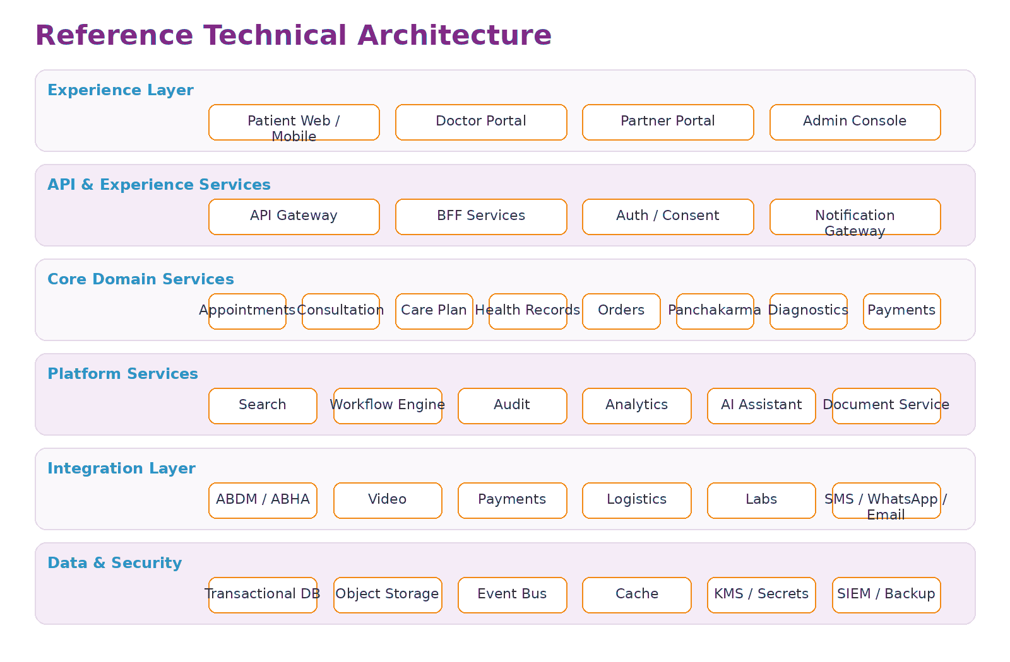
Recommended architecture characteristics
- API-first and modular; begin as a well-structured modular monolith or limited service set, then split services only where scale/ownership justifies it.
- Event-driven state changes for bookings, orders, reports, reminders and settlements.
- Workflow engine for multi-step care orchestration and exception handling.
- Object storage for signed documents and reports; structured clinical data stored separately.
- Search index for provider/service discovery; never use search rank as the sole clinical recommendation mechanism.
- Dedicated audit/event store for sensitive actions.
- Observability from day one: logs, metrics, traces, synthetic monitoring and business-event monitoring.
- Zero-trust principles for partner/admin access and environment isolation.
19. Core Data Model & Integrations
Core domain entities
Domain | Key entities
Identity | User, Patient, FamilyMember, Practitioner, StaffUser, Organisation, Role, Consent.
Provider network | PractitionerProfile, Facility, Service, Location, Credential, Verification, Availability.
Clinical | Encounter, ClinicalNote, Assessment, Prescription, CarePlan, Goal, Intervention, Task, Outcome.
Diagnostics | DiagnosticOrder, TestItem, LabBooking, SpecimenStatus, DiagnosticReport.
Therapy | TherapyReferral, TherapyCourse, Session, Therapist, SessionNote, Incident.
Commerce | MedicineOrder, OrderItem, InventoryOffer, Invoice, Shipment, Return, Refund.
Payments | Payment, Fee, Commission, Payout, Settlement, Reconciliation.
Operations | Case, Complaint, SafetyEvent, SLAEvent, Notification, AuditEvent.

Likely integrations
- ABDM/ABHA/HPR/HFR integrations subject to approved onboarding and technical requirements.
- Video consultation provider or WebRTC service.
- Payment gateway and payout/settlement provider.
- SMS, email and WhatsApp messaging providers with consent/template governance.
- Logistics aggregators for medicine delivery.
- Diagnostic lab APIs or secure report exchange.
- Maps/geocoding for service areas and clinic discovery.
- KYC/identity and document-verification services where legally and contractually appropriate.
- Accounting/tax systems for partner reconciliation.
20. MVP & Release Roadmap
Validate the care journey before building the full marketplace.
Phase | Scope | Exit criteria
0 - Discovery | Clinical advisory board, partner interviews, legal/compliance mapping, clickable UX prototype, pilot-city economics. | Validated workflows, signed pilot partners, risk register, measurable hypotheses.
1 - Core care | Patient app/web, doctor portal, credential review, appointments, video/clinic consultation, records, prescription, simple Care Plan, payments, admin. | Successful consultations, follow-up completion, stable support operations.
2 - Medicine | Licensed fulfilment partners, prescription-linked ordering, invoicing, delivery tracking, refunds/reconciliation. | Reliable fulfilment SLA and acceptable refund/complaint rate.
3 - Diagnostics | Clinician orders, lab booking, collection status, report upload/API and practitioner review. | End-to-end report turnaround and record integration validated.
4 - Panchakarma | Centre onboarding, referral, capability matching, session scheduling/charting, course tracking, quality cases. | Safe, repeatable therapy-course operations across pilot centres.
5 - Scale | ABDM integration, multilingual, AI assistance, doctor SaaS tiers, advanced analytics, more cities. | Interoperable, secure platform with scalable partner operations.

MVP discipline
Do not build every service before proving that patients complete the core loop: consultation -> plan -> fulfilment -> follow-up.

21. Operating Model & KPIs
Teams required as the business grows
- Clinical governance and practitioner success.
- Partner onboarding and quality assurance.
- Care coordination and customer support.
- Marketplace/category operations for pharmacy, diagnostics and therapy.
- Product and engineering.
- Information security, privacy and compliance.
- Finance, settlements and reconciliation.
- Growth, content and community.
North-star and supporting metrics
Metric group | Examples
North star | Percentage of activated Care Plans that reach the intended follow-up milestone.
Access | Time to next appointment, consultation show rate, geography/language coverage.
Continuity | Follow-up completion, 30/90-day active care rate, repeat practitioner continuity.
Fulfilment | Medicine delivery SLA, lab TAT, therapy attendance/completion, failed-order rate.
Quality | Credential-verification coverage, complaints/1,000 transactions, safety events, audit pass rate.
Experience | Patient satisfaction, practitioner satisfaction, support resolution time.
Economics | CAC, contribution margin, GMV, take rate, SaaS ARPU, partner payout cycle, refund cost.
Security/privacy | MFA adoption, privileged-access events, incidents, patch SLA, data-request turnaround.

22. Key Risks & Mitigations
Risk | Why it matters | Mitigation direction
Clinical safety | Bad advice or poor escalation can cause patient harm. | Qualified practitioners, clinical governance, red-flag routing, incident process, AI limits.
Credential fraud | Unqualified provider destroys trust and creates legal exposure. | Registry checks, document verification, periodic reverification, suspension controls.
Marketplace conflict | Commercial incentives may bias referrals. | Neutral ranking rules, disclosures, audit referral patterns, clinician independence.
Data breach | Health records are highly sensitive. | Privacy/security by design, encryption, least privilege, audit, vendor review, IR.
Medicine quality | Counterfeit, expired or inappropriate product creates harm. | Licensed partners, traceability, batch/expiry controls, recalls and complaints.
Therapy variability | Facility capability and hygiene differ widely. | Onboarding standards, service capability matrix, audits and incident reporting.
Operational complexity | Multiple partners create failure points. | Workflow engine, care coordination, exception queues, SLA ownership.
Regulatory change | Health, drugs, privacy and digital rules evolve. | Dedicated compliance owner and configurable policies/consents/catalogues.
Overbuilding | Large scope can consume capital before validation. | Phased MVP with explicit exit criteria and pilot economics.

23. Competitive Positioning
Compete on orchestration and neutrality, not merely on the existence of online Ayurveda services.
Current providers validate consumer demand for online Ayurveda and integrated services. For example, Jiva publicly offers phone/video/clinic consultation, medicine delivery and clinic-based Panchakarma across its network. The proposed platform should therefore avoid positioning itself as “Ayurveda online” and instead differentiate as an independent care-orchestration network connecting multiple verified providers.
Dimension | Typical vertically integrated provider | Proposed network platform
Provider model | Primarily own/affiliated doctors and clinics. | Independent verified practitioners and partner facilities.
Patient record | Often tied to one provider network. | Patient-centred longitudinal record and consented portability.
Fulfilment | Own or preferred products/services. | Multi-partner fulfilment with governance and clinical neutrality.
Core moat | Brand, clinics, products and protocols. | Workflow, provider network, care-plan continuity, trust data and interoperability.
B2B software | May support internal operations. | Doctor/clinic SaaS is a first-class revenue and retention layer.

24. Example End-to-End Patient Scenario
Illustrative scenario
A 42-year-old patient seeks Ayurveda care for a non-emergency chronic digestive concern. The scenario below demonstrates product flow only and is not a treatment recommendation.

1. Patient registers in Hindi, creates profile and uploads recent reports.
2. Patient filters verified practitioners who offer Hindi video consultation and books a slot.
3. Practitioner reviews history, conducts consultation and documents a structured assessment.
4. Practitioner creates an 8-week Care Plan containing prescribed medicines, diet/lifestyle instructions, selected diagnostic tests and a follow-up date.
5. Patient chooses a verified lab for home collection and a licensed fulfilment partner for prescribed medicines.
6. Lab status flows from booked -> collected -> processing -> report available. The practitioner receives a review task.
7. After reviewing results, practitioner records that no change is required and keeps the existing plan.
8. At week 3, practitioner recommends a defined therapy course and referral; patient chooses an eligible verified centre based on location and availability.
9. Centre records each completed session and any exception. Patient sees progress in the same Care Plan timeline.
10. At week 8, follow-up is completed. Practitioner records outcome, closes or extends the plan, and the patient retains the complete record.
25. Recommended Launch Plan
Pilot geography
Use one tightly managed city/region first. The objective is not maximum downloads; it is to prove reliable orchestration across a small network of excellent practitioners and partners.
Illustrative pilot supply
Partner type | Pilot target | Selection priority
Practitioners | 10-20 | Strong registration evidence, communication, digital willingness, follow-up discipline.
Panchakarma centres | 3-5 | High facility quality, clear supervision, willingness to document sessions.
Labs | 1-2 | Reliable home collection, digital reports, clear TAT and escalation.
Pharmacy/fulfilment | 1-2 | Licensed operation, consistent stock, invoicing and delivery integration.

First 90-day hypotheses
- Patients will complete a structured intake before consultation if it is short and multilingual.
- Doctors will create structured Care Plans if documentation is faster than existing paper/WhatsApp workflow.
- A meaningful share of patients will fulfil at least one Care Plan task through the platform.
- Care coordination will improve follow-up completion enough to justify its operating cost.
- Partners will share status updates if the workflow directly drives paid business and reduces phone calls.
Go / no-go evidence before city expansion
- High credential-verification completion and low partner-quality exception rate.
- Stable booking and fulfilment SLAs.
- Repeat consultations and follow-up completion show genuine care continuity, not one-time lead generation.
- Positive contribution-margin trajectory after real support and refund costs.
- No unresolved safety/compliance gaps that would scale with growth.
26. Regulatory & Market Reference Points
Selected sources used to ground the blueprint. Requirements must be re-validated before production launch.
National Commission for Indian System of Medicine - National Register Notifications: https://www.ncismindia.org/national-register-notifications.php
NCISM - Ethics and Registration Regulations, 2023: https://ncismindia.org/The%20National%20Commission%20for%20Indian%20System%20of%20Medicine%20%28Ethics%20and%20Registration%29%20Regulations%2C2023.pdf
Ayushman Bharat Digital Mission - official portal: https://abdm.gov.in/
ABDM - overview of ABHA, HPR, HFR and UHI: https://abdm.gov.in/
Ministry of Electronics & IT - Digital Personal Data Protection Rules, 2025: https://www.meity.gov.in/documents/act-and-policies/digital-personal-data-protection-rules-2025-gDOxUjMtQWa?pageTitle=Digit
CDSCO - Traditional Drugs / Ayurvedic, Siddha and Unani regulatory information: https://www.cdsco.gov.in/opencms/opencms/en/Traditional_Drugs/
Ministry of Ayush - official portal: https://www.ayush.gov.in/
Jiva Ayurveda - current service model reference: https://www.jiva.com/
Closing product statement
The platform thesis
The strongest version of this business is not an “Ayurveda app.” It is a trusted care-orchestration and practice-infrastructure platform that helps qualified practitioners coordinate a patient’s complete journey across consultation, diagnostics, medicines, therapies and follow-up.

27. Customer Support, Sales & Technical Operations
A healthcare marketplace needs an operating console, not only patient and doctor apps.
Why this matters for ABIES
In Ayurveda care, the customer journey is long-running: consultation, test booking, medicine delivery, therapy sessions, follow-up and renewals. Support, sales and technical operations must be designed as first-class product modules from the MVP stage.

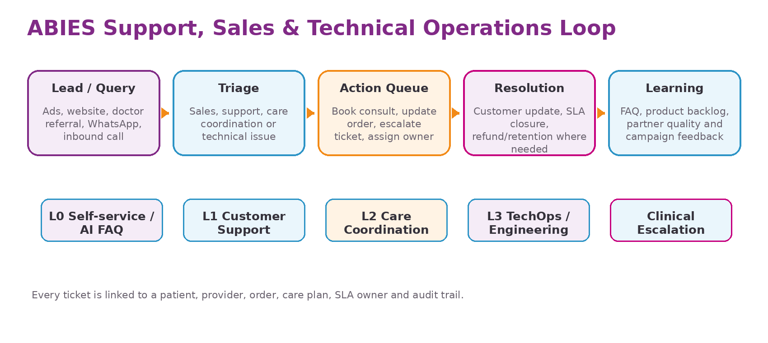
Customer Support Console
Module | Core capabilities | Why it matters
Customer 360 | Patient profile, family profiles, bookings, Care Plans, orders, tickets, payments and history in one view. | Agents resolve issues without asking patients to repeat details.
Omnichannel ticketing | In-app, WhatsApp, phone, email, website form and partner-raised tickets. | Most Indian healthcare support still starts from calls or WhatsApp.
Care coordination queue | Follow-up reminders, missed appointments, pending reports, delayed medicine orders and therapy-session exceptions. | Keeps treatment continuity alive beyond the first consultation.
Complaint and safety triage | Clinical concern, adverse reaction, medicine mismatch, therapy complaint and urgent escalation paths. | Separates routine support from sensitive health/safety cases.
Refund / cancellation desk | Refund rules, partner no-show cases, payment disputes and approval workflow. | Protects trust while controlling leakage.
Knowledge base | Doctor FAQ, medicine order FAQ, therapy preparation instructions, diagnostics FAQ and partner SOPs. | Improves first-contact resolution and reduces training time.

Sales & Partner Growth Console
Pipeline area | What to manage | Typical users
Patient acquisition | Campaign leads, landing-page forms, call-back requests, referral coupons, appointment conversion and reactivation lists. | Inside sales, growth, call centre
Doctor onboarding | Lead source, qualification, registration verification, agreement status, profile completion and go-live checklist. | Doctor success, city manager
Panchakarma centre sales | Facility assessment, therapies offered, slot capacity, pricing, photos, audit status and training completion. | Partner sales, quality auditor
Lab/pharmacy partnerships | Service area, catalogue, SLA, license documents, settlement model, escalation contacts and API readiness. | Partner operations, finance
Corporate / institutional sales | Employer wellness programs, clinic chains, camps, bulk health programs and recurring packages. | Business development

Technical Support & TechOps Console
Capability | Expected functionality | Operational output
Incident management | P1/P2/P3/P4 classification, owner, timeline, RCA, customer impact and closure notes. | Reliable response during app, payment, video or partner API failures.
System health dashboard | App uptime, API latency, payment success, notification delivery, video-call failure, partner API status. | Operations team can see failure before customers flood support.
Release support | Release notes, feature flags, rollback plan, production checklist and post-release monitoring. | Safer deployment cadence across patient, doctor and partner apps.
Data reconciliation | Payments, settlements, orders, refunds, lab reports and partner confirmations. | Avoids financial and clinical-status mismatches.
Access and audit review | Admin access logs, user impersonation rules, sensitive data views and suspicious activity. | Supports privacy, security and compliance expectations.

Support SLA Model
Priority | Examples | Target response | Target resolution / update
P1 Critical | Payment charged but booking failed at scale; app outage; exposed sensitive data; urgent safety complaint. | 15 minutes | Hourly update until controlled; RCA after closure
P2 High | Doctor cannot start multiple consultations; lab report missing for active plan; pharmacy SLA breach. | 1 hour | Same business day or clear workaround
P3 Medium | Single booking issue, refund query, reschedule request, profile correction. | 4 business hours | 1-2 business days
P4 Low | General enquiry, feature request, content clarification. | 1 business day | Tracked through backlog/knowledge base

28. Support, Sales and Tech Journeys
Detailed operating journeys for assisted healthcare delivery.
Patient support journey
Step | Patient action / issue | System action | Owner
1 | Patient asks for help via app, phone or WhatsApp. | Create ticket; map to patient, booking, order or Care Plan. | L1 support
2 | Issue is classified: booking, payment, report, medicine, therapy, clinical concern or technical issue. | Priority and routing rules trigger SLA timer. | Support desk
3 | Agent checks Customer 360 and available partner/doctor status. | Suggested resolution, templates and escalation path shown. | L1/L2
4 | If clinical/safety concern exists, case is routed to assigned doctor or clinical governance queue. | Support cannot provide medical advice; only coordinates escalation. | Clinical escalation
5 | Resolution is sent and ticket is closed after confirmation. | CSAT, reason codes and defect signals are captured. | Support ops

Sales journey for doctors and partners
Stage | Doctor / partner journey | ABIES action | Exit criterion
Lead | Provider expresses interest or is sourced by city team. | Capture source, specialty/service, location and expected capacity. | Qualified / not qualified
Verification | Registration, license, facility, photos and documents submitted. | Perform credential verification and compliance checks. | Verified or rejected
Commercial | Commission/subscription/SLA model agreed. | Agreement, pricing, service catalogue and settlement setup. | Signed agreement
Enablement | Portal training, SOP training and test booking/order flow. | Sandbox/demo account and go-live checklist. | Ready for pilot
Activation | Provider starts receiving bookings/referrals. | Monitor quality, response time, cancellations and patient rating. | Stable operating partner

Technical issue journey
Step | Signal | TechOps response | Business communication
Detect | Monitoring alert, support ticket, crash report or partner API failure. | Classify severity and create incident. | Notify support lead if customer-facing.
Stabilise | Identify affected service and apply workaround/rollback if needed. | Feature flag, retry, partner fallback or manual queue. | Agents use approved response template.
Resolve | Fix, test and deploy through emergency or normal release path. | Validate payments/orders/reports were reconciled. | Update affected customers/partners.
Learn | RCA, preventive action, runbook update and backlog item. | Review in weekly product/ops meeting. | Close loop with customer support.

29. Development Sprint Plan
A practical delivery roadmap that takes ABIES from concept to controlled city pilot.
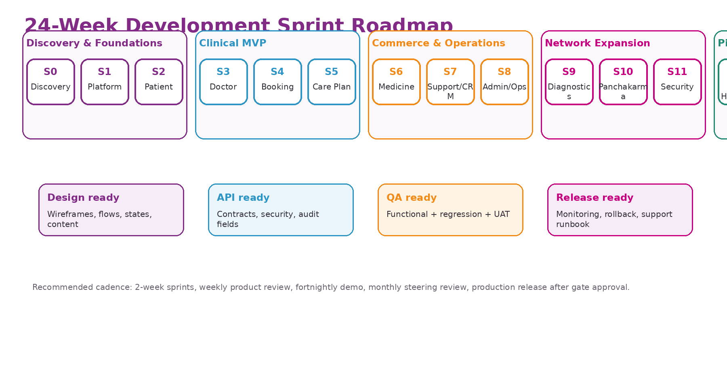
Sprint-by-sprint delivery plan
Sprint | Theme | Scope | Exit criteria
0 | Discovery & solution design | Finalise personas, MVP scope, workflows, data model, compliance assumptions, success metrics and vendor decisions. | Approved PRD, information architecture, architecture runway and MVP backlog.
1 | Platform foundation | Authentication, role model, base database schema, admin shell, design system, environments and CI/CD. | Dev/UAT environments ready; RBAC and audit foundations working.
2 | Patient onboarding & discovery | Registration, family profiles, health intake, doctor search, profile view and consent screens. | Patient can register, complete intake and select a verified doctor.
3 | Doctor onboarding & verification | Doctor registration, credential upload, admin verification, profile publishing and availability setup. | Verified doctor can become visible to patients.
4 | Appointments, payments & video | Slot booking, reschedule/cancel, payment flow, reminders and video consultation launch. | Patient can book and complete a paid consultation.
5 | Consultation, prescription & Care Plan | Doctor notes, Ayurveda assessment fields, digital prescription, care tasks, follow-up and patient instructions. | Doctor can complete consultation and publish a structured Care Plan.
6 | Medicine fulfilment | Pharmacy catalogue, prescription order, inventory confirmation, invoice, dispatch, delivery and refill reminders. | Prescribed medicine can be ordered and tracked.
7 | Support CRM & sales console | Customer 360, tickets, SLA, call notes, sales leads, doctor/partner pipeline and knowledge base. | Support and sales teams can operate the pilot from one console.
8 | Admin operations & settlements | Partner management, pricing, refunds, settlements, dashboards, reports and operational exceptions. | Finance/ops can reconcile bookings, orders and partner payouts.
9 | Diagnostics workflow | Lab onboarding, test catalogue, booking, collection status, report upload and doctor-review trigger. | Doctor can order/review diagnostic reports through Care Plan.
10 | Panchakarma workflow | Centre onboarding, therapy catalogue, slots, referral, session tracking, notes and package payments. | Patient can book verified Panchakarma sessions linked to Care Plan.
11 | Security, privacy & reliability hardening | Consent logs, data minimisation, audit trail, backup, monitoring, incident process and vulnerability fixes. | Pilot-ready security and operations gate cleared.
12 | Controlled beta and launch hardening | Pilot launch, UAT fixes, performance tuning, partner training, support scripts and launch dashboard. | Go-live decision based on pilot metrics and defect trend.

Recommended delivery team
Role | Recommended allocation during MVP | Notes
Product owner / founder representative | 1 | Owns prioritisation, scope control and business decisions.
Product manager / business analyst | 1 | Turns blueprint into PRD, user stories, acceptance criteria and release notes.
UX/UI designer | 1 | Creates flows, wireframes, design system, prototype and usability testing.
Backend engineers | 2-3 | APIs, services, integrations, workflow, security and data model.
Frontend web engineer | 1-2 | Admin, doctor and partner portals.
Mobile engineer / cross-platform engineer | 1-2 | Patient mobile app or responsive PWA depending MVP choice.
QA engineer | 1-2 | Manual QA, regression suite, UAT support and release certification.
DevOps / cloud engineer | 0.5-1 | CI/CD, environments, monitoring, backup and production readiness.
Security/compliance advisor | Part-time | Reviews privacy, health data, access, audit and incident controls.

30. Delivery Governance & Release Gates
Controls that prevent the project from becoming a large, uncontrolled build.
Sprint ceremonies and operating rhythm
Cadence | Meeting / checkpoint | Purpose
Weekly | Product backlog review | Confirm priorities, remove unclear items and protect MVP scope.
Weekly | Design and workflow review | Validate screens against real patient, doctor and operations journeys.
Every sprint | Sprint planning | Commit only to stories with acceptance criteria and dependencies resolved.
Every sprint | Demo and retrospective | Show working software to business, operations, doctor advisor and support leads.
Monthly | Steering review | Review budget, delivery risk, vendor issues, go-live blockers and pilot readiness.

Definition of Ready and Definition of Done
Control | Minimum standard
Story ready | User role, workflow, field list, validations, edge cases, acceptance criteria, dependencies and analytics event defined.
Design ready | Wireframe/prototype approved with empty states, error states, mobile view and support/ops implications.
API ready | Request/response, auth, error handling, audit fields, rate limits and privacy requirements documented.
QA ready | Test cases written for happy path, failure path, permissions, notifications and data visibility.
Release ready | UAT sign-off, known issues listed, rollback plan, monitoring and support script available.

Release gates
Gate | Must pass before moving forward
MVP build gate | Patient, doctor, admin and support core flows can run end-to-end in UAT.
Clinical safety gate | Clinical escalation, prescription boundaries, support scripts and doctor accountability are documented.
Privacy/security gate | Consent, access control, audit logs, backup, retention and incident response are verified.
Operational gate | Support team trained, partner SOPs ready, city pilot roster approved and escalation contacts active.
Commercial gate | Pricing, commissions, refund rules, settlement cycle and unit-economics tracker are approved.
Pilot expansion gate | CSAT, SLA, repeat consultation, follow-up completion and partner quality show stable trend.

Recommended MVP technology decision
Start with a responsive patient web/PWA plus doctor, partner, support and admin web portals. Build native mobile applications after the care journey, support model and unit economics are validated. This reduces first-build cost and accelerates learning.

Updated closing statement
For ABIES, the opportunity is not only an Ayurveda appointment app. The stronger product is a coordinated healthcare operating platform: patient journeys, practitioner tools, partner networks, customer support, sales operations, technical support and measurable care-plan continuity working together.

