AI-BASED ATTENDANCE SYSTEM
USING FACE RECOGNITION
System Requirement Specification, Flowchart
& Project Timeline Chart

Project Report
Document Version: 1.0
Date: August 2026

Table of Contents

1. Introduction
This document specifies the System Requirement Specification (SRS), the process flowchart, and the development timeline chart for the AI-Based Attendance System Using Face Recognition. It is intended to serve as a technical reference for developers, project guides, and evaluators, describing precisely what the system must do, how data flows through it, and the schedule on which it will be built.

2. System Requirement Specification (SRS)

2.1 Purpose
The purpose of this SRS is to define the functional and non-functional requirements, interfaces, and constraints of the AI-Based Attendance System Using Face Recognition, so that the design and implementation teams have a single, unambiguous reference for what the system must achieve.

2.2 Scope
The system will capture live video from a camera, detect and recognise enrolled faces, and automatically record attendance with a timestamp in a database. It will provide an administrator interface for enrolling users, managing records, and exporting attendance reports. The scope covers a single-institution deployment (school, college, or office) and does not extend to nationwide identity verification or law-enforcement use.

2.3 Intended Audience
- Project developers and the technical team building the system.
- Project guide/supervisor and academic evaluators reviewing the project.
- System administrators who will operate and maintain the deployed system.

2.4 Overall Description

2.4.1 Product Perspective
The system is a standalone application composed of a camera-based recognition module, a database module, and an administrative interface. It is not dependent on any existing legacy system and can be deployed on a single computer connected to a webcam or CCTV camera.

2.4.2 Product Functions (Summary)
- Enrol new users by capturing and storing facial image samples.
- Train/update the recognition model using enrolled data.
- Detect and recognise faces from a live camera feed in real time.
- Automatically mark and timestamp attendance for recognised individuals.
- Allow manual correction of attendance records by an administrator.
- Generate and export attendance reports.

2.4.3 User Characteristics
Administrators are expected to have basic computer literacy but no programming knowledge. The interface is therefore designed to be simple, icon/button-driven, and free of technical jargon.

2.4.4 Assumptions and Dependencies
- A camera with a minimum resolution of 720p is available at the deployment site.
- Users provide consent for facial data collection before enrolment.
- A stable power supply and, for web-based deployment, network connectivity are available.

2.5 Functional Requirements
ID | Requirement | Description
FR-1 | User Enrolment | Capture and store multiple facial images per user along with ID, name, and department/class.
FR-2 | Model Training | Process enrolled images to generate or update facial encodings for recognition.
FR-3 | Real-Time Detection | Detect one or more faces from a continuous live camera feed.
FR-4 | Face Recognition | Match a detected face against the enrolled database and return the closest identity.
FR-5 | Attendance Marking | Automatically log date, time, and identity of a recognised person; prevent duplicate entries in one session.
FR-6 | Manual Override | Allow an administrator to add, edit, or delete an attendance entry.
FR-7 | Reporting | Generate and export daily/weekly/monthly attendance reports in CSV/Excel format.
FR-8 | Search & Filter | Allow searching attendance records by name, ID, date, or department.
FR-9 | Authentication | Require administrator login before enrolment, configuration, or report access.
FR-10 | Notifications (Optional) | Send an email/SMS alert on marked or missed attendance, if configured.

2.6 Non-Functional Requirements
Category | Requirement
Performance | Face detection and recognition shall complete within 1-2 seconds per frame under normal lighting.
Accuracy | The recognition model shall achieve at least 95% accuracy under controlled lighting conditions.
Usability | The interface shall require minimal training for non-technical administrative staff.
Reliability | The system shall log attendance consistently without data loss during operating hours.
Scalability | The system shall support additional enrolled users without major performance degradation.
Security | Facial data and personal records shall be stored securely with role-based access control.
Availability | The system shall be available throughout all scheduled attendance-taking hours.
Maintainability | The codebase shall be modular so the recognition engine or database can be upgraded independently.

2.7 External Interface Requirements

2.7.1 Hardware Interfaces
- HD webcam or CCTV camera (720p or higher) connected via USB or IP network.
- Host computer/server: minimum Intel i5 processor (or equivalent) with 8 GB RAM.
- Optional GPU for accelerated deep-learning-based recognition at scale.

2.7.2 Software Interfaces
- Operating System: Windows 10/11 or Linux (Ubuntu recommended for server deployment).
- Recognition engine: Python with OpenCV and a deep-learning face-recognition library (e.g., FaceNet/ArcFace via DeepFace, or dlib-based face_recognition).
- Database: MySQL / SQLite / Firebase for storing user and attendance records.

2.7.3 User Interfaces
- A desktop GUI (Tkinter/PyQt) or web dashboard (Flask/Django) for enrolment, live monitoring, and reports.
- Clear, icon-based navigation with confirmation prompts for critical actions (e.g., deleting a record).

2.7.4 Communication Interfaces
- Optional REST API endpoints for integration with external HR/academic ERP systems.
- Optional SMTP/SMS gateway integration for notification alerts.

2.8 Constraints
- Recognition accuracy is sensitive to lighting, camera angle, and facial occlusion (masks, sunglasses).
- Biometric data handling must comply with institutional policy and applicable data-protection regulations.
- The system requires an initial dataset of clear facial images for every user prior to first use.

3. System Flowchart
The flowchart below illustrates the end-to-end process flow of the face recognition attendance module, from capturing a camera frame to generating the final attendance report.
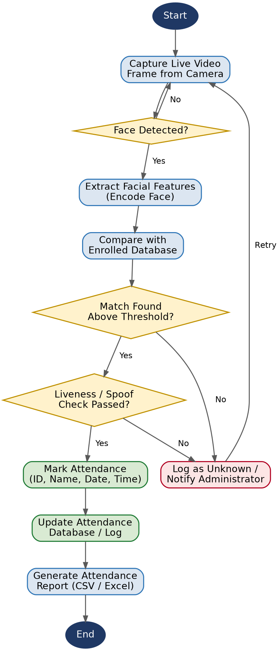
Figure 1: Process flowchart of the AI-Based Attendance System

4. Project Timeline Chart
The chart below presents the planned development schedule for the project across an 8-week timeline, broken down by phase.
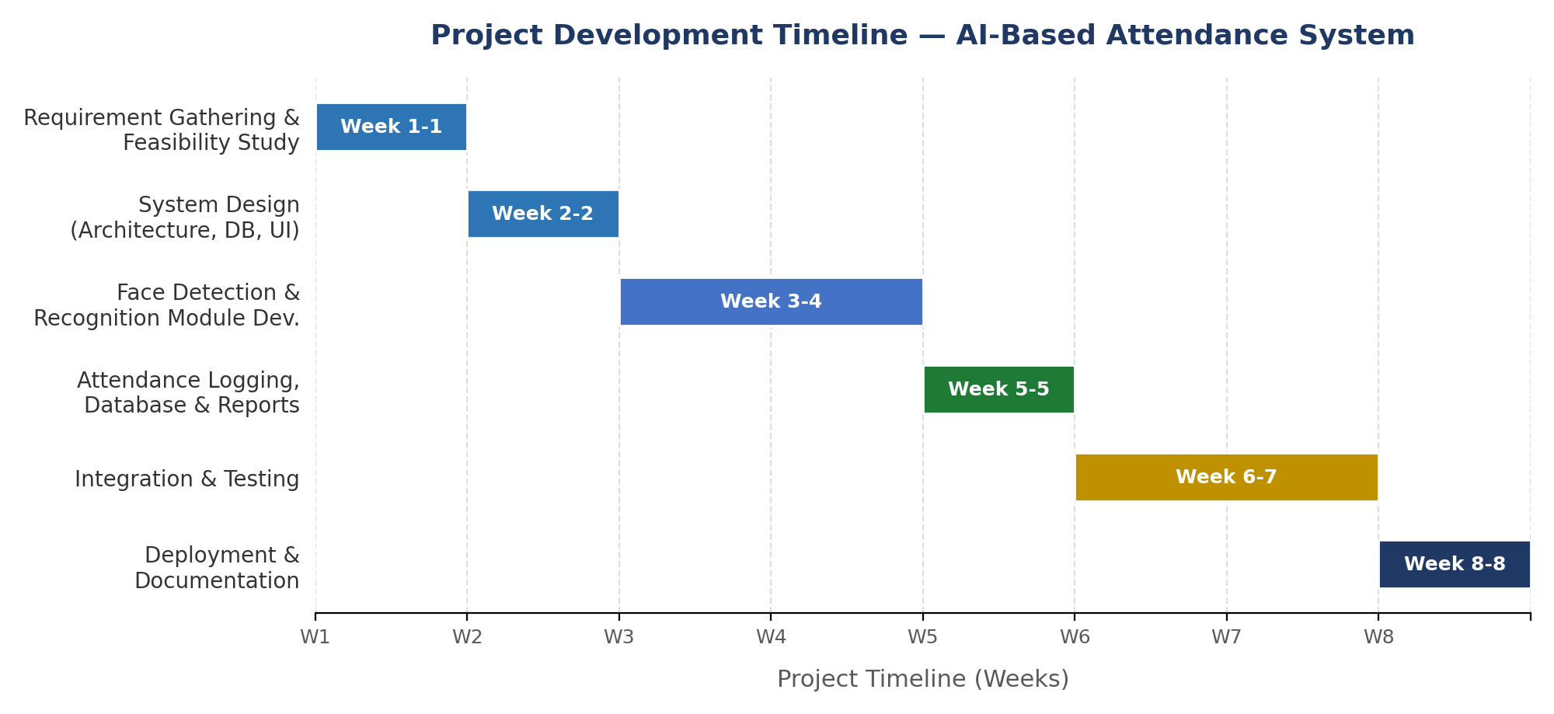
Figure 2: Project development timeline (Gantt-style chart)

4.1 Phase-wise Breakdown
Phase | Activity | Duration
Phase 1 | Requirement gathering and feasibility study | Week 1
Phase 2 | System design (architecture, database, UI) | Week 2
Phase 3 | Face detection & recognition module development | Week 3-4
Phase 4 | Attendance logging, database, and report module | Week 5
Phase 5 | Integration, testing, and bug fixing | Week 6-7
Phase 6 | Deployment and documentation | Week 8

5. Conclusion
This document has defined the complete System Requirement Specification for the AI-Based Attendance System Using Face Recognition, mapped its operational logic through a detailed process flowchart, and laid out a realistic 8-week development timeline. Together, these artefacts provide a clear, unambiguous foundation for the design and implementation phases that follow.

