CYBERSECURITY INCIDENT TRACKER

Project Title

Cybersecurity Incident Tracker Using Node.js, Express.js, MySQL, and MongoDB

Project Outcome

The Cybersecurity Incident Tracker was successfully designed and developed to provide a centralized platform for managing cybersecurity incidents. The application enables organizations to report, monitor, investigate, and resolve security incidents efficiently through RESTful APIs. The project demonstrates practical implementation of backend web development, database management, and API integration using both relational and NoSQL databases.

The developed system successfully performs CRUD (Create, Read, Update, Delete) operations on users, incidents, investigations, analysts, and evidence records. MySQL was used for storing structured information such as users, incidents, investigations, analysts, and their relationships, while MongoDB was integrated for storing evidence documents in a flexible JSON format.

The application was thoroughly tested using Postman, where all API endpoints were validated successfully. The project demonstrates concepts such as database connectivity, REST API development, hybrid database architecture, foreign key relationships, and secure data management. Overall, the Cybersecurity Incident Tracker serves as a practical solution for incident management while strengthening knowledge of modern backend technologies.

Tools Used with Version

Software/Tool Version Purpose
Node.js v26.0.0 javascript runtime environment Express.js v5.1.0. Backend Framework
MySQL Server 8.x Relational Database
MySQL Workbench 8.x Database Administration
MongoDB Community Server 8.x NoSQL Database
MongoDB Compass Latest. MongoDB GUI Tool
Mongoose v8.18.0 MongoDB Object Modeling
MySQL2 v3.14.4 MySQL Driver
Postman Latest API Testing
Visual Studio Code Latest Source Code Editor
npm Latest Package Manager
Git Latest Version Control
GitHub Web Platform Source Code Repository

Output Screenshots with Explanation

Screenshot 1: Project Folder Structure

Explanation:

This screenshot displays the complete folder structure of the Cybersecurity Incident Tracker project. The project is organized into separate folders such as config, routes, and models, which improves maintainability and modularity. The root directory also contains the main server file (server.js), package configuration files, and environment settings.

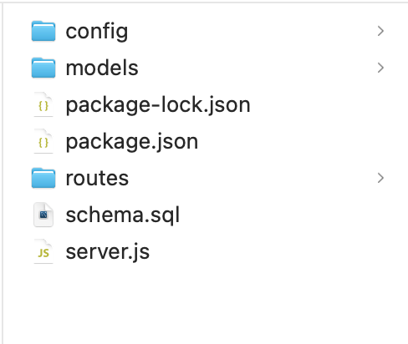

Screenshot 2: MySQL Database Tables

Explanation:

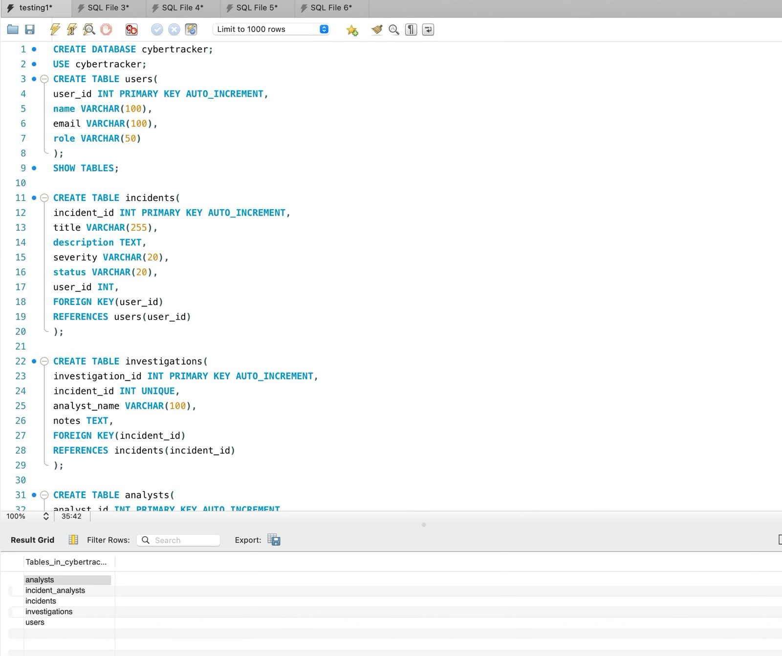
This screenshot shows the MySQL database named cybertracker along with all the created tables, including users, incidents, investigations, analysts, and incident_analysts. These tables store structured information related to cybersecurity incidents and maintain relationships using foreign keys.

Screenshot 3: MongoDB Compass

Explanation:

This screenshot demonstrates the MongoDB database and the Evidence collection. Evidence documents are stored in JSON format, allowing flexible storage of cybersecurity evidence such as filenames, descriptions, uploader details, and incident references.

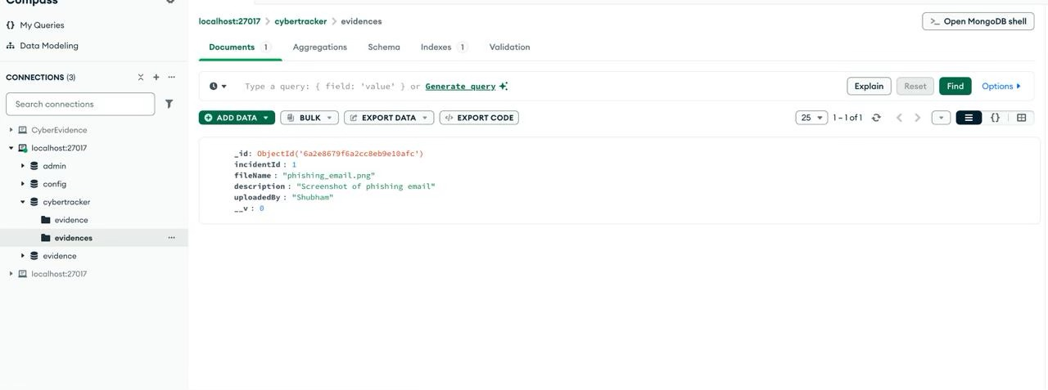

Screenshot 4: Server Running

Explanation:

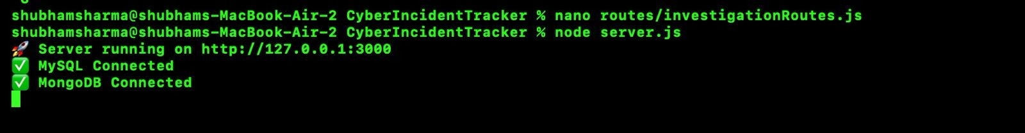
This screenshot displays the successful startup of the Node.js server. The terminal confirms successful connections to both MySQL and MongoDB databases, followed by the server listening on http://localhost:3000.

Screenshot 5: POST User API

Explanation:

The POST User API creates a new user in the database. The request body contains the user’s name, email, and role. After successful execution, the API returns a confirmation message along with the generated user ID.
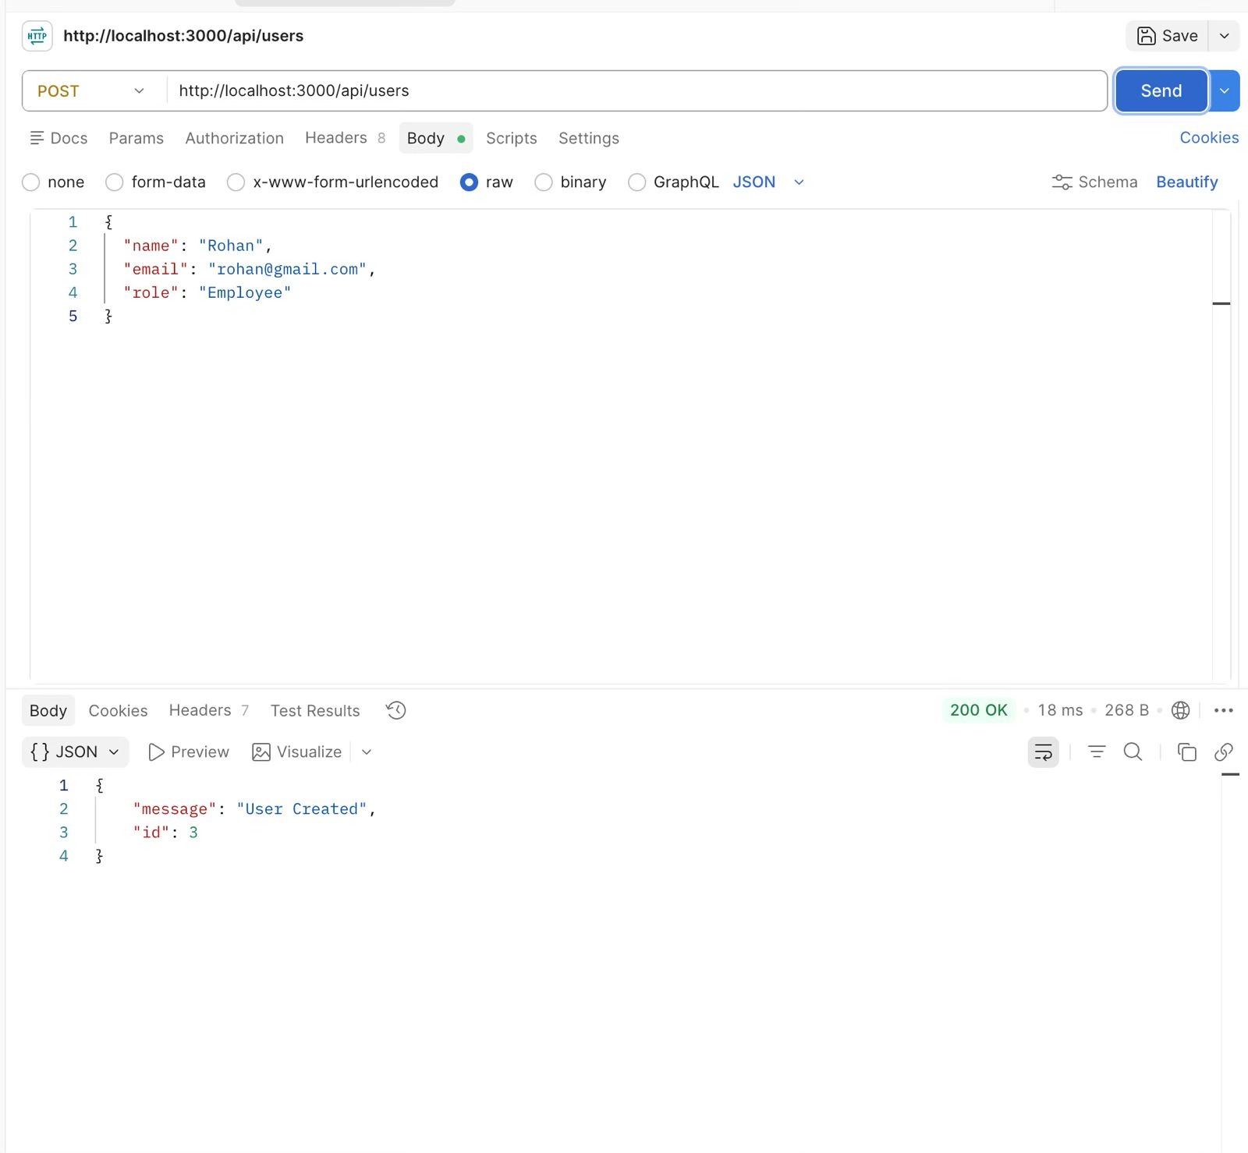

Screenshot 6: GET User API

Explanation:

The GET User API retrieves all registered users from the MySQL database. The response is returned in JSON format, displaying user information including user ID, name, email, and role.

Screenshot 7: PUT User API

Explanation:

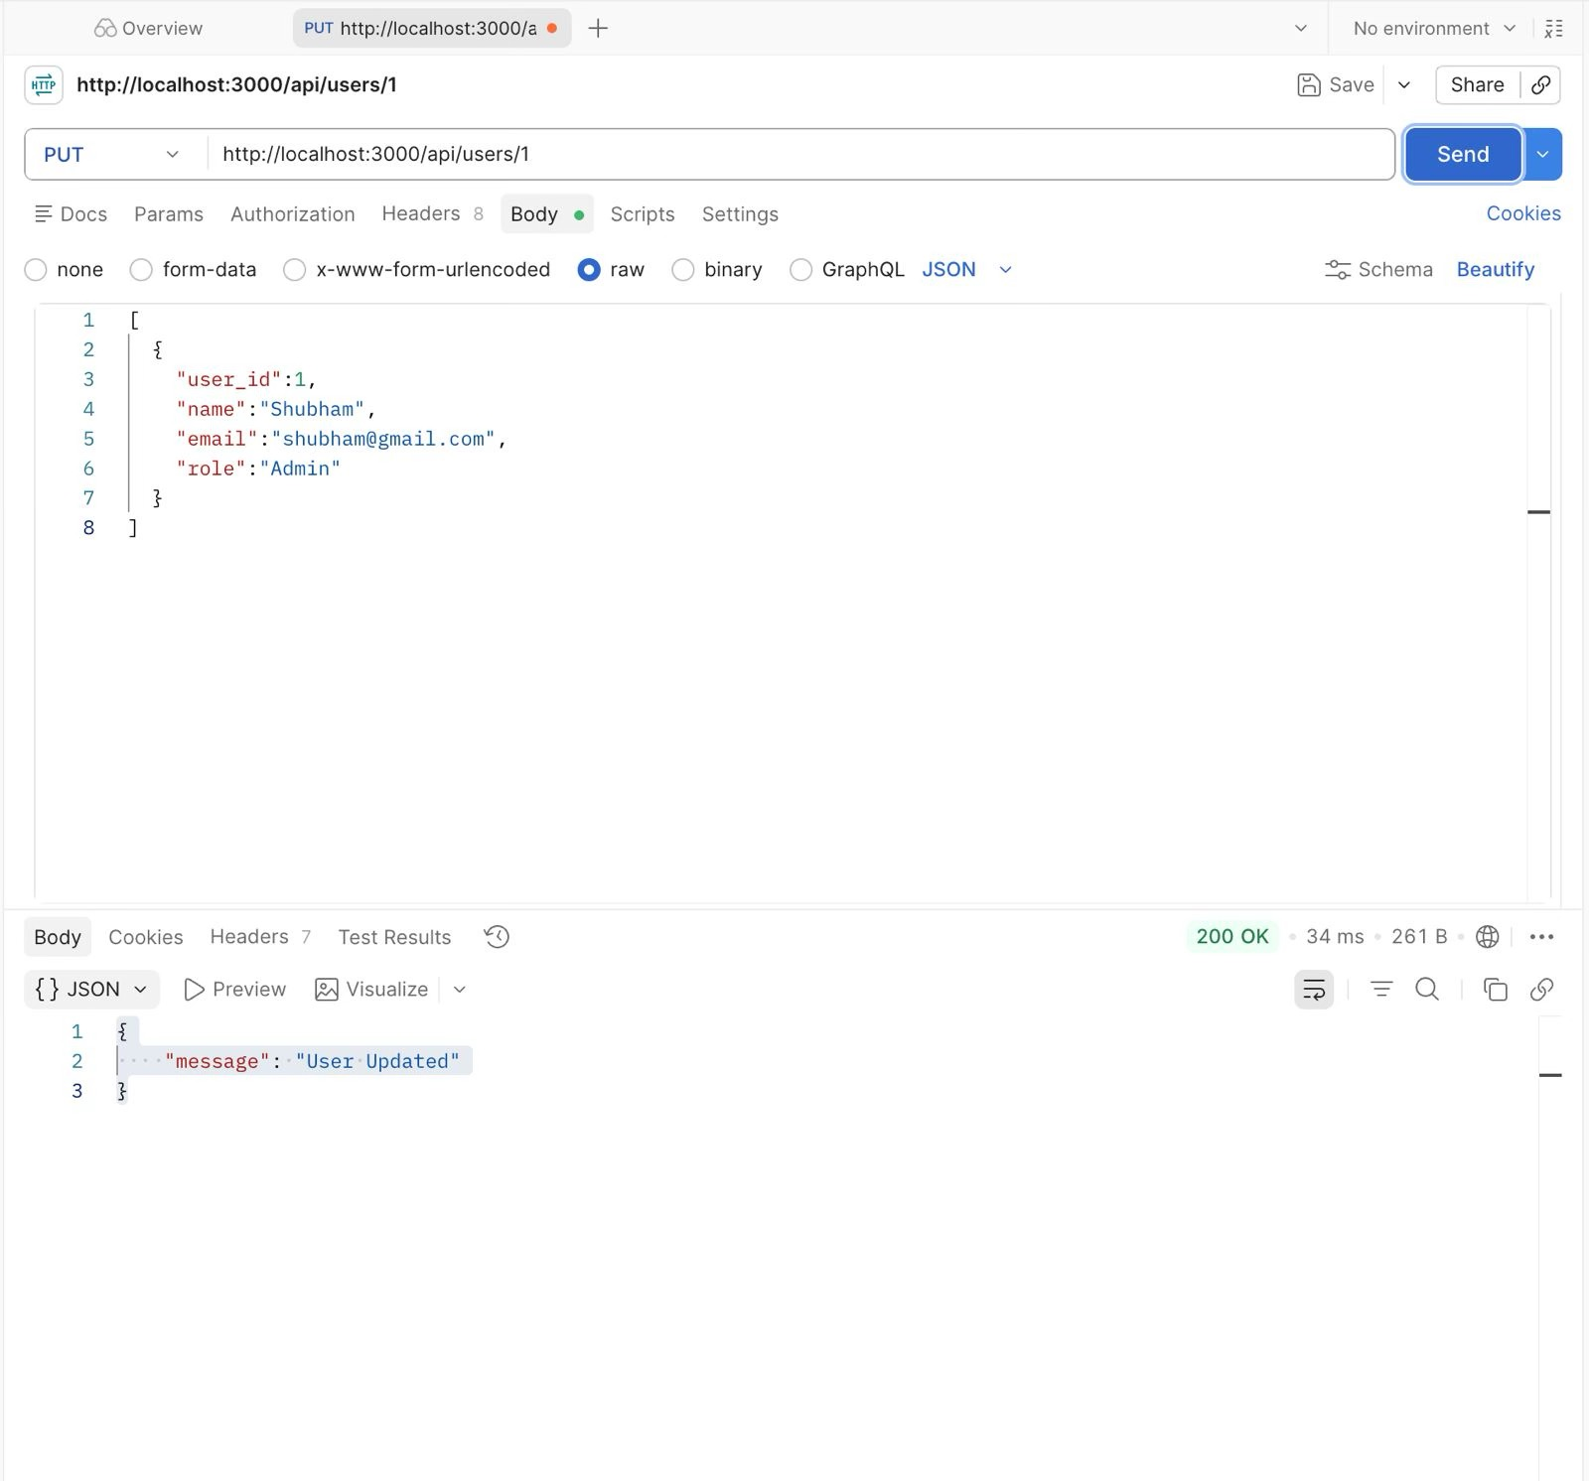
The PUT User API updates existing user information based on the user ID provided in the URL. It allows modification of user details such as name, email, and role.

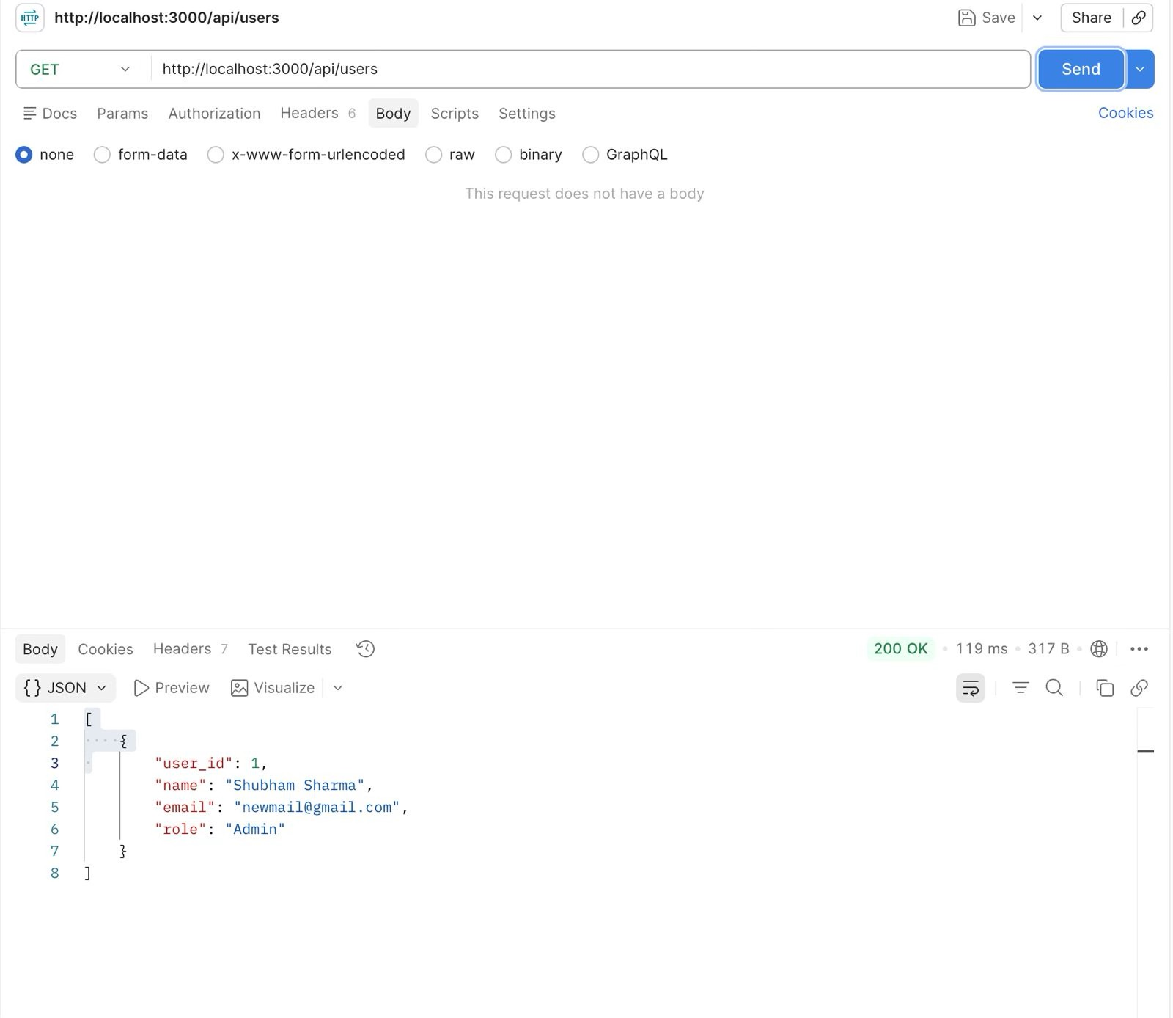

Screenshot 8: DELETE User API

Explanation:

The DELETE User API removes a user from the database. During testing, foreign key constraints prevented deletion of users who were associated with incidents, ensuring data integrity.

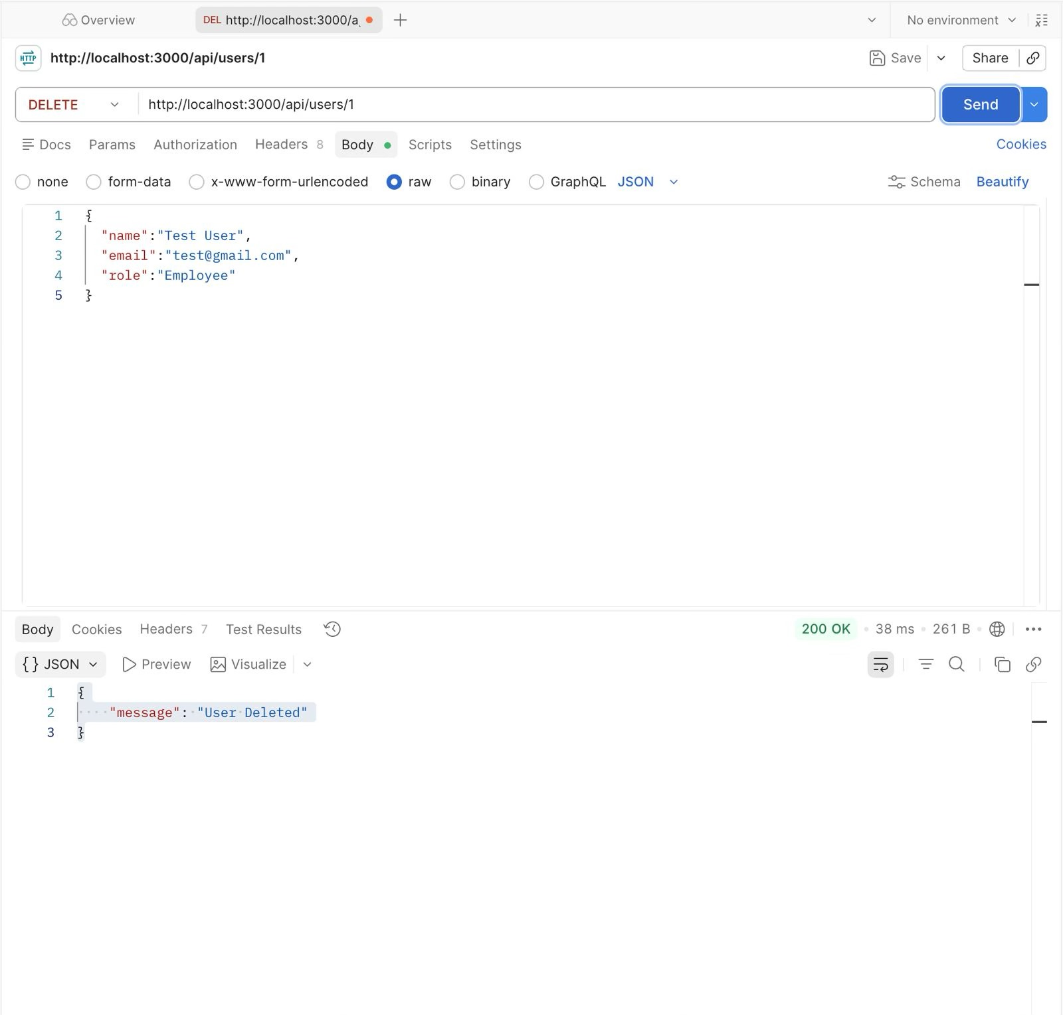
Screenshot 9: POST Incident API

Explanation:

The POST Incident API creates a new cybersecurity incident by storing details such as title, description, severity, status, and the reporting user’s ID. Each incident is linked to a valid user using a foreign key relationship.

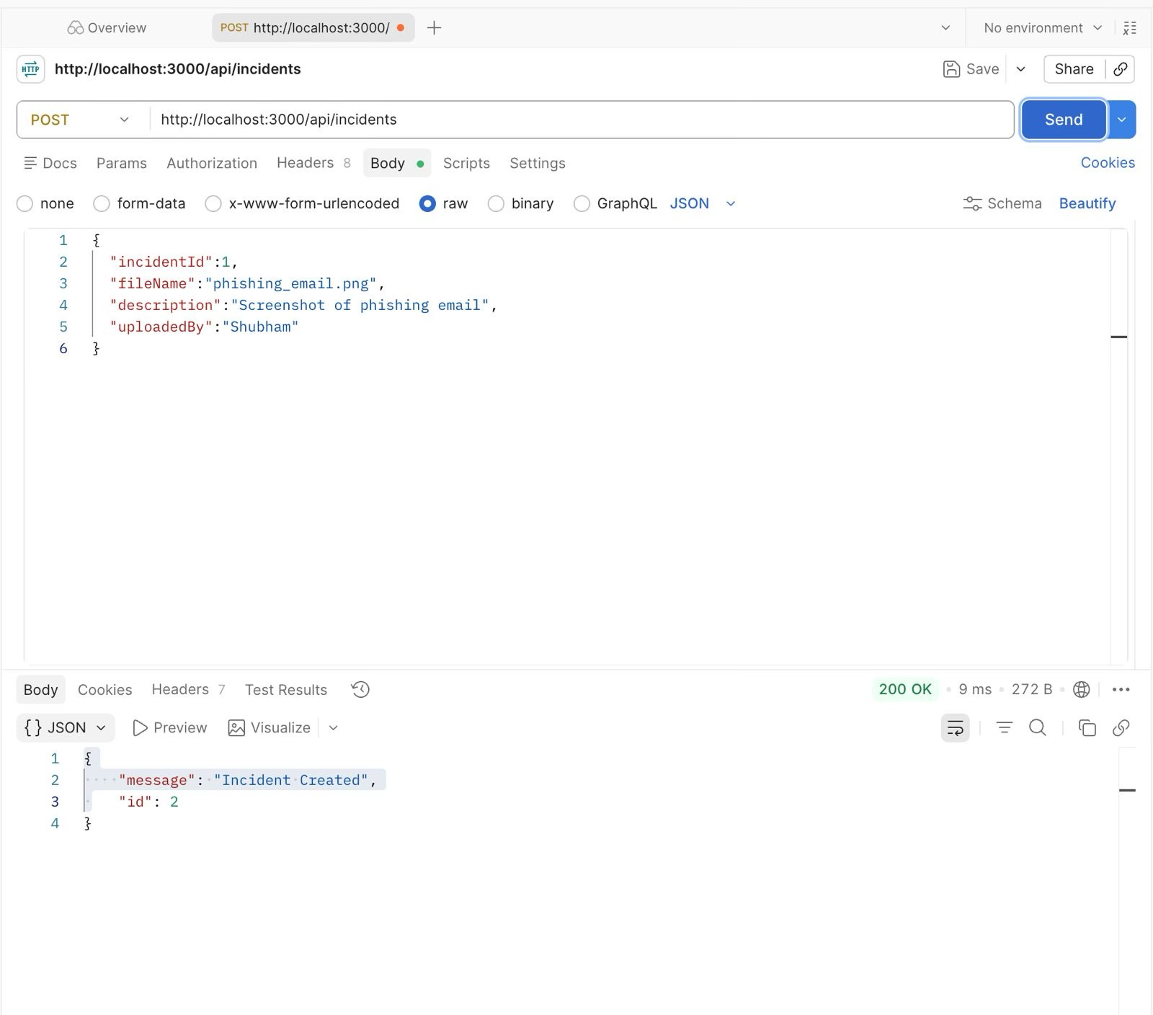

Project Summary

The Cybersecurity Incident Tracker is a backend-based incident management application developed using Node.js, Express.js, MySQL, and MongoDB. The project demonstrates the implementation of RESTful APIs, CRUD operations, and hybrid database architecture. MySQL stores structured data related to users, incidents, analysts, and investigations, while MongoDB stores evidence documents in a flexible format.

The project successfully integrates multiple technologies to create a secure and scalable backend application. Database relationships including one-to-many, one-to-one, and many-to-many were implemented using foreign key constraints and junction tables. API functionality was verified using Postman, ensuring reliable communication between the client and server. Overall, the project provides practical experience in backend web development and cybersecurity incident management.

Conclusion

The Cybersecurity Incident Tracker successfully fulfills its objective of providing a centralized system for reporting, managing, and investigating cybersecurity incidents. The project demonstrates strong understanding of backend application development, REST API design, relational and NoSQL database integration, and secure data management practices.

The application enables efficient management of users, incidents, analysts, investigations, and evidence through well-designed APIs. Testing confirmed the successful implementation of CRUD operations and database relationships. The hybrid use of MySQL and MongoDB highlights the advantages of combining relational and document-oriented databases in a single application.

This project serves as an effective learning experience in modern backend development and provides a solid foundation for future enhancements such as user authentication, role-based access control, file uploads, real-time notifications, and cloud deployment.

