package mongodb;

import com.mongodb.client.FindIterable;
import com.mongodb.client.MongoClient;
import com.mongodb.client.MongoClients;
import com.mongodb.client.MongoCollection;
import com.mongodb.client.MongoDatabase;
import com.mongodb.client.model.Filters;
import com.mongodb.client.model.Updates;
import org.bson.Document;

public class MongoCRUDExample {

public static void main(String[] args) {

MongoClient mongoClient = null;

try {
// Connect to MongoDB
mongoClient = MongoClients.create("mongodb://localhost:27017");

// Access database
MongoDatabase database = mongoClient.getDatabase("CollegeDB");

// Access collection
MongoCollection<Document> collection =
database.getCollection("Students");

// ==========================
// CREATE (Insert)
// ==========================
Document student = new Document("id", 101)
.append("name", "John")
.append("department", "CSE")
.append("cgpa", 8.7);

collection.insertOne(student);

System.out.println("Document Inserted Successfully");

// ==========================
// READ (Find)
// ==========================
System.out.println("\nStudent Records:");

FindIterable<Document> students = collection.find();

for (Document doc : students) {
System.out.println(doc.toJson());
}

// ==========================
// UPDATE
// ==========================
collection.updateOne(
Filters.eq("id", 101),
Updates.set("cgpa", 9.2)
);

System.out.println("\nDocument Updated Successfully");

// ==========================
// READ Updated Record
// ==========================
Document updatedStudent =
collection.find(Filters.eq("id", 101)).first();

System.out.println("\nUpdated Record:");

if (updatedStudent != null) {
System.out.println(updatedStudent.toJson());
}

// ==========================
// DELETE
// ==========================
collection.deleteOne(Filters.eq("id", 101));

System.out.println("\nDocument Deleted Successfully");

} catch (Exception e) {
e.printStackTrace();
} finally {
if (mongoClient != null) {

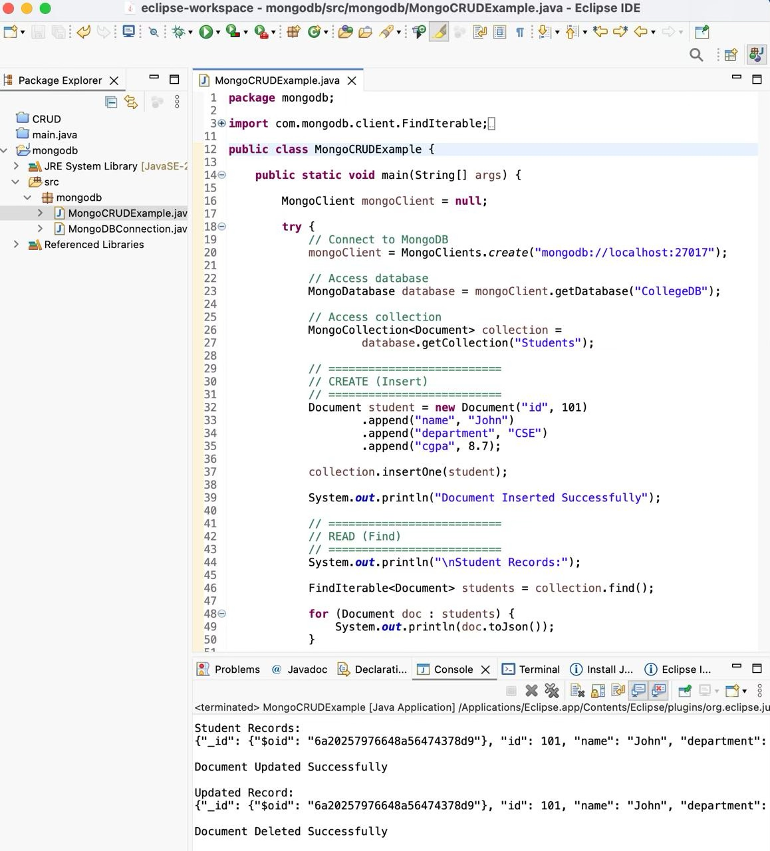
mongoClient.close();
}
}
}
}

package mongodb;

import com.mongodb.client.FindIterable;
import com.mongodb.client.MongoClient;
import com.mongodb.client.MongoClients;
import com.mongodb.client.MongoCollection;
import com.mongodb.client.MongoDatabase;
import com.mongodb.client.model.Filters;
import com.mongodb.client.model.Updates;

import org.bson.Document;

import java.util.Arrays;

public class MongoCRUDExample {

public static void main(String[] args) {

MongoClient mongoClient = null;

try {

// Connect to MongoDB
mongoClient = MongoClients.create("mongodb://localhost:27017");

// Access Database
MongoDatabase database = mongoClient.getDatabase("CollegeDB");

// Access Collection
MongoCollection<Document> collection =
database.getCollection("Students");

System.out.println("Connected Successfully to MongoDB");

// =====================================
// INSERT ONE DOCUMENT
// =====================================

Document student = new Document("id", 101)
.append("name", "John")
.append("department", "CSE")
.append("cgpa", 8.7);

collection.insertOne(student);

System.out.println("\nDocument Inserted Successfully");

// =====================================
// READ ALL DOCUMENTS
// =====================================

System.out.println("\nStudent Records:");

FindIterable<Document> students = collection.find();

for (Document doc : students) {
System.out.println(doc.toJson());
}

// =====================================
// UPDATE DOCUMENT
// =====================================

collection.updateOne(
Filters.eq("id", 101),
Updates.set("cgpa", 9.2)
);

System.out.println("\nDocument Updated Successfully");

// =====================================
// READ UPDATED DOCUMENT
// =====================================

Document updatedStudent =
collection.find(Filters.eq("id", 101)).first();

System.out.println("\nUpdated Record:");

if (updatedStudent != null) {
System.out.println(updatedStudent.toJson());
}

// =====================================
// INSERT MANY DOCUMENTS
// =====================================

collection.insertMany(Arrays.asList(

new Document("id", 1)
.append("name", "Alice")
.append("department", "CSE")
.append("cgpa", 8.5),

new Document("id", 2)
.append("name", "Bob")
.append("department", "IT")
.append("cgpa", 7.9),

new Document("id", 3)
.append("name", "Charlie")
.append("department", "ECE")
.append("cgpa", 8.1)
));

System.out.println("\nMultiple Documents Inserted");

// =====================================
// FIND SPECIFIC DOCUMENT
// =====================================

Document doc =
collection.find(Filters.eq("id", 2)).first();

System.out.println("\nSpecific Document:");

if (doc != null) {
System.out.println(doc.toJson());
}

// =====================================
// UPDATE SPECIFIC DOCUMENT
// =====================================

collection.updateOne(
Filters.eq("id", 2),
Updates.set("name", "Bobby")
);

System.out.println("\nSpecific Document Updated");

// =====================================
// DELETE SPECIFIC DOCUMENT
// =====================================

collection.deleteOne(
Filters.eq("id", 2)
);

System.out.println("\nSpecific Document Deleted");

// =====================================
// DELETE DOCUMENT WITH ID 101
// =====================================

collection.deleteOne(
Filters.eq("id", 101)
);

System.out.println("\nDocument Deleted Successfully");

} catch (Exception e) {

System.out.println("Error: " + e.getMessage());
e.printStackTrace();

} finally {

if (mongoClient != null) {
mongoClient.close();
System.out.println("\nMongoDB Connection Closed");
}
}
}
}

