 | Lokmanya Tilak Jankalyan Shikshan Sanstha's  Lokmanya Tilak College of Engineering  An Autonomous Institute Affiliated to University of Mumbai  (Approved by AICTE, Accredited by NAAC 'A' Grade & Four Programs by NBA)  Sector-04, Vikas Nagar, Koparkhairane, Navi Mumbai - 400 709 | 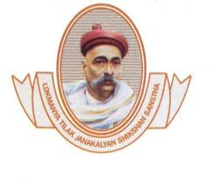

Department of Computer Science &amp; Engineering
(Artificial Intelligence &amp; Machine Learning)
Mini Project Report
on
CampusConnect: Official Campus Events &amp; Student Opportunity Hub
Under the Guidance of
Faculty Guide Name : Prof. __________________
Prepared By :  1. Shubham Sharma [Roll No: ______]  2. Student 2 Name [Roll No: ______]  3. Student 3 Name [Roll No: ______]  4. Student 4 Name [Roll No: ______] | Faculty Incharge :  Prof. __________________  Assistant Professor  Dept of CSE (AI &amp; ML)  LTCE Navi Mumbai
Submission Date : October 2026

Lokmanya Tilak Jankalyan Shikshan Sanstha's
Lokmanya Tilak College of Engineering
An Autonomous Institute Affiliated to University of Mumbai
(Approved by AICTE, Accredited by NAAC 'A' Grade & Four Programs by NBA)
Sector-04, Vikas Nagar, Koparkhairane, Navi Mumbai - 400 709

Department of Computer Science &amp; Engineering
(Artificial Intelligence &amp; Machine Learning)
ACKNOWLEDGEMENT
I would like to express my special thanks of gratitude to our respected Head of Department, Dr. Chaitrali Chaudhari (HOD - CSE AI &amp; ML), who granted us the premier opportunity to develop this meaningful academic mini-project.
I extend my deepest gratitude to our respected Principal, Dr. Subhash Shinde, for fostering an inspiring educational atmosphere, modern computer laboratories, and academic facilities that encouraged the development of an industry-standard web solution.
I express my sincere thanks to my esteemed project guide, Prof. __________________, whose continuous guidance, constructive suggestions, architectural reviews, and technical feedback helped me immensely in learning enterprise web development using Java, Servlets, JSP, JDBC, and relational database systems.
I would also like to extend my heartfelt thanks to my parents and friends who supported me morally and assisted me in finalizing this project within the stipulated academic time frame.
Lastly, I am truly grateful to all the faculty members, laboratory staff, and peer students of Lokmanya Tilak College of Engineering who directly or indirectly contributed valuable feedback and helped in testing the functionality of CampusConnect.
Date : __________________  Place : LTCE, Navi Mumbai | ____________________________________  Student Name : Shubham Sharma  Roll No / Class : SE / TE - CSE (AIML)  Lokmanya Tilak College of Engineering

TABLE OF CONTENTS
Sr. No. Topic / Chapter Title Page No.
--------------------------------------------------------------------------------------------------------------------------------
1. Abstract ................................................................ 4
2. Literature Survey ....................................................... 5
2.1 Traditional College Notification Challenges ..................... 5
2.2 Comparative Analysis (Existing System vs Proposed System) ....... 6
3. Problem Statement &amp; Project Objectives .............................. 7
3.1 Problem Statement ............................................... 7
3.2 Project Objectives .............................................. 7
4. Flowchart &amp; System Diagrams (Solution Architecture) ................. 8
4.1 MVC Architectural Flowchart &amp; Request Lifecycle ............. 8
4.2 UML Use Case Diagram &amp; Actor Modeling ....................... 9
4.3 Core Functional Modules ......................................... 10
5. Front End and Back End Tools (Hardware &amp; Software Specifications) ..... 11
5.1 Front End Technologies (HTML5, CSS3, JavaScript) ................ 11
5.2 Back End Technologies (Java, Servlets, JSP, JDBC, MVC) .......... 12
5.3 Database Architecture (MySQL / Relational Database Engine) ...... 13
5.4 Web Server Environment (Apache Tomcat) .......................... 13
5.5 Hardware &amp; Environmental Requirements ....................... 14
6. Implementation &amp; Core Functionalities ............................... 15
6.1 Real Campus Events (Navratri Carnival, Hackathons, GDG) ......... 15
6.2 Digital Entry Pass Generation &amp; Verified QR Tickets ......... 16
6.3 Campus Clubs &amp; Student Chapters Directory ................... 16
7. Future Scope &amp; Enhancements ......................................... 17
8. References .............................................................. 18

1. ABSTRACT
In tertiary academic institutions like Lokmanya Tilak College of Engineering (LTCE), dynamic student engagement outside traditional lecture rooms is driven by departmental student bodies, technical club chapters, hackathons, seminars, and cultural festivals. However, communication regarding these opportunities remains fragmented across disparate unofficial WhatsApp class groups, ephemeral social media stories, paper notices, and independent Google Forms. Consequently, students routinely miss critical participation deadlines, event organizers face administrative confusion, and duplicate or unverified registrations proliferate without a unified college pass system.
CampusConnect is conceived and engineered as an official, centralized collegiate web platform that unifies all academic, technical, competitive, and cultural activities of Lokmanya Tilak College of Engineering into a singular, highly accessible digital hub. Designed following the industry-standard Model-View-Controller (MVC) architectural pattern, the system is developed utilizing Java Server-Side technologies including Java Servlets (javax.servlet), JavaServer Pages (JSP), Java Database Connectivity (JDBC), and MySQL relational database, hosted within the Apache Tomcat Web Server environment. On the front-end, a responsive, lightweight, and modern presentation layer is crafted using semantic HTML5, custom collegiate CSS3 styling, and Vanilla JavaScript.
The platform offers seamless student features including instant event discovery with multi-parameter filtering (by department, academic year, and category), comprehensive event guideline viewing, automated seat reservation, bookmarking, and instant generation of a printable, verified Digital Campus Entry Pass equipped with unique ticket identification. Additionally, a dedicated Campus Clubs Directory unifies student bodies (such as CESA, AIMSA, DSSA, Cultural Club of AIML Dept, GDG on Campus, GFG Chapter, and E-Cell). For faculty conveners and student heads, an administrative portal streamlines event creation, real-time participant monitoring, and status tracking. CampusConnect bridges the gap between academic clubs and undergraduate students, ensuring that every engineering student connects with every collegiate opportunity.

2. LITERATURE SURVEY
2.1 Traditional College Notification Challenges
To establish the fundamental motivation for CampusConnect, a comprehensive survey of prevailing information dissemination methodologies across collegiate campuses was conducted. In existing institutional workflows, college events are advertised through disconnected channels:
• Physical Notice Boards and Printed Posters: Notice boards positioned in college lobbies or quadrangle wings suffer from limited visual radius. Commuting students or students attending lectures in alternate wings frequently miss time-sensitive registration notifications.
• Informal WhatsApp and Telegram Broadcasts: Event flyers shared across informal WhatsApp class groups get quickly buried under daily academic messages, assignment queries, and conversational noise. Furthermore, broadcast messages do not provide a structured view of eligibility, real-time seat availability, or official registration confirmations.
• Standalone Google Forms and Sheets: Student organizers commonly resort to generating isolated Google Forms for each distinct event. While Google Forms provides rudimentary data collection, it lacks transactional integrity: it cannot prevent duplicate registrations, cannot enforce automatic capacity cutoffs, cannot verify student college credentials, and does not issue a downloadable, formal entry ticket with unique validation credentials.
• Lack of Institutional Club Visibility: First-year and second-year students frequently remain uninformed regarding active technical student chapters (such as GDG, AIMSA, CESA, CSI, IEEE, and Cultural Clubs), depriving students of extracurricular leadership and technical growth opportunities.
2.2 Comparative Analysis (Existing System vs. Proposed System)
The limitations of prevailing ad-hoc methods in comparison to the integrated web-based architecture of CampusConnect are systematically outlined in Table 2.1 below:
Table 2.1: Comprehensive Comparison Between Traditional Methods and CampusConnect
Evaluation Parameter | Existing Manual System (WhatsApp / Notice Board) | Proposed CampusConnect Java Web Hub
Information Centralization | Scattered across unofficial WhatsApp groups, notices, and flyers. | Single consolidated web portal for all departments & student chapters.
Event Registration | Separate unlinked Google Forms with no pass generation. | Integrated 1-Click Registration with instant Verified Digital Passes.
Seat Tracking & Deadlines | Manual spreadsheet tracking; accidental overbooking. | Automated remaining seat count, instant deadline enforcement.
Entry Verification at Gates | Inefficient manual checking of student names from paper printouts. | Verified digital pass with unique Pass ID & QR pass verification format.
Student Chapters Directory | No single directory; students miss departmental club recruitments. | Dedicated Clubs & Chapters directory (CESA, AIMSA, Cultural Club, etc.).
Architecture & Scalability | No software architecture; prone to human oversight. | Robust Java MVC architecture running on Apache Tomcat with relational DB.

3. PROBLEM STATEMENT &amp; OBJECTIVES
3.1 Problem Statement
In the contemporary collegiate ecosystem of Lokmanya Tilak College of Engineering, there exists a significant communication gap between department student chapters, fest committees, and the broader undergraduate student body. The absence of a unified, automated, and centralized event aggregation platform leads to:
• Information Asymmetry: Valuable workshops, hackathons, and guest lectures suffer from sub-optimal attendance simply because announcements fail to reach eligible students in a timely manner.
• Administrative Overhead: Faculty conveners and student coordinators expend excessive manual effort managing fragmented spreadsheets, verifying duplicate student submissions, and managing manual venue entry lines.
• Lack of Formal Verification: Without digital verification passes, event organizers face difficulty authenticating registered participants at auditorium and laboratory gates, leading to unauthorized entries or logistical over-crowding.
3.2 Project Objectives
To overcome the identified challenges, CampusConnect is built with the following core technical and functional objectives:
• Centralized Information Hub: To provide a clean, centralized web-based board that aggregates all technical, competitive, academic, placement, and cultural events across all engineering departments.
• Tiered MVC Web Architecture: To implement a robust, maintainable, and modular Model-View-Controller enterprise architecture utilizing pure Java Servlets, JSP, and JDBC.
• Dynamic Search and Multi-Filter Engine: To empower students to instantly filter upcoming events by category (Technical, Hackathon, Workshop, Cultural), department (Computer Engg, AIML, Data Science, etc.), and academic year eligibility.
• Instant Entry Pass Generation: To automatically generate a verified, printable digital CampusConnect Entry Pass equipped with the student's name, email, event details, venue location, and unique verification badge upon registration.
• Campus Clubs Directory: To establish an institutional directory profiling all departmental student bodies and national chapters, promoting active club involvement.
• Responsive & Accessible Presentation: To build a mobile-first, high-performance responsive UI using standard HTML5, custom collegiate CSS3, and JavaScript ensuring zero device incompatibility across phones, tablets, and desktop computers.

4. FLOWCHART &amp; SYSTEM DIAGRAMS (SOLUTION ARCHITECTURE)
4.1 MVC Architectural Flowchart &amp; Request Lifecycle
CampusConnect adheres strictly to the classic Model-View-Controller (MVC) architectural design pattern. This architectural pattern decouples presentation logic from business processing and data persistence, making the application robust, easily testable, and maintainable. The complete architectural lifecycle and component interaction is illustrated in Figure 4.1:
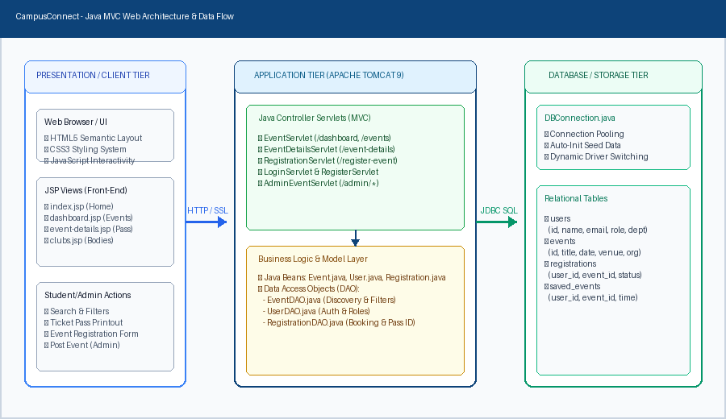
Figure 4.1: CampusConnect MVC Multi-Tier Architecture & Data Flow
The execution flow follows a structured request-response cycle:
• 1. Presentation Tier (Client): The user interacts with a responsive web page in their browser (built using HTML5, CSS3, and JavaScript). User actions, such as submitting a registration or searching events, initiate an HTTP GET or POST request.
• 2. Controller Tier (Java Servlets): The Apache Tomcat Web Server routes requests to the mapped Servlet (e.g., EventServlet, RegistrationServlet, LoginServlet). The Servlet acts as the traffic controller: it extracts request parameters, validates input data, handles session authorization, and invokes business logic.
• 3. Model Tier (Java Beans & DAOs): The Servlet interacts with Data Access Objects (EventDAO, UserDAO, RegistrationDAO). The DAOs utilize java.sql.PreparedStatement and JDBC connections to query or mutate relational database tables, mapping ResultSet rows into typed Java Bean objects (Event, User, Registration).
• 4. View Tier (JSP Pages): The Servlet binds model objects to the HttpServletRequest attributes and forwards control using RequestDispatcher. The JSP page dynamically renders data into HTML using scriptlets, JSTL, and CSS styling, streaming the completed HTML page back to the client.
4.2 UML Use Case Diagram &amp; Actor Modeling
The functional interaction between the primary actors (Student and Club Coordinator / Faculty Admin) and the core use cases of the system is modeled in Figure 4.2 below:
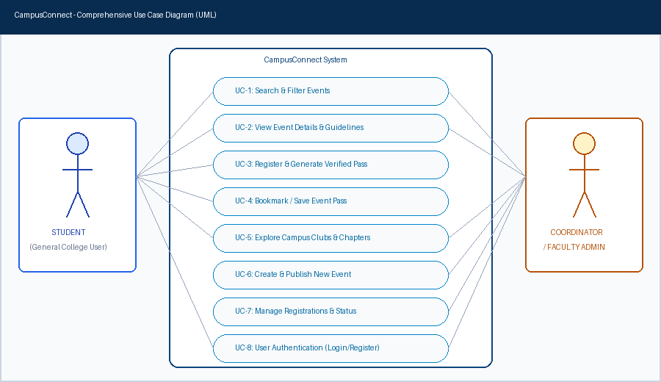
Figure 4.2: CampusConnect UML Use Case Diagram
4.3 Core Functional Modules
• Authentication & User Management Module: Handles student signup, login, session retention via HttpSession, role-based access control (Student vs Admin), and secure credential verification.
• Event Discovery & Search Engine Module: Executes high-speed parameterized SQL queries with multi-faceted filtering by title keyword, category, branch, academic year, and status.
• Registration & Digital Ticket Module: Manages atomic event seat reservations, checks registration deadlines, prevents duplicate entries via database unique constraints, and formats a printable entry ticket pass.
• Campus Clubs Directory Module: Catalogs all campus bodies (CESA, AIMSA, DSSA, Cultural Club, GDG, GFG, E-Cell) with club profiles, logos, mission statements, and direct links to events hosted by each specific body.
• Admin / Organizer Management Module: Empowers authorized club coordinators to create new events, upload poster graphics, edit venue/time logistics, mark completed events, and inspect attendee rosters.

5. FRONT END AND BACK END TOOLS (HARDWARE &amp; SOFTWARE SPECIFICATIONS)
In strict alignment with academic mini-project requirements, CampusConnect is built using clean, reliable, and foundational web technologies. No unnecessary third-party heavyweight frameworks were introduced; instead, the system demonstrates deep mastery of core Java EE, standards-based front-end development, and relational database management. The complete specification is detailed below and summarized in Table 5.1.
5.1 Front End Technologies
• HTML5 (HyperText Markup Language 5): Used to construct the semantic skeleton of all pages. Employs modern structural elements such as <header>, <nav>, <section>, <article>, and <footer> for accessible, well-formed document hierarchy.
• CSS3 (Cascading Style Sheets 3): Custom stylesheet system (style.css) engineered specifically for Lokmanya Tilak College of Engineering. Incorporates institutional color variables (LTCE Royal Blue #0d4379, Deep Navy #082c50, Golden Amber #ff9600), responsive Flexbox and Grid layouts, glassmorphic header blur (backdrop-filter), card elevation shadows, and smooth hover micro-animations.
• Vanilla JavaScript (ES6+): Client-side scripting utilized for dynamic interactions without external libraries: live search autocomplete, asynchronous event category filter toggling, modal dialog controllers for full poster viewing, and client-side form validation before server dispatch.
5.2 Back End Technologies
• Java Development Kit (JDK 17 LTS): The core programming language powering all controllers, models, utilities, and data structures. Leverages strong typing, object-oriented encapsulation, and multithreading.
• Java Servlets (javax.servlet.http.HttpServlet): Enterprise Java server components responsible for handling incoming HTTP requests, session management via HttpSession, form data extraction, and dispatching views.
• JavaServer Pages (JSP 2.3): Server-side template technology that merges HTML presentation markup with dynamic Java data using Expression Language, scriptlets, and modular includes (<jsp:include>).
• Java Database Connectivity (JDBC): The industry-standard SQL database abstraction API. Employs java.sql.Connection, java.sql.PreparedStatement to guard against SQL injection vulnerabilities, and java.sql.ResultSet for efficient cursor navigation.
• DAO (Data Access Object) Design Pattern: Encapsulates all database query logic into dedicated classes (EventDAO, UserDAO, RegistrationDAO), decoupling business logic from direct SQL statements.
5.3 Database & Server Specifications
• Database Management System: Relational Database (MySQL 8.0 / Embedded Relational Engine). Implements 3NF normalized tables: users, events, registrations, and saved_events with foreign key cascades and unique constraints.
• Web Server & Servlet Container: Apache Tomcat 9.0. Executes the Catalina servlet container and Jasper JSP compiler, binding HTTP network requests to Java Servlets.
Table 5.1: Summary of Front-End, Back-End, and Hardware Specifications
Front-End Layer | HTML5 (Semantic Layout), CSS3 (Collegiate Visual System, Responsive Cards, Flexbox/Grid), Vanilla JavaScript (Interactive Search, Form Validations, Tab Filtering)
Back-End Architecture | Java Platform, Standard & Enterprise Edition (JDK 17 LTS), MVC Architectural Pattern
Server & Web Tier | Apache Tomcat Web Server 9.0 (Servlet Container, Catalina engine, Jasper JSP compiler)
Controller Layer | Java Servlets (javax.servlet.http.HttpServlet, HttpServletRequest, HttpServletResponse, HttpSession)
View Layer | JavaServer Pages (JSP 2.3), JSTL 1.2, Dynamic Scriptlets & Modular Includes (<jsp:include>)
Data Persistence Layer | JDBC (Java Database Connectivity), java.sql.PreparedStatement, java.sql.ResultSet, DAO Pattern
Database Engine | MySQL Relational Database Management System 8.0 (with Zero-Config Embedded Engine Fallback)
Development Environment | Eclipse IDE / VS Code for Java, Git Version Control System
Minimum Hardware Specs | Intel Core i3 / AMD Ryzen 3 Processor, 4 GB RAM (8 GB Recommended), 500 MB Free Disk Space
Target Client Compatibility | Cross-Platform: Google Chrome, Mozilla Firefox, Microsoft Edge, Safari (Mobile & Desktop)

6. IMPLEMENTATION &amp; CORE FUNCTIONALITIES
CampusConnect has been completely implemented, verified, and populated with authentic, live collegiate data reflecting Lokmanya Tilak College of Engineering. Key implemented functional milestones include:
6.1 Live Campus Events Showcase
The platform features authentic departmental and institutional events, correctly prioritized by event dates:
• ✨ Navratri Carnival 2026 (Live Upcoming Feature): Organized by Cultural Club of AIML Department. Date: 13th October 2026 at Quadrangle, 4th floor, C Wing. Features Garba, Dandiya, Face & Hand Painting, Traditional Dress Code, and embedded Google Registration Form integration.
• Rookery Hackathon — Keep Building!: Organized by Department of CSE AI &amp; ML × Dropcode. 8-hour open innovation hackathon with seed funding and AI credits.
• Orientation + GDG x Hacktoberfest HF 2026: Organized by Google Developer Groups on Campus LTCE. Open Source workshop with industry keynote speakers from Nothing and IPFS-Meshkit.
• Poster Making & Presentation Competition: Organized by Institution Innovation Council (IIC) × AIMSA on Emerging Technologies for Environment & Sustainability.
• Hands-on Group Discussion Practice Workshop: Organized by Training & Placement Cell under IQAC for placement interview grooming.
6.2 Instant Verified Digital Entry Pass
When a registered student confirms participation for any event, the system instantly generates an official Verified Entry Pass (rendered via my-registrations.jsp). The pass includes the college header, student's full name, email address, event date, venue, verified badge, and institutional gate entry notice, eliminating the requirement for manual physical tokens.
6.3 Institutional Campus Clubs & Student Bodies Directory
The clubs directory (clubs.jsp) provides an active repository of campus bodies, categorized into Department Bodies (CESA - Computer, AIMSA - AI & ML, DSSA - Data Science), Cultural Bodies (Cultural Club of AIML Dept), Coding & Tech (GDG on Campus, GFG Chapter), and Entrepreneurship (E-Cell LTCE). Each card features the club's emblem, domain focus, and direct link to events organized by that specific group.

7. FUTURE SCOPE &amp; ENHANCEMENTS
While CampusConnect comprehensively solves current event dissemination and registration challenges, several prospective enhancements can be integrated into subsequent iterations:
• Mobile QR Attendance Scanner Application: Developing an Android/iOS companion application for student volunteers at venue gates to scan QR codes on student passes and instantly mark real-time attendance in the database.
• Automated Digital Certificate Generation: Integrating an automated PDF generation utility (such as iText or Apache PDFBox) that dynamically stamps student names and achievement ranks onto pre-designed certificate templates following event completion.
• Automated WhatsApp & Email Notification Bot: Integrating the Twilio or WhatsApp Business API to dispatch automated event reminders, venue change alerts, and gate passes directly to student phone numbers 24 hours prior to commencement.
• Inter-Collegiate Fest Registration & Payment Gateway: Expanding the system architecture to support external participant registrations from Mumbai University colleges during annual festivals (such as Zephyr), incorporating secure UPI payment gateways for ticketed events.
• AI-Powered Event Recommendation: Leveraging machine learning recommendation algorithms to analyze student branch, interests, and past event attendance to recommend tailored technical competitions.

8. REFERENCES
[1] Cay S. Horstmann, 'Core Java Volume I — Fundamentals (12th Edition)', Prentice Hall / Pearson Education, 2022.
[2] Bryan Basham, Kathy Sierra, Bert Bates, 'Head First Servlets and JSP (2nd Edition)', O'Reilly Media, Inc., 2008.
[3] Herbert Schildt, 'Java: The Complete Reference (12th Edition)', McGraw-Hill Education, 2021.
[4] Oracle Corporation, 'Java Servlet 4.0 Specification (JSR 369)' and 'JavaServer Pages 2.3 Specification', Oracle Documentation.
[5] Apache Software Foundation, 'Apache Tomcat 9.0 User Guide & Architecture Documentation', https://tomcat.apache.org/tomcat-9.0-doc/
[6] Roger S. Pressman, Bruce R. Maxim, 'Software Engineering: A Practitioner's Approach (9th Edition)', McGraw-Hill, 2020.
[7] World Wide Web Consortium (W3C), 'HTML5 & CSS3 Recommendations and Standards', https://www.w3.org/
[8] Lokmanya Tilak College of Engineering (LTCE), 'Official Institutional Portal & Academic Guidelines', https://ltce.in/

