**Effect of E-sports on Smartphone Purchasing**

1. **Abhishek Ranjan**

Department of Metallurgical and Materials Engineering, Indian Institute of Technology Roorkee**,18118004**

1. **Swapnil Kumar**

Department of Metallurgical and Materials Engineering, Indian Institute of Technology Roorkee**,18118073**

1. **Arunav Raj**

Department of Metallurgical and Materials Engineering, Indian Institute of Technology Roorkee**, 18118015**

1. **Ayush Uttam**

Department of Metallurgical and Materials Engineering, Indian Institute of Technology Roorkee**, 18118019**

1. **Shubham Kumar**

Department of Metallurgical and Materials Engineering, Indian Institute of Technology Roorkee**,18118066**

**Contents**

Abstract

1. Introduction
2. Objective
3. Literature review
   1. Factors influencing customer's intention to purchase Smartphone
      1. Price
      2. Product feature
      3. Brand name
      4. Social influence
      5. Gaming performance
4. Hypothesis
5. Research Methodology
   1. Sampling
   2. Scale
   3. Data Preparation
   4. Data Analysis
   5. Hypothesis testing
6. Conclusion

References

**Abstract**

The present study explores the effects of e-sports/mobile Gaming on consumers' purchasing intention of smartphones. The study also attempts to determine any significant difference between male and female responses concerning the factors (Gaming performance, Product Features, Price, Brand name, and Social Influence), which generally affect consumers' purchase of Smartphone.

Methods: Data was collected through a structured questionnaire developed from previous studies, on a 5-point Likert scale, rank-order scale. A sample of 200 respondents was selected from among the IIT Roorkee students and some of our hometown friends using a non-probabilistic sampling technique.

Hypothesis testing methods such as Multivariate Analysis of Variance (MANOVA), analysis of variance (ANOVA) used to determine the relationship between the factors mentioned above, and purchase intention. Chi-square was applied to compare the responses of male and female consumers on the above factors.

Keywords: Likert Scale, ANOVA, MANOVA, Chi-Square

**1. Introduction**

The smartphone ecosystem has changed so much in the past five years, and we have come to the point where mobile devices have become so unique and differentiated. Today there are so many varieties of smartphones one can ever think of. There are thousands of manufacturers churning out devices, and almost on a daily basis, new phones are launched. These days, choosing a smartphone is difficult. This is a difficult task for first-time users already, but it is even more tedious for those accustomed to smartphones.

Selecting the specifications we want is one thing, then balancing it with our budget could yet be something else entirely. Confusion might set in, and we will be stuck for months trying to figure out the best phone to buy. You can see a feature one phone comes with, and then you wish another phone would have the same feature. If possible, I know most of us would pick up features from many phones to build our own phone. If wishes were horses... Sadly, there's no such thing as a perfect phone, so we eventually settle for something and give up the rest.

The first surge in the smartphone sale was noticed after Jio gave the free 4G data for 12 months in 2016. With the sudden overflow of free 4G data to the consumers, Indian teens started exploring mobile Gaming. Then **PUBG** came into the picture, the most significant player in mobile Gaming. Now PUBG has become a synonym for E-sports in India. But, people don't know that the esports industry is more than a decade old and has just shot up in India in the past few years, with more developers and investors jumping into the sector. The Esports industry is changing people's behaviors, especially young adults; however, surveys that have been carried out are still insufficient. There is a lack of understandings on the **behavior of the gamers and their preferences towards smartphones**. In addition, the industry of mobile phones always showed drastic and tremendous changes. New Smartphone models are launched to the market from time to time to gain a competitive advantage in the market.

As the Smartphone market is growing rapidly, understanding consumer behavior regarding consumers' characteristics in influencing their buying behavior is crucial. By understanding the consumer behavior of Smartphone purchasing, this study is very significant to a wide spectrum of many industries related to the Smartphone to bring a real-life change in the marketing mix and marketing strategy as per the characteristics of consumers to enhance their sales.

One of the most sought after features when buying a smartphone today is **"Isme game bahut achha chalta hai?".** Responding to the demand, a handful of smartphone brands in India offer gaming-dedicated phones like ASUS ROG Phone, Nubia Red Magic series, and Black Shark. Qualcomm Snapdragon and MediaTek had recently released gaming-dedicated chipsets for smartphones — Snapdragon 732G and Helio G95.

**2.Objective**

The present study tries to achieve the following objectives:

1. To explore the difference in purchasing intention of smartphones of a gamer and non-gamer.

2. To explore the factors affecting consumer's purchasing intention of Smartphones.

3. To find out if there is any significant difference between the male and female consumers in their response towards the factors affecting consumer's Smartphone purchasing.

**3.Literature**

The history of E-Sports in India has been widely undocumented. That's because there isn't one to speak of. From the outside, the Indian gaming community seems to be made of children, haplessly whiling away time on video games. The past decade has been a pivotal time for **competitive Gaming** as it began capturing the global market's attention in recent years. Still, no country has made remarkable progress as fascinating and as appealing as the Indian gaming scene. From $253.6 million in-game revenues in 2014, it gradually picked up speed to an astounding $1.1 billion in 2019 and is predicted by Statista to double its pace by this year with a $2.4 billion projection. As a matter of fact, the leading company in games and esports analytics, Newzoo, reported that India has now secured the second spot next to China in the top list of countries with most smartphone users, thereby accounting for 345,916,000 users with a 25.3% smartphone penetration rate. For India, this means a more significant market brimming with so much untapped potential.

This widespread use of mobile phones can be attributed mainly to lower price tags and more affordable data plans primarily driven down by stiff market competition among India's mobile phone manufacturers. In turn, more people were able to own a mobile device, and an internet connection has also been more accessible than ever. India is going to be one of the first few markets this year where the introduction of the 5G cellular network is underway, so that is another thing to watch out for. So, 5G smartphone with better hardware specifications can lure the young population of 2020. As technology became more obtainable and convenient, more Indians were drawn to play on their mobile devices, thus sparking the public's interest in competing in virtual games eventually. PUBG Mobile, for instance, created a name for itself when it launched in India in March of 2018. Almost immediately upon its release, it garnered a massive sum of loyal following.

**3.1. Factors influencing customer's intention to purchase Smartphone**

The present study tries to find out the factors which affect consumer's intent to buy a Smartphone. According to (Moschis 1976), **"Consumer behavior is affected by a lot of variables, ranging from personal motivations, needs, attitudes and values, personality characteristics, socioeconomic and cultural background, age, sex, professional status to social influences of various kinds exerted by family, friends, colleagues, and society as a whole."** Various factors have been found in reviewing the relevant literature, influencing consumers' intention while purchasing a Smartphone.

**3.1.1. Price:**

Price is one of the most important factors which affect the consumer's choice to purchase a particular product. According to the Law of Demand, as the commodity price increases, the demand for the same decreases.

**3.1.2. Product Features:**

The feature is an attribute of a product to meet the satisfaction level of consumers' needs and wants by owning the product, usage, and utilization of a product. Nowadays, there are many high technology features of smartphones in the market. Thus, different people will choose different features of smartphones that can meet their needs and desires. Smartphones nowadays are being featured with multimedia presentation and capture, high-resolution displays, several gigabytes of storage and location, and movement sensors.

**3.1.3. Brand Name:**

Customers will always find ways to differentiate themselves from others, especially in the smartphone industry that keeps changing the technology. Organizations have to find new technology that is not available in the market and meet the customers' demand. The brand name can be an identity and exclusivity that represent the organization. A brand name can be a name, term, symbol, and design to differentiate the organization from the competitors. Most customers emphasize brand names that can be an invaluable asset to their products and services. This can be a competitive advantage for the organization.

**3.1.4. Social Influence:**

Social influences mean one person causes another to change his/her feelings, attitudes, thoughts, and behavior, intentionally or unintentionally. It is due to the interaction with other people that know each other such as parents and peers. Media, parents, and peers would influence consumers to purchase smartphones.

**3.1.5. Gaming Performance:**

Since eSports is all about online Gaming, then your Internet connection speed is obviously a great starting point to ensure a good gaming experience. **"**Remember the time there is a lag between the action in the game and the time it is displayed on your screen?**"** For your gaming avatar, this can prove to be fatal. Another scenario could be participating in a multiplayer game, but you have a high ping rate, your competitor's action will register faster than yours. Your chances of winning take a significant hit. To get your speed right is more than just picking the right hardware.

**4.Hypothesis**

1. **H1:** There is a significant relationship between being an E-Sport Enthusiast and giving preference to particular features (Camera, Display, Battery, Processor, Ram-storage) while smartphone purchasing.
2. **H2:** There is a significant relationship between being an E-sports Enthusiast and giving preference to Brand/Budget/Product-features/Social-influence/Gaming-performance while smartphone purchasing.
3. **H3:**  Females are generally not interested in E-sports.
4. **H4:** E-sports Enthusiast are ready to compromise with essential features like (Camera, Display, etc.) for better gaming performance in the Smartphone

**5.Research Methodology**

This study used a survey questionnaire as the primary data source. We formed a set of questions and got it filled by the target audience. The response from the target audiences is our data source for the study. Our respondents were mainly of the age group between 16-25. This research primarily draws conclusions for the young population. This is because the younger generation is generally more involved in Gaming or e-sports. We don't see much from the other generation, i.e., from age group 30-40 or 40-50; this may be because the other peoples are working peoples. They don't get enough time for these activities. The younger generation research more before replacing their mobiles to get the best in their budget while the other generation doesn't think too much apart from one or two things, mainly budget.

**5.1. Sampling:**

We used Snowball sampling, which is one of the non-probabilistic technique. We simply floated our questionnaire among our friends and acquaintances and asked them to further spread it in their network. This way, we collected a total of 220 samples. After data cleaning, 200 were finally used for hypothesis testing.

**5.2. Scale:**

Data is collected on a nominal, 5-point Likert scale and rank-order scale.

**5.3. Data preparation:**

The primary data obtained from respondents was further cleaned. We removed null values, outliers, and those responses which were not filled with care or randomly filled so that they don't deviate our analysis. We encoded the column name for better analysis our data. Reference of our column name is present column_ref.txt file.

**5.4. Data analysis:** 100 responses each of gamers and non-gamers were taken and then used 'IBM SPSS Statistics Version 27.0' software for both descriptive and inferential analysis.

The objectives of data analysis are getting a feel for the data (descriptive analysis), testing the goodness of the data (scale measurement), and testing the hypothesis develop for the research (inferential analysis).

**Some descriptive analysis: -**

**Major activities on a smartphone**

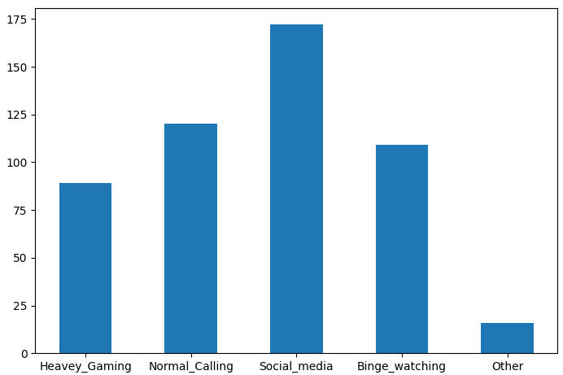

**Female respondents**

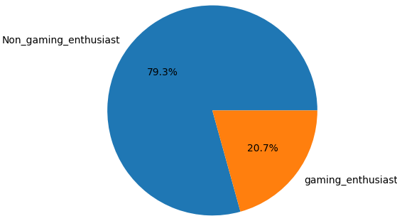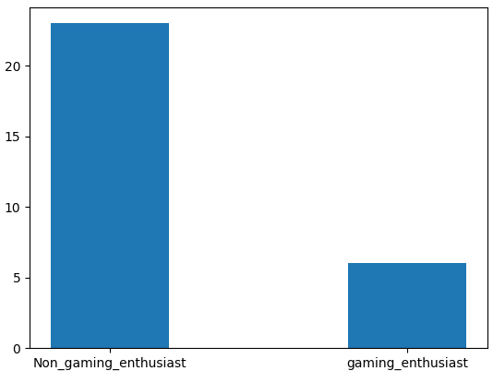

**Male Respondents**

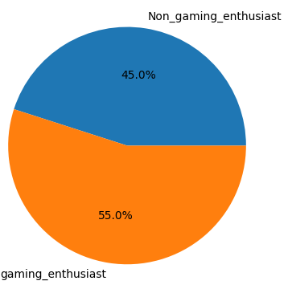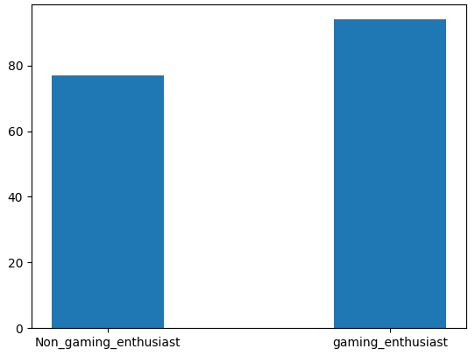

**5.5. Hypothesis Testing**

There are lots of hypothesis technique are available. Choosing the best fit technique for our data type was a tedious task. We followed this flow chart to select the hypothesis testing technique to be applied.

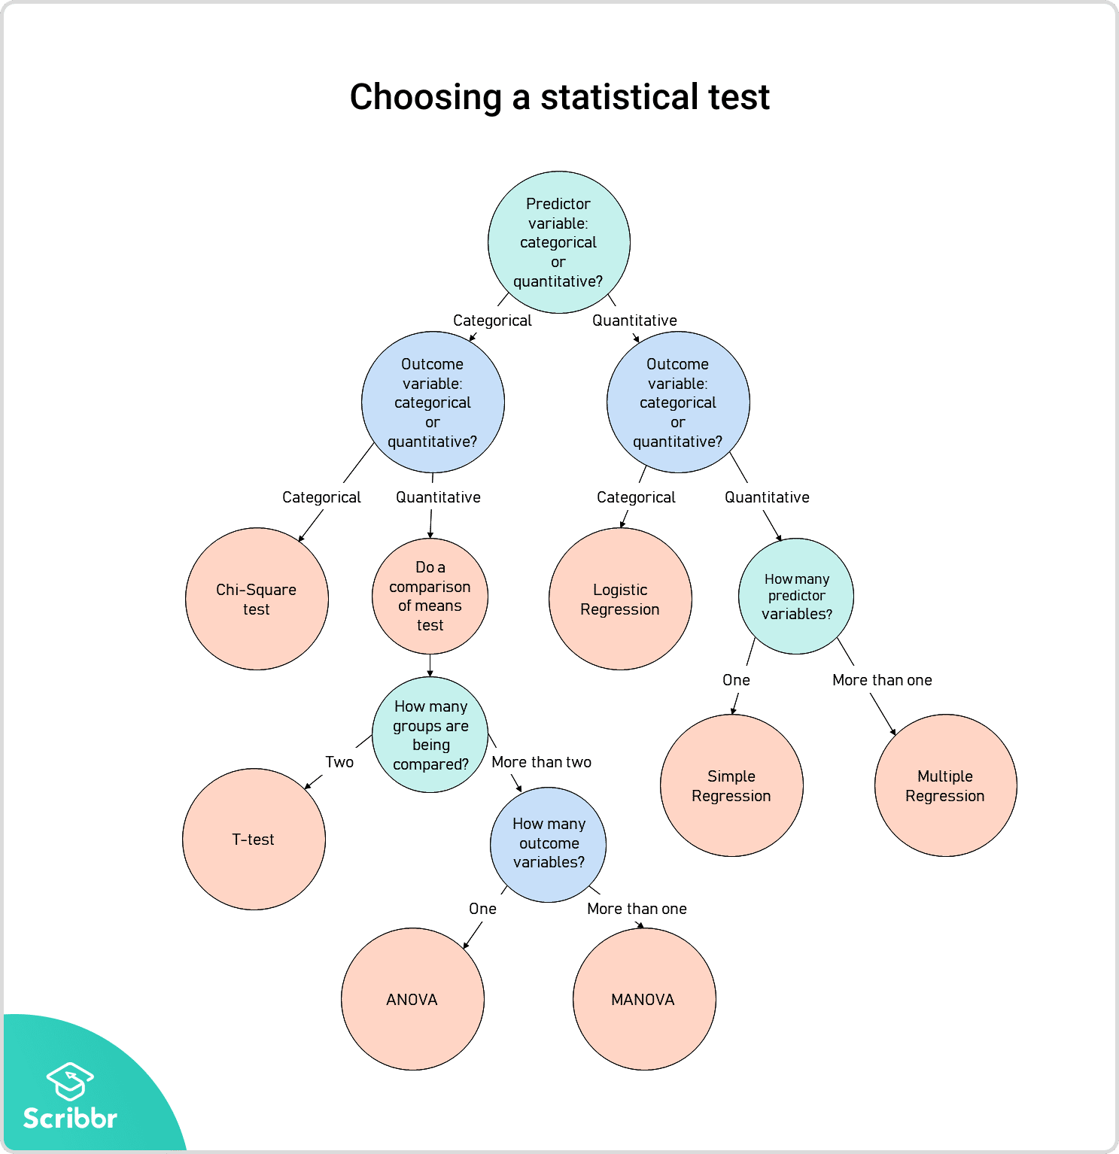

Here the independent variable is named Predictor, and the dependent variable is called outcome variable. We have used Parametric tests such as ANOVA, MANOVA, as well as Non-Parametric tests such as the Chi-Square test. Although ANOVA and MANOVA can be applied only with continuous independent variables, we have collected ordinal data on the Likert scale. But after reading some research papers, we found some relevant references which are evident that Likert scale can be applied on ANOVA and MANOVA. Whether we use ANOVA for Likert scale items depends on our general attitude towards averaging Likert scale items. And Here In our dataset, it doesn't seem to us any issue with averaging out Likert scale.

**H1:**

There were 1 Independent variable (Gaming Enthusiast) and 5 dependent variables (Camera, Display, Battery, Processor, Ram-storage). Therefore, we used MANOVA testing for this.

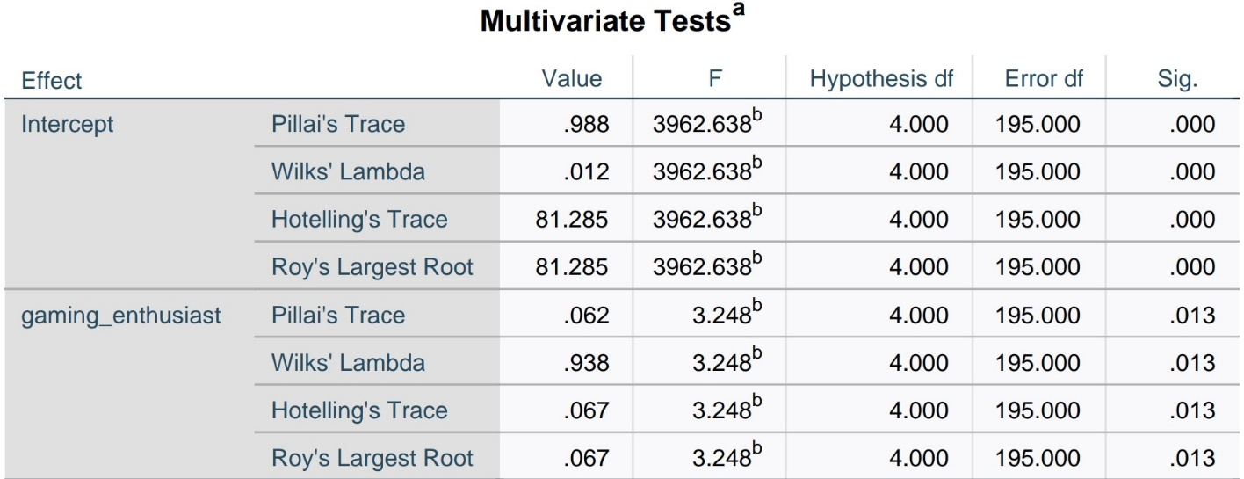Wilk's Lambda distribution was used for interpretation. There was statistically significant difference on features preference based on whether person is gaming enthusiast or not as p-value (0.013) < 0.05 and F-score (4,195) = 3.24 > 2.37. Hence, we will reject the null hypothesis.

**H2:**

There were 1 Independent variable (Gaming Enthusiast) and 5 dependent variables (Brand, Budget, Product-features, Social-influence, Gaming-performance). Therefore, we used MANOVA testing for this.

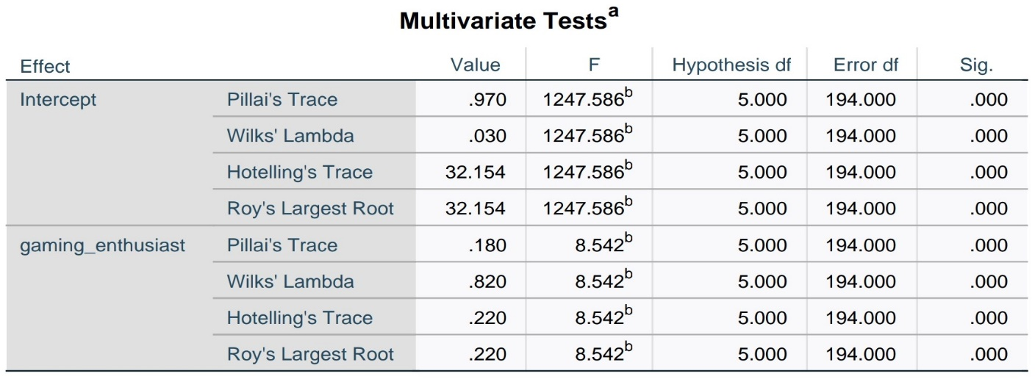

Wilk's Lambda distribution was used for interpretation. There was statistically significant difference on whether the person gives preference to Brand, Budget, Product-features, Social-influence, or Gaming-performance while smartphone purchasing based on whether he is a gaming enthusiast or not as p-value < 0.05, F-score (5,194) = 8.542 which is greater than F-statistic (2.2141). Hence, we will reject the null hypothesis.

**H3:**

There were 1 independent (Gaming Enthusiast) and 1 dependent (Gender). Both were nominal variables. Hence, we used the Chi-Square test.

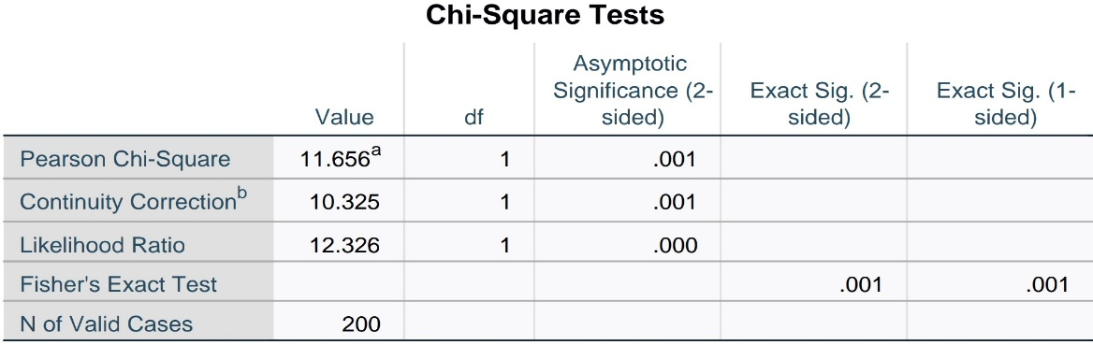

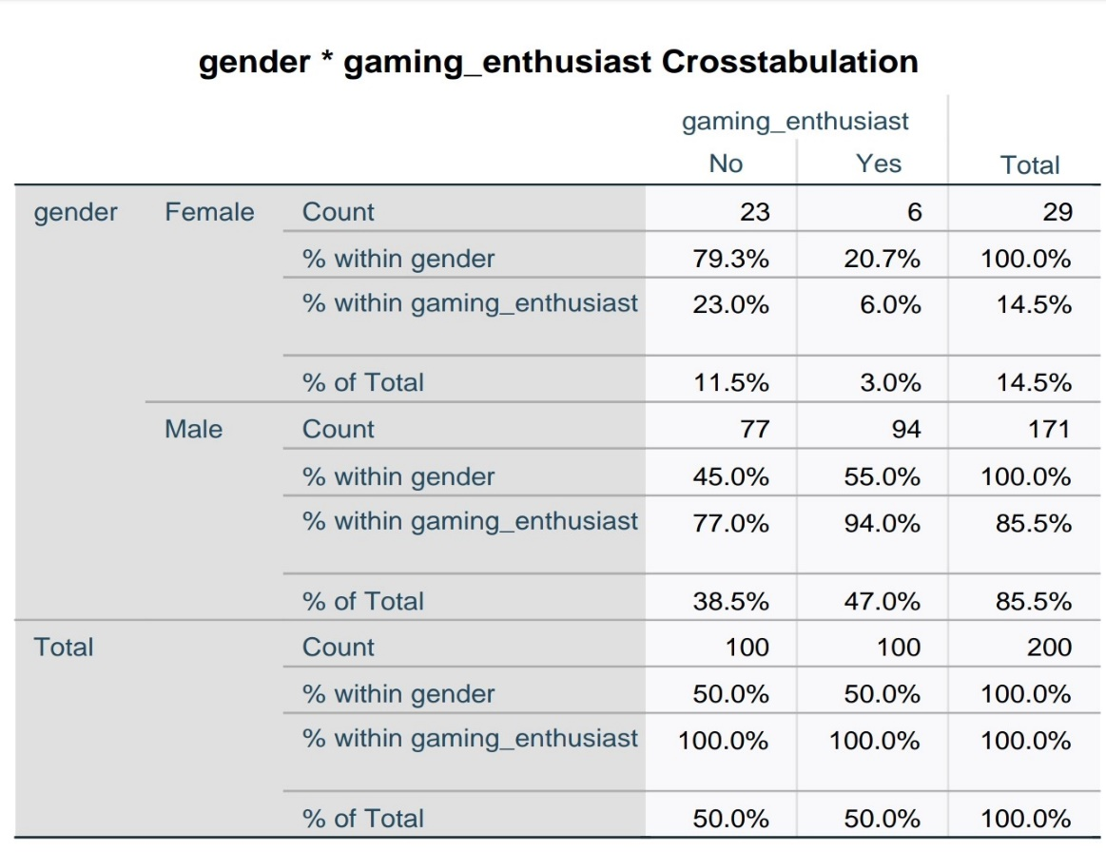

There was statistically significant difference in the Gaming Enthusiast nature of person based upon their Gender as Pearson Chi-Square (1,0.05) =0.001, which is less than 0.05. Hence, we will reject the null hypothesis.

**H4:**

There were 1 independent (Gaming Enthusiast) and 1 dependent variable (launch_gamingphone_compromising_basicfeatures). Therefore, we used ANOVA testing for this.

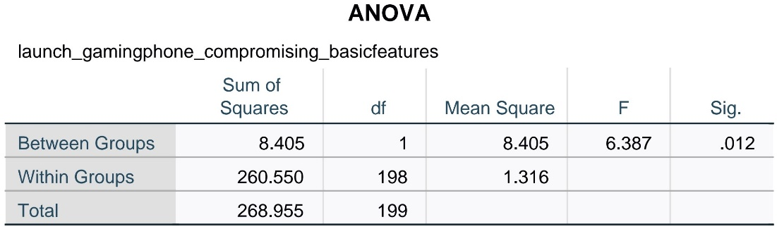

There was statistically significant difference whether the person is ready to compromise basic features of Smartphone for excellent gaming performance based on whether he/she is a gaming Enthusiast or not as P-value (0.012) < 0.05 and F-score (1,198) = 6.387 which is greater than F-statistic (3.8415). Hence, we will reject the null hypothesis.

**6.Conclusion**

This study aimed to understand the behavior of gamers and their preferences towards smartphones. Specifically, this study tried to determine the difference in E-sports enthusiasts' smartphone purchasing intention and others. Data were collected from 220 respondents. Four hypotheses were presented to test the relationship between independent variables (Gaming Enthusiast) and various dependent variables. In all, the four null hypotheses were rejected.

From H1, it was confirmed that Camera Quality is more preferred feature by Non-Gaming Enthusiast. And For other features like Battery, Display, Processor, Ram, and storage there was no significant difference observed based on the Gaming Enthusiast variable. From H2, it was confirmed that gaming performance affects Gaming Enthusiast positively. And for the brand name, budget, social influence, there was no significant difference observed based on the Gaming Enthusiast variable. As suggested by H3, there is a significant relationship between being a gaming enthusiast and gender of the person. It was observed that females are slightly less interested than males.H4 suggests that the gaming enthusiast tends to compromise basic features for getting better gaming performance.

The above study indicated that smartphone manufacturers should focus on the Gaming performance of the phone. It is also predicted by Statista that the Indian E-sports Industry would reach 120 billion by 2023. Hence, Gaming specific smartphones will be the cash cow in the upcoming years.

**References**

[1] [P.Mean: Use of Likert data with ANOVA (created 2009-10-13)](http://www.pmean.com/09/LikertAnova.html)

[2] [Choosing the Right Statistical Test | Types and Examples (scribbr.com)](https://www.scribbr.com/statistics/statistical-tests/)

[3] [Factors Influencing Purchasing Intention of Smartphone among University Students - ScienceDirect](https://www.sciencedirect.com/science/article/pii/S2212567116301216)

[4] [Nagarkoti_Bishal.pdf (theseus.fi)](https://www.theseus.fi/bitstream/handle/10024/70466/Nagarkoti_Bishal.pdf)

[5] [The Exemplary Growth Of ESports In India | Inventiva](https://www.inventiva.co.in/trends/the-exemplary-growth-of-esports-in-india/)

[6] [What Made Choosing Your Smartphone so Hard? (xda-developers.com)](https://www.xda-developers.com/what-made-choosing-your-smartphone-so-hard/)

[7] [More Than Just Games – The Rise Of India's Esports Industry - Homegrown](https://homegrown.co.in/article/803783/more-than-just-games-the-rise-of-indias-esports-industry)

[8] [With ESL, the history of eSports in India may have just begun | Digit](https://www.digit.in/features/gaming/the-history-of-esports-in-india-may-have-just-begun-30588.html)

[9] [2020 Gaming Industry Statistics, Trends & Data (Biggest Study) (gamingscan.com)](https://www.gamingscan.com/gaming-statistics/)