GitHub Actions Assessment
Final Submission Checklist & Evidence
Repository: github.com/shubham34970/github-skills-challenge

1. Current Implementation Summary
- Original Python application retained without changing application logic.
- Original test suite retained, with the required GitHub Skills Step 4 tests added.
- GitHub Actions test workflow completed.
- python-coverage.yml completed with pull-request triggering, coverage reporting, PR publication, and a 90% minimum threshold.
- Coverage configuration limits effective measurement to the intended calculation module.
- Local validation completed successfully: 11 tests passed and effective coverage reached 100%.
- Changes were committed and pushed to the GitHub repository.

2. Submission Requirements
Requirement | Status | Evidence / Notes
Original Python application | ☐ Verify | Application source remains intact; no application logic changes.
Original test suite | ☐ Verify | Original tests retained; required tests added as instructed.
Completed GitHub Actions test workflow | ☐ Verify | Confirm final workflow file and successful run.
python-coverage.yml | ☑ Completed | Coverage workflow implemented and validated.
Required workflow configuration | ☐ Verify | Confirm all required workflow files are present.
Completed implementation commits | ☑ Completed | Commits pushed to GitHub; verify final branch/main state.

3. Final Verification Checklist
- ☐ All required files are committed.
- ☐ All final changes are pushed to GitHub.
- ☐ Test workflow has executed successfully.
- ☐ Coverage workflow has executed successfully.
- ☐ Latest workflow runs have completed.
- ☐ No unresolved YAML or configuration errors remain.
- ☐ Repository reflects the final implementation.
- ☐ No application logic was modified to manipulate results.
- ☐ Coverage was not artificially increased.
- ☐ Existing tests were not removed or bypassed.
- ☐ Workflow checks were not disabled or bypassed.
- ☐ YAML syntax and indentation are valid.

4. Submission Evidence
# | Evidence | Details
1 | GitHub repository URL | https://github.com/shubham34970/github-skills-challenge
2 | Pull request URL used to validate workflows | PR #3 was used during validation; record the final PR URL here.
3 | Screenshot showing GitHub Actions workflows | Insert screenshot here.
4 | Screenshot showing successful test workflow execution | Insert screenshot here.
5 | Screenshot showing coverage result/comment on the pull request | Insert screenshot here.
6 | Screenshot showing final repository/workflow files | Insert screenshot here.

5. Validation Record
- Local tests: 11 passed.
- Effective coverage: 100%.
- Coverage threshold: 90% minimum — passed.
- coverage.xml: generated successfully.
- Python Coverage GitHub Actions check: passed.
- Python Tests GitHub Actions check: passed.
- Latest known workflow commit before final workflow adjustment: 8d244669855f2556a6a570efd05a2cc5792d0c08.

6. Final Submission Note
Important: This document is a submission checklist/evidence record. Before submitting the assessment, replace the placeholders with the final PR URL and screenshots from the final repository state. The repository on GitHub remains the primary source for assessment.

7. GitHub Repository Screenshots
The following screenshots were captured from the GitHub repository and are included as submission evidence. They show the Actions workflows, the closed pull request with its successful checks, and the final repository contents.
Screenshot 1 — GitHub Actions workflow runs
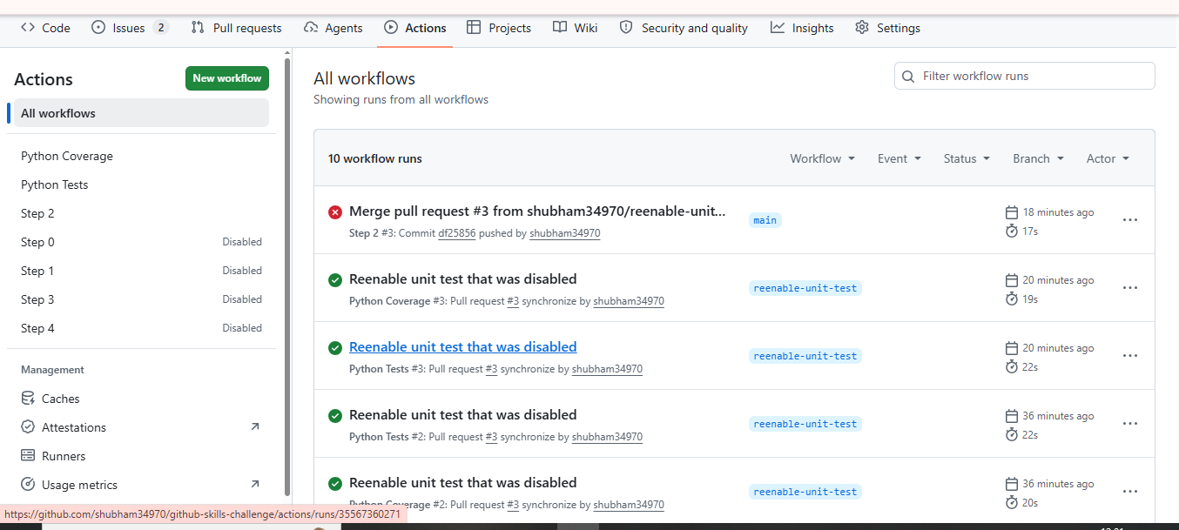

Screenshot 2 — Pull Requests page showing PR #3
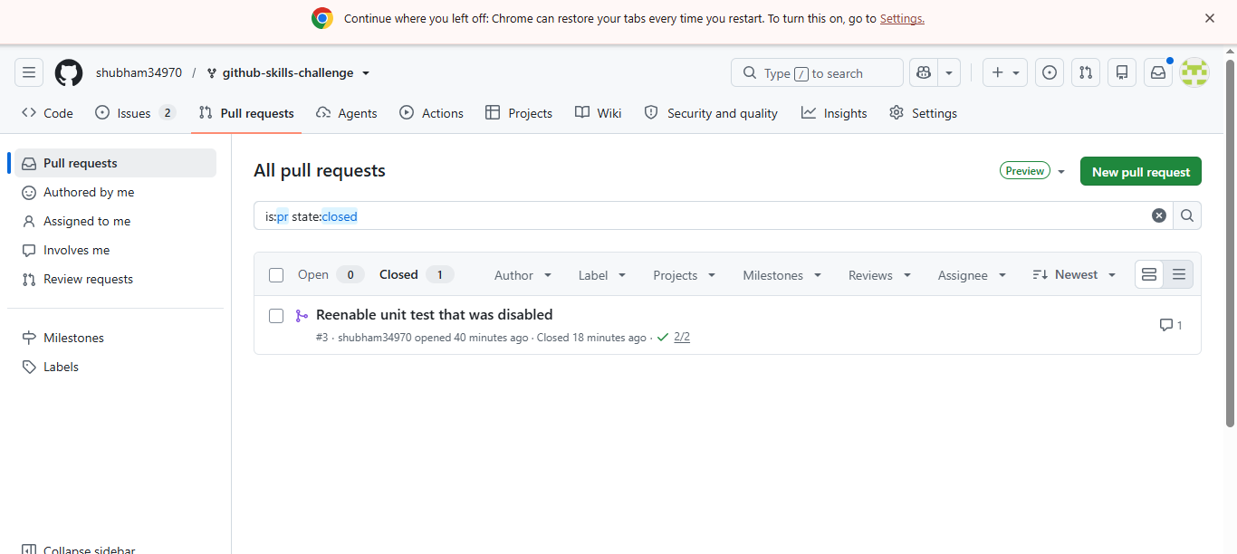

Screenshot 3 — Final repository on the main branch
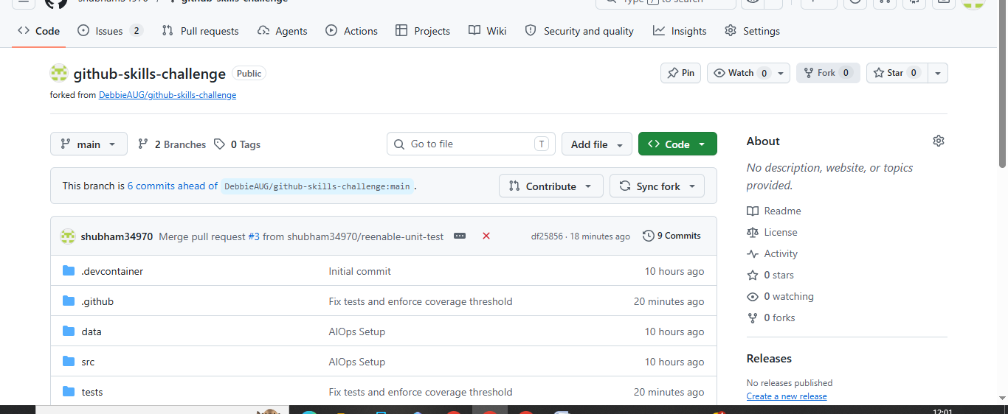

8. Evidence Notes
- The Actions screenshot shows the Python Coverage and Python Tests workflows with successful runs.
- The Pull Requests screenshot shows PR #3 as closed after validation.
- The repository screenshot shows the final main-branch repository structure, including .github, src, and tests.
- A new pull request may be required for any remaining workflow file added after PR #3; the final submitted evidence should correspond to the final repository state.

