COMFYUI PRACTICAL ASSIGNMENT
Dance Video with Wan Animate
A motion-transfer case study built around a current 1980s throwback-photo aesthetic, a familiar Bollywood nostalgia cue, and a fully ComfyUI-native animation workflow.

Assignment Brief

Task 5 — Dance Video with Wan Animate (ComfyUI Only)
Use ComfyUI exclusively to create a video of yourself dancing on a reference video using the Wan Animate workflow.
Deliverables
- Reference video used
- ComfyUI workflow screenshot or exported JSON
- Final output video
Evaluation Criteria
- Motion quality
- ComfyUI workflow understanding
- Output smoothness
Submission Format
Submit a Google Doc containing:
- Your name and the tasks chosen
- For each task: output file/link and a screen recording of the process
- An explanation of the process

Submission Links
Reference video: youtube.com/shorts/92172gsa-DI
Final ComfyUI output: youtube.com/shorts/S8OCs0qX4ic
Workflow files (Google Drive): drive.google.com/drive/folders/1RvZjyKK35_JubhAyUYHsgs6MHbvl6s4_

01 Creative Direction

From the 80s photo wave to moving pictures
The current throwback-photo wave gives the project its visual starting point: a recognisably modern person is reimagined through retro styling, colour, lighting and period-film character. The assignment then pushes the idea one step further. Instead of stopping at a still image, the character is made to move using Wan Animate.
That creates a clean narrative for the submission: establish the character, choose a culturally familiar dance reference, then use ComfyUI to transfer the movement while keeping the character's appearance anchored.

Why Bachna Ae Haseeno?
The song was chosen as the cultural bridge. The title track used for the 2008 film revisits the name and musical identity of the 1977 Hum Kisise Kum Naheen original. That gives the project a useful nostalgia loop: an older Bollywood memory was reworked for a later generation, and this project reinterprets that memory again through a modern AI motion-transfer workflow.
Bachna Ae Haseeno was selected because the nostalgia is immediately legible. The song connects the visual throwback concept to a recognisable Bollywood reference without requiring the technical workflow to carry the entire story.
The project in one line: a present-day character enters a retro visual frame, then moves through a familiar Bollywood dance reference, recreated entirely inside ComfyUI.

02 Inputs
Wan Animate separates what the character looks like from how the character moves. The reference image supplies identity and appearance. The reference video supplies the motion sequence.

Reference video
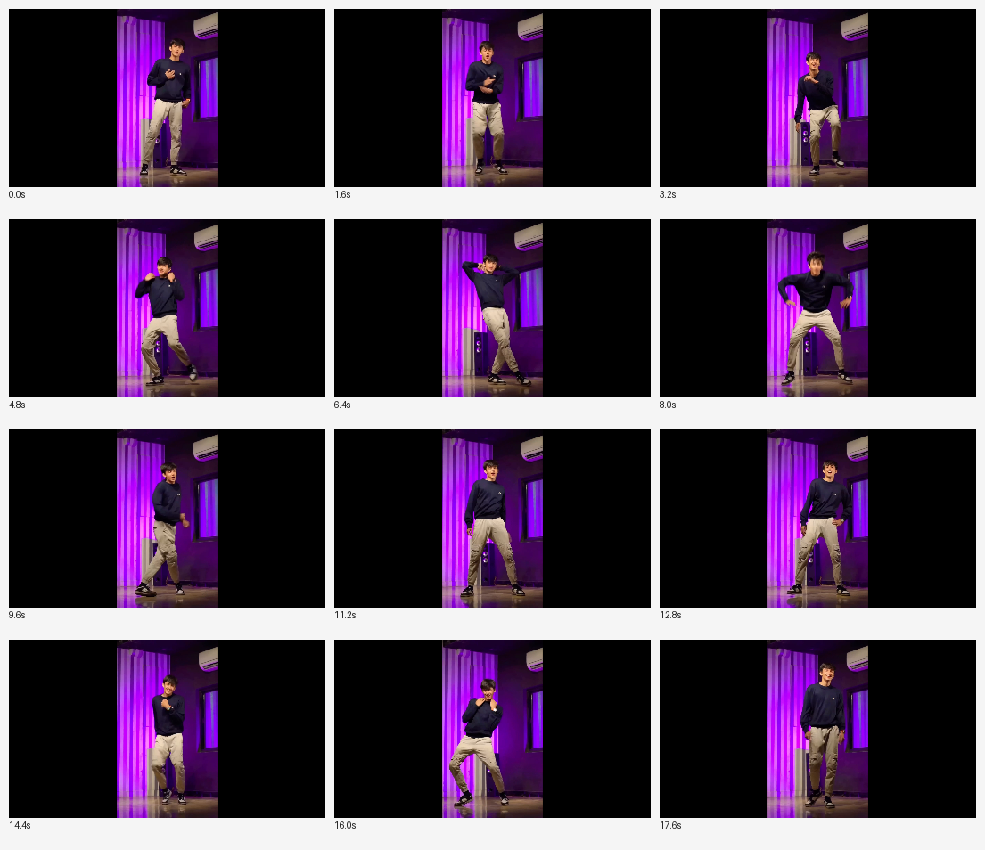
Updated reference video used for the motion-transfer stage.
Sourced as a vertical YouTube Short (linked above) and used purely as the motion source: it supplies pose and timing, not appearance.

Character reference
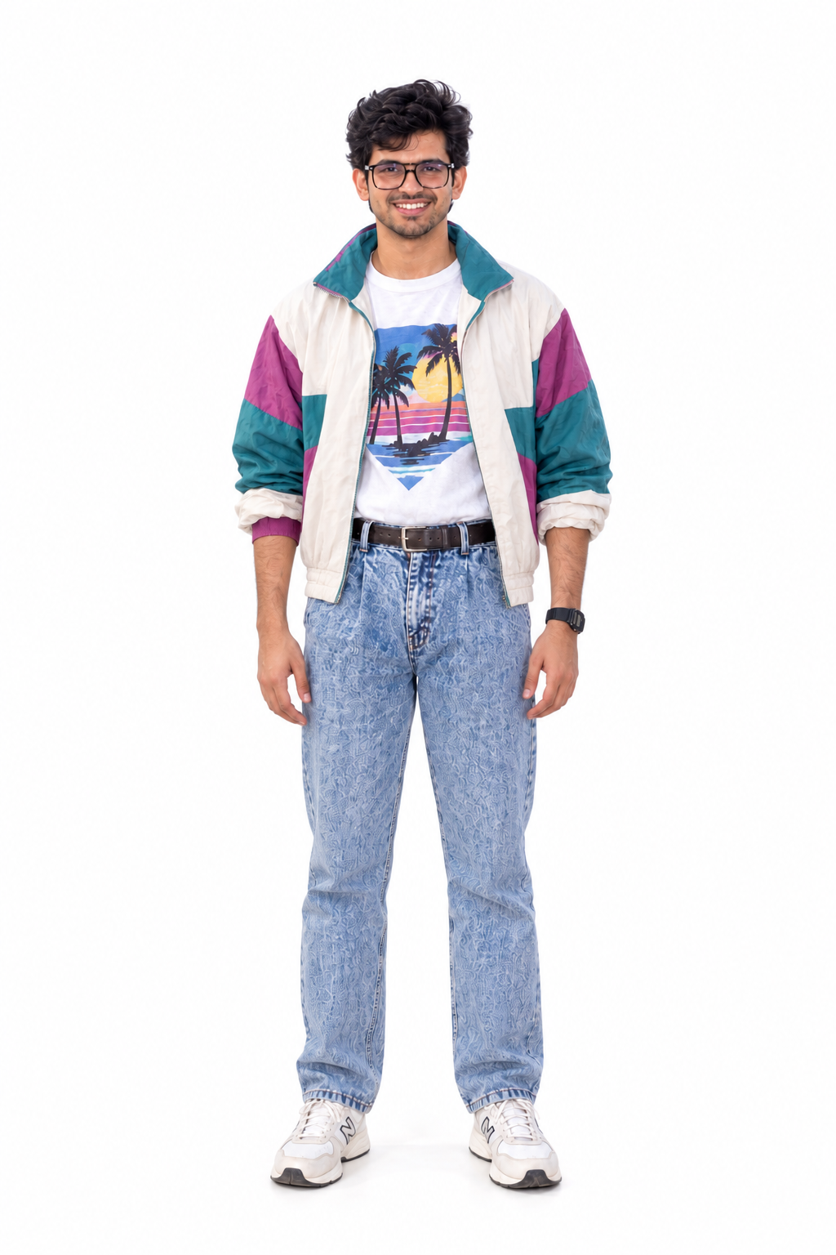
Full-body character image prepared for identity conditioning and replacement.
Identity stays constant in the reference image; motion comes from the dance video. The workflow maps the second onto the first.

03 Workflow
The workflow is a sequence of specialised stages. Each stage produces a representation that the next stage consumes, so the project demonstrates workflow understanding rather than simply invoking one model.
Workflow Step 01 — Load the motion source and establish the working frame
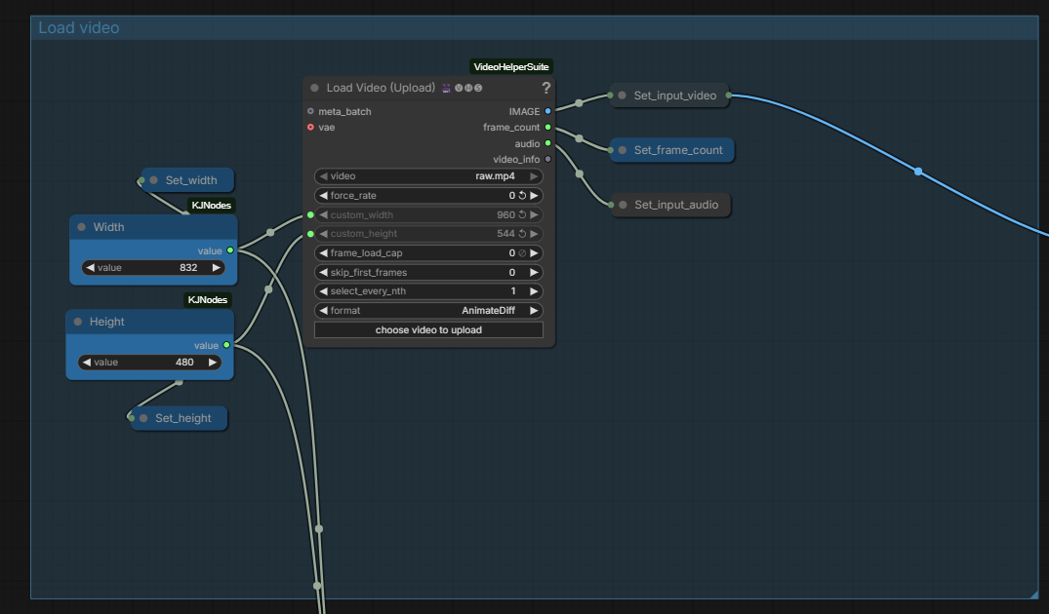
ComfyUI evidence · Step 01
The Load Video section brings the dance clip into ComfyUI and exposes the controls used to define the working video stream. Width and height are routed through KJNodes, while the video image sequence, frame count and audio are published as named values for downstream nodes. Establishing one consistent vertical working size before pose extraction keeps all later stages in the same coordinate space.
Settings: Working generation path is 480 × 832, preserving 9:16. The video branch also publishes frame count and audio so those values can be reused downstream.
Workflow Step 02 — Prepare the identity reference
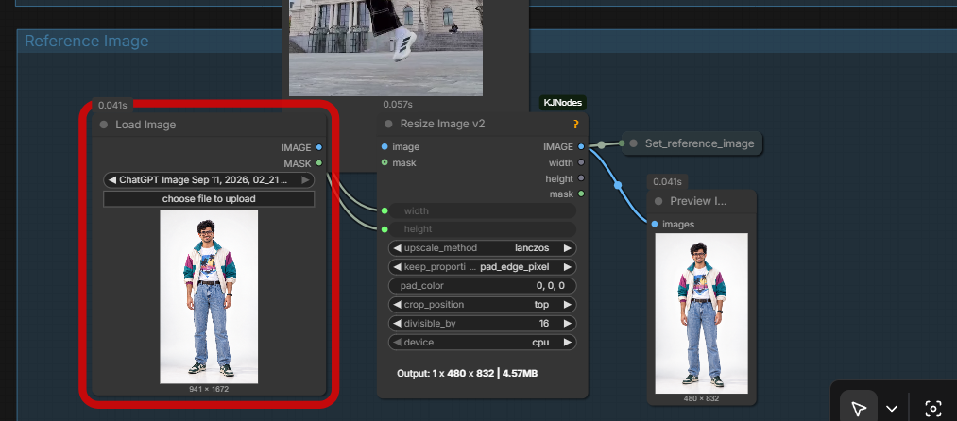
ComfyUI evidence · Step 02
The reference image enters through Load Image and is resized through Resize Image V2. Lanczos scaling is used, with proportion-preserving padding rather than distortion. The result is stored as reference_image, creating the identity side of the pipeline and keeping it independent from the motion source.
Settings: The reference is resized to 480 × 832. Padding protects the full-body composition and avoids cropping limbs or altering proportions.
Workflow Step 03 — Extract pose, face and subject mask
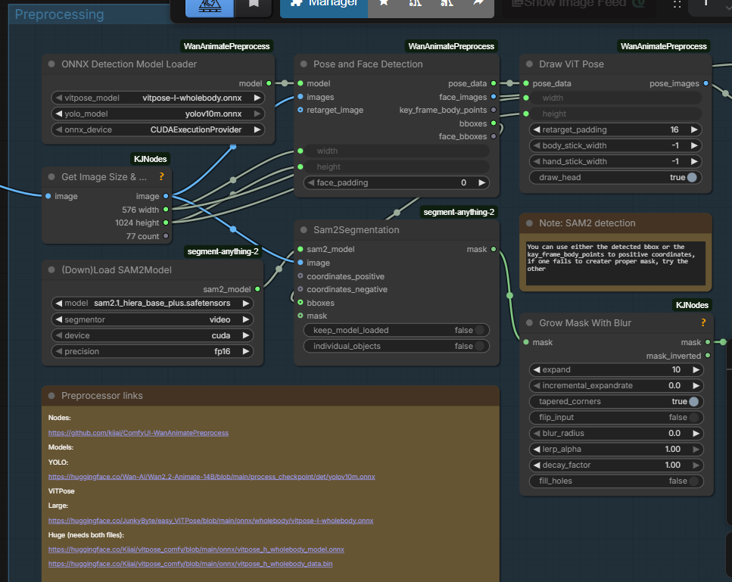
ComfyUI evidence · Step 03
WanAnimatePreprocess converts the raw motion footage into structured conditioning. YOLOv10 detects the performer, ViTPose WholeBody estimates the body pose, and the pose/face detection node produces pose data and face images. SAM2 then generates a subject mask from the detection signals, which is expanded and softened before downstream character replacement.
Settings: This stage turns the video from raw pixels into motion-control signals: pose, face and segmentation. Those signals are later combined with the identity reference.

04 Generation
Condition the model, then generate.
Workflow Step 04 — Load Wan 2.2 Animate and the supporting LoRAs
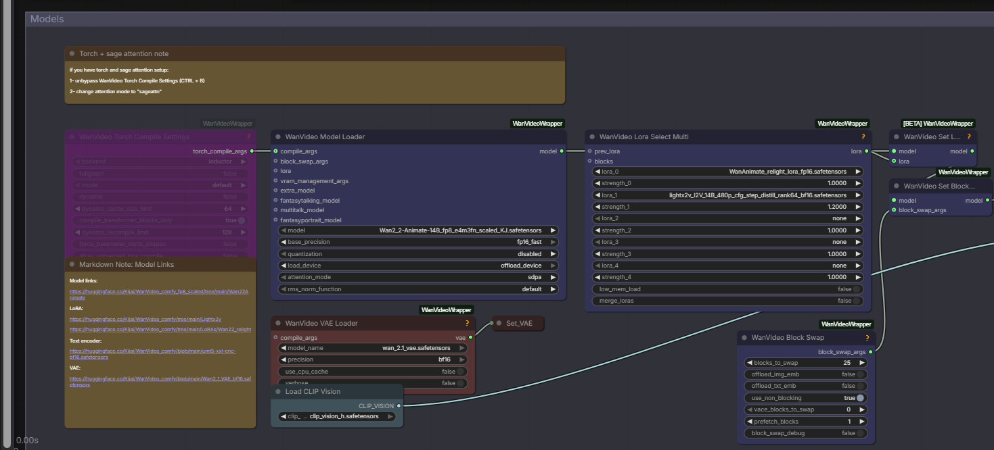
ComfyUI evidence · Step 04
The model section loads the Wan 2.2 Animate 14B checkpoint and the Wan VAE, then routes the model through the selected LoRAs before sampling. The workflow uses the WanAnimate relight LoRA and the LightX2V I2V LoRA. This is the point where the graph becomes specific to the Wan Animate generation stack rather than generic image/video manipulation.
Settings: WanAnimate relight strength: 1.0. LightX2V strength: 1.2. Base checkpoint: Wan2_2-Animate-14B_fp8_e4m3fn_scaled_KJ.safetensors.
Workflow Step 05 — Build character and motion conditioning
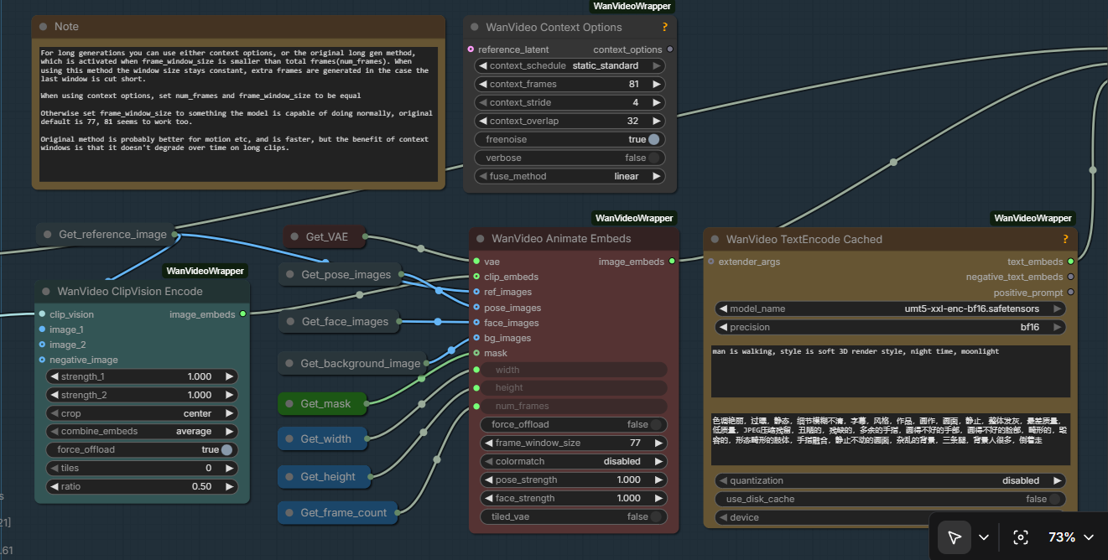
ComfyUI evidence · Step 05
WanVideo Animate Embeds receives the reference image, pose images, face images, background and mask signals created upstream. It packages those inputs into image embeddings for the animation model. In parallel, CLIP Vision encodes the visual reference, while the cached text encoder provides language conditioning. This is the key conditioning stage: identity, motion and prompt information are assembled before diffusion sampling.
Settings: Animate Embeds path uses 480 × 832 conditioning, a 77-frame window, and pose and face strength of 1.0. The context node is configured with an 81-frame context, 4-frame stride and 32-frame overlap.
Workflow Step 06 — Sample the animation and decode the generated frames
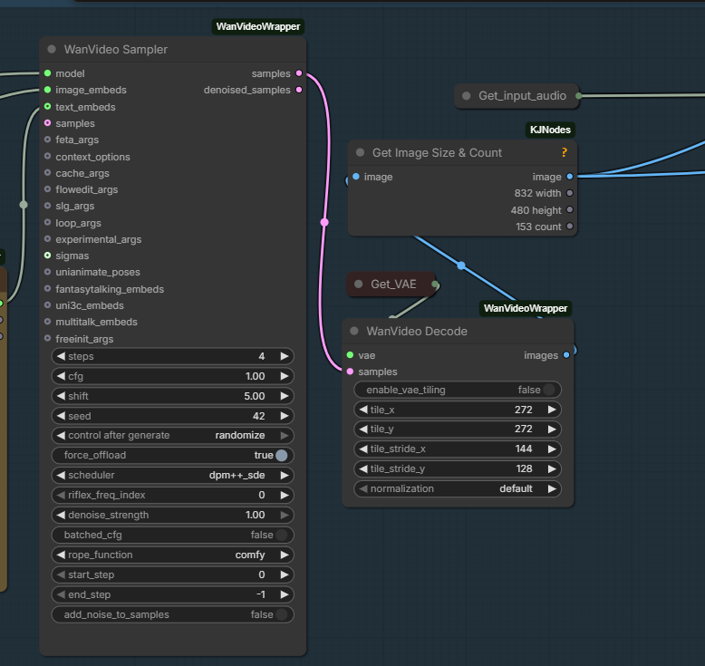
ComfyUI evidence · Step 06
The WanVideo Sampler receives the model and conditioned embeddings and performs the diffusion generation. The latent samples then pass into WanVideo Decode, which reconstructs image frames through the Wan VAE. This is where the motion-conditioned representation becomes a visible character video.
Settings: Sampler uses 4 steps, CFG 1.00, shift 5.00, seed 42 with randomisation enabled, and the dpm++_sde scheduler.

05 Post-Processing
Workflow Step 07 — Interpolate, upscale and export
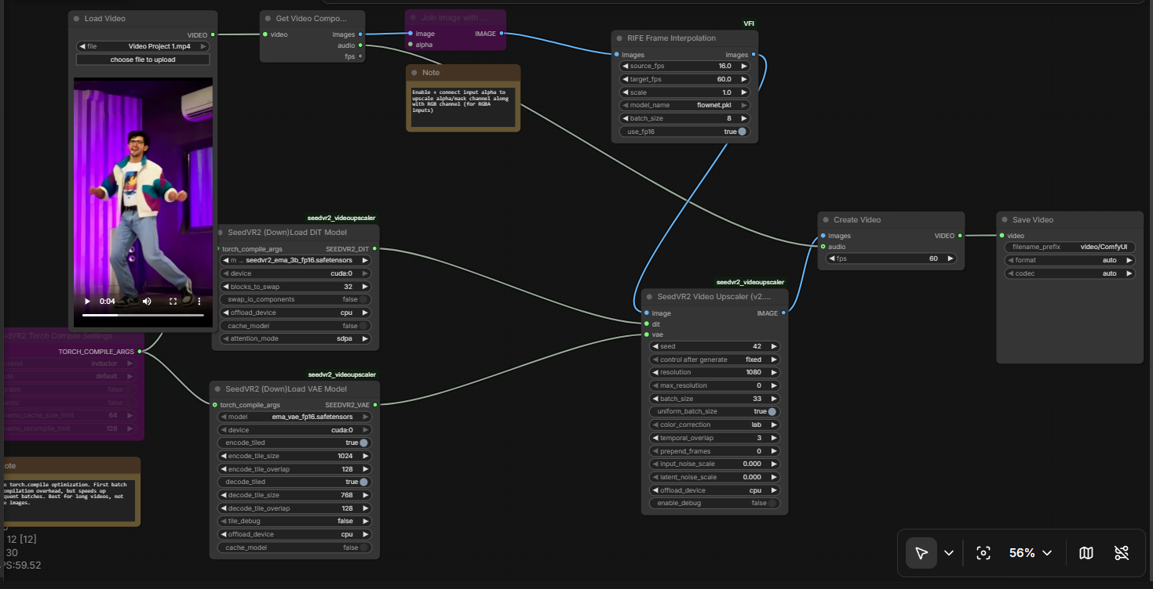
ComfyUI evidence · Step 07
The generated frame sequence moves through the output-processing branch. RIFE converts the native 16 FPS sequence into a 60 FPS presentation. SeedVR2 then performs video upscaling toward the final delivery resolution. The processed image sequence and audio are sent to Create Video, and the resulting video is passed to Save Video for the final MP4.
Settings: RIFE: source 16 FPS → target 60 FPS. SeedVR2: 1080 resolution target. Final export: vertical 1080 × 1920 MP4 at 60 FPS.

Why this post-processing stage is explicit
The generation and delivery stages have different jobs. Wan Animate is responsible for character and motion synthesis. RIFE improves temporal cadence. SeedVR2 improves delivery resolution. Keeping these nodes visible in the submission makes the complete ComfyUI workflow auditable from source video to final file.

06 Final Deliverables
Reference Video | Workflow | Final Output | Format
YouTube Short  92172gsa-DI | Google Drive  exported JSON files | YouTube Short  S8OCs0qX4ic | Vertical MP4  1080 × 1920 · 60 FPS

Final links
Reference video: youtube.com/shorts/92172gsa-DI
ComfyUI output: youtube.com/shorts/S8OCs0qX4ic
Workflow files: drive.google.com/drive/folders/1RvZjyKK35_JubhAyUYHsgs6MHbvl6s4_

Deliverables checklist
- Reference video used: Updated reference video linked above.
- ComfyUI workflow screenshot or exported JSON: Readable workflow screenshots in this document, plus the exported workflow files in the Drive folder.
- Final output video: Final ComfyUI output linked above.
This package focuses on the creative rationale, workflow understanding, evidence, links and required deliverables.

One Honest Reflection
What was the hardest part, and what did you learn?
[Add your reflection here — a few honest sentences on the hardest part of this task and what you learned from it.]
END OF SUBMISSION

