**Compare Price**

**Submitted To:** Dr. Shridevi S

**Team Member:** Shubham Bajaj (18BCE1114)

Jay Daftari (18BCE1299)

**Introduction**

Here is an app which saves your Gb’s of space by providing you feature of one in all. you can search on different website from this particular app without downloading specific app for same.

Now you don’t need to search again and again on different website and compare price. Just search ones and find result from everywhere.

Instant change your website by just selecting it and you don’t have to search that product again

**Existing System**

There are different apps which allows you to access different website from their app. But they lack in feature which allows you to search only ones and get result everywhere.

Also, they have complicated user interface and are slow in use.

Very few people use this type of app. They generally have different app to buy product and they compare prices manually. This sometime become problematic when it comes to search on 4-5 app.

**Proposed System**

This app will automatically compare prices from different app and provide you dialog box with prices written on it, so you don’t have to search on different app.

Also, you can switch instantly to any website where you can see result without searching it again.

Here you have different website which you can access within app.

**Implementation**

**Software used:** Android studio 3.5.3

JRE:1.8.0_202-release -1483-b03 amd64

JVM: OpenJDK 64-Bit Server VM by JetBrains

**Language used:** java for backend and logical part

Xml for user interface

**Major Library:** org.jsoup:jsoup:1.12.1

junit:junit:4.12

App uses webview class which is extension of android views class where loadurl() method helps to load URl and show it to particular activity.

jsoup library is used for web scrapping to pull out product price from html page by first parsing it and then searching it with specific elements and attribute name with their values.

Threading is used to ensure we did not get any error and our searching goes in backend where we see website in front. Threading also make process smooth, fast and allows phone to work with its maximum capacity.

All the searches are done within try and catch block in order to make sure our app doesn’t crash in any case.

**Result**

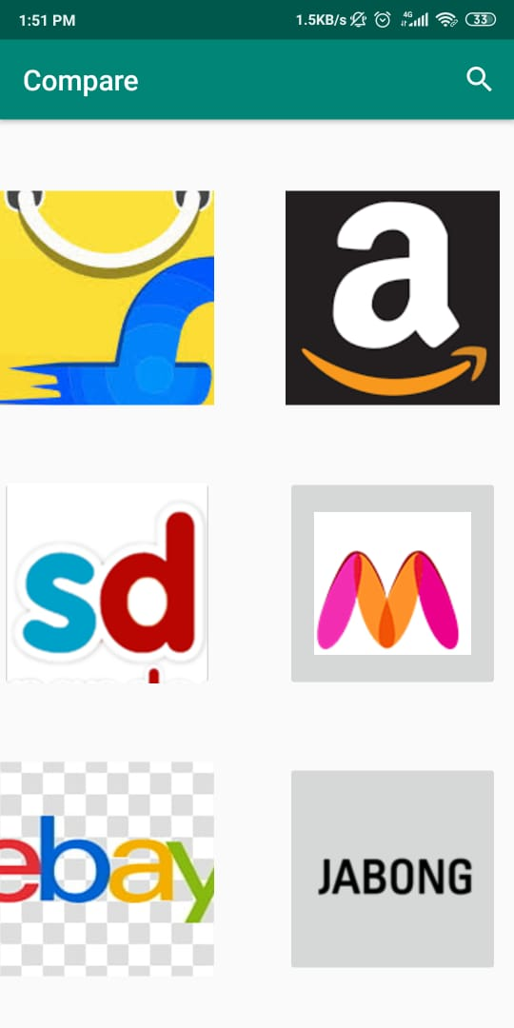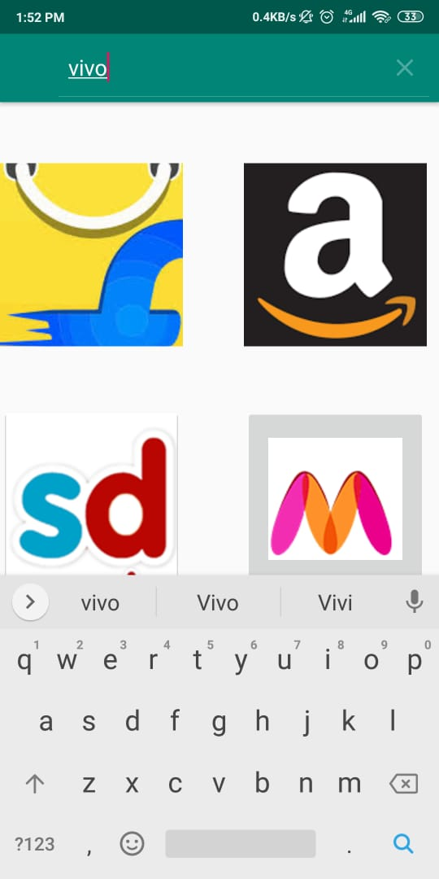

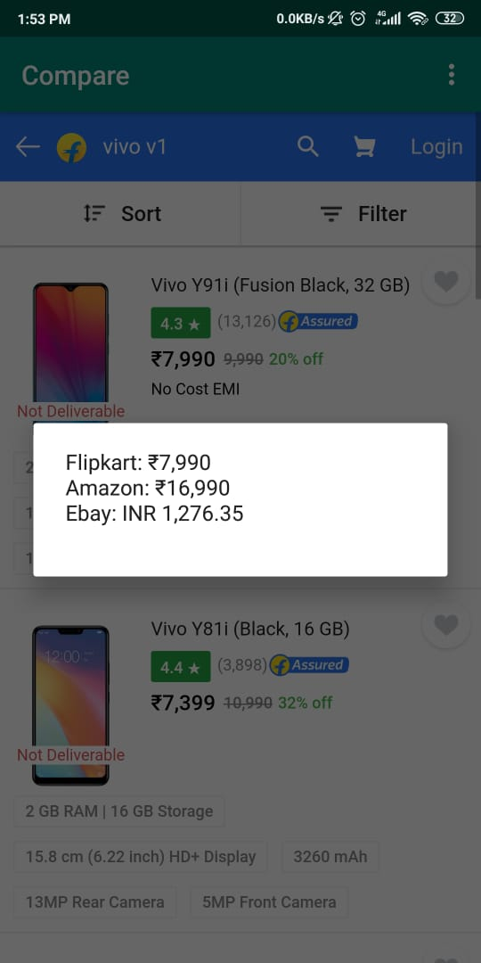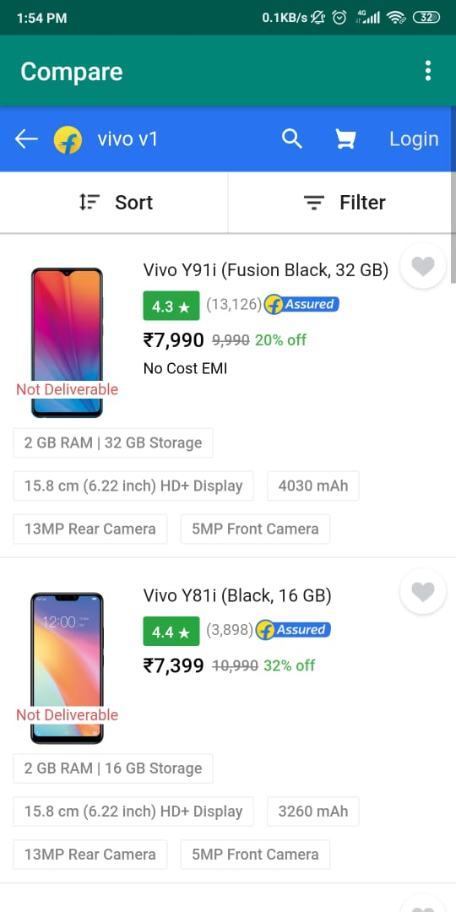

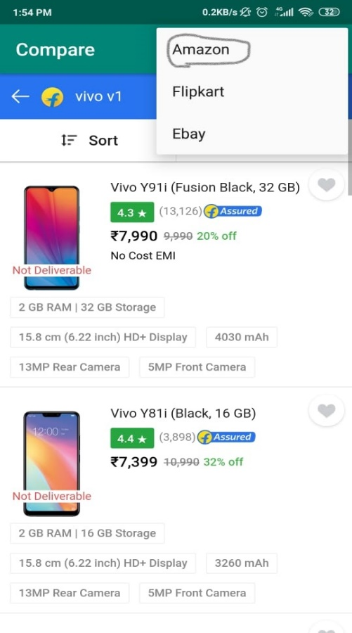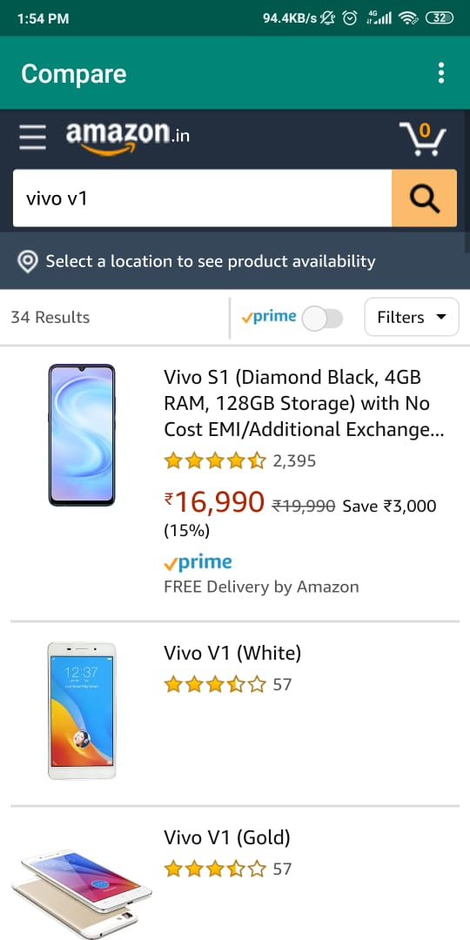

**Conclusion**

We have successfully implemented threading and jsoup library and got the required output.

This app will help user to save their time and space.

**Thank you**