**Reconnaissance**

Nmap Scan

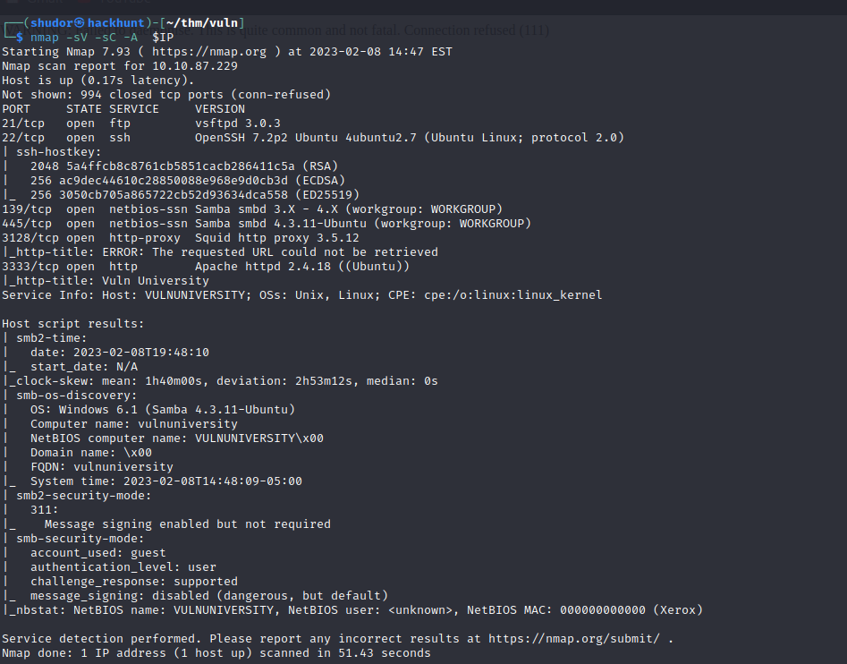

Scan the box, how many ports are open?

6

With the help of above image we can say that there is 6 port open

What version of the squid proxy is running on the machine?



3.5.12

How many ports will nmap scan if the flag -p-400 was used?

All port from 1 to 400 so it will be 400 ports

<https://nmap.org/book/port-scanning-options.html>

Using the nmap flag -n what will it not resolve?

DNS

<https://nmap.org/book/man-briefoptions.html>

What is the most likely operating system this machine is running?

Ubuntu

What port is the web server running on?

3333



**Locating Directories using gobuster**

Gobuster Scan

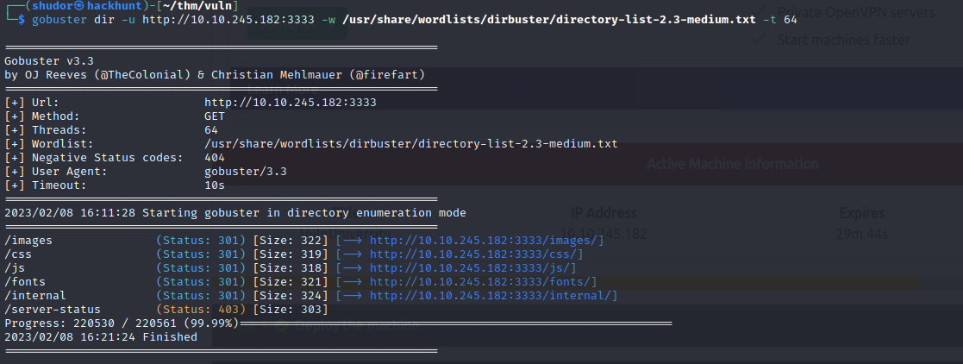

What is the directory that has an upload form page?

/internal

**Compromise the web server**

What common file type, which you'd want to upload to exploit the server, is blocked? Try a couple to find out.

Php

What is the name of the user who manages the webserver?

bill

What is the user flag?

8bd7992fbe8a6ad22a63361004cfcedb

**Privilege Escalation**

On the system, search for all SUID files. What file stands out?

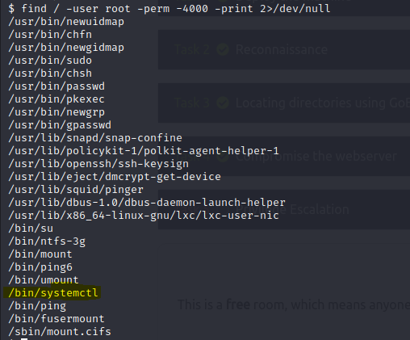

Become root and get the last flag (/root/root.txt)

