**PROJECT REPORT**

**PROJECT NAME** :- Billing System.

**DEVELOPMENT** :- C Language.

**PROJECT BY** :- Shubham Pawar.

Customer Billing System

## TABLE OF CONTENTS

|  |  |  |
| --- | --- | --- |
| **S No.** | **Content** | **Page No.** |
| **1.** | Introduction | **3** |
| **2.** | Objective | **4** |
| **3.** | Requirements | **5** |
| **4.** | Flow chart | **6** |
|  |  |  |
| **5.** | Input and output Display | **7** |
| **6.** | Future scope | **8** |
| **7.** | Reference | **9** |

Customer Billing System

# INTRODUCTION

Customer Billing System Project is a simple console application designed to demonstrate the practical use of C programming language and its features as wells as to generate an application which can be used in any departmental store, shops, cafes etc. for billing to the customer.

You can use this application to keep the records such as name, address, mobile number, paid amount, due amount, payment date etc. of your regular costumer. Moreover, if you have a new customer, you can add and edit the account at any time.

**Features:**

1. It can hold any number of accounts and account can be added to the program at any time.
2. The programming of simple calculations such as calculation of due amount, balance etc. have been embed in the code of project.
3. The Customer Billing System project in C gives you the facility of searching the account by two ways, either by name of the customer or by the number of customer.
4. The due amount to be paid is shown as negative balance.

5. If you have nothing to do with the program, you can directly exit from the main menu.

Customer Billing System

**OBJECTIVE**

Customer Billing System Project is a simple console application designed to demonstrate the practical use of C programming language and its features as wells as to generate an application which can be used in any departmental store, shops, cafes etc. for billing to the customer.

Customer Billing System application is so simple to use. In order to use the application, click at the exe file and then, you will have three options to:

1. To add account
2. To search account
3. To exit

As per your need, enter 1, 2,or 3 and follow the instructions provided by the application itself.

Customer Billing System

**REQUIREMENTS**

**Software Requirement**

* Operating System : Windows
* Application Software: Code-Blocks/Visual Studio
* Language : C-Programming

#### Hardware Requirements Specification

#### Processor : Intel core i3 or i5

#### Hard Disk : 250GB

#### Ram : 2GB

Customer Billing System

**FLOW CHART**

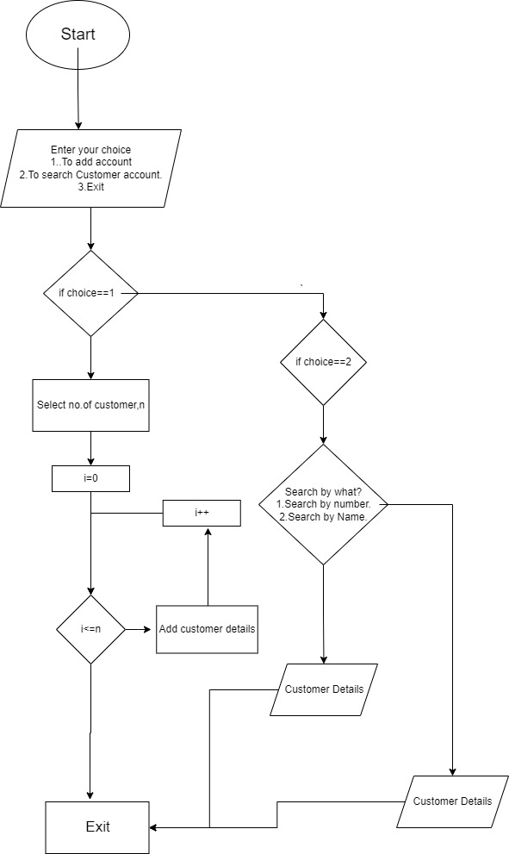

Customer Billing System

**INPUT AND OUTPUT DISPLAY**

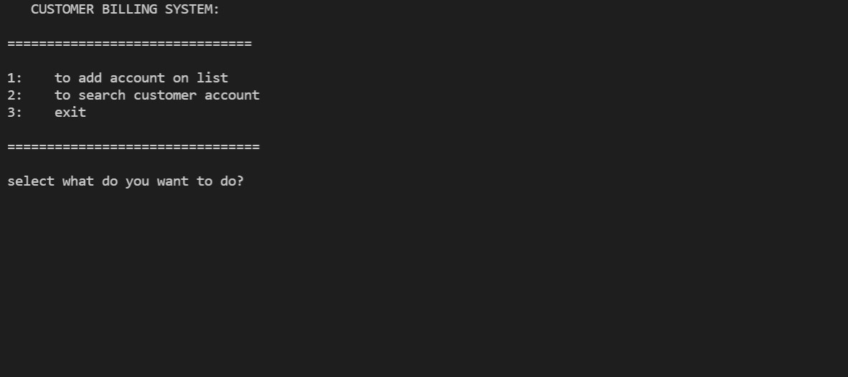

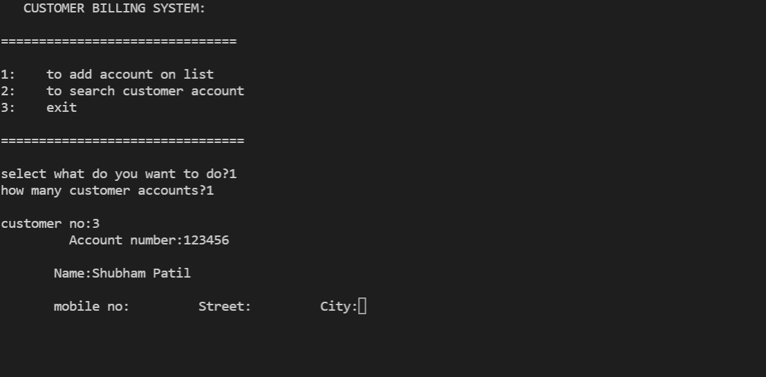

Customer Billing System

**Future Scope Of Project**

This Project can be modified with better graphics and we can add some extra features according user requirements. The scope of billing software solution services ranges from simple invoice production to comprehensive business management.

We can add features like :-

* Application can send notification to customer about account information like current balance,amount to be paid etc.

Customer Billing System

**Reference**

* <https://www.codewithc.com>.
* [www.youtube.com](http://www.youtube.com).