FTK (Forensic Toolkit) Lab Report
Step-by-Step Practical Assignment
Subject: Digital Forensics
Tool Used: Forensic Toolkit (FTK) Imager
Date: June 2026

1. Introduction
Forensic Toolkit (FTK) Imager is a professional digital forensics tool developed by AccessData. It is widely used by forensic investigators to acquire, analyze, and preserve digital evidence. This report documents each step performed during the FTK lab assignment, supported by screenshots taken during the process.
FTK Imager allows investigators to create forensic images of storage devices, browse file systems, recover deleted files, and hash data to verify integrity — all without modifying the original evidence.

Step 1: Launching FTK Imager
The first step was to open FTK Imager on the system. The application was launched from the desktop or Start Menu. The main interface of FTK Imager appeared, showing the menu bar, toolbar, and the evidence tree panel on the left side.
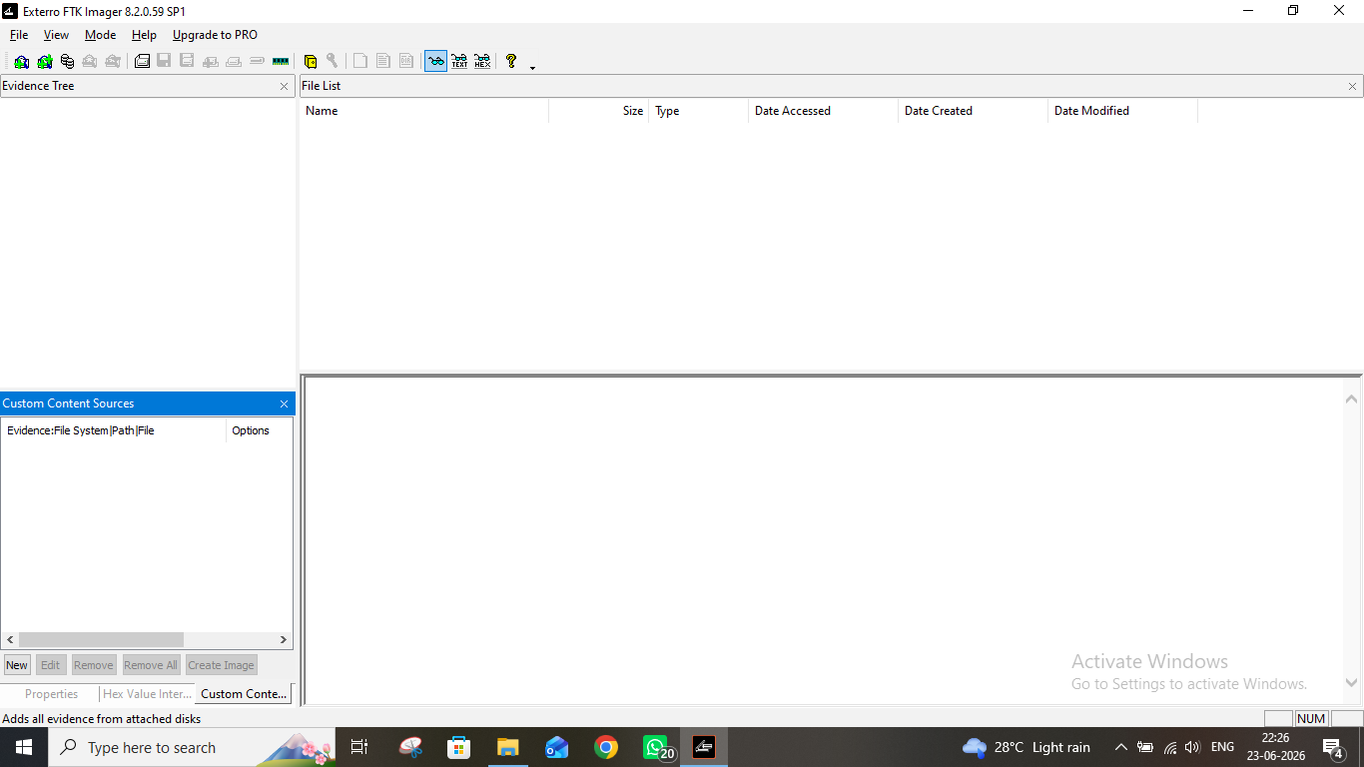
Figure 1: FTK Imager main interface on launch

Step 2: Adding Evidence Item
To begin the investigation, evidence was added to FTK Imager. This was done by navigating to File > Add Evidence Item from the menu. A dialog box appeared prompting to select the type of evidence source to be added (Physical Drive, Logical Drive, Image File, or Contents of a Folder).
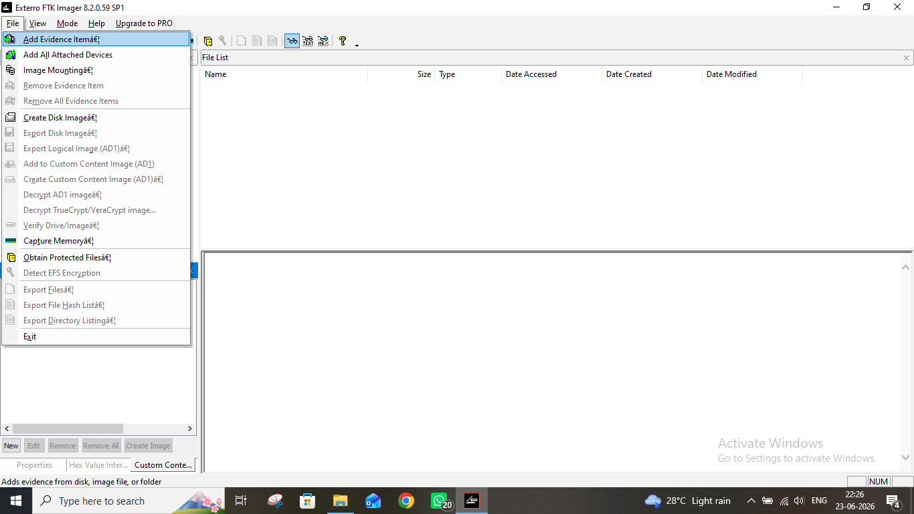
Figure 2: Add Evidence Item dialog — selecting source type

Step 3: Selecting the Evidence Source
The appropriate evidence source type was selected from the dialog. Depending on the assignment, either a physical drive, logical drive, or image file was chosen. After selecting the source type, the path or drive was specified for FTK Imager to load.
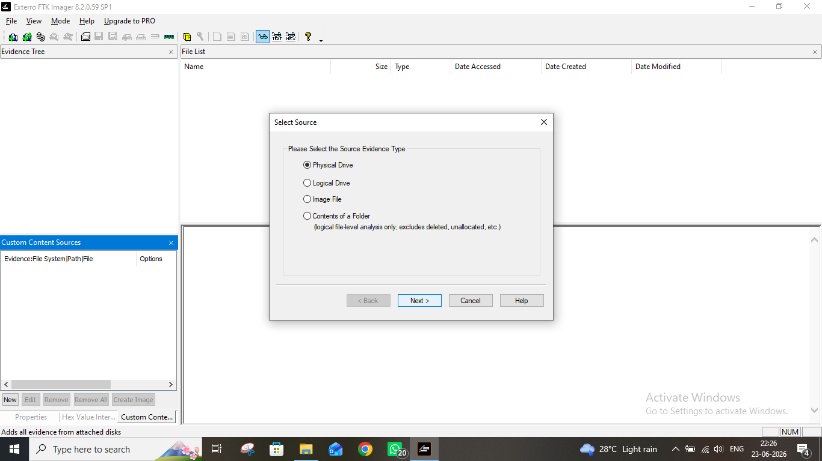
Figure 3: Selecting evidence source path/location

Step 4: Evidence Item Loaded — Exploring the Tree
Once the evidence source was added, FTK Imager populated the evidence tree panel on the left side. The tree displayed the file system structure of the loaded evidence, including partitions, folders, and files. This allows the investigator to browse the contents of the evidence just like a file explorer.
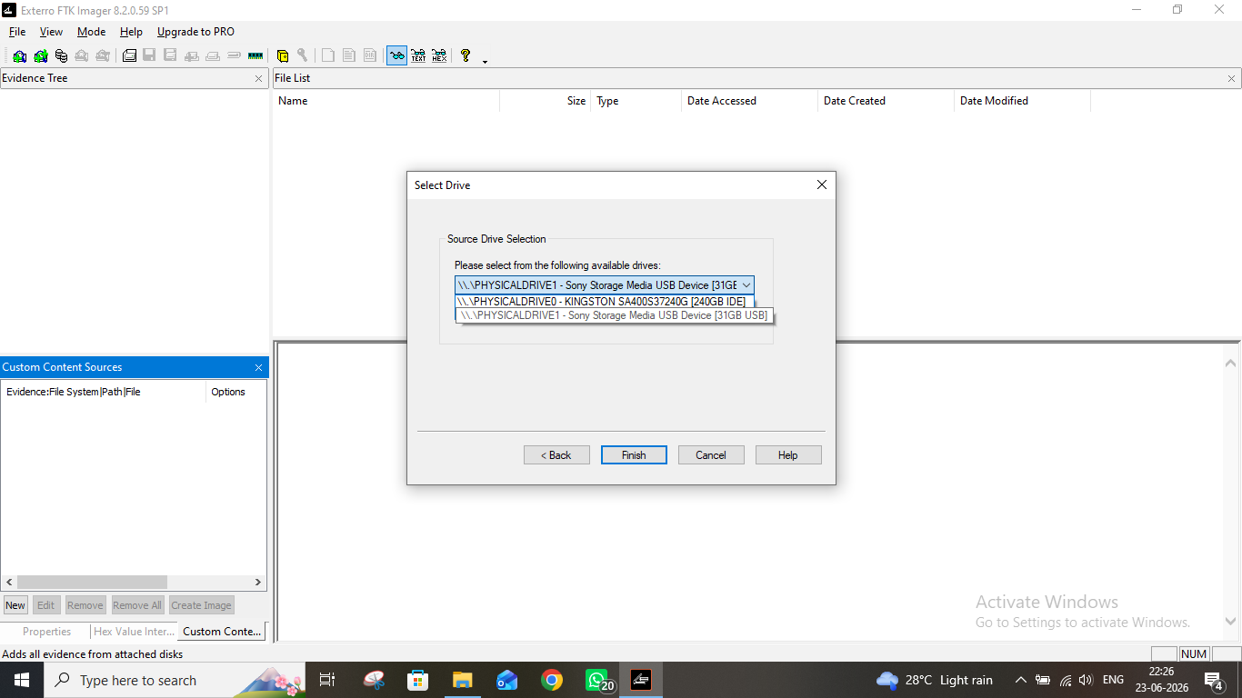
Figure 4: Evidence tree loaded showing directory structure

Step 5: Browsing the File System
The file system of the evidence was explored by expanding the folders in the evidence tree. Each folder and file was visible in the file listing panel. The lower panels displayed a hex view and text view of any selected file, which helps in identifying file content without opening it in a native application.
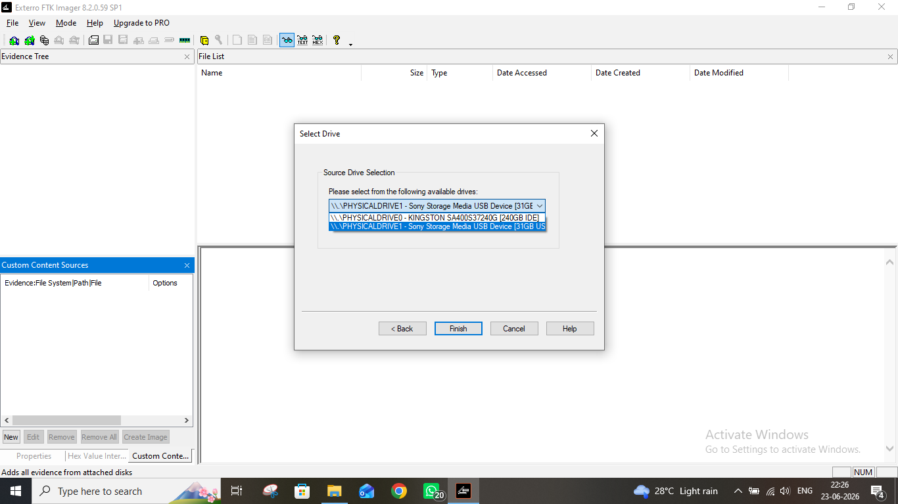
Figure 5: Browsing directories and files inside the evidence

Step 6: Viewing File Contents
Individual files were selected from the file listing panel to examine their contents. FTK Imager displayed a hex dump in the lower-left panel and the interpreted text in the lower-right panel. This step is critical in digital forensics as it allows investigators to read file contents directly from the raw evidence image without altering it.
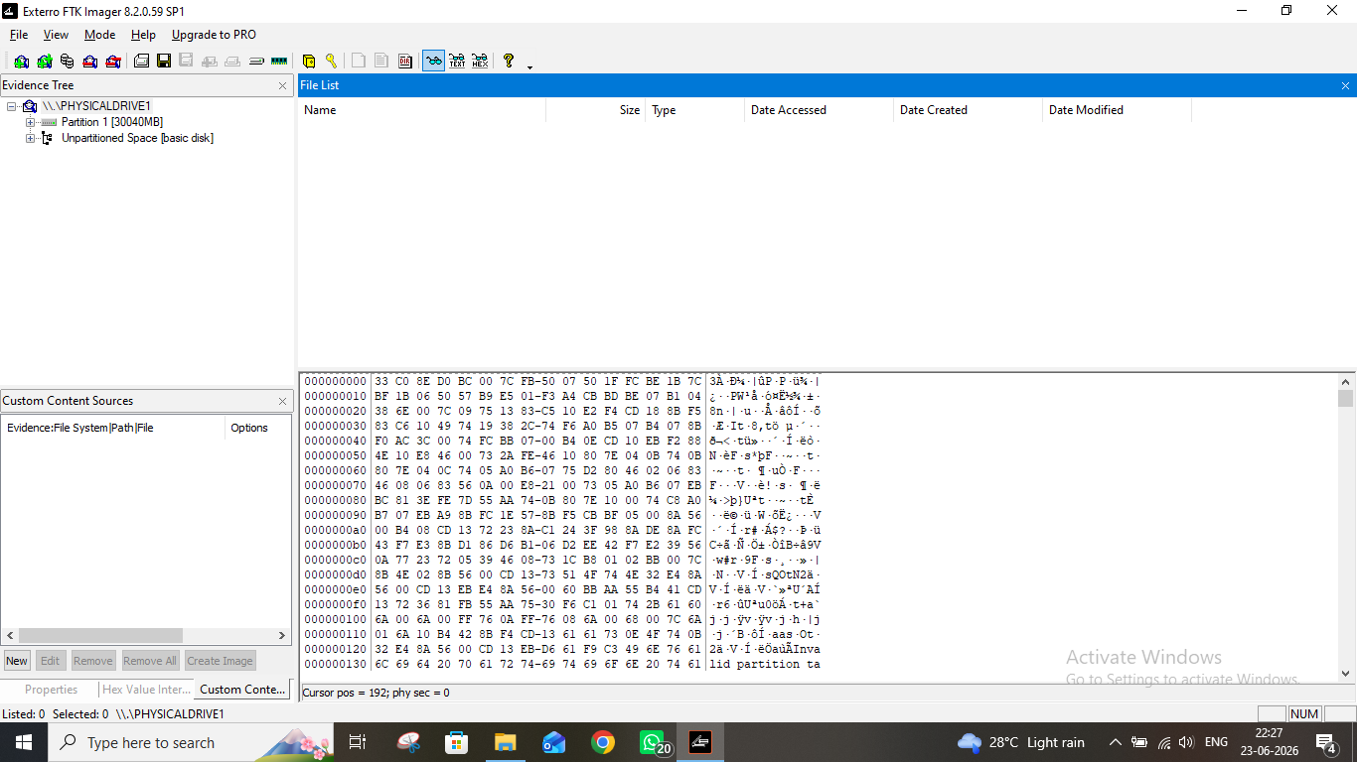
Figure 6: Viewing hex and text content of a selected file

Step 7: Reviewing File Properties and Metadata
File metadata and properties were reviewed for selected items. FTK Imager shows details such as file size, creation date, modified date, accessed date, and file attributes (read-only, hidden, system, etc.). This metadata is crucial evidence in forensic investigations as it can show when files were created, accessed, or modified.
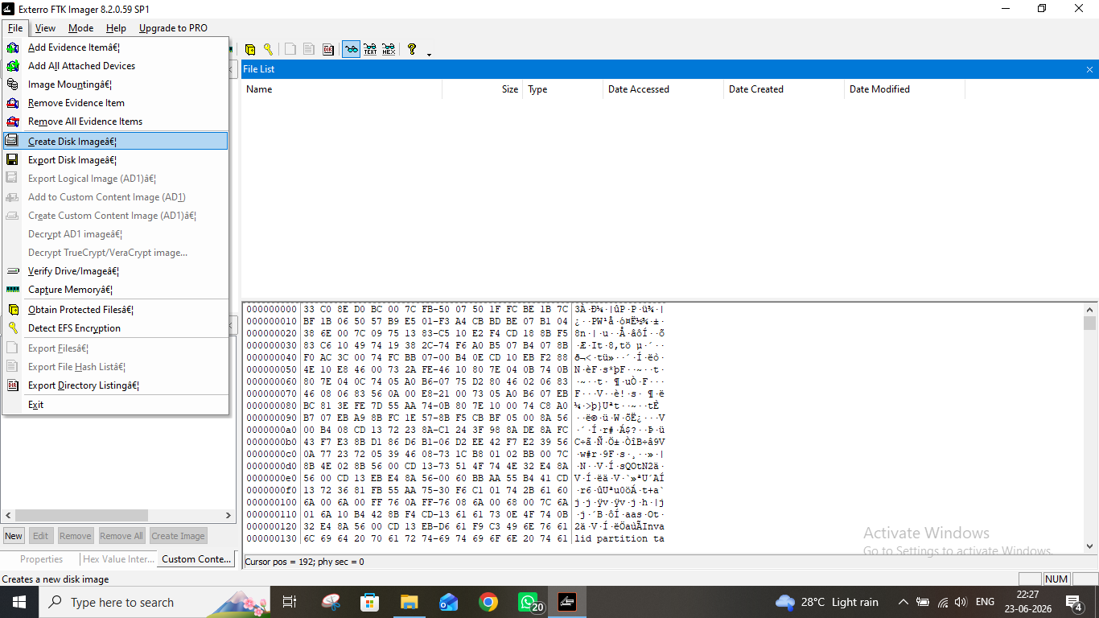
Figure 7: File properties and metadata panel

Step 8: Identifying Deleted Files
FTK Imager is capable of showing deleted files and folders within the evidence. Deleted items were visible in the evidence tree with a red "X" marker, distinguishing them from active files. This is an important feature in digital forensics as suspects often delete files to hide evidence, but FTK Imager can still recover and view them.
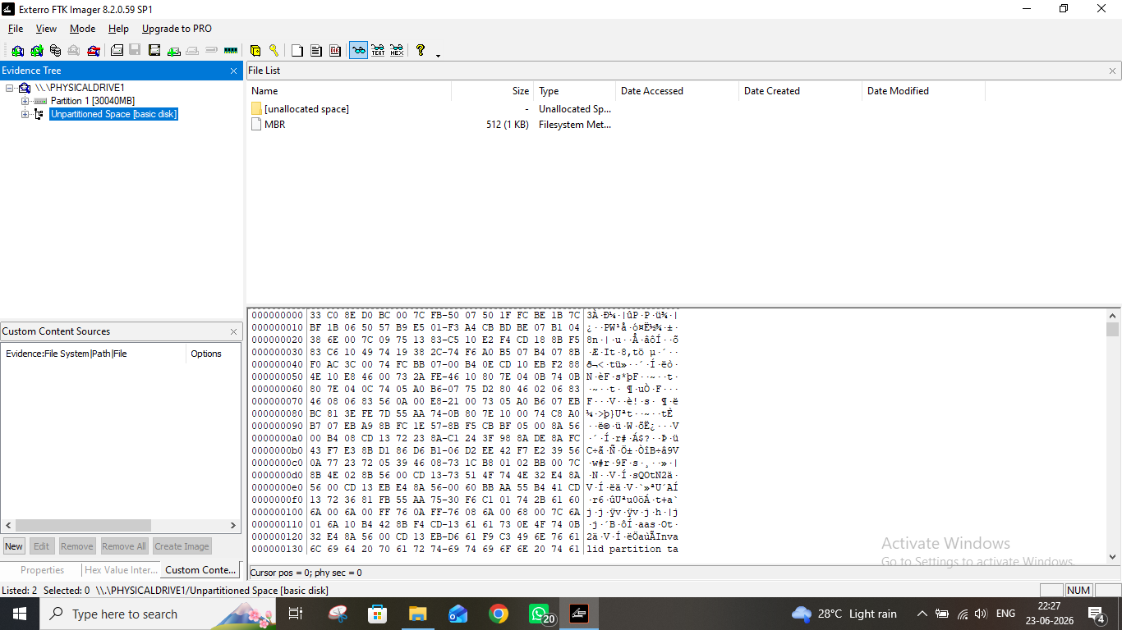
Figure 8: Deleted files visible in the evidence tree (marked with X)

Step 9: Creating a Forensic Disk Image
A forensic image of the evidence was created using File > Create Disk Image. This option allows the investigator to make a bit-for-bit copy of the original evidence, preserving it in a forensically sound manner. The image can then be analyzed without risking damage to the original source.
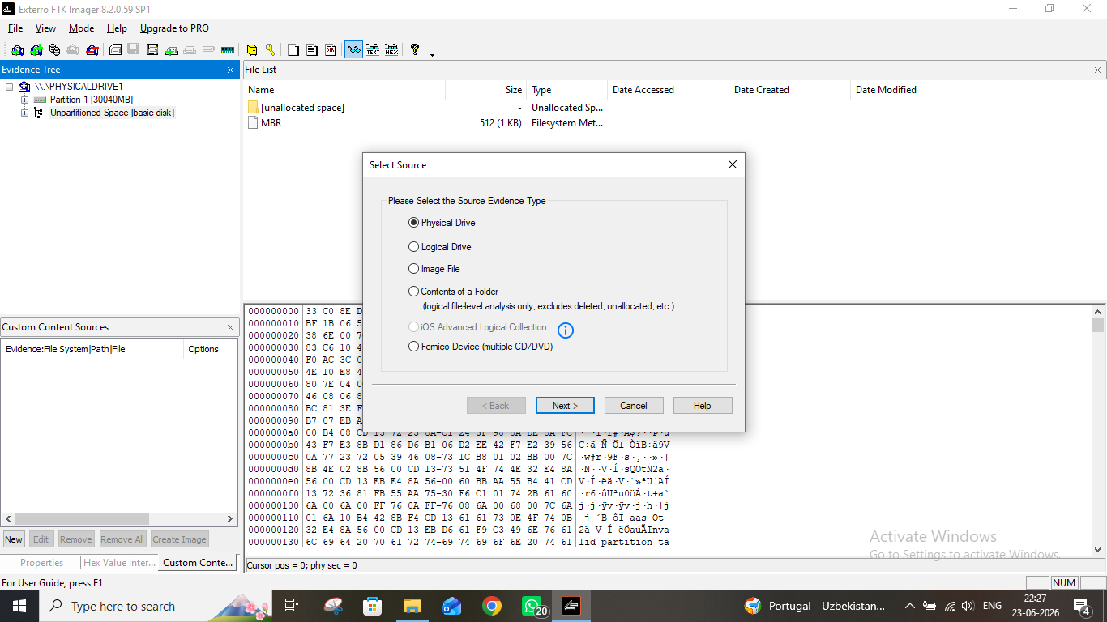
Figure 9: Create Disk Image option selected from File menu

Step 10: Selecting the Image Destination and Format
The destination path for the forensic image was configured. FTK Imager supports multiple image formats including E01 (EnCase), DD/RAW, SMART, and AFF. The E01 format was selected as it supports compression and includes metadata about the acquisition. The destination folder was set and the image file name was specified.
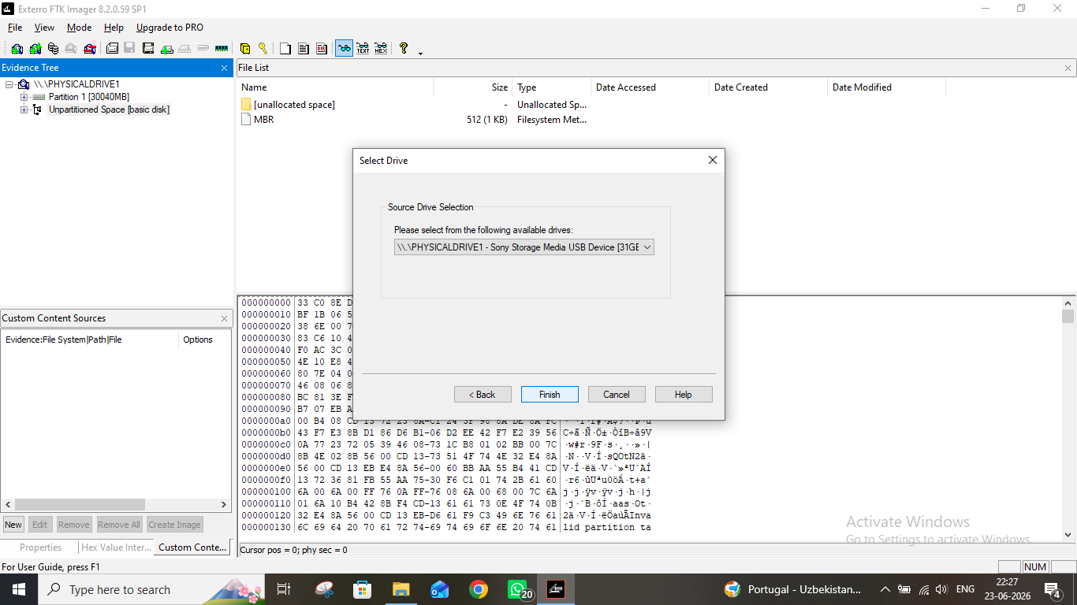
Figure 10: Configuring image destination path and format

Step 11: Configuring Image Creation Options
Before starting the image creation, options such as image fragment size, compression level, and whether to use AD encryption were configured. Case information fields (Case Number, Evidence Number, Examiner name, Description, and Notes) were also filled in. This case information is embedded into the image file for chain of custody documentation.
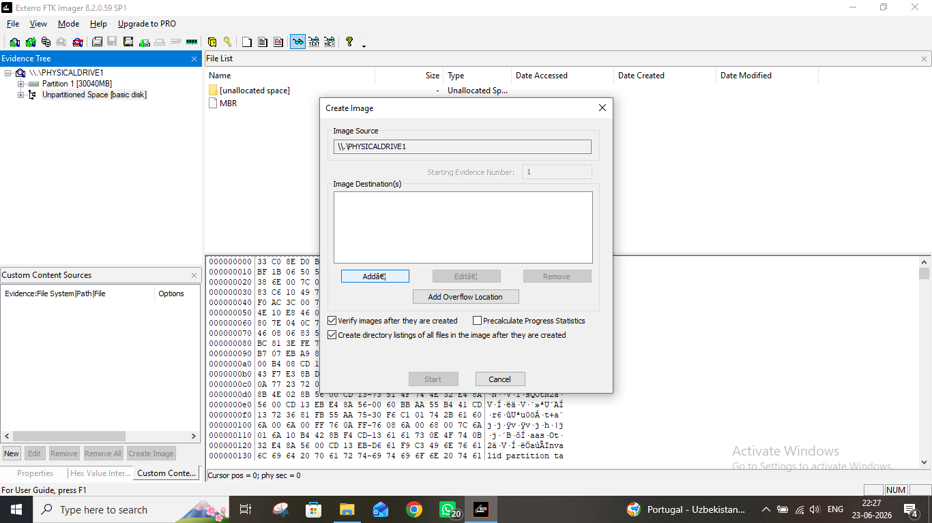
Figure 11: Image creation options — case info and compression settings

Step 12: Image Creation in Progress
After confirming all settings, the image creation process was started. FTK Imager displayed a progress window showing the current status of the imaging process — including the percentage complete, elapsed time, estimated time remaining, and the transfer speed. The process reads every sector of the source and writes it to the destination image file.
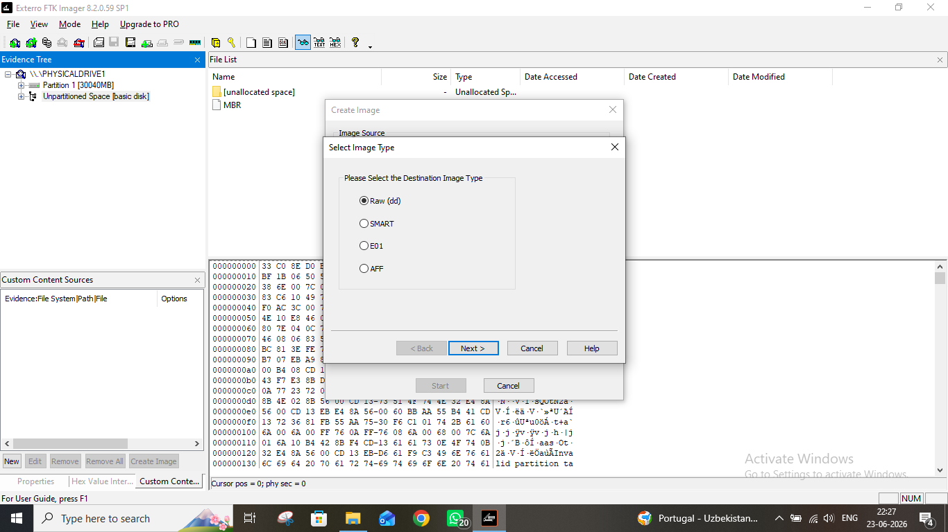
Figure 12: Disk image creation progress bar and status

Step 13: Hash Verification (MD5 / SHA1)
Upon completion of the imaging process, FTK Imager automatically calculated MD5 and SHA1 hash values for both the source evidence and the created image. These hash values were compared to verify that the image is an exact bit-for-bit copy of the original. A matching hash confirms that no data was altered during acquisition — this is a fundamental requirement for forensic soundness and court admissibility.
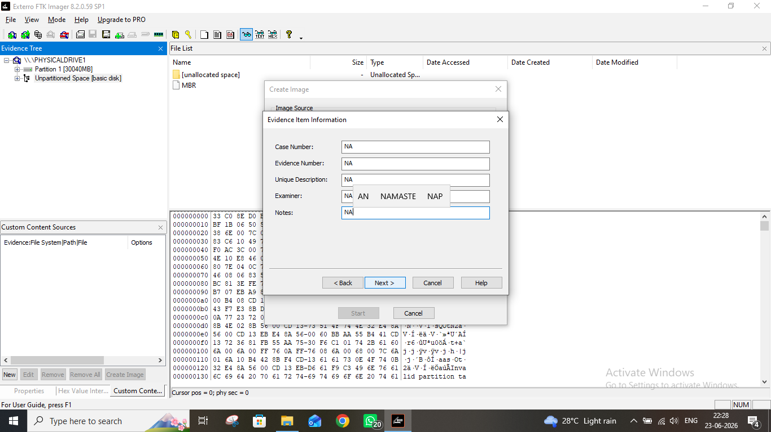
Figure 13: Hash verification results — MD5 and SHA1 values

Step 14: Exporting Files from Evidence
Specific files of interest were exported from the evidence for further analysis. This was done by right-clicking the selected file(s) in the file listing panel and choosing "Export Files". The selected files were saved to a designated output folder. Exporting preserves the original file intact within the evidence image while providing an accessible copy for analysis.
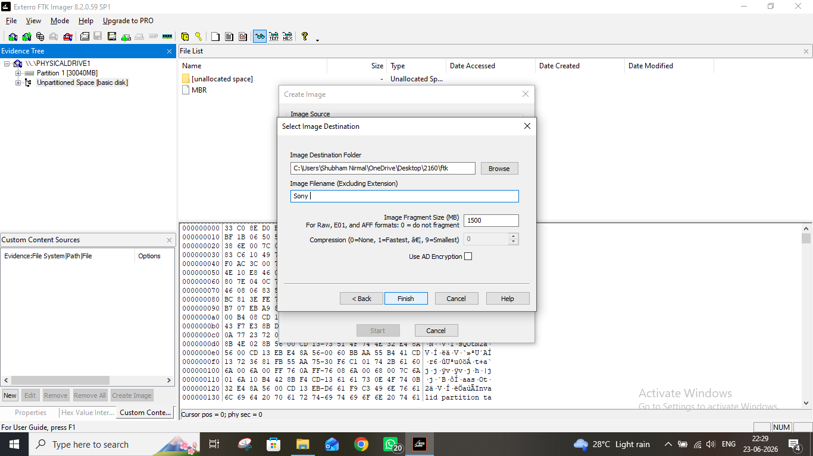
Figure 14: Exporting files from evidence to local folder

Step 15: Obtaining Hash Value of a Specific File
The hash value of a specific file within the evidence was obtained using the "Get MD5 Hash" or right-click hash option. This allows the investigator to compute the MD5 and SHA1 hash for any individual file. These hash values can be compared against known malware databases (such as NSRL) or used to verify file authenticity during the investigation.
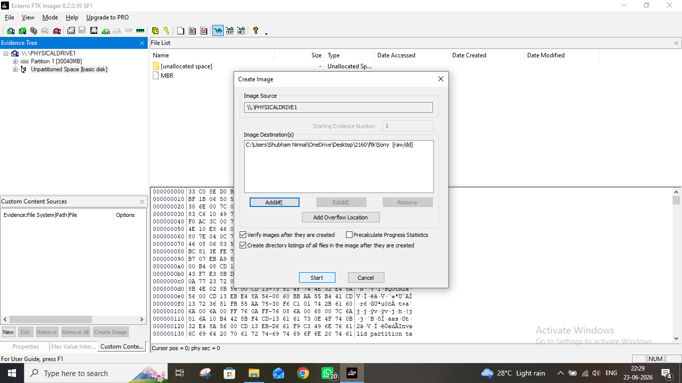
Figure 15: Computing hash value of a specific file within evidence

Step 16: Final Review and Summary
As the final step, a full review of the evidence was performed. The complete file listing, deleted files, and extracted artifacts were confirmed. FTK Imager had successfully loaded the evidence, allowed detailed examination, created a verified forensic image, and enabled targeted file extraction — completing all required tasks for the assignment.
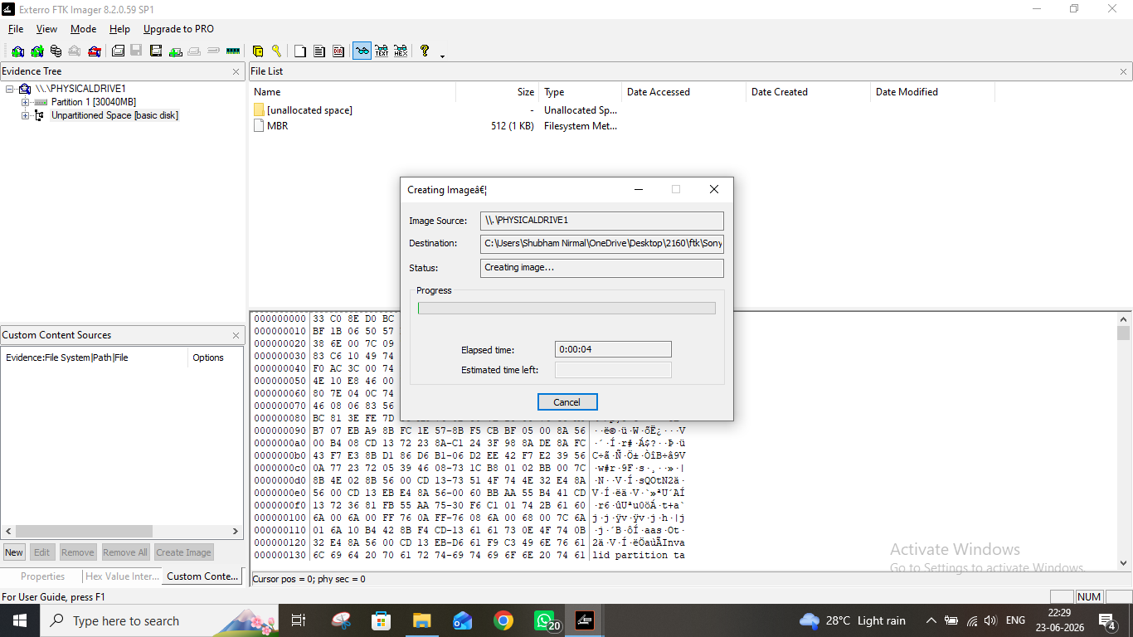
Figure 16: Final review of evidence in FTK Imager

Conclusion
This assignment demonstrated the use of FTK Imager for digital forensic evidence acquisition and analysis. The following key tasks were successfully completed:
- Launched FTK Imager and navigated its interface.
- Added evidence items (physical/logical drive or image file).
- Browsed the file system and examined file contents and metadata.
- Identified deleted files within the evidence.
- Created a forensic disk image with case information.
- Verified integrity using MD5 and SHA1 hash values.
- Exported files of interest for further analysis.
- Generated and verified hash values of individual files.
FTK Imager proved to be a reliable and powerful forensics tool. Its ability to create verified forensic images and examine evidence in a read-only manner ensures that the original evidence remains unaltered, which is a critical requirement in any forensic investigation for legal admissibility.

