METASPLOITABLE 2
PENETRATION TEST REPORT
Intern ID: 2160

▌ CORE METASPLOIT COMMANDS

COMMAND | PURPOSE
msfconsole | Starts the Metasploit hacking framework terminal.
use <module> | Loads the specific attack script for the service you want to target.
set RHOSTS <IP> | Tells Metasploit the IP address of the victim machine.
set LHOST <IP> | Tells the victim machine where to send the control stream back to.
set RPORT <Port> | Changes the port if the service isn't running on its default.
exploit | Fires the attack script and opens up your connection to the victim.

▌ THE 4 ATTACKS

TARGET 1: UnrealIRCD (Port 6667) — The Secret Backdoor

- The Flaw: Hackers sneaked a hidden backdoor into this chat software's code long ago. If you send the secret characters AB;, the system opens up and lets you run any command.
- What we did: We loaded the unreal_ircd module, pointed it at the target, and fired.
- The Result: It gave us a Meterpreter session (a hacker control menu). We typed shell to get a normal Linux command line, and whoami proved we were root.

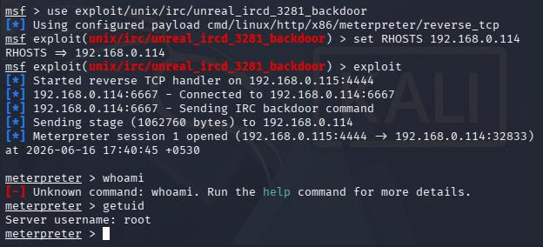

TARGET 2: Samba (Port 139 / 445) — The Username Trick

- The Flaw: This file-sharing service gets confused if a username contains weird code characters. Instead of checking the name, it accidentally executes the weird characters as a system command.
- What we did: We ran the usermap_script module against the target IP.
- The Result: The victim system ran our hidden command blindly. Because file-sharing software runs with high privileges, it instantly handed us a terminal prompt as root.

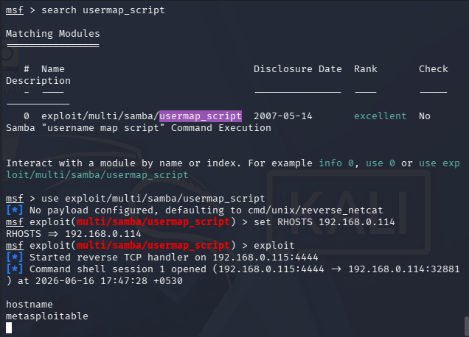

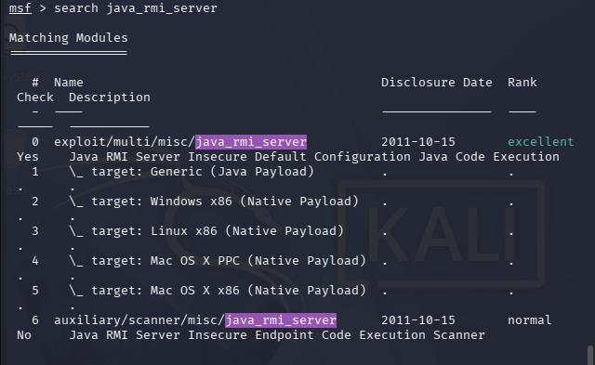

TARGET 3: Java RMI (Port 1099) — The Blind Trust Flaw

- The Flaw: Bad settings. The Java setup on the victim machine was configured to completely trust anyone on the network. It would accept and run any code file sent to it without asking for a password.
- What we did: We used the java_rmi_server module and told it to send a heavy-duty "Meterpreter" control payload.
- The Result: The system ran our code without a second thought. We used the sysinfo command to peek inside the system configuration directly through its Java framework.

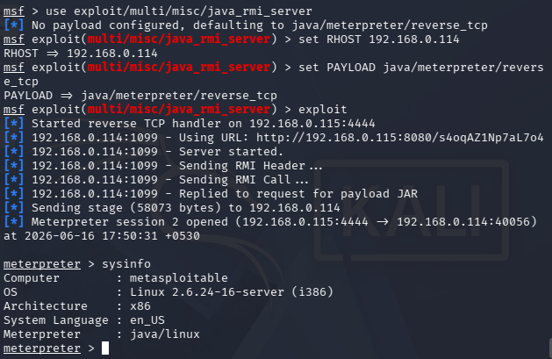

TARGET 4: Tomcat Manager (Port 8180) — The Guessable Password

- The Flaw: The website's administrator dashboard was left wide open using the factory-default username and password: tomcat / tomcat.
- What we did: We told Metasploit to target port 8180, gave it the default credentials, and told it to upload a malicious application file (.war).
- The Result: The website server accepted the file and ran it for us. This gave us a control shell inside the website's background folder, with all the access rights of the Tomcat application.

