AUTOPSY FORENSIC TOOL
Lab Assignment Report
Digital Forensics Investigation Walkthrough
Examiner: Shubham
Case Name: 1 | Case Number: 1
Tool Version: Autopsy 4.23.1
Date: 24 June 2026

Introduction
Autopsy is an open-source, GUI-based digital forensics platform built on The Sleuth Kit (TSK). It is widely used by law enforcement, corporate investigators, and students to analyze disk images and other digital evidence. This report documents the complete step-by-step process of performing a forensic investigation using Autopsy 4.23.1, from creating a new case to generating the final HTML report.
The evidence examined in this lab is a Sony disk image (.001 format) analyzed under Case 1 by examiner Shubham on 24 June 2026.

Step-by-Step Procedure

Step 1: Launching Autopsy and the Welcome Screen
After launching Autopsy 4.23.1, the Welcome dialog box is displayed with three main options:
- New Case - Create a brand new forensic case
- Open Recent Case - Reopen a previously created case
- Open Case - Open an existing case from disk
For this lab, the "New Case" option was selected to start a fresh investigation.
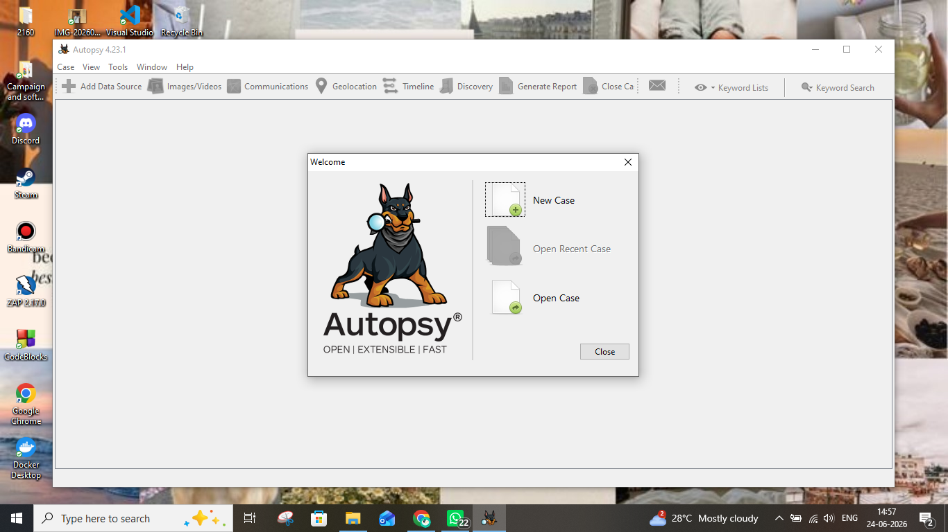
Screenshot 1 - Autopsy 4.23.1 Welcome Screen showing the three case options

Step 2: Entering Case Information
The "New Case Information" wizard opened with two sub-steps: Case Information and Optional Information. In the Case Information step, the following details were filled in:
- Case Name: 1
- Base Directory: D:\New folder\
- Case Type: Single-User (selected)
The case data storage path was automatically set to D:\New folder\1. After filling in the details, the "Next" button was clicked to proceed.
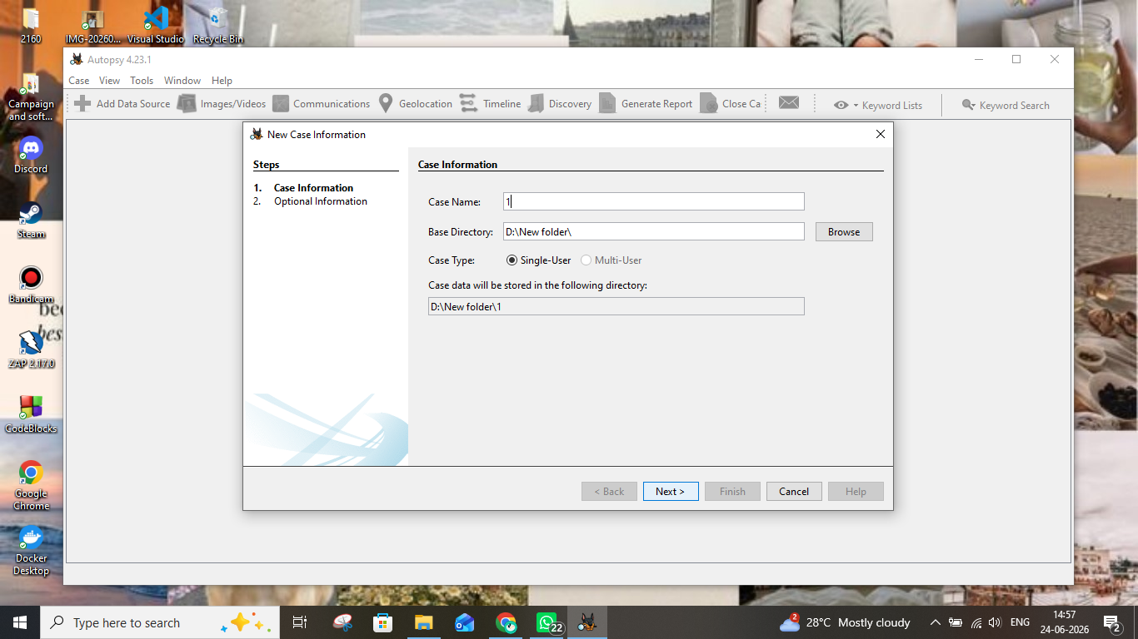
Screenshot 2 - New Case Information dialog - entering Case Name and Base Directory

Step 3: Filling in Optional / Examiner Information
The second step of the new case wizard required examiner and organization details. The following information was entered:
- Case Number: 1
- Examiner Name: shubham
- Phone: na
- Email: na
- Notes: test
- Organization: Not Specified
After completing all fields, the "Finish" button was clicked to create the case.
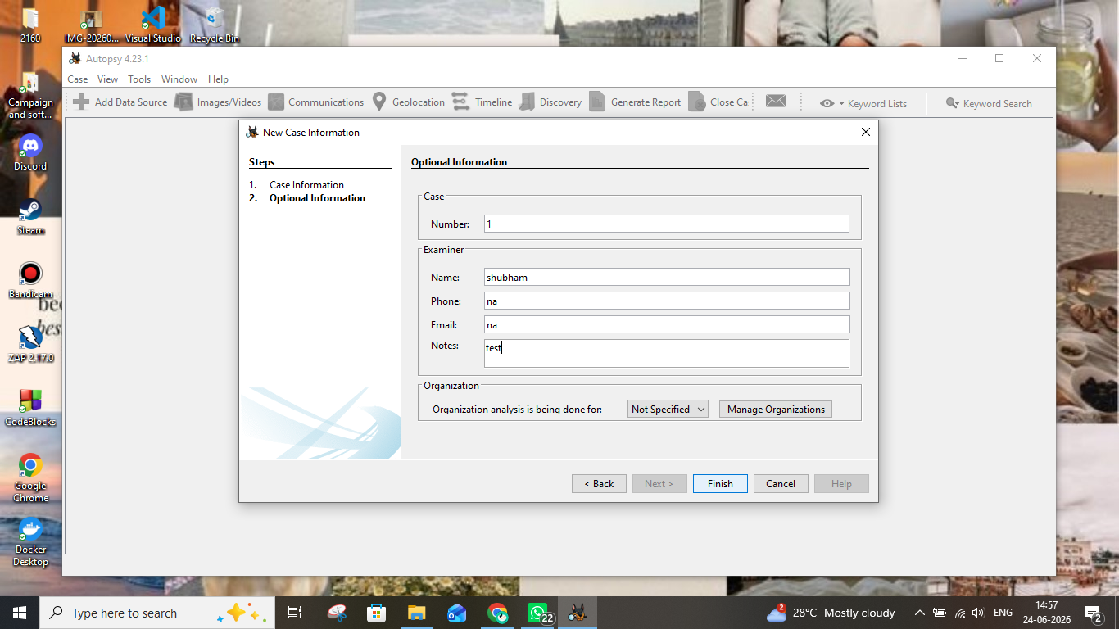
Screenshot 3 - Optional Information step with Examiner name "shubham" and case notes

Step 4: Adding a Data Source - Selecting the Host
Once the case was created, Autopsy prompted to add a data source through the "Add Data Source" wizard. The first step required selecting how the host should be identified. The option "Generate new host name based on data source name" was selected (default), which automatically assigns a hostname from the evidence file name.
The wizard consists of 5 steps: Select Host, Select Data Source Type, Select Data Source, Configure Ingest, and Add Data Source.
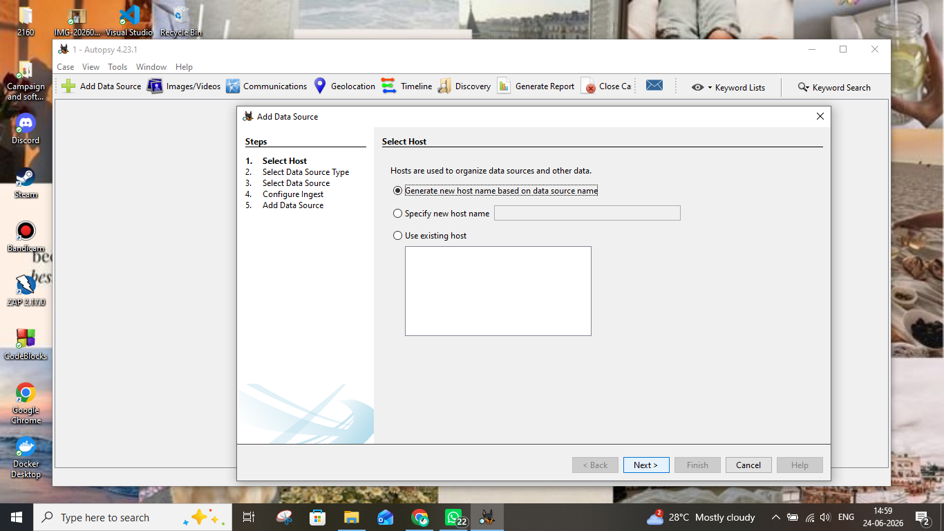
Screenshot 4 - Add Data Source wizard: Step 1 - Select Host configuration

Step 5: Selecting the Data Source Type
In Step 2 of the Add Data Source wizard, the type of evidence to analyze was selected. The available options were:
- Disk Image or VM File (selected)
- Local Disk
- Logical Files
- Unallocated Space Image File
- Autopsy Logical Imager Results
- XRY Text Export
"Disk Image or VM File" was chosen as the evidence is a Sony forensic disk image in .001 (EnCase/Expert Witness) format.
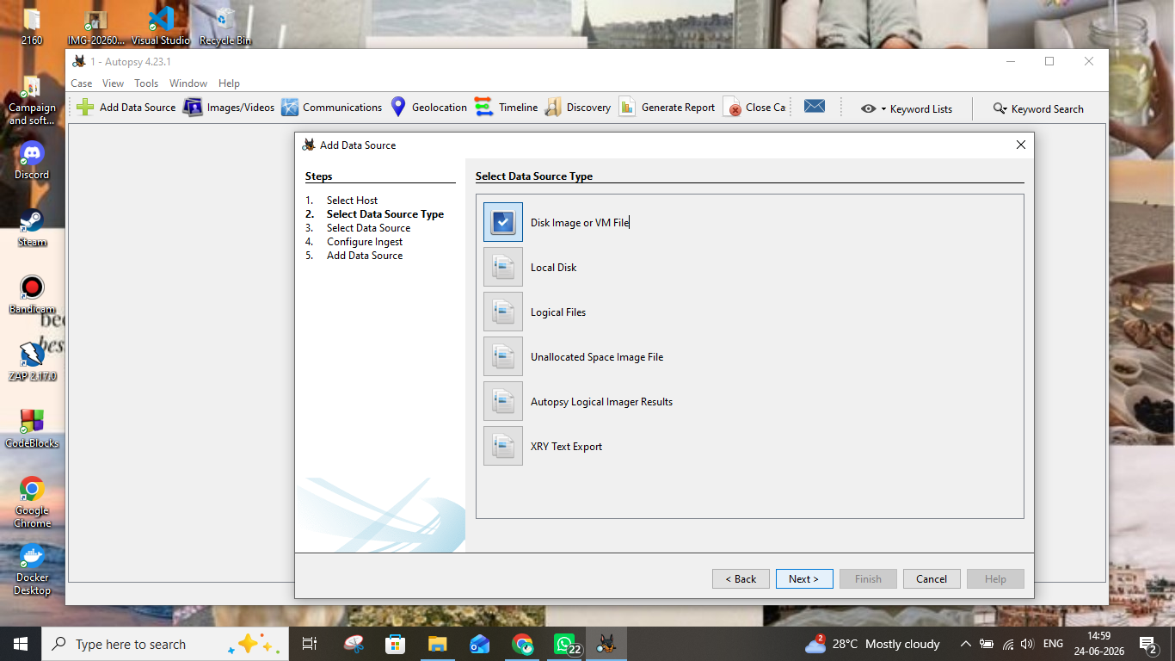
Screenshot 5 - Select Data Source Type: "Disk Image or VM File" selected

Step 6: Selecting the Evidence File
In Step 3 of the wizard, the actual path to the disk image was specified. The following configuration was applied:
- Path: D:\New folder\Sony .001
- Timezone: (GMT+6:30) Indian/Cocos
- Sector Size: Auto Detect
- Bitlocker Password: (left blank - not encrypted)
- Hash Values (MD5, SHA-1, SHA-256): left blank (optional integrity verification)
The "Browse" button was used to navigate to and select the Sony .001 disk image. Hash values were left blank as they were not provided with the evidence. After verifying the path, "Next" was clicked.
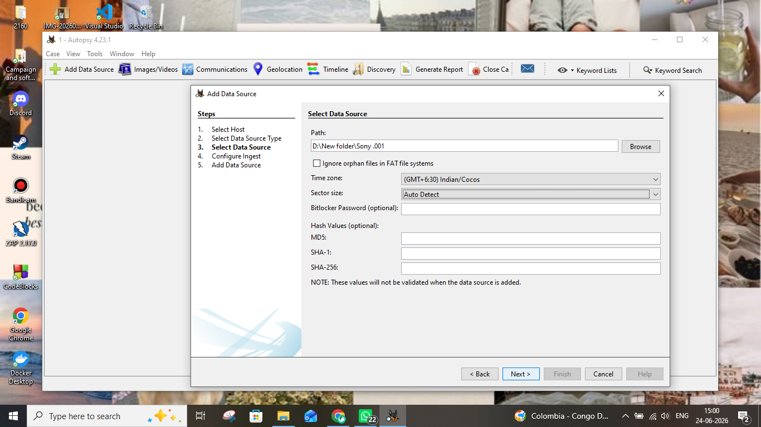
Screenshot 6 - Select Data Source: Sony .001 disk image path and timezone settings

Step 7: Configuring Ingest Modules
Step 4 of the wizard allowed configuration of ingest modules - the analysis plugins that automatically process the evidence. The scope was set to "All Files, Directories, and Unallocated Space". The following ingest modules were enabled:
- Recent Activity - recovers recently accessed files, browser history, etc.
- Hash Lookup - checks files against known hash databases
- File Type Identification - identifies file types by signature
- Extension Mismatch Detector - flags files with wrong extensions
- Embedded File Extractor - extracts embedded files (e.g., archives)
- Picture Analyzer - analyzes images
- Keyword Search (highlighted/selected) - searches for keywords in files
- Email Parser - parses email artifacts
- Encryption Detection - flags encrypted content
- Interesting Files Identifier - flags suspicious files
- Central Repository - stores artifact data across cases
- PhotoRec Carver - carves deleted files from unallocated space
- Virtual Machine Extractor
On the right panel, keyword lists enabled included Email Addresses. OCR was not enabled. "Add text to Solr Index" was checked for full-text search. The "Keyword Search" module was highlighted in blue, confirming it was selected. "Next" was clicked to proceed.
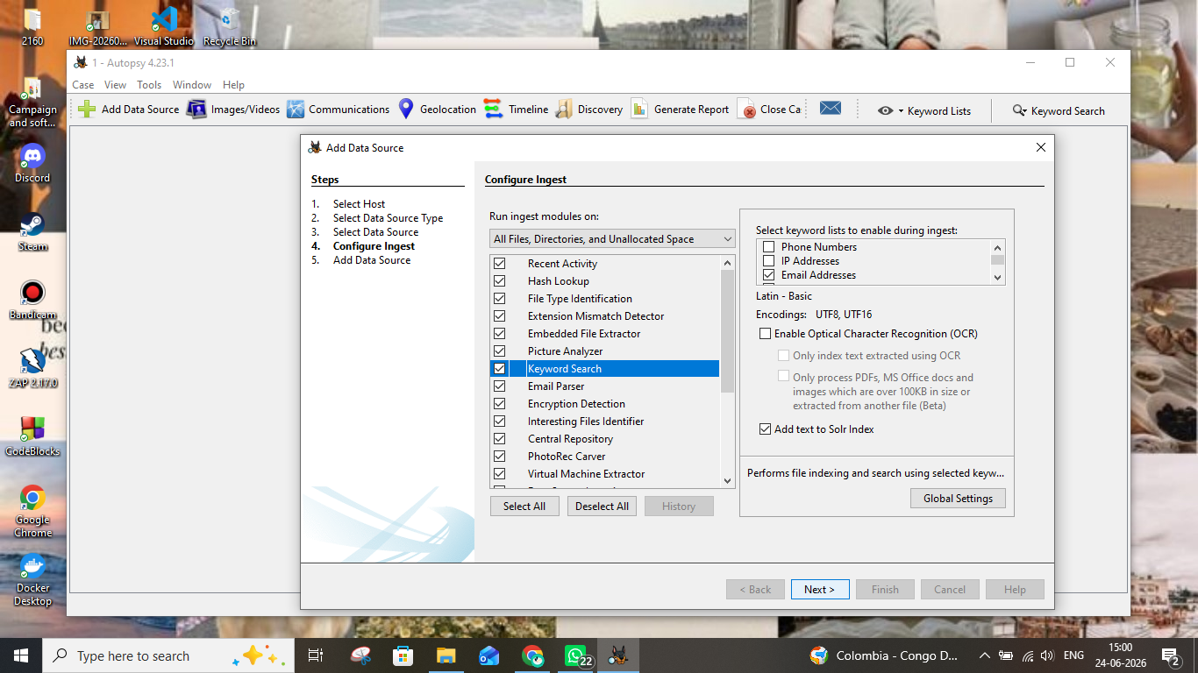
Screenshot 7 - Configure Ingest Modules with Keyword Search selected and modules enabled

Step 8: Data Source Processing Progress
After clicking "Next" in the Configure Ingest step, Autopsy began processing the data source. Step 5 "Add Data Source" showed:
- A progress bar indicating the data source was being processed
- Status: "Processing data source and adding it to a local database. File analysis will start when this finishes."
- A notification badge (2) appeared on the email icon in the toolbar, indicating some communications data was already identified
This step indexes the disk image structure into Autopsy's internal SQLite database before analysis begins. A note on screen warned: "This process may take some time for large data sources."
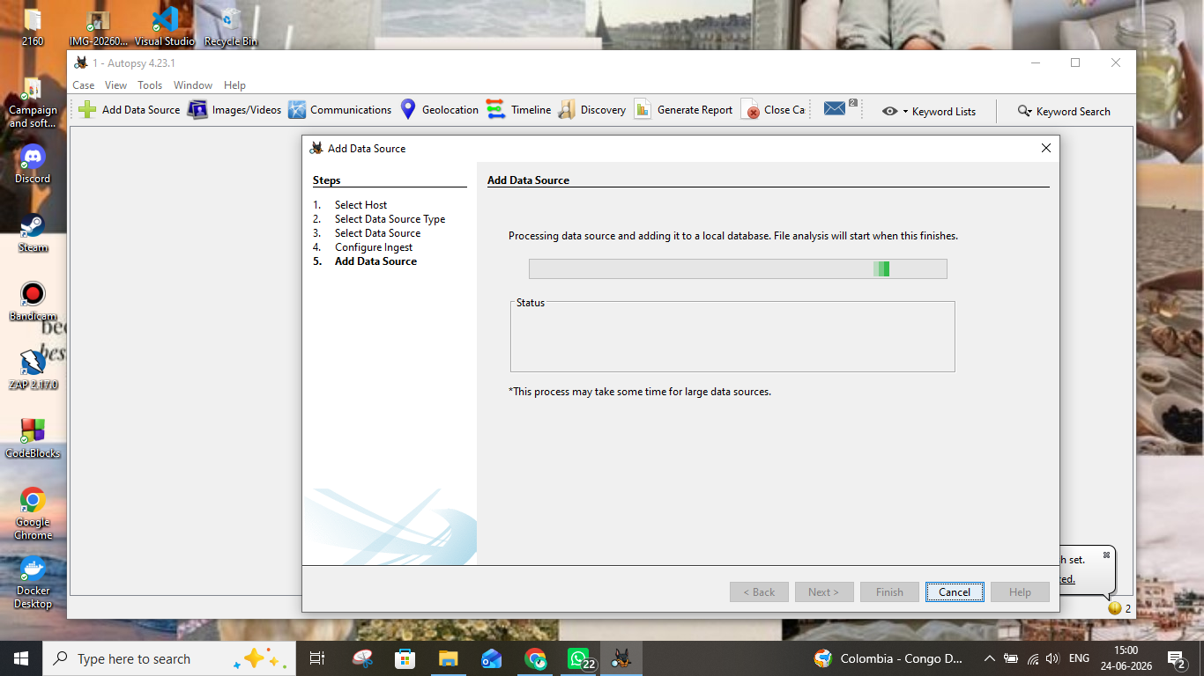
Screenshot 8 - Add Data Source Step 5: processing progress bar while indexing the disk image

Step 9: Data Source Successfully Added
Once the initial processing was complete, Step 5 confirmed: "Data source has been added to the local database. Files are being analyzed." The left-side tree panel in Autopsy was now populated with:
- Data Sources
- File Views (with sub-items: File Types, Deleted Files, File Size)
- Data Artifacts
- Analysis Results
- OS Accounts
- Tags
- Score
- Reports
The "Finish" button was now available and was clicked to close the wizard. Background ingest analysis continued running (visible in the status bar). The email notification showed a count of 10, indicating email artifacts found.
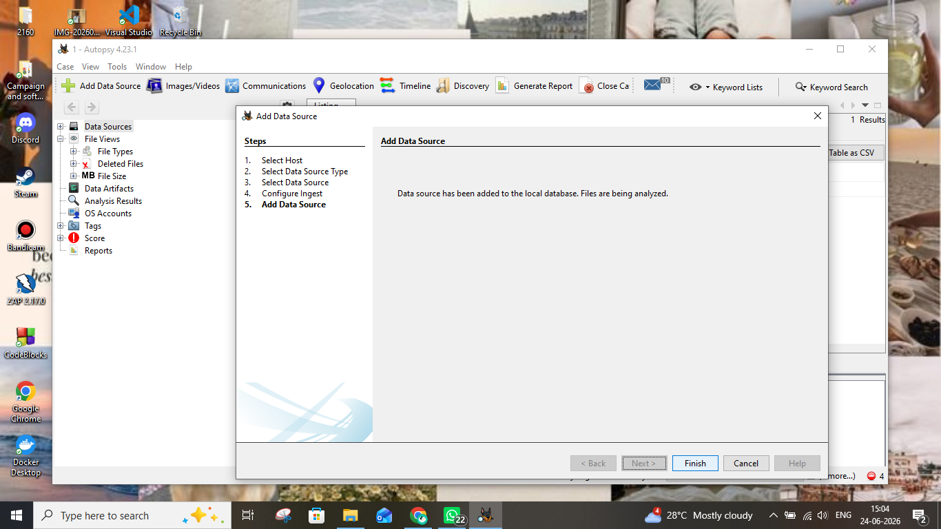
Screenshot 9 - Data source confirmed added; left panel shows tree structure; Finish button available

Step 10: Reviewing the Data Source in the Main Interface
After finishing the wizard, the main Autopsy interface displayed the "Listing" tab showing the Data Sources section. The Sony .001 disk image appeared as "Sony .001_1 Host" in the listing panel. The analysis was ongoing - the status bar at the bottom showed "Analyzing files from Sony .001" at 7% completion. The lower pane showed tabs for Hex, Text, Application, File Metadata, OS Account, Data Artifacts, Analysis Results, Context, Annotations, and Other Occurrences.
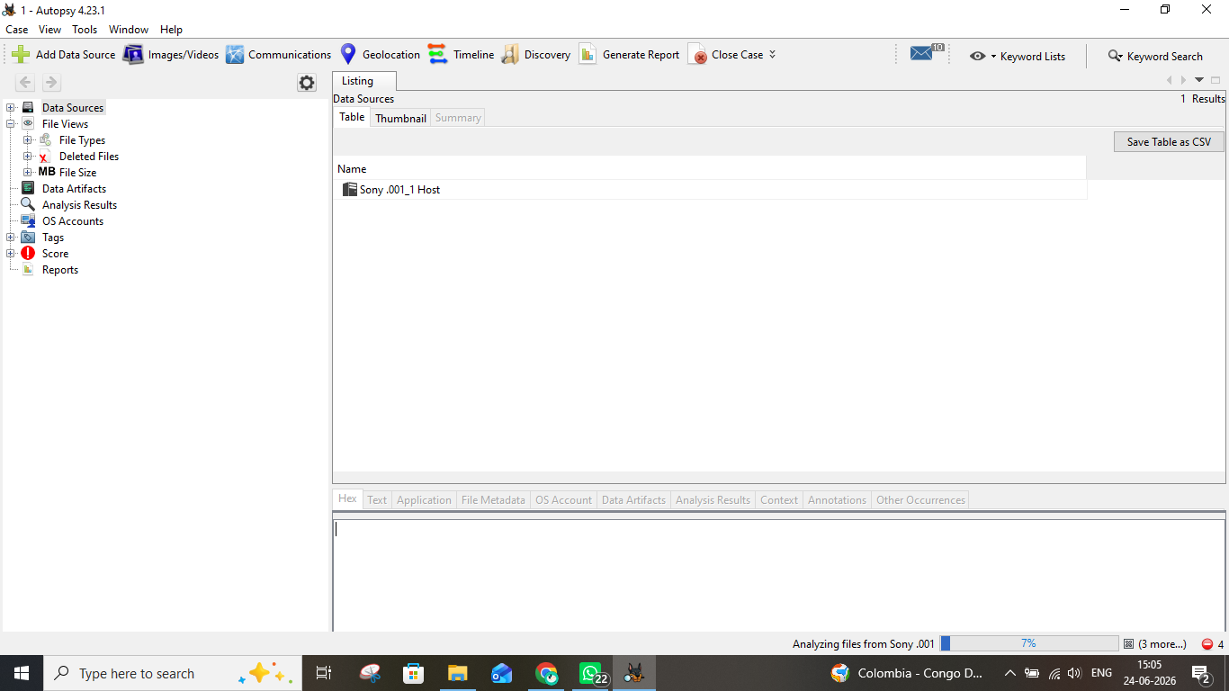
Screenshot 10 - Main interface showing Sony .001_1 Host data source; analysis at 7%

Step 11: Exploring the Image/Video Gallery
The Image/Video Gallery tool was opened by clicking "Images/Videos" in the top toolbar. This module displays all image files found in the evidence, organized by folder path. The left panel showed a folder tree navigating through the evidence directory structure:
- img_Sony.001 > vol_vol2 > OpenClaude-Portable-main > data > npm-cache > _cacache > tmp > 64e0a523 > 64e0a523 > 0
A folder named "0" was selected (highlighted in blue) containing a "package" subfolder with "scss (1)" and "styles (1)" subfolders. The center panel showed a thumbnail of an image file named "pojoaque.jpg" - a mostly black image. The Details panel on the right displayed:
- Name: pojoaque.jpg
- Analyzed: true
- Path: /img_Sony.001/vol_vol2/OpenClaude-Portable-main/...
The hash-set category panel at bottom showed zero hits for Child Abuse Material, CGI/Animation, and Comparison Images. The ingest was at 8% completion at this point.
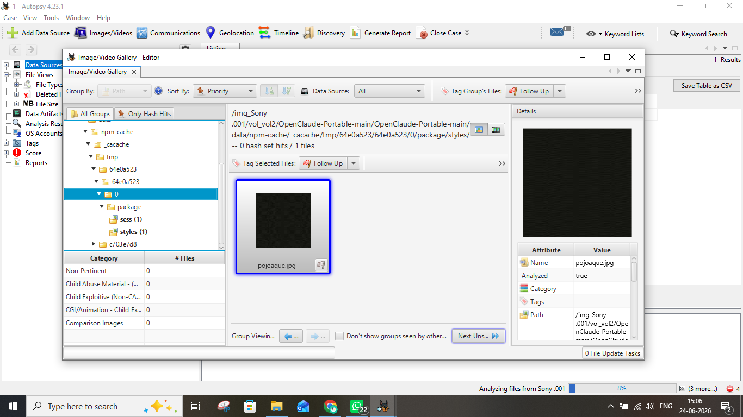
Screenshot 11 - Image/Video Gallery showing folder tree and pojoaque.jpg thumbnail

Step 12: Performing Timeline Analysis
The Timeline feature was opened by clicking "Timeline" in the top toolbar. The Timeline Editor displayed file system events plotted across time. Key observations:
- View Mode: Counts (bar chart showing event frequency, logarithmic scale)
- The X-axis spans from 1979 to approximately 2036, showing file timestamps across decades
- Significant activity spikes visible around 1997-1998 and 2024-2025
- The Y-axis uses a Logarithmic scale (number of events)
- Start time shown: 31-Dec-1979, 11:01:04 pm (earliest recorded timestamp)
The filter panel on the left allowed filtering by: text (Must include text), tagging (Must be tagged), and description visibility (Hidden Descriptions). Time zoom controls were available (Years/Days/Minutes). The lower panel showed Table, Thumbnail, and Summary views for selected time ranges.
Timeline analysis is useful for establishing a chronology of file system activity during an investigation. The analysis was at 10% completion.
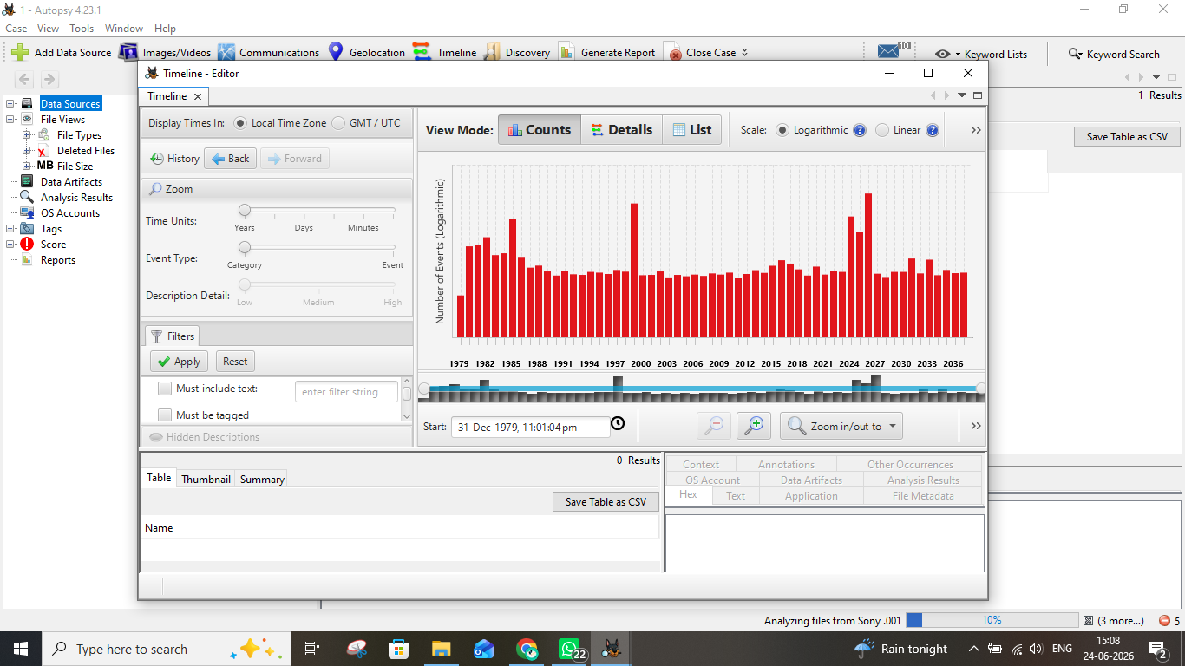
Screenshot 12 - Timeline Analysis showing file event counts from 1979-2036 in logarithmic bar chart

Step 13: Generating the Forensic Report - Selecting Report Module
To generate a forensic report, the "Generate Report" button was clicked in the top toolbar. The "Generate Report" wizard opened, showing the "Select and Configure Report Modules" screen. Available report format options included:
- HTML Report (selected) - produces an interactive HTML report of results and tagged items
- Excel Report
- Files - Text
- Data Source Summary Report
- Save Tagged Hashes
- Extract Unique Words
- TSK Body File
- Google Earth KML
- CASE-UCO
- Portable Case
"HTML Report" was selected as it provides a comprehensive, easily navigable report with all findings. The Header and Footer fields were left blank. "Next" was clicked to proceed.
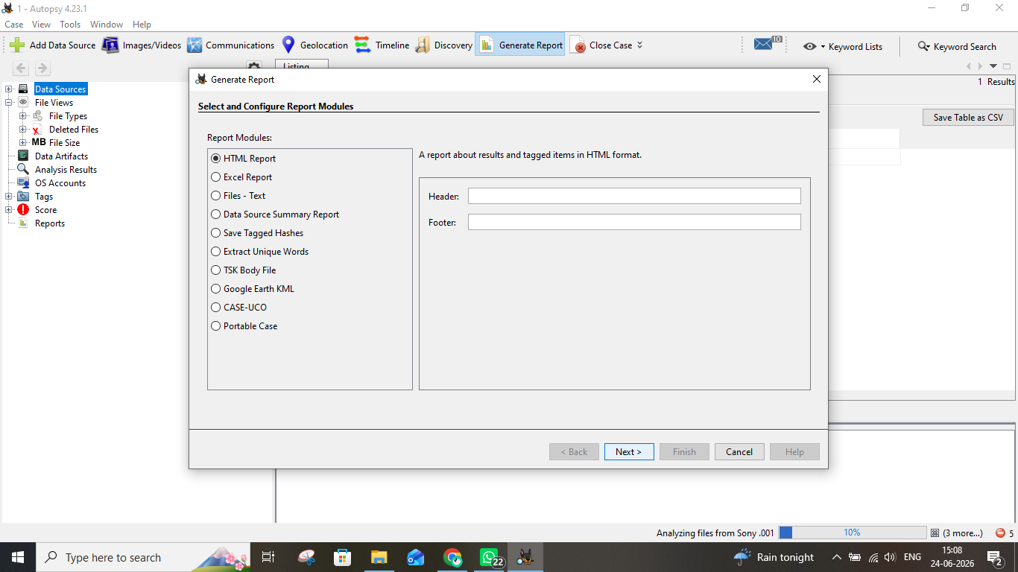
Screenshot 13 - Generate Report wizard: HTML Report module selected

Step 14: Selecting Data Source(s) for the Report
The next step of the report wizard asked which data source(s) to include in the report. The available data source was:
- Sony .001 (checked/selected)
The "Sony .001" checkbox was already ticked, indicating it would be included. The "Check All" and "Uncheck All" buttons allowed bulk selection. Since there was only one data source in this case, it was left checked and "Next" was clicked.
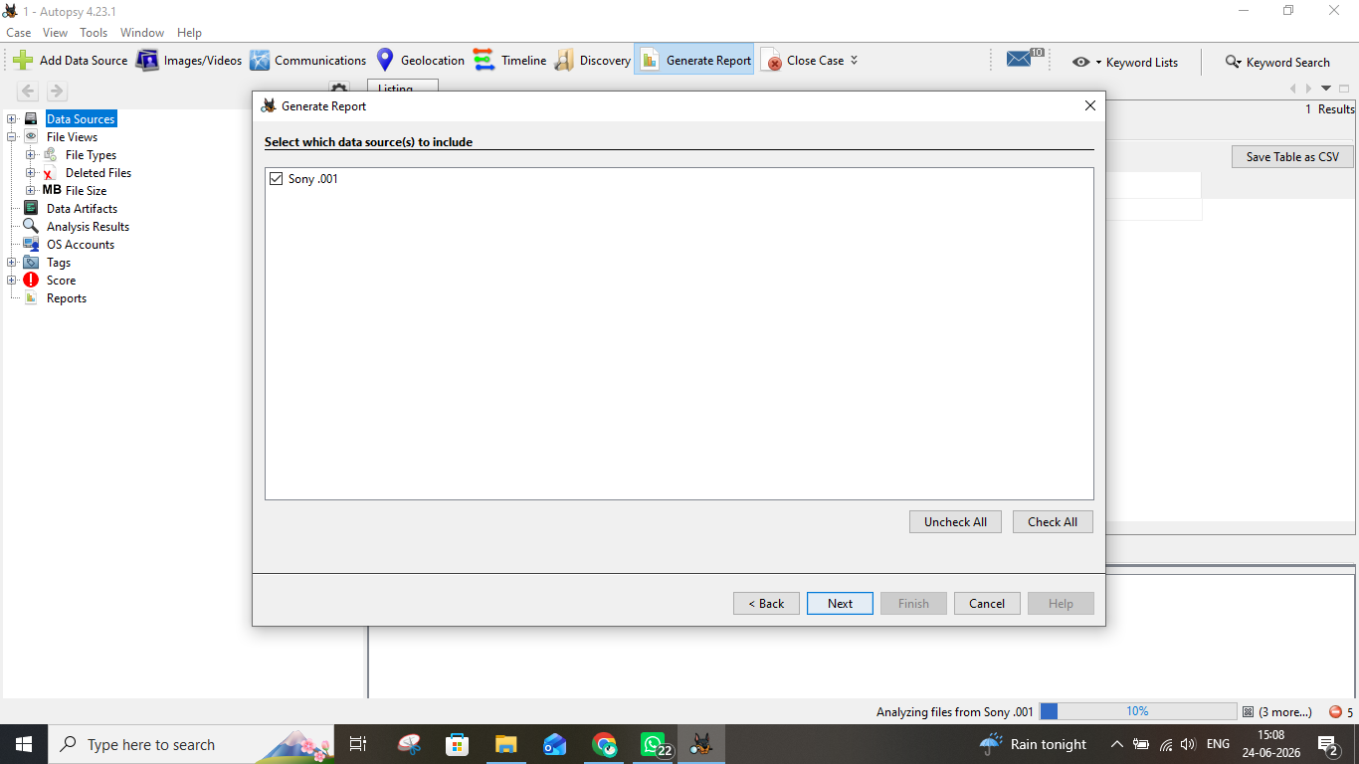
Screenshot 14 - Select data sources for report: Sony .001 checked

Step 15: Configuring the Report Content
The "Configure Report" step allowed selection of which data to include in the HTML report. Three options were available:
- All Results (selected) - includes all analysis findings
- All Tagged Results - only items that were manually tagged
- Specific Tagged Results - only specific tag categories
"All Results" was selected to include everything Autopsy had analyzed. The "Choose Result Types..." button was available to further refine which artifact types to include, but default settings were used. The "Finish" button was clicked to generate the report.
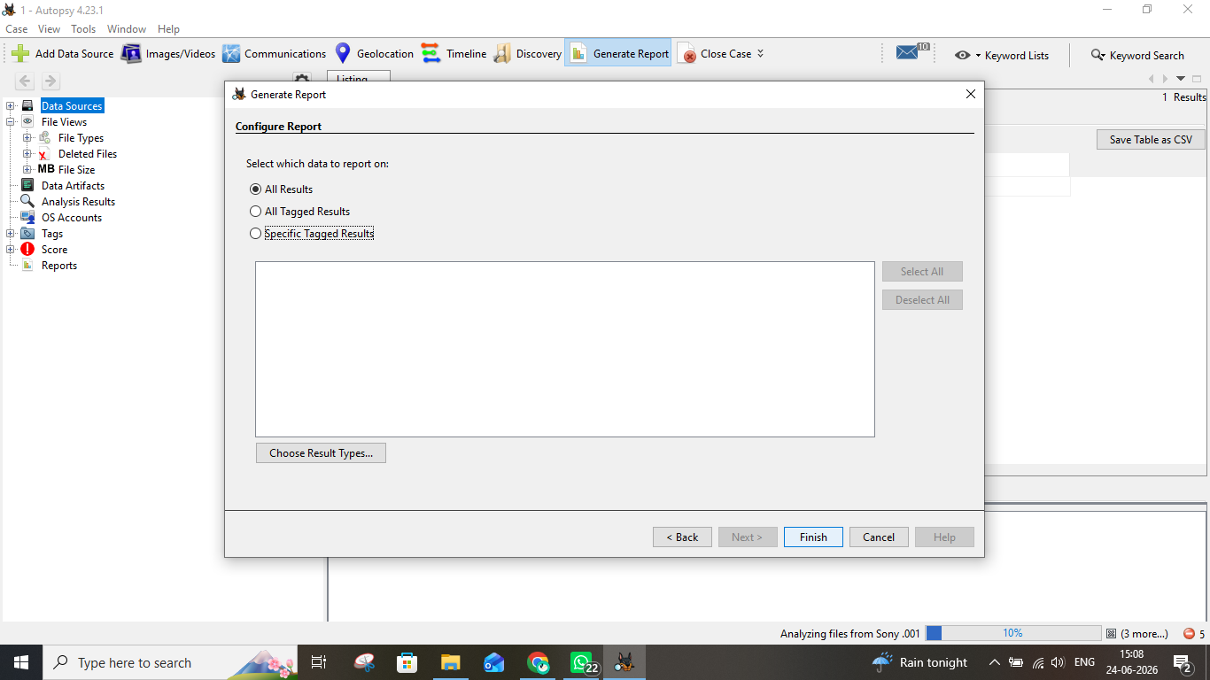
Screenshot 15 - Configure Report: "All Results" selected; Finish button ready

Step 16: Report Generation Complete
After clicking Finish, the "Report Generation Progress" dialog displayed a green "Complete" progress bar and confirmed the report location:
- Report Path: D:\New folder\1\Reports\1 HTML Report 06-24-2026-15-08-52\report.html
- Status: Complete
The report filename includes a timestamp (06-24-2026-15-08-52) for easy identification. The report was saved within the case folder structure under "Reports". The "Close" button was clicked to dismiss the dialog.
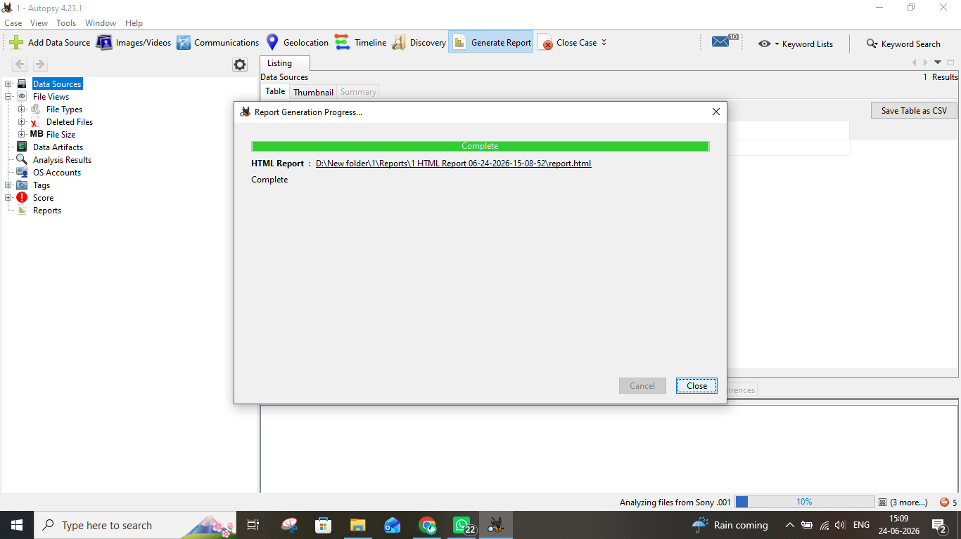
Screenshot 16 - Report generation complete with green progress bar and report path

Step 17: Viewing the Generated Autopsy Forensic Report
The generated HTML report was opened in Google Chrome browser from the file path: D:/New folder/1/Reports/1 HTML Report 2006-24-2026-15-08-52/report.html. The Autopsy Forensic Report displayed:
- Title: Autopsy Forensic Report
- Warning: "Warning, this report was run before ingest services completed!" (shown in red) - the report was generated while analysis was still at 10%)
- Case: 1
- Case Number: 1
- Number of data sources in case: 1
- Notes: test
- Examiner: shubham
The left navigation panel showed sections: Case Summary, Data Source Usage (1), Tagged Files (0), Tagged Images (0), Tagged Results (0). The "Image Information" section listed the Sony .001 disk image and its segment paths (Sony .001, .002, .003, .004, and more) stored in D:\New folder\.
Note: The warning about running before ingest completion means the report captured findings up to the point when "Generate Report" was clicked (approximately 10% through analysis). A complete report should be generated only after ingest finishes 100%.
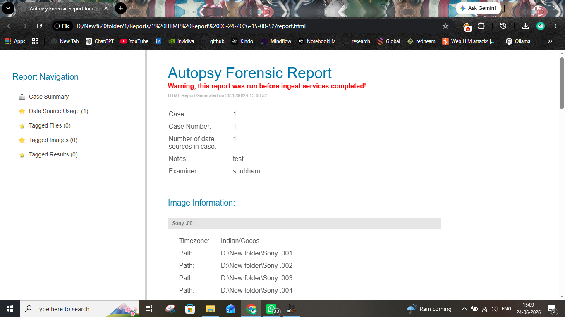
Screenshot 17 - Final Autopsy HTML Report viewed in Chrome showing case summary and image information

Summary of Steps
The following table summarizes all 17 steps performed during this Autopsy forensic investigation:

Step | Action | Key Details
1 | Launch Autopsy | Opened Autopsy 4.23.1; Welcome screen shows New Case / Open Recent / Open Case
2 | Create New Case | Case Name: 1, Base Directory: D:\New folder\, Single-User type
3 | Enter Examiner Info | Examiner: shubham, Case Number: 1, Notes: test, Phone/Email: na
4 | Select Host | Chose "Generate new host name based on data source name" (default)
5 | Select Data Source Type | Selected "Disk Image or VM File" for Sony .001 evidence
6 | Select Evidence File | Path: D:\New folder\Sony .001, Timezone: GMT+6:30 Indian/Cocos, Auto sector size
7 | Configure Ingest Modules | All modules enabled including Keyword Search, PhotoRec, Hash Lookup, Email Parser
8 | Data Source Processing | Progress bar shows data source being indexed into local database
9 | Data Source Added | Confirmation: database populated; tree panel shows File Views, Artifacts, Reports
10 | Main Interface | Sony .001_1 Host visible in Data Sources; analysis running at 7%
11 | Image/Video Gallery | Browsed folder tree; pojoaque.jpg found; 0 hash set hits for known bad content
12 | Timeline Analysis | Events plotted 1979-2036 logarithmic chart; peak activity at 1997 and 2024-2025
13 | Generate Report - Select Module | HTML Report format selected for comprehensive output
14 | Report - Select Data Source | Sony .001 data source selected for inclusion in report
15 | Report - Configure Content | "All Results" selected to include all analysis findings
16 | Report Generation Complete | Report saved to D:\New folder\1\Reports\...\report.html
17 | View HTML Report | Report opened in Chrome; shows case summary, examiner info, image paths; warning: ran before ingest complete

Conclusion
This lab successfully demonstrated the complete workflow for conducting a digital forensic investigation using Autopsy 4.23.1. The following key competencies were demonstrated:
- Creating and configuring a new forensic case with proper examiner documentation
- Adding a multi-part disk image (.001 format) as a data source
- Configuring and running ingest analysis modules for automated evidence processing
- Navigating Autopsy's tree-based evidence browser for exploring the disk image structure
- Using the Image/Video Gallery to visually review media files and check against known-bad hash sets
- Performing Timeline Analysis to establish a chronological record of file system activity
- Generating an HTML Forensic Report documenting all findings

Important Note: The report was generated while ingest was still running at approximately 10% completion. For a complete and final forensic report, it is best practice to wait until all ingest modules have finished processing (status bar shows 100%) before generating the report. This ensures all artifacts - including keyword search hits, carved files, and email artifacts - are fully indexed and included.

The Sony .001 disk image investigation yielded initial findings including images within npm cache directories, email/communication artifacts (10 items flagged in the notification bar), and file system events spanning from 1979 to the present day as captured in the Timeline. Further analysis with completed ingest would reveal the full scope of evidence contained in the disk image.

