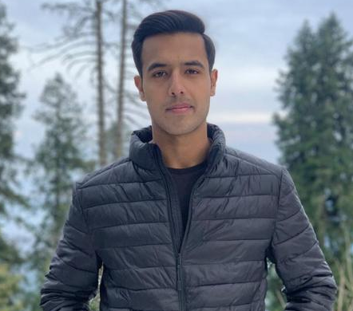
DAWER BILAL

Mobile: +44 7587499542
15 Lockwood Scar Huddersfield
dawar.bhangu@gmail.com

Career Objective:

A self-motivated ACCA student, along with a high level of curiosity and initiative in pursuing a challenging career in the professional life. I aim to get hold of a position at a well-known organization that helps me improve my learnings and enhance my capabilities.

Personal Information:

Nationality: | Pakistani
Religion: | Islam
DOB: | 14-02-2000
Gender: | Male
Marital Status: | Single

Qualifications:

2018 - present ACCA part qualified
PAC

2016-2018 A levels
University College Lahore

2013-2016 O levels
Bloomfield Hall School

Experience:

- Evergy Solar Ltd 2020 – 2022
(Assistant Accountant)

References:

- Available on request

