Eldho Mannaparambil Varghese
System Support Engineer

 +447471059670  eldhomv12@gmail.com
https://www.linkedin.com/in/eldho-mannaparambil-varghese-7401b9127/
31 Rycroft,Stevenage,United Kingdom

summary

A highly motivated and dedicated individual with a master’s from the University of Hertfordshire. I am passionate about evolving in IT support and am excited at the prospect of pursuing my carrier in this field.

EDUCATION

MSc in Computer Networking and System Security
January 2021-2023
University of Hertfordshire, Hatfield, United Kingdom
- Bachelor of Computer Application
June 2014-2017
Mahatma Gandhi University, Kerala, India

Experience
1. System Administrator in Urogulf Group of Companies (March 2018 –January 2021)
- Worked as L1
- Worked in Tickets based system.
- Create and maintain Active directory environment management documentation on an as-necessary basis
- Assisted in the administration of Office 365 accounts and services.
- Performed user account management tasks such as creating new accounts, resetting passwords, and managing user permissions.
- Helped resolve technical issues with Office 365 applications and services.
- Makes recommendations to purchase hardware and software, coordinates installation and provides backup recovery
- Built, installed, and configured servers in a data centre environment.
- Administered local and remote servers regularly providing weekly status reports to the Team head.
- Supporting data management through on-site & off-site storage and retrieval service.
- monitor and maintain computer systems and networks
- Installed new or existing servers and configure their hardware, peripherals, services, settings, directories, and network, storage following standards and project /operational requirements.
- Troubleshoot and resolve software and hardware problems, interface with vendor technical support to resolve problems and work with other technical staff to support their needs.
- Respond to security alerts with a risk evaluation and monitoring /report on unauthorised access attempts.
- Optimise performance by tracking daily utilisation to determine if problems are imminent.
- Installed and configured printers, cameras, and storages devices online and offline
- Managed security (Fortinet 100D and 80D) and network switches.

ProfESsional skill
- Knowledge of Microsoft Office, Active Directory
- Good knowledge of Linux flavour.
- Configure Routers, switches and security firewall
- Knowledge of Command-Line Utilities,
- File System Management, User and group management.
- Designing Network
- OPERATING SYSTEMS: RHEL 7, Ubuntu, Windows. Debian
- APPLICATION SERVERS: Apache, MySQL.
- PACKAGE MANAGEMENT: Red hat Package Manager, YUM.

certification
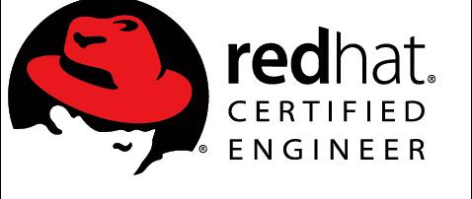
- Redhat Certified Engineer (RHCE)
Certification No:170-180-103
- Redhat Certified System Administrator (RHCSA) 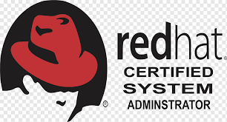
Certification No:170-180-103

Reference
- Nooh P S
Senior System administrator
Urogulf group
https://www.linkedin.com/in/nooh-ps-70947561/
noozzy786@gmail.com

