Use of GitHub

An Introduction

# Introduction

First up, here is some compulsory reading: <http://www.bloomberg.com/graphics/2015-paul-ford-what-is-code/>. Every last one of you should have read this by next time. There will be a quiz ☺

Now while you are going through the article, you will encounter GitHub. And you will see that it is *blooming-flowerbed fantastic!* And you will want to try it out *right away!*

Pleased to be of service …

# Getting It

You will need to download somethings. Go to <https://git-scm.com/download/> and click on the “downloads for Windows” button. See Figure 1.

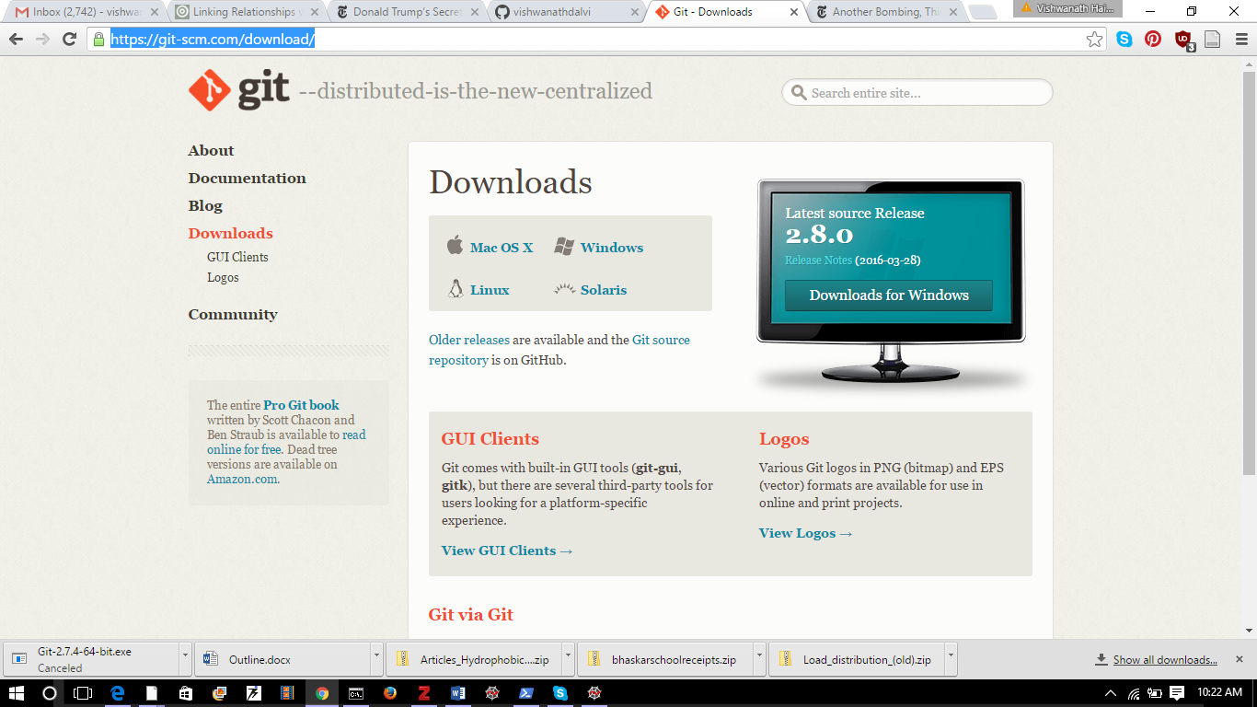

Figure 1: Click the Downloads for Windows Button

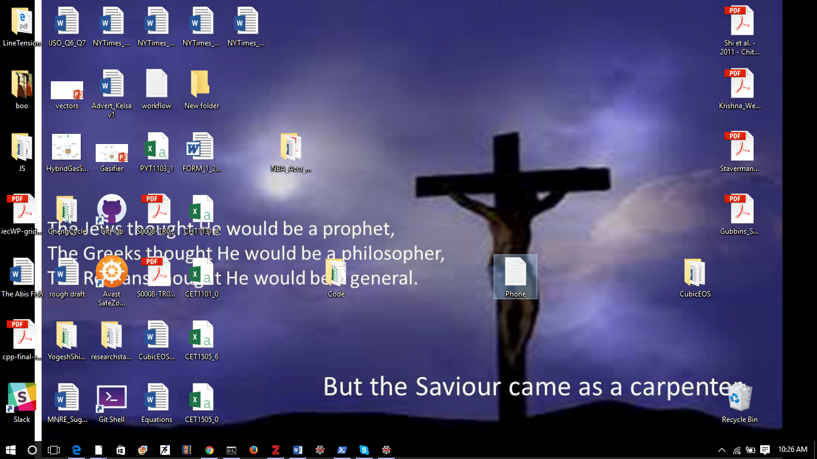That was easy. Wait for the .exe file to download and double-click on it to run it. Choose all the default settings so that *you don’t need admin privileges!*

You should get a Git Shell icon on your desktop. It looks like this:

Double-click it. You should get something like Figure 2.

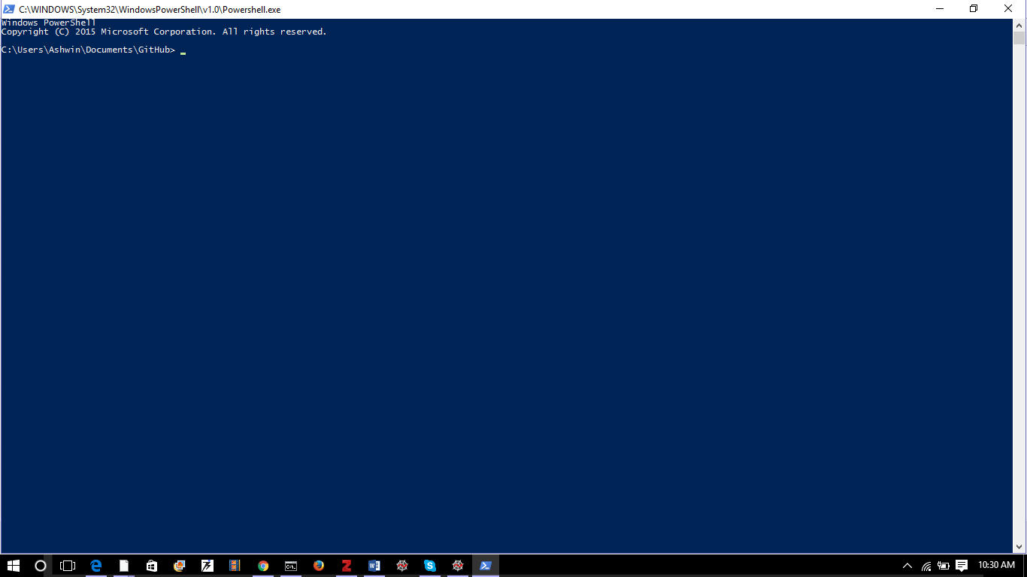

Figure 2: The Windows Power Shell

Great! Now you have GitHub!

# Using It

Which is not much good if you can’t use it. GitHub is a way of linking your local folder to a *remote repository* (new word!).

## Getting a GitHub Account

So you have to prepare the remote repository first. Lets do that. Go to <https://github.com/> . You will see the screen shown in Figure 3.

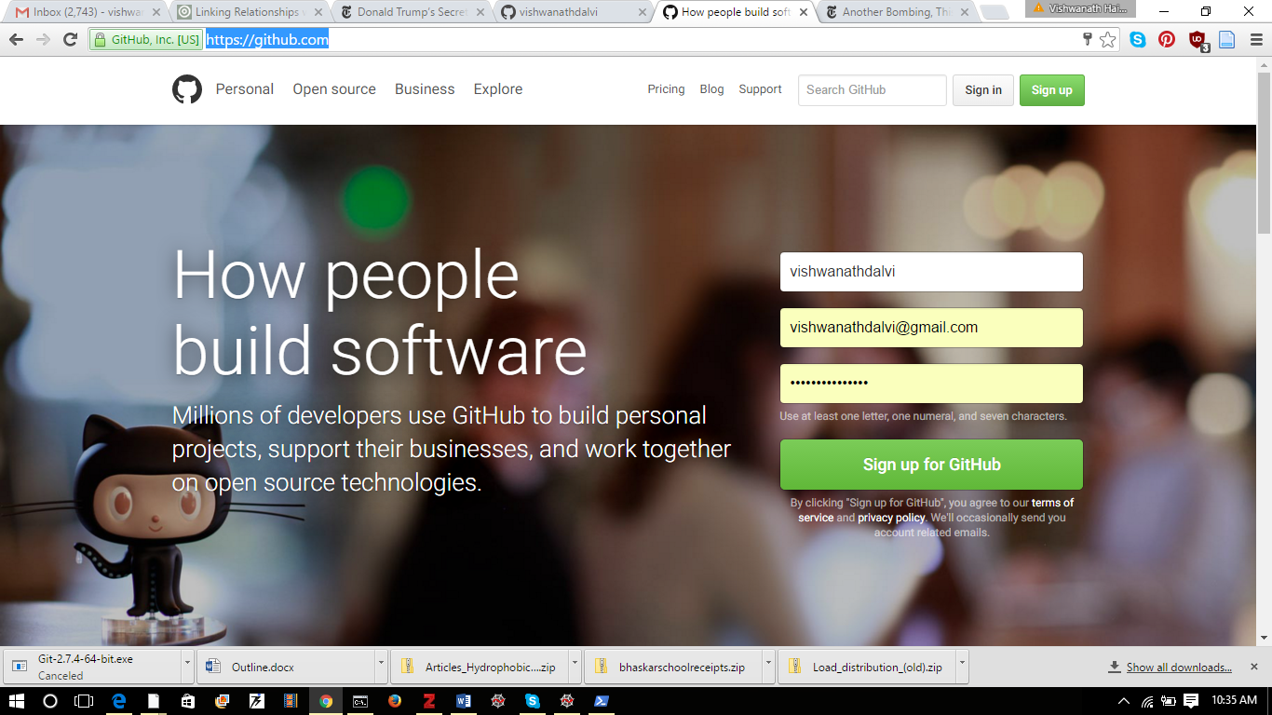

Figure 3: Sign-up for GitHub ☺

Go ahead and sign up: pick a username, enter your email id and pick a password (need not be the same as your email password). And sign-up!

## Make a Repository

You will be taken to the page shown in Figure 4. Click on the “New Repository” button. This will take you to the page shown in Figure 5. Fill it up and “Create Repository”! And there you have it: it looks like Figure 6. Copy the web-address of the repository to the clipboard. We will need it.

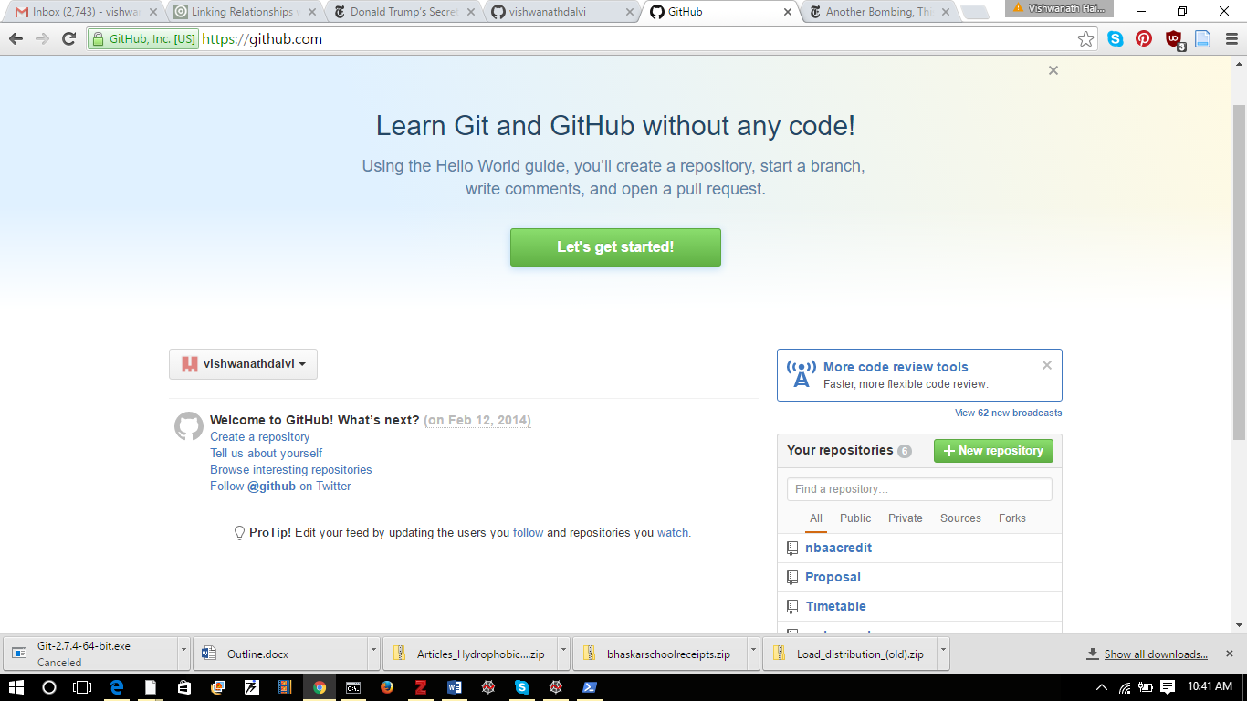

Figure 4: Your landing page. Click on “New Repository”

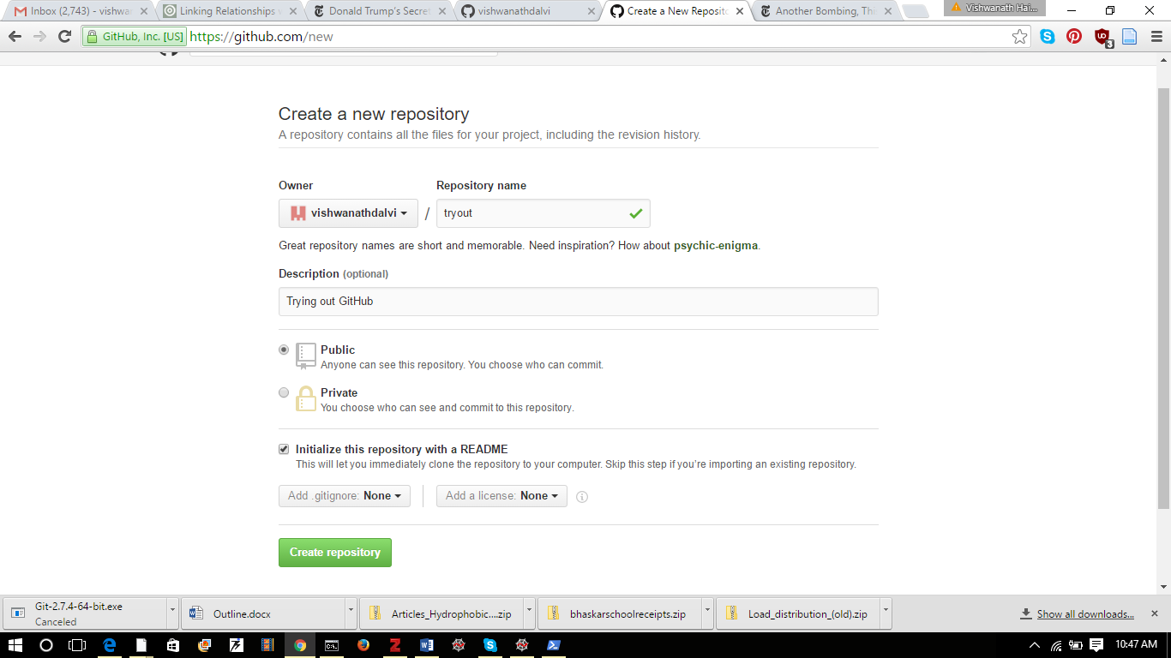

Press this button!

Tick this option

Some description:

Pick a name, any name.

Figure 5: Create New Repository!

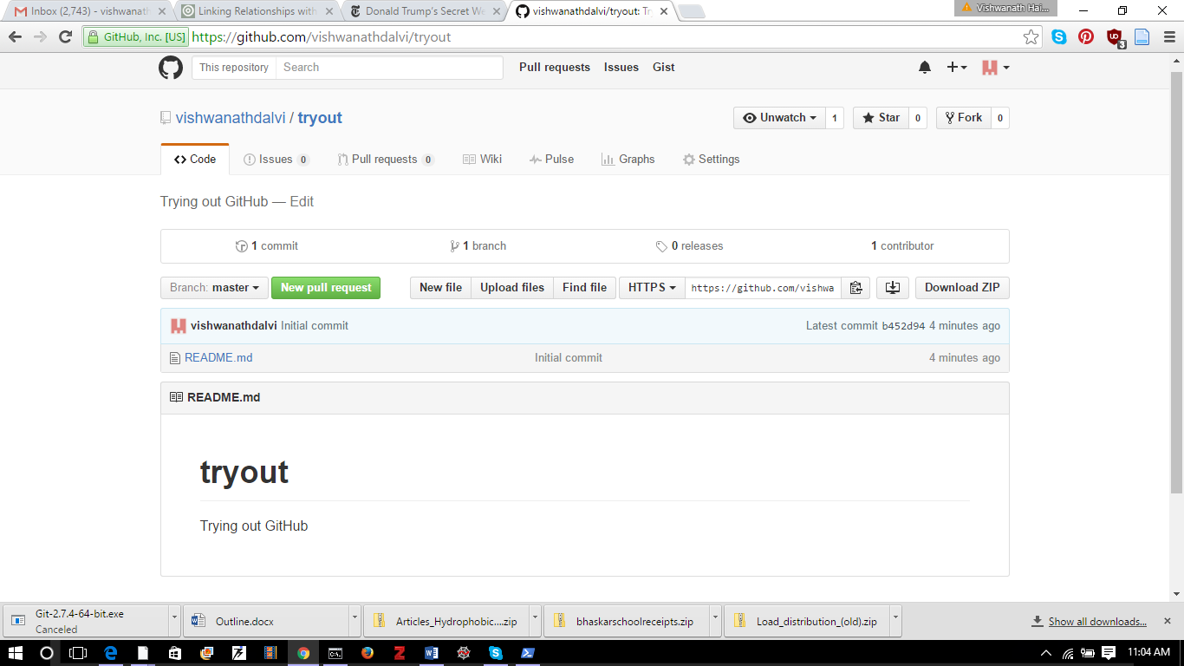

Click this to copy web-address to clipboard

Figure 6: Your new remote repository! Click the button indicated to copy its web address to clipboard: we will need it soon.

## Local to Remote Linking

Now you need to link your remote repository to your local folder. This is how. Lets go back to the Windows Powershell. See Figure 7.

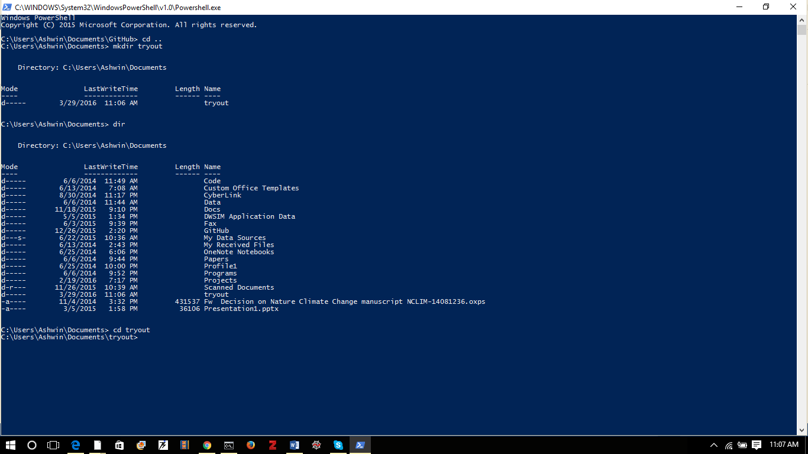

Enter the folder called “tryout”

There it is!

List contents of the folder

Make New Directory called “tryout”

Figure 7: Make new directory called “tryout” (**same name** as the remote repository) and enter (“cd”) into it. Folder and Directory mean the same thing here.

Now comes the git magic! See Figure 8:

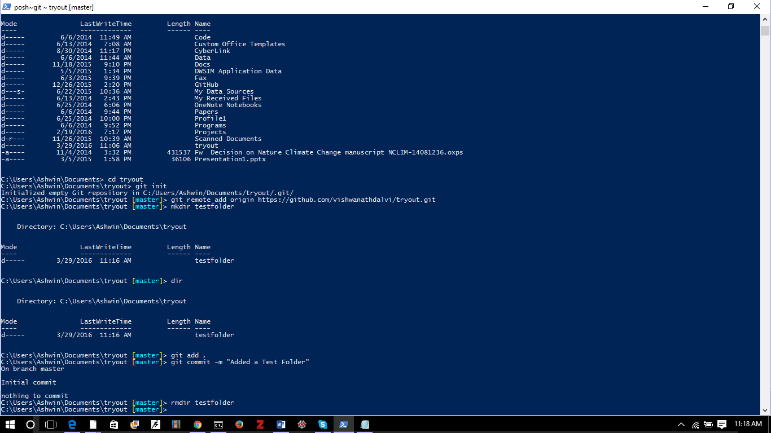

Figure 8: Turn this folder into a local repository using “git init”. You will see it is not tagged with [master]. Connect it to the remote repository using: “git remote add origin [paste address from clipboard]”. This is where you need the address you had previously copied to clipboard. Now “origin” will stand for the remote repository and “master” will stand for the local repository.

# Add, Commit, Push, Pull

Now imagine we have done some work in the folder called tryout. We have two (right now pretty useless) word files there (that’s right, Git works will *all* types of data, including word files. It’s not just for python code ☺). The folder looks like Figure 9:

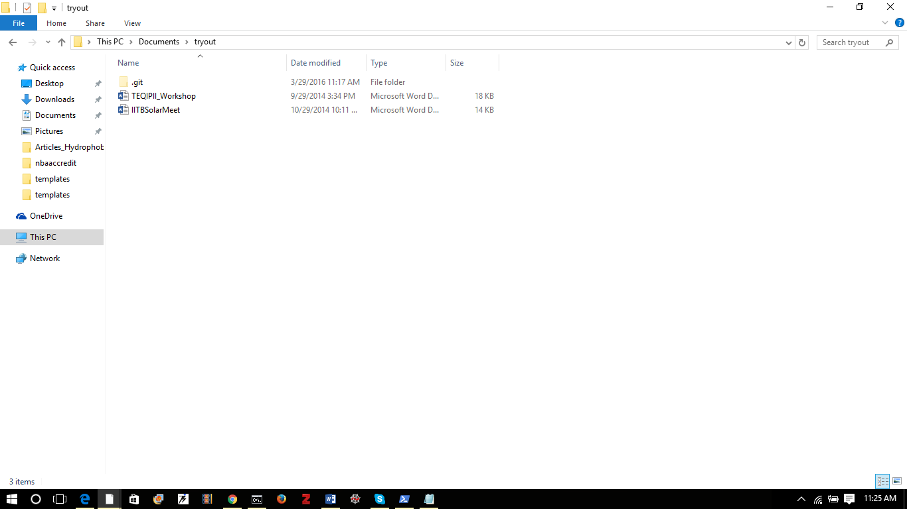

Figure 9: Our local repository with some word files.

First lets merge the remote with the local using the “git pull origin master” command. See Figure 10.

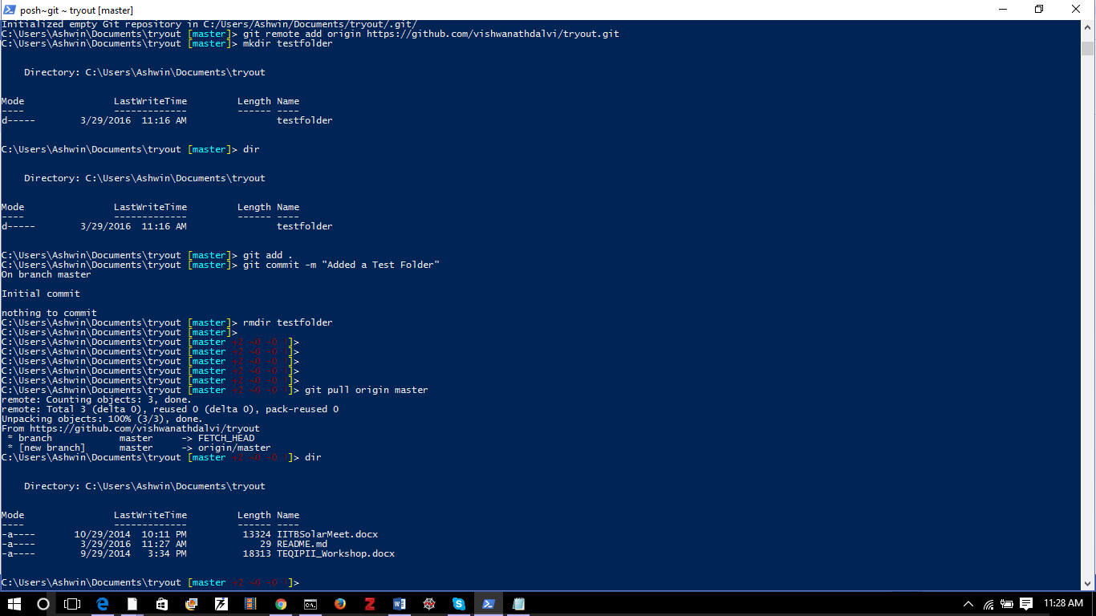

Remote and local data together in local repository

Pulling data from remote repository

Figure 10: We “pulled” data from the remote repository. Hence now the local repository also contains the README.md file in addition to the two word files already there.

Now lets “add” changes using “git add .” . The ‘.’ implies ALL changes. Add is equivalent to putting a letter in an envelope. Now lets commit changes using “git commit –m ‘Commit message’” where commit is the equivalent of stamping and sealing the envelope. A commit message is useful to figure out later what changes happened. Now to *post*  the changes to the remote repository we use: “git push origin master”. See Figure 11for the commands and Figure 12 for a snapshot of the remote repository after the push operation.

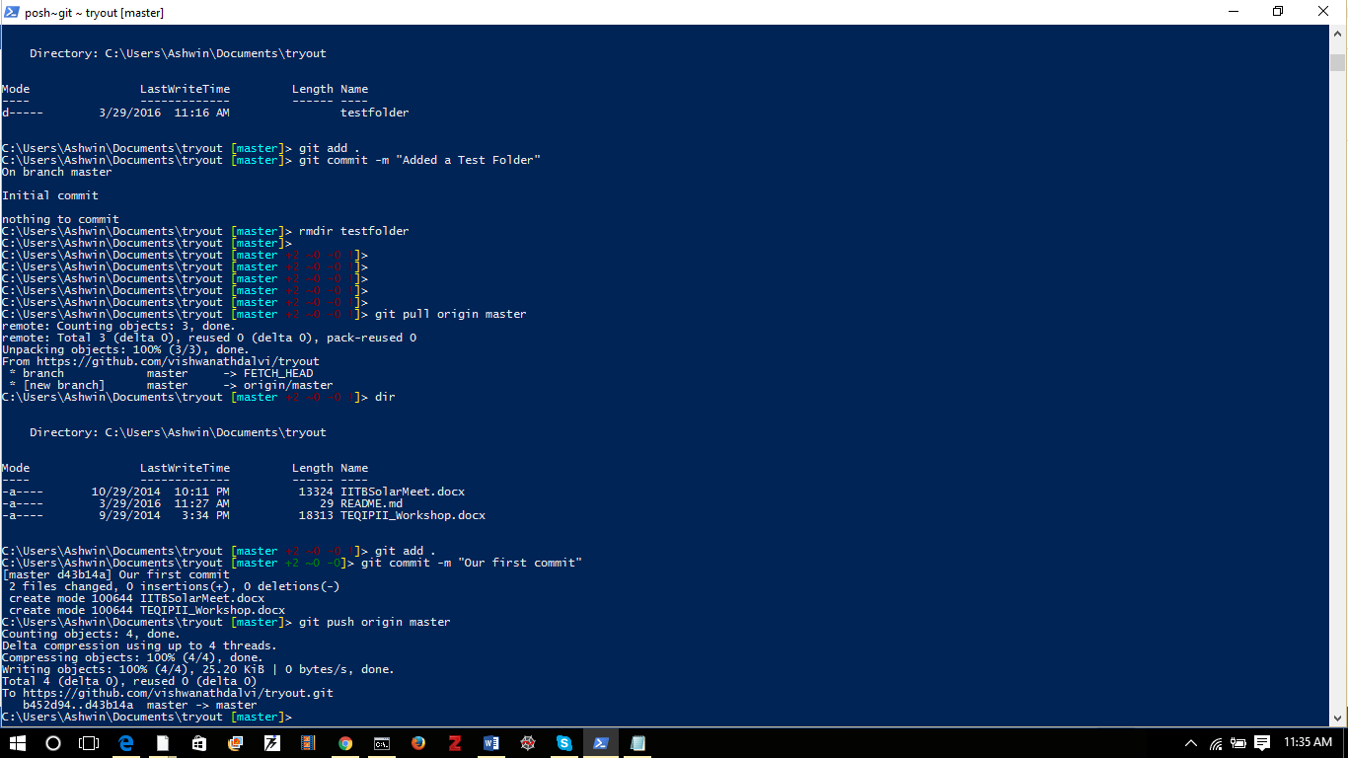

Figure 11: Common git operations. Add is equivalent to putting a letter in a envelope, commit is sealing the envelope and push is posting the envelope. Origin is the remote repository and master is the local repository.

Refresh the remote repository and it will look like this:

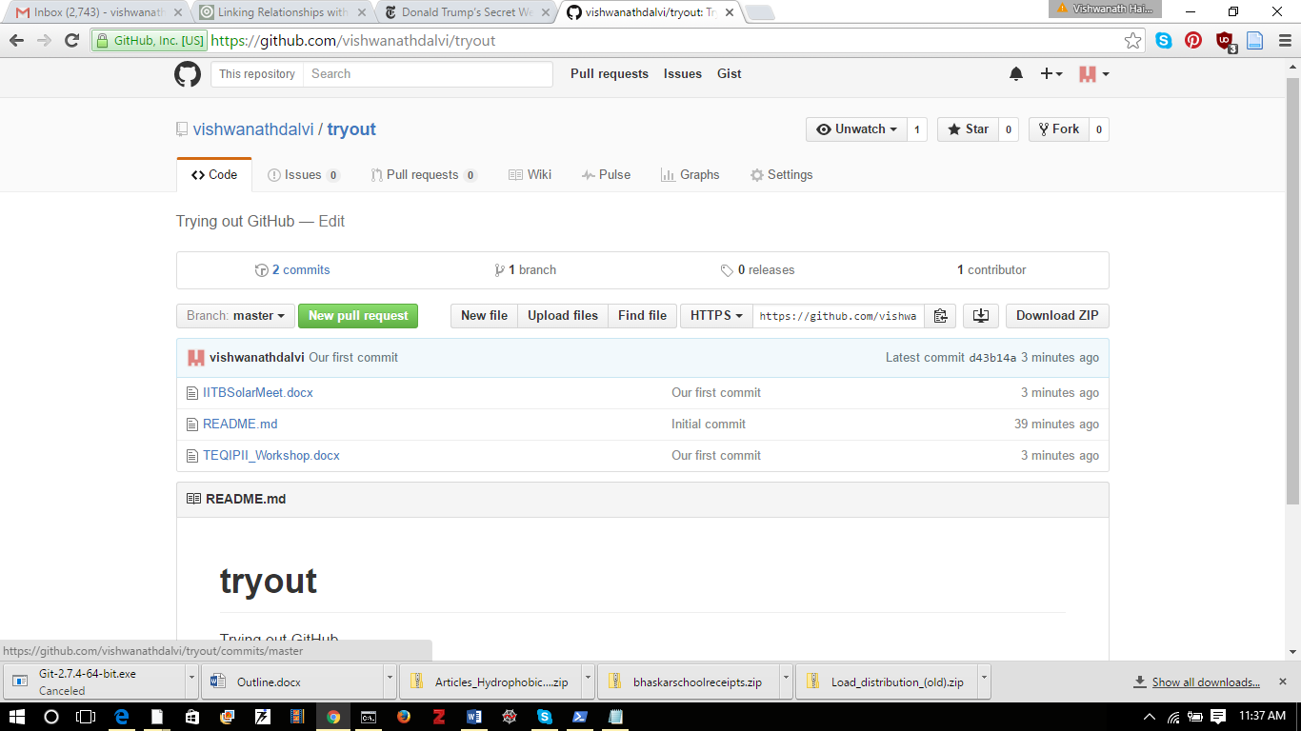

Figure 12: The updated remote repository: See how there are the new files there. You can download the files directly by clicking on them. Or you can clone the repository on another machine.

# Cloning

Now if you see some wonderful git repository which you would like to work on, you can *clone* it to your local machine to work on it. To do so, you first get the address of the git repository you would like to clone (see Figure 6).

“git clone [address of remote git repository to be cloned] [name of local folder]”

Hence if we want to clone (for whatever reason) our remote repository <https://github.com/vishwanathdalvi/tryout.git> to a folder called “tryout_2” we can do it like this:

“git clone <https://github.com/vishwanathdalvi/tryout.git> tryout_2”

Go ahead. Try it!

# Further Reading

So we started with a reading assignment. Now lets end with one:

Read this: <https://git-scm.com/book/en/v2>

Note that using GitHub will be compulsory for all projects from now on. Get on it ☺