Shubham Sharma
Section L
CPRE 308

Lab 2: Report

Summary of what I learned in various sections.[not more than 2 paras]

..

Experiments:

Experiment 3.1:

Screenshot of “ps -l”
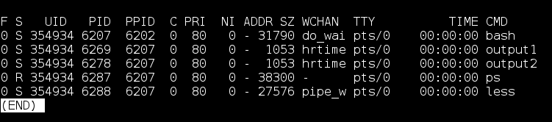
Here we can see the following items:
- Output: A table with information of the running processes in the terminal window
- Process Name: This on the column CMD. There output names for the two processes are output1 and output2 as seen in the column
- Process State: As seen from the screenshot below, we can find out the process state codes by looking through the man page. According the the man page, the two created processes are ‘S’ which means that they are in ‘interruptible sleep’
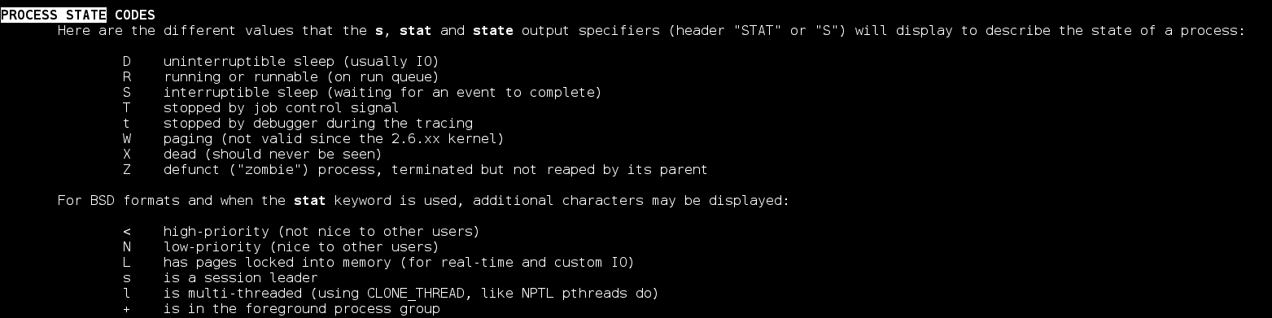
- Process ID (PID): The PID of output1 is 6269 and the PID of output2 is 6278 as seen in the PID column
- Parent process ID (PPID): The PPID of output1 and output2 is 6207. They have the same PPID as they are created by the same process.

Screenshot of the repeated experiment:
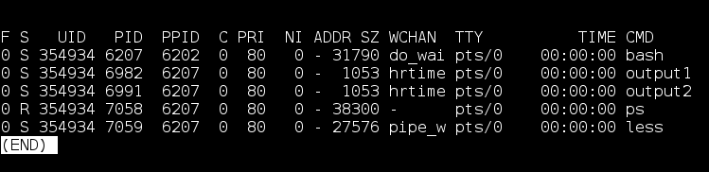
When comparing the repeated experiment we can see that a 2 main things have changed.
The PID of output1 and the PID of output2. This is because we ran a new process in the repeated experiment which created new processes, due to this they were given a new PID.

Other fields did not change as much as it is running the same instance of the parent process. For example we can see that the PPID of all of the process is the same in the repeated experiment. This is because the parent process was not stopped, hence it still is running the same instance.

Screenshot demonstrating the use of the ‘killall’ command:
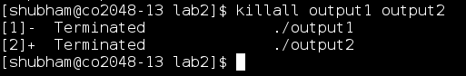

Here we terminated 2 processes using the ‘killall’ command. Since I created these processes in the terminal the system gave me permission to kill the processes.

Experiment 3.2:

Output of the program:
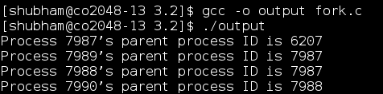

Process Tree:
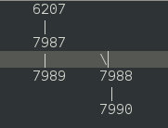

In the tree we can see that the total number of processes are 4. This makes sense as we call fork() only twice. As fork() by definition is creates a new process, which is called child process, which runs concurrently with the parent process. So on running 2 fork() commands will result in 2² = 4 total processes.

PPID for a process is 1:
This mean that the parent process has already completed running and exited by the time the third child checked for the parent's PID. That would have caused the child to be re-parented under init, due to which it has the parent process ID 1.

Experiment 3.3:

Screenshot of the completed program:
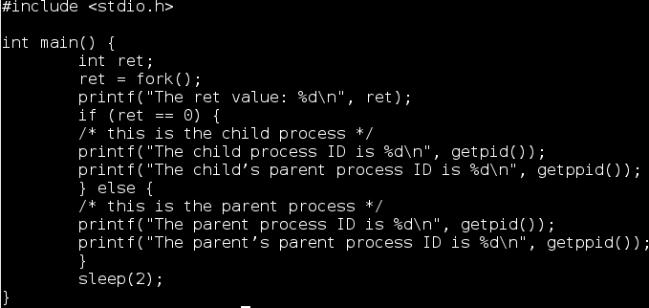

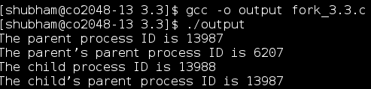

Screenshot of the ouput:

It is useful to have fork return different values for the parent and the child as it helps the programmer identify which is which, since fork() runs the same code in different threads. For example,

