Name: Shubham Sharma

Section: L

University ID: 866653811

**Lab 5 Report: The Linux Kernel**

Summary:

For this lab we were introduced to the Linux Kernel. We setup a working kernel on our computers so we can perform operations on it. Like loading and unloading a module, and performing operations associated to the driver.

1. List five architectures that the Linux kernel supports.
   * ARM
   * x86 Architecture
   * MIPS architecture
   * PowerPC architecture
   * SPARC
2. In your report list three filesystem types Linux supports
   * jfs
   * XFS
   * ext4
3. On the usermode terminal cd into the hello-world directory in the /host filetree. In that directory run the following commands and include their outputs in your lab report.
   * Outputs for the hello-world commands:

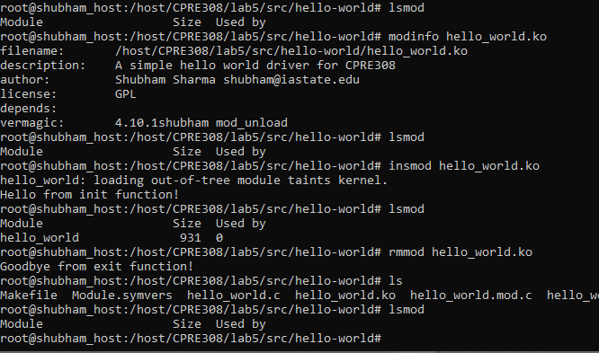

1. In your lab report comment on why the prototypes are not identical and what the extra parameters are for (use your intuition to help answer this question)
   * I think it is not identical because of the static state for the kernel. Also, looking at the arguments it makes more sense to use the ssize t read(struct file *file, char *buffer, size t length, loff t *offset) prototype as the arguments matches the character device example in the lab (while the other prototype does not).
2. In your report list six operations that files can support
   * read
   * rrite
   * open
   * iterate
   * llseek
   * read_iter
3. In your report give your expected output when the file is opened, written to, read from, and closed.
   * Opened
     + I already told you 0 times Hello World!
   * Written
     + Sorry, this operation isn’t supported
   * Read
     + <None>
   * Closed
     + <None>
4. From the um kernel cd into the hellofile directory and run insmod hello file.ko. In your lab report include the major number of the module
   * Output on running the command ‘insmod hello_file.ko’:

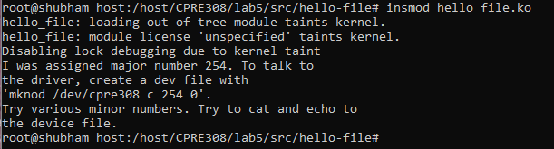

1. In your lab report mention the output of each of these:

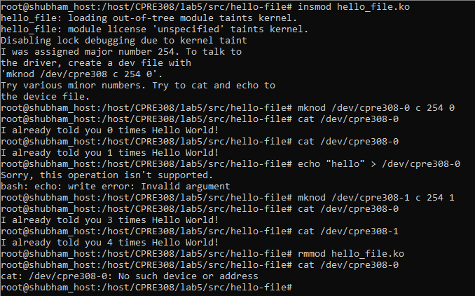

Any Comments, please email: shubham@iastate.edu