[CprE 381] Computer Organization and Assembly-Level Programming, Fall 2018

Project B - Report

Name(s) Diego Realpe Tobar and Shubbam Sharma

Section /Lab Time 5:10 – 7:00PM / L

Refer to the highlighted language in the Project B instruction for the context of the following questions.

- [Part 1] Explain the conflict and how it relates to assumption that we will be making for forwarding and hazard detection (Hint: It has to do with the fact that we assume an instruction in the ID stage will get the data being written by the WB stage).

Since all the stages of the MIPS architecture are organized where the first half reads information and the second half writes information. When we have the register file being asked information from the next ID and also info being written from WB on a rising edge then it could give us a hazard where we read old information and write it to the EX latch since the write from WB is still waiting for a rising edge. Hence we make it a falling edge to get it to write the register and when the moment to write to the latch it already has the updated value.

Give an example sequence of instructions that the processor we are designing will not be able to properly handle without additional logic or another change.

- [Part. 4] Provide a description of a few test cases (at least one test case for each of the six instructions) and clear screenshots depicting your functioning test cases.

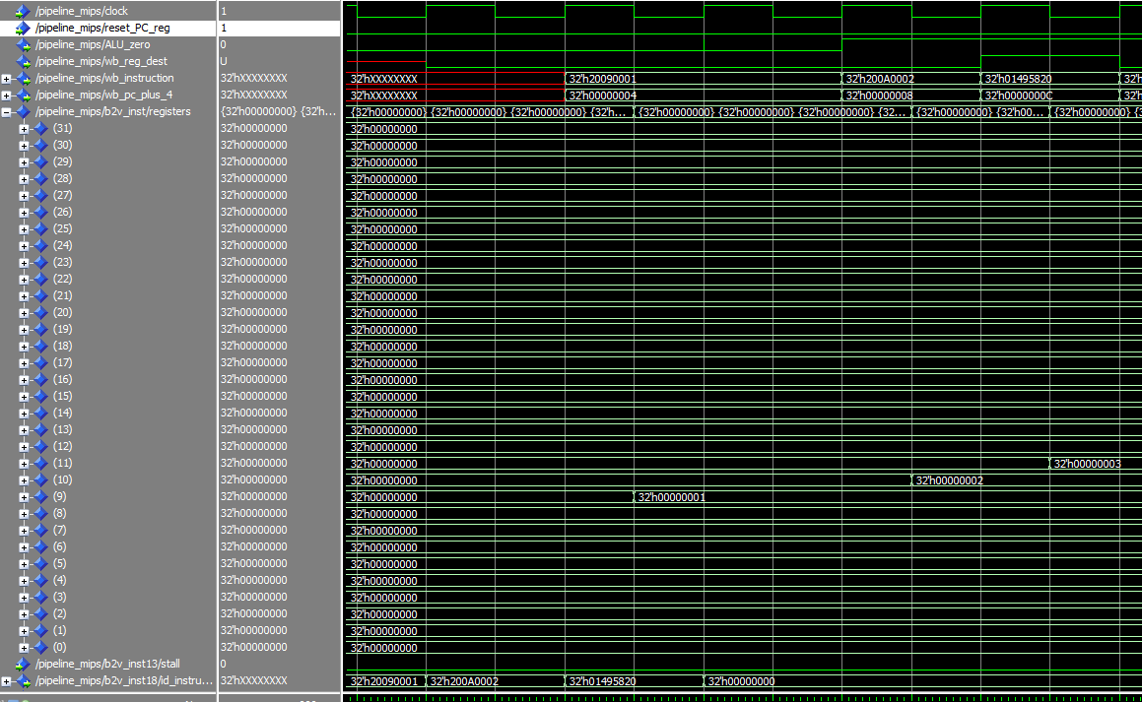
- ADD

The screenshot above shows the simulation for the instructions:
addi $t1, $zero, 0x001 #$t1=0x1
addi $t2, $zero, 0x002 #$t2=0x2
add $t3, $t2, $t1 #$t3=t2+t1

First we reset the PC, and then we execute the ADDI instructions. Which sets the value of reg t1&t2 to 0x2 and 0x3 respectively. The result of the ADD instruction is stored in register t3 (11) is equal to 0x3. This means the ADD instruction has been successfully completed as 1+2=3.

- ADDI
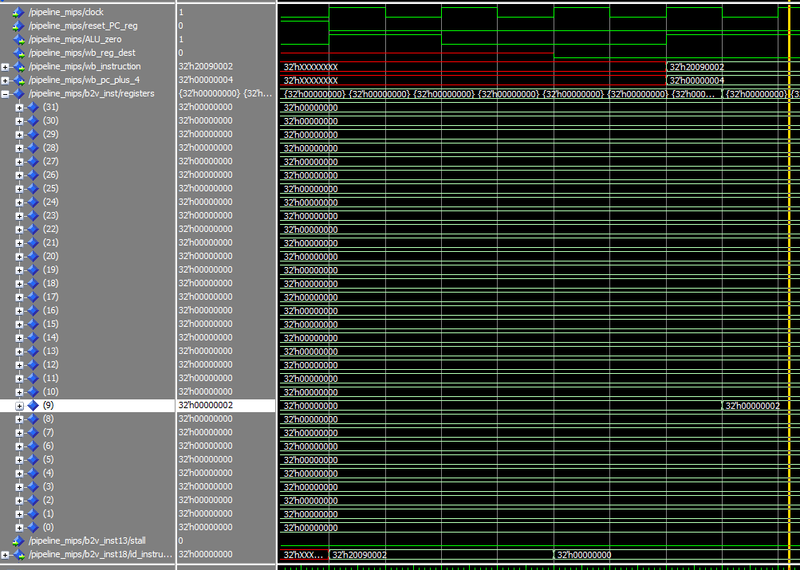

The screenshot above shows the simulation for the instructions:
addi $t1, $zero, 0x0014 #$t1=0x2
First we reset the PC, and then we execute the ADDI instruction. Here, we can see the value of the register (9) is equal to 0x2. This means the ADDI instruction has been successfully completed.

- LW
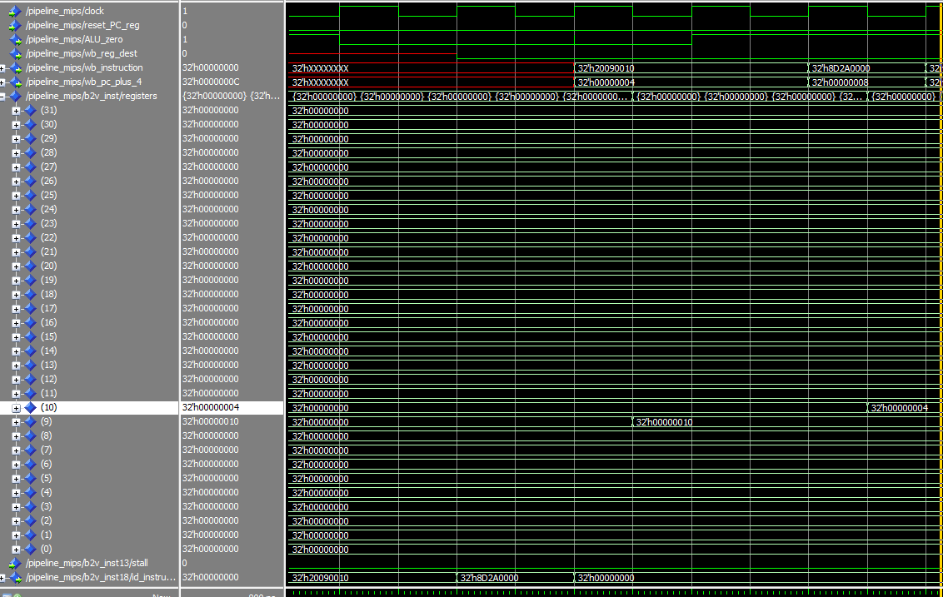

The screenshot above shows the simulation for the instructions:
addi $t1, $zero, 0x10 #$t1=0x10
lw $t2, 0($t1) #$t2= value at 0x10
Register t1 (9) is loaded with a value of 0x10 which is 16 in decimal. This is because every word is 4 bytes which would mean to access the fourth element in the memory we would multiple the size of each word with the index position, i.e. 4x4=16. Hence, loading the value in the 0x10 address saves 4 to register t2 (10)

- SW
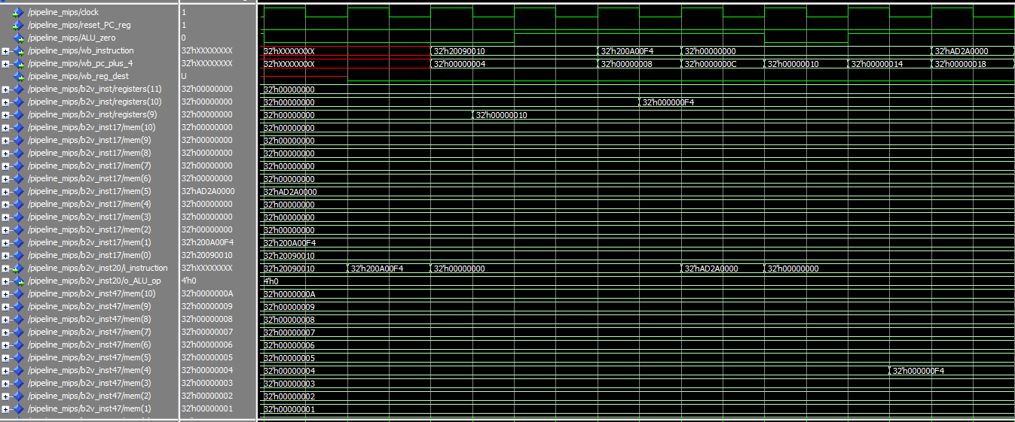

The screenshot above shows the simulation for the instructions:
addi $t1, $zero, 0x10 #$t1=0x10
addi $t2, $zero, 0xF4 #$t2=0xF4
sw $t2, 0($t1) #Stores 0xF4 to 0x10
Register t1 (9) is loaded with 0x10 which is 16 in decimal. This is to write to the 4th element in the memory. Register t2 (10) is loaded with the value to store in the 4th element which is 0xF4. From the screenshot we can see a successful store word where the 4th element had the value of 0x04 and is updated to 0xF4

- BEQ
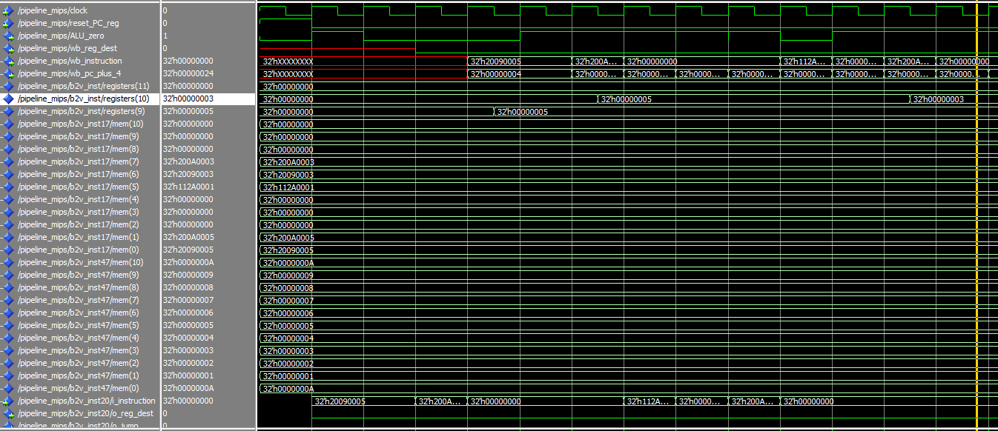
The screenshot above shows the simulation for the instructions:
addi $t1, $zero, 0x5 #$t1=0x5
addi $t2, $zero, 0x5 #$t1=0x5
beq $t1, $t2, 0x1 # branch if t1==t2
addi $t1, $zero, 0x3 #$t1=0x3
addi $t2, $zero, 0x3 #$t1=0x3

Register t1 (9) is loaded with the value 0x5 and register t2 (10) is loaded with the value 0x5. Then the branch on equal instruction checks if the value of register t1 (9) is equal to the value of register t2 (10). Since 5=5, the statement after the offset (0x1) is executed, i.e. the statement that assigns t1(9) = 3 is skipped and the next statement is executed. These instructions can been seen in the simulation above.

- J

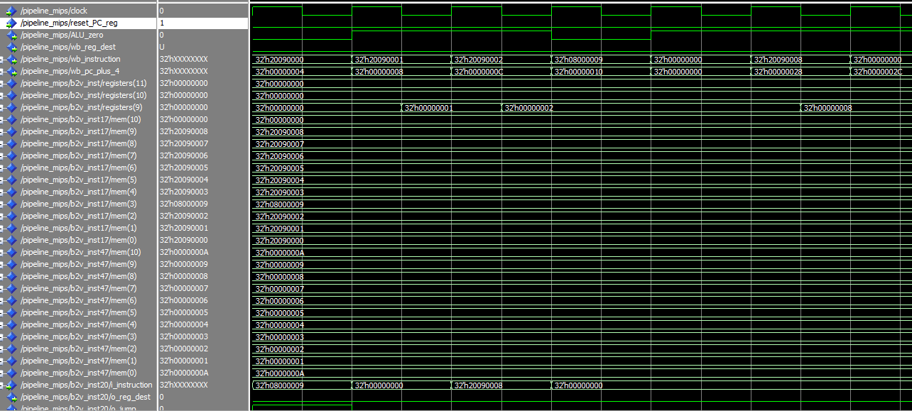

The screenshot above shows the simulation for the instructions:
addi $t1, $zero, 0x0 #$t1=0x0
addi $t1, $zero, 0x1 #$t1=0x1
addi $t1, $zero, 0x2 #$t1=0x2
J 0x0000009 #Jumps to addr
addi $t1, $zero, 0x3 #$t1=0x3
addi $t1, $zero, 0x4 #$t1=0x4
addi $t1, $zero, 0x5 #$t1=0x5
addi $t1, $zero, 0x6 #$t1=0x6
addi $t1, $zero, 0x7 #$t1=0x7
addi $t1, $zero, 0x8 #$t1=0x8

Here we see a code where register t1 (9) is assigned values from 0 to 8 individually on each step. We can see a jump instruction in between. The jump instruction jumps to address 0x9, which is the step where t1 is assigned the value of 8. So, the value of t1 assigned are in the order as follows: 0x0, 0x01,0x02, (jumps), then 0x08. This behavior can be seen in the screenshot.

- [Part 5] Implement ID stage branch resolution and provide a legible simulation-screenshot of a taken-branch instruction correctly executing.

- [Part 6a] Implement a forwarding unit (using VHDL) to support the following data dependent cases. Give simulation screenshots of correct forwarding for each case, make sure to provide an explanation of the instructions you ran to show the below hazards:
i) ALU producer to ALU consumer at distance 1 (e.g. ADD $1, $2, $3; ADD $4, $1, $2)
ii) ALU producer to ALU consumer at distance 2 (e.g. ADD $1, $2, $3; <INST>; ADD $4, $1, $2)
iii) Load producer to ALU consumer distance 2 (e.g. LW $1, 0($10); <INST>; ADD $5, $1, $r2)
iv) ALU producer to BEQ consumer at distance 2 (e.g. ADD $1, $2, $3; <INST>; BEQ $1, $2, label)

- [Part 6b] Implement a hazard detection unit (using VHDL) to support the following data dependent cases. Give simulation screenshots of correct forwarding for the cases described in the lab manual, provide an explanation.

- [Part 6c] Connect your forwarding and hazard detection units to your pipelined processor and provide a simulation screenshot showing that your pipeline correctly executes the given test program.

Extra Credit (5 points) (This is not required):
- Explain the potential impact that the falling edge trigger register fill has on the critical path for the processor we are designing (2.5 points).
- Implement a fix (in VHDL) to the issue we have caused that will allow the register file to continue to write on the rising edge. Draw (or screenshot) the change that you have made and explain how it solves the potential issue.

