**INTRODUCTION**

The importace of placement system is increasing day by day. Thousands of applicants are depending placement cell. But the applicants are facing so many problems. This project is an attempt to minimize the problems of an applicant to find a correct job. If we can make it an online computerized and a mobile alert process it will be so fast and convenient for the applicants.Far from upsetting matters, however, new technologies have predominantly made life better and considerably easier for most people, and so it must be concluded that they should be welcomed.

**About project** :- This project is madde in java language and for pages jsp are used which has code in HTML and java.for runnig of this project you will need NetBeans and MYSQL for database.

**TOOLS USED:**

**Front end:** NetBeans

**Back end:** MYSQL ,TOMCAT SERVER

# MODULE DESCRIPTION

1). Applicant registration

2). Company registration

3). Job search

4). Vacancy Registration

5). Message

1) **Applicant registration:**

The applicant can register into the site by providing his details and he can set his username and password for logging in later.

2) **Company registration:**

The authority of the company can register into the site by providing its details and they can set its username and password for logging in. They can also specify their requirements for each vacancy.

3) **Job search:**

Applicants can search for the job vacancies in the fields of their choice and apply as interested.

4) **Vacancy registration:**

Authority of the company can provide all the necessary information about the vacancies in each post along with eligibility criteria.

To run project- Open this zip in NetBeans and by using xampp server start Apache and mysql server and create one database named **abc** and in that create tables as shown in photos.

Table name-applicant

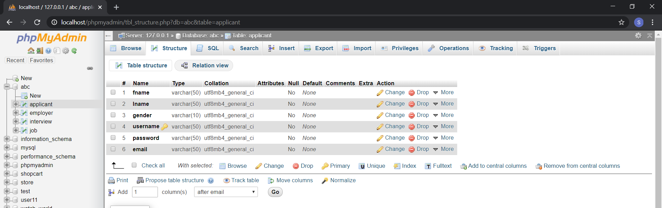

Table name- employer

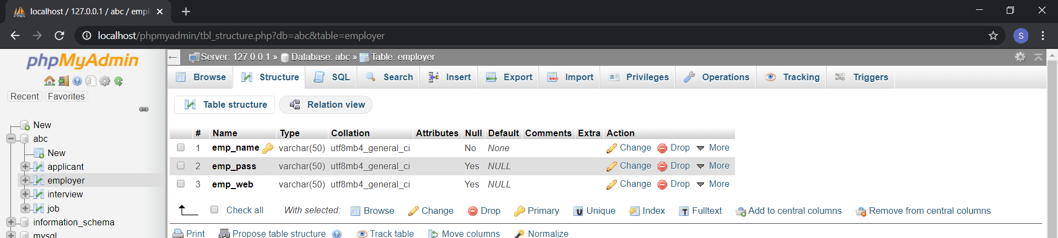

Table name-interview

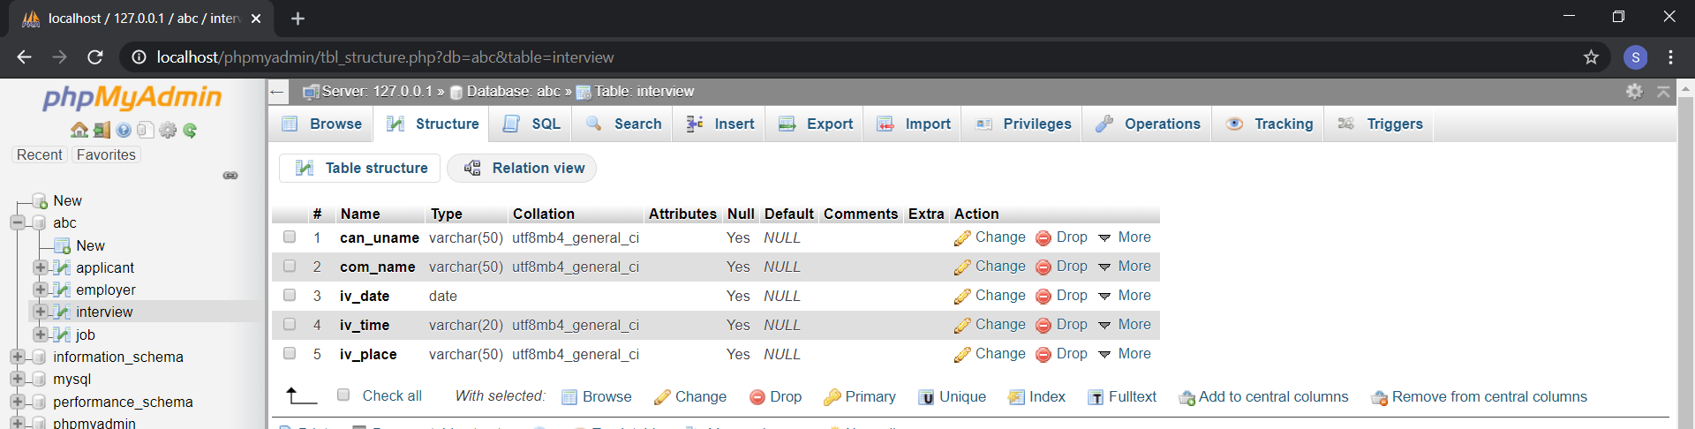

Table name- job

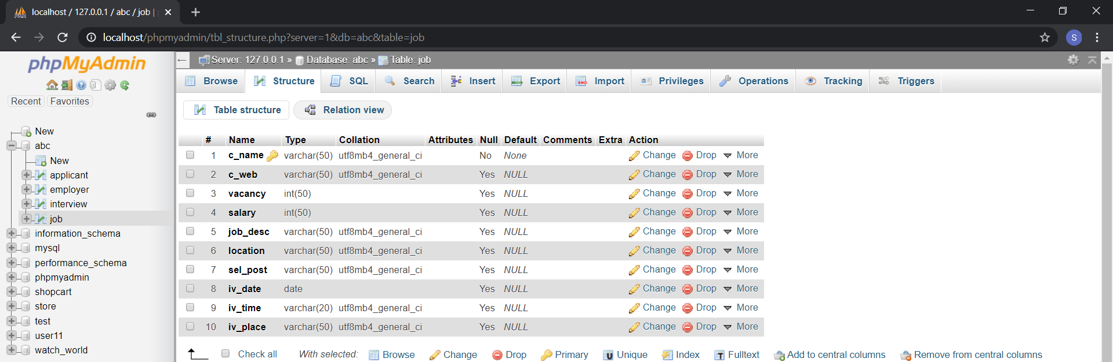

After creating tables, run home1.jsp file from netbeans or use this link:- [**http://localhost:8080/online%20job%20portal/home1.jsp**](http://localhost:8080/online%20job%20portal/home1.jsp)

After that job seeker and job provider can register themselves and will be able to login whereas job provider will be able to add job and job seeker will be able to search for a job and apply for a job.