Introduction:

JavaScript and Java are completely different languages, both in concept and design JavaScript was invented by Brendan Eich in 1995, and became an ECMA standard in 1997 it is a lightweighted, do more, event handeling programming language.

JavaScript is a cross-platform, object-oriented scripting language used to make webpages

interactive (e.g., having complex animations, clickable buttons, popup menus, etc.).

JavaScript comments can be used to explain JavaScript code, and to make it more

readable.

Single Line Comments

Single line comments start with //

#Multi-line Comments

Multi-line comments start with /* and end with */

Variable

4 ways declare a javascipt variable

Using var

Using let

Using const

Using

#Declaring a JavaScript Variable

Creating a variable in JavaScript is called "declaring a variable.

You declare a JavaScript variable with the var or the let keyword:

var carName:

Or

let carName,

After the declaration, the variable has no value (technically it is undefined).

To assign a value to the variable, use the equal sign

carName = "Volvo"

You can also assign a value to the variable when you declare it:

let carName = "Volvo"

#One Statement, Many Variables

#JavaScript Var

Variables defined with let can be Redeclared

 <script type="text/javascript">

        var name="shubham";

        console.log(name);

        var name="riteh";         //it is right in var variable

        console.log(name);

                // document.write(name);

    </script>

 <script type="text/javascript">

        a=10;

        console.log(a);

       var a;           //you can do it

   </script>

<script type="text/javascript">

        var a=10;

        console.log(a);

        {

            var a=20;

            console.log(a);         //it is right and a same as first block scope ka koi mtlb ni

        }

        console.log(a);

     </script>

#JavaScript Let

The let keyword was introduced in ES6 (2015);

Variables defined with let cannot be Redeclared.

<script type="text/javascript">

        let name="shubham";

        console.log(name);

        let name="riteh";         //it is not right in let variable

        console.log(name);

                // document.write(name);

    </script>

Variables defined with let must be declared before use.

<script type="text/javascript">

        a=10;

        console.log(a);

       let a;           //you cannot do it

   </script>

Variables defined with let have block scope.

 <script>

        let a=20;

        console.log(a);

        {

            let a=30;       // this a is only use inside this block

            console.log(a);  //this is a different a not a=20 as . so it is right

        }

        console.log(a);         //this is first a

     </script>

<script>

        let a=20;

        console.log(a);

        {

           // let a=30;

            console.log(a);  //here a print 20 because we didnot initialise and it will take its parent value;

        }

        console.log(a);         //this is first a

     </script>

#JavaScript Const

The const keyword was introduced in ES6 (2015);

Variables defined with const cannot be Redeclared.

  <script type="text/javascript">

        const a=10;

        a=30; //we cannot do it in const variable

    </script>

Variables defined with const cannot be reassigned.

Variables defined with const have block scope.

Arithmetic Operators are used to perform arithmetic on numbers:

|  |  |
| --- | --- |
| **Operator** | **Description** |
| + | Addition |
| - | Subtraction |
| * | Multiplication |
| ** | Exponentiation ([ES2016](https://www.w3schools.com/js/js_2016.asp)) |
| / | Division |
| % | Modulus (Division Remainder) |
| ++ | Increment |
| -- | Decrement |

Assignment Operator in JavaScript

|  |  |  |
| --- | --- | --- |
| **Operator** | **Example** | **Same As** |
| = | x = y | x = y |
| += | x += y | x = x + y |
| -= | x -= y | x = x - y |
| *= | x *= y | x = x * y |
| /= | x /= y | x = x / y |
| %= | x %= y | x = x % y |
| **= | x **= y | x = x ** y |

Ex    <script>

        let ms="shubham"

        ms+="kanaujiya"

        ms+="from satan"

        document.write("<h1>",ms,"</h1>")

    </script>

Comparison Operations

== equal

=== equal value and equal type

!= not equal

!== not equal value or nto equal

#Logical Operators

Operator description

&& Logical and

|| logical or

! logical not

Typeof() returns the type of a variable .

 <script>

     let a=10;

    let b="Shubham"

    let c=344.3

    let d=function(){}

    let e=["sk","gk","vk"]

    let f={

        "roll":23,

        "name":"shubf"

    }

    document.write("<h1>",a," ",typeof(a),"</h1>");

    document.write("<h1>",b," ",typeof(b),"</h1>");

    document.write("<h1>",c," ",typeof(C),"</h1>");

    document.write("<h1>",d," ",typeof(d),"</h1>");

    document.write("<h1>",e," ",typeof(e),"</h1>");

    document.write("<h1>",F," ",typeof(f),"</h1>");

   </script>

#javaScript types are Dynamic

js has dynamic types. this means that the same variable can be used to hold different data types:

ex

let x; //now x is undefined

x=5; //now x is number

x=”sdh” //x is now String

JavaScript Sntax:-

<!DOCTYPE html>

<html lang="en">

<head>

    <meta charset="UTF-8">

    <meta http-equiv="X-UA-Compatible" content="IE=edge">

    <meta name="viewport" content="width=device-width, initial-scale=1.0">

    <title>Document</title>

    <script src="sk.js"></script>

    <!-- or -->

    <script type="text/javaScript">

        //code

    </script>

</head>

<body>

    <!-- or -->

    <script  type="text/javaScript">

        //code

    </script>

</body>

</html>

Alert()

This function is used to display alert() messages in box format .

Alert box has only one button which is OK button. When we click ok buton this function does not retun any value.

Note :- it always takes only one parameter

Syntax:-

Alert(message to be display);

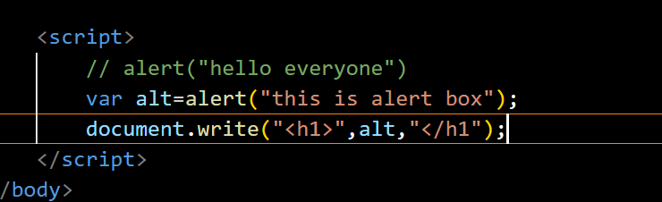

Confirm()

This function is used to display confirmation messages in box format

Confirm box has two button ok and CANCEL . when we click OK button this box retun true and when we click CANCEL button this box return false.

Syntax:-

Confirm(message to be display);

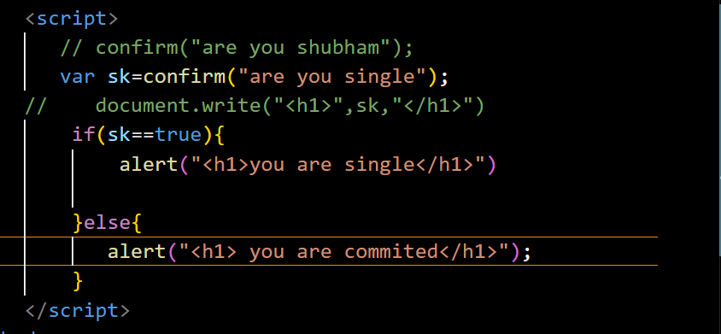

Prompt()

This function is used to take input by user. This function has two parameter message and default value.

The default vaue is an optional parameter.

Syntax:-

Prompt(message to be display,default vlaue);

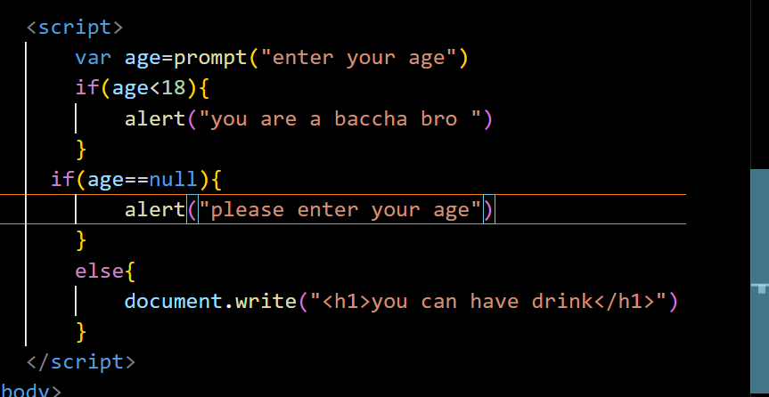

Function and event:-

Functions : function are small programm or sub program , we can create function in js by using function keyword follow with function name.

Syntax

Functoin function_name(){

//body of the function

}

Event :-

Event are some specific type of situation and is this situation we can perform some specificv task. Java script is a event handeling programming languages, which support various type of event like: onclick , onmouseover, onmouseout , onfocus, onblur, onchange , onkeyup,onkeydown, onload, onunload, onsubmit….etc.

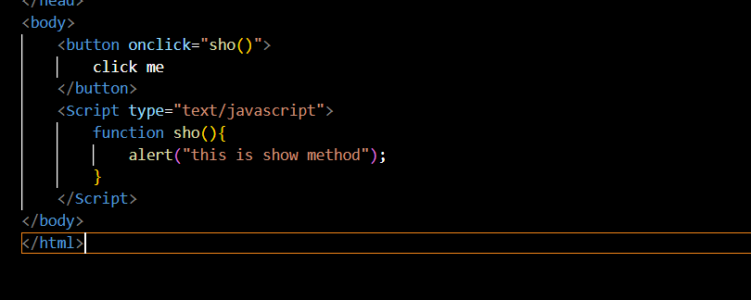

Get html control values:-

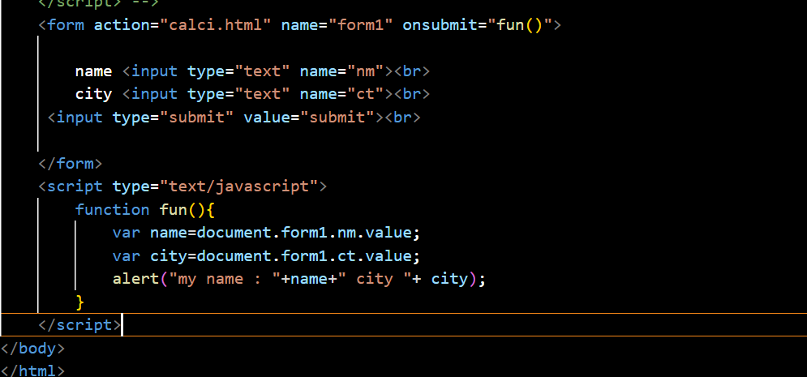

Form validation

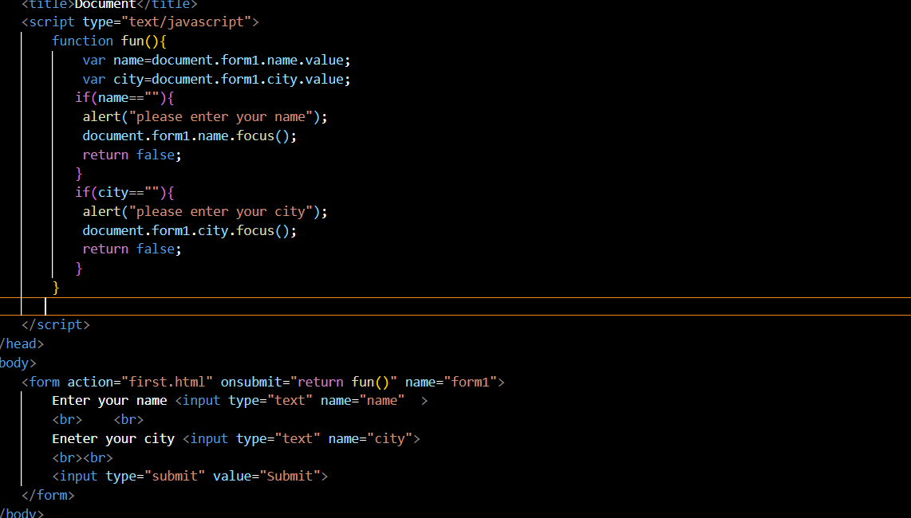

#Conditional Statement in js

1. Simple if statement
2. If else statement
3. Miltiple if else statement
4. Switch statement
5. Simple if and if – else statement

Syntax

If(condition){

//statement

}

<script type="text/javascript">

          let a=prompt("enter a number: ")

          if(a>20){

            document.write("you are eligible")

          }else{

            document.write("not eligible")

          }

   </script>

3 . multiple if else

<script type="text/javascript">

          let a=prompt("enter a number: ")

          if(a>20){

            document.write("you are eligible")

          }

          if(a>30){

            document.write("you are eligible but")

          }

          else{

            document.write("not eligible")

          }

   </script>

getElementById():- this method is used to get element by using its id.

 Enter Your name : <input type="text" id="name">

   <button onclick="fun()">click</button>

   <h1 id="text"></h1>

   <script type="text/javascript">

        function fun(){

            var a=document.getElementById('name').value;

            document.getElementById('text').innerHTML=a;

        }

   </script>