ASSIGNMENT NO. 1
Identify the Association between Dependent and Independent Variables

Aim
Work out which input columns of a dataset move together with the output column, and how strongly, by using correlation coefficients, p-values and two plots.

Objectives
- Be clear about what dependent and independent variables are.
- Compute how strongly every input column correlates with the output.
- Read p-values to separate genuine relationships from ones that arose by chance.
- Visualise the findings with a heatmap and a scatter plot.

Software and tools
Everything was coded in Python 3 using Jupyter Notebook (VS Code also works) on a Windows machine. Libraries: pandas, matplotlib, scipy, scikit-learn.

Theory

1. Dependent and independent variables
Every prediction task has one quantity we want to estimate. This is the dependent variable, also known as the target or output. The columns used to estimate it are the independent variables, also called features or predictors.
In a house-price problem, the price is dependent, while floor area, number of rooms and locality are independent. The price is driven by those factors and not the other way round: a bigger flat costs more, yet raising the price of a flat will never enlarge it.

2. What 'association' means
Two variables are associated if a shift in one tends to be accompanied by a shift in the other. Students who put in more study hours generally earn higher marks, so hours and marks are associated.
The direction can differ. Height and weight grow together (positive association), whereas speed and travel time move oppositely (negative association). Some pairs, such as shoe size and exam marks, show no relationship whatsoever.
Association should not be confused with causation. Ice-cream sales and drowning incidents both peak in summer, yet ice cream does not cause drowning; the hot weather lies behind both. This practical only checks whether a relationship exists and how strong it is.

3. Ways of measuring association
The suitable technique depends on the type of data:
- Pearson correlation (r): two numeric columns whose relationship is roughly a straight line.
- Spearman rank correlation: relationships that curve but keep moving in one direction, or data containing outliers.
- Chi-square test: two categorical columns, e.g. gender versus branch chosen.
- Scatter plots and heatmaps: the same information presented visually.

4. Pearson correlation coefficient
Pearson's r is the most commonly used measure:
r = Σ (x − x̄)(y − ȳ) / √[ Σ (x − x̄)² × Σ (y − ȳ)² ]
Here x̄ and ȳ denote the averages of x and y. The result always lies from −1 to +1 and is read approximately as follows:
Value of r | How to read it
+0.7 to +1.0 | Strong positive relationship
+0.4 to +0.7 | Moderate positive relationship
+0.1 to +0.4 | Weak positive relationship
Around 0 | No linear relationship
−0.1 to −1.0 | Same strengths as above, but in the negative direction

5. The p-value
Even columns of purely random numbers will occasionally show some correlation. The p-value tells us how likely a correlation of the observed size would be if no real relationship existed. A p-value below 0.05 is taken as statistically significant.

Dataset used
The diabetes dataset bundled with scikit-learn was used. It covers 442 patients and has 10 predictor columns: age, sex, bmi (body mass index), bp (mean blood pressure) and s1–s6 (six blood-serum measurements). The target is a numeric score of how much the disease had progressed a year after the baseline readings.
The predictor values look unusual (age appears as 0.038, for instance) because scikit-learn supplies them pre-scaled. Scaling has no effect on correlation, so they were used unchanged.

Procedure
- Import pandas, matplotlib, scipy and the dataset loader.
- Load the diabetes data into a pandas DataFrame.
- Display the shape and the first five rows.
- Create the correlation matrix using df.corr().
- Rank the correlation of each predictor with the target, highest first.
- Call pearsonr() from scipy for every predictor to obtain r and its p-value.
- Plot a heatmap of the complete correlation matrix.
- Plot bmi, the strongest predictor, against the target as a scatter plot.
- Record what the results indicate.

Program
# Assignment 1 - Association between dependent and independent variables
import pandas as pd
import matplotlib.pyplot as plt
from scipy import stats
from sklearn.datasets import load_diabetes

pd.set_option('display.width', 150)
pd.set_option('display.max_columns', None)

# load the diabetes dataset as a table
data = load_diabetes(as_frame=True)
df = data.frame # 10 input columns + 'target' column
print("Shape of data:", df.shape)
print(df.head().round(3))

# correlation of every input column with the target
corr = df.corr()
print("\nCorrelation with target (highest to lowest):")
print(corr['target'].drop('target').sort_values(ascending=False).round(3))

# Pearson r and p-value for each column
print("\nColumn r value p value")
for col in data.feature_names:
r, p = stats.pearsonr(df[col], df['target'])
print(f"{col:6s} {r:7.3f} {p:.4f}")

# heatmap of the whole correlation matrix
plt.figure(figsize=(7, 6))
plt.imshow(corr, cmap='coolwarm', vmin=-1, vmax=1)
plt.colorbar()
plt.xticks(range(len(corr)), corr.columns, rotation=90)
plt.yticks(range(len(corr)), corr.columns)
plt.title('Correlation Heatmap')
plt.tight_layout()
plt.savefig('a1_heatmap.png')
plt.show()

# scatter plot of the strongest column against the target
plt.figure(figsize=(6, 4))
plt.scatter(df['bmi'], df['target'], s=10)
plt.xlabel('bmi')
plt.ylabel('disease progression (target)')
plt.title('BMI vs Target')
plt.tight_layout()
plt.savefig('a1_scatter.png')
plt.show()

Output
Shape of data: (442, 11)
age sex bmi bp s1 s2 s3 s4 s5 s6 target
0 0.038 0.051 0.062 0.022 -0.044 -0.035 -0.043 -0.003 0.020 -0.018 151.0
1 -0.002 -0.045 -0.051 -0.026 -0.008 -0.019 0.074 -0.039 -0.068 -0.092 75.0
2 0.085 0.051 0.044 -0.006 -0.046 -0.034 -0.032 -0.003 0.003 -0.026 141.0
3 -0.089 -0.045 -0.012 -0.037 0.012 0.025 -0.036 0.034 0.023 -0.009 206.0
4 0.005 -0.045 -0.036 0.022 0.004 0.016 0.008 -0.003 -0.032 -0.047 135.0

Correlation with target (highest to lowest):
bmi 0.586
s5 0.566
bp 0.441
s4 0.430
s6 0.382
s1 0.212
age 0.188
s2 0.174
sex 0.043
s3 -0.395
Name: target, dtype: float64

Column r value p value
age 0.188 0.0001
sex 0.043 0.3664
bmi 0.586 0.0000
bp 0.441 0.0000
s1 0.212 0.0000
s2 0.174 0.0002
s3 -0.395 0.0000
s4 0.430 0.0000
s5 0.566 0.0000
s6 0.382 0.0000

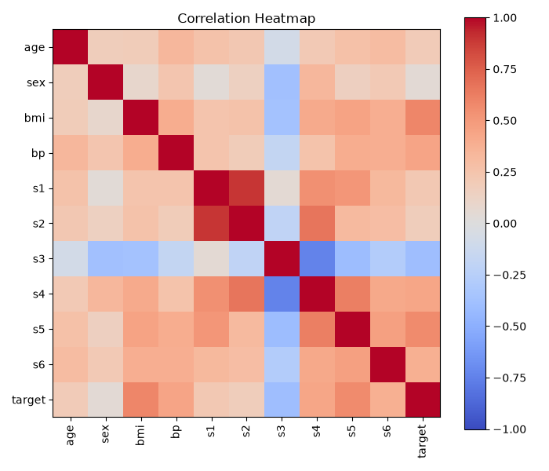
Figure 1.1: Heatmap of correlations among all columns
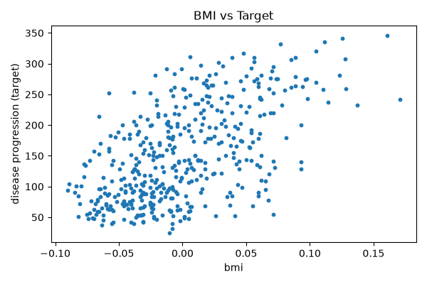
Figure 1.2: Scatter plot of BMI versus the target

Observations
- bmi is most strongly related to the target (r = 0.586); patients with a higher BMI tended to show greater progression.
- s5 (0.566) and bp (0.441) follow, both moderate and positive.
- s3 is the only predictor with a negative sign (r = −0.395): higher s3 readings accompanied lower target values.
- sex is almost unrelated to the target (r = 0.043) and its p-value of 0.3664 is far above 0.05, so the link is not significant.
- Every other predictor has a p-value below 0.05.
- The bmi scatter plot rises from left to right, matching the positive r, but the points are widely scattered, so BMI alone cannot account for the target.

Conclusion
bmi, s5 and bp turned out to be the predictors most tied to diabetes progression, s3 relates negatively, and sex hardly matters. Examining correlations in this way before modelling shows which columns deserve to be kept, and it needs only a few lines of code.
ASSIGNMENT NO. 2
Clustering Techniques using Unsupervised Learning

Aim
Group similar data points together using K-Means and hierarchical clustering, without supplying the model with any labels.

Objectives
- Understand the idea behind unsupervised learning.
- Apply K-Means clustering to a dataset.
- Select the number of clusters with the elbow method.
- Compare K-Means against agglomerative (hierarchical) clustering using the silhouette score.

Software and tools
Everything was coded in Python 3 using Jupyter Notebook (VS Code also works) on a Windows machine. Libraries: numpy, matplotlib, scikit-learn.

Theory

1. Supervised versus unsupervised learning
In supervised learning each row carries its correct answer (a label) and the model learns from these solved examples. Unsupervised learning has no answers: the model receives only the data and must discover structure on its own.
Imagine a jar of mixed buttons. No one tells you which groups exist, but you would still end up sorting them by colour or size. An unsupervised algorithm does the same with data.

2. What clustering does
Clustering divides data into groups so that members of one group resemble each other and differ from members of other groups. Retailers use it to group customers with similar shopping habits, news apps to collect stories about one event, banks to spot transactions that fit no normal group, and image tools to reduce the number of colours in a picture.

3. The K-Means algorithm
K-Means is among the most popular clustering methods because it is simple and fast. K stands for the number of clusters requested. The algorithm loops as follows:
- Decide the number of clusters, k.
- Choose k random points as initial centres (centroids).
- Attach each point to its closest centroid.
- Shift every centroid to the mean position of the points attached to it.
- Repeat the last two steps until the centroids no longer move.
'Closest' is judged by straight-line (Euclidean) distance:
d = √[ (x₁ − x₂)² + (y₁ − y₂)² ]

4. Picking k: the elbow method
K-Means cannot determine k by itself. We therefore run it for k = 1, 2, 3, … and note the WCSS (within-cluster sum of squares) each time, which is the total squared distance from every point to its own centroid. WCSS always falls as k increases, but beyond a certain point the improvement is tiny. On a graph this point resembles a bent elbow and is normally a good value for k.

5. Silhouette score
The silhouette score indicates how well separated the clusters are, on a scale from −1 to +1. A value near +1 means points sit close to their own cluster and far from the rest; a value near 0 means the clusters overlap.

6. Hierarchical (agglomerative) clustering
Here every point begins as its own cluster, and the two nearest clusters are merged repeatedly until only the requested number remains. The history of merges can be drawn as a tree called a dendrogram. There is no random initialisation, so results are identical on every run, but the method becomes slow on large datasets.

7. Why feature scaling is needed
Both techniques rely on distances. If one column runs into the thousands while another stays between 0 and 1, the large column dominates. StandardScaler solves this by rescaling each column to mean 0 and standard deviation 1.

Dataset used
The Iris dataset from scikit-learn was used: 150 flowers, each described by four measurements (sepal length, sepal width, petal length, petal width). The species are also recorded, but the labels were left out completely. We do know there are three species, which makes Iris a good test of whether clustering can discover natural groups unaided.

Procedure
- Import the required libraries.
- Load only the four measurement columns of Iris.
- Standardise the data with StandardScaler.
- Run K-Means for k = 1 to 10, store the WCSS values and draw the elbow graph.
- Choose k = 3 from the graph and train the final K-Means model.
- Print the size of each cluster and the silhouette score.
- Run agglomerative clustering with 3 clusters and compare its silhouette score.
- Plot the clusters together with their centroids.

Program
# Assignment 2 - Clustering using unsupervised learning
import numpy as np
import matplotlib.pyplot as plt
from sklearn.datasets import load_iris
from sklearn.preprocessing import StandardScaler
from sklearn.cluster import KMeans, AgglomerativeClustering
from sklearn.metrics import silhouette_score

# we only take the measurements, the flower names are NOT used
X = load_iris().data
X = StandardScaler().fit_transform(X)

# elbow method: try k from 1 to 10
wcss = []
for k in range(1, 11):
km = KMeans(n_clusters=k, n_init=10, random_state=42)
km.fit(X)
wcss.append(km.inertia_)
print("WCSS for k = 1 to 10:")
print(np.round(wcss, 2))

plt.figure(figsize=(6, 4))
plt.plot(range(1, 11), wcss, marker='o')
plt.xlabel('Number of clusters (k)')
plt.ylabel('WCSS')
plt.title('Elbow Method')
plt.tight_layout()
plt.savefig('a2_elbow.png')
plt.show()

# final K-Means with k = 3
km = KMeans(n_clusters=3, n_init=10, random_state=42)
labels = km.fit_predict(X)
print("\nPoints in each K-Means cluster:", np.bincount(labels))
print("Silhouette score (K-Means):", round(silhouette_score(X, labels), 3))

# hierarchical clustering for comparison
agg = AgglomerativeClustering(n_clusters=3)
labels2 = agg.fit_predict(X)
print("Points in each Agglomerative cluster:", np.bincount(labels2))
print("Silhouette score (Agglomerative):", round(silhouette_score(X, labels2), 3))

# plot the clusters using petal length and petal width
plt.figure(figsize=(6, 4))
plt.scatter(X[:, 2], X[:, 3], c=labels, cmap='viridis', s=20)
plt.scatter(km.cluster_centers_[:, 2], km.cluster_centers_[:, 3],
c='red', marker='X', s=200, label='Centroids')
plt.xlabel('Petal length (scaled)')
plt.ylabel('Petal width (scaled)')
plt.title('K-Means Clusters (k = 3)')
plt.legend()
plt.tight_layout()
plt.savefig('a2_clusters.png')
plt.show()

Output
WCSS for k = 1 to 10:
[600. 222.36 139.82 114.09 90.93 81.54 72.63 62.54 55.12 47.39]

Points in each K-Means cluster: [53 50 47]
Silhouette score (K-Means): 0.46
Points in each Agglomerative cluster: [71 49 30]
Silhouette score (Agglomerative): 0.447

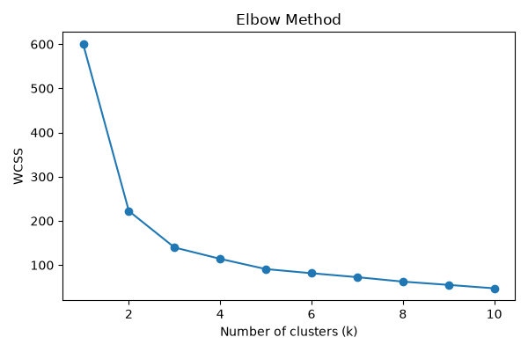
Figure 2.1: Elbow curve (WCSS versus number of clusters)
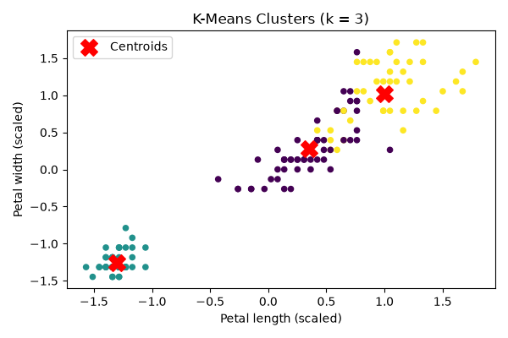
Figure 2.2: Clusters discovered by K-Means

Observations
- WCSS falls steeply from 600 at k = 1 to 139.82 at k = 3 and then flattens, so the elbow lies at k = 3.
- K-Means produced clusters of 53, 50 and 47 points, very near the true 50 per species, even though it never saw a species name.
- K-Means obtained a silhouette score of 0.46, slightly higher than the 0.447 of agglomerative clustering.
- Agglomerative clustering divided the points less evenly, into groups of 71, 49 and 30.
- In the cluster plot one group in the lower left is fully isolated, while the other two touch slightly, so neither method separates them perfectly.

Conclusion
The elbow method indicated three clusters for the Iris data, and K-Means found groups that closely match the three real species without being shown a single label. It also separated the data marginally better than hierarchical clustering. When labels are unavailable, clustering is a fast way to discover which groups the data already contains.
ASSIGNMENT NO. 3
Dimensionality Reduction using PCA

Aim
Reduce the number of features in a dataset using Principal Component Analysis (PCA) while retaining as much information as possible.

Objectives
- Understand why having too many features causes trouble.
- Learn how PCA constructs new features called principal components.
- Find how many components are required to keep 95% of the variance.
- Check that a model still performs well on the reduced data.

Software and tools
Everything was coded in Python 3 using Jupyter Notebook (VS Code also works) on a Windows machine. Libraries: numpy, matplotlib, scikit-learn.

Theory

1. The problem with many features
Real datasets can contain dozens or hundreds of columns. Models then train slowly, consume more memory and overfit more easily, i.e. they learn noise instead of the genuine pattern. Visualisation also becomes impossible because we can only see two or three dimensions. This collection of difficulties is called the curse of dimensionality.

2. Ways to lower the dimension
There are two routes. Feature selection keeps a subset of the original columns and discards the others. Feature extraction creates a smaller set of new columns, each a blend of the old ones. PCA belongs to the second group.

3. Working principle of PCA
PCA looks for the direction along which the data is most spread out; this becomes the first principal component, PC1. PC2 is the direction with the next largest spread that is perpendicular to PC1, and so on. Most of the spread typically lies in the first few components, so those are kept and the rest dropped.
An analogy is photographing a 3D object. From a well-chosen angle, a flat photo still shows nearly everything important, and PCA finds that angle for our data.

4. Steps in PCA
- Standardise the data so each column has mean 0 and standard deviation 1.
- Compute the covariance matrix, which describes how the columns vary together.
- Obtain the eigenvalues and eigenvectors of that matrix.
- Order the eigenvectors by eigenvalue, largest first.
- Retain the top k eigenvectors; these are the principal components.
- Project the original data onto them to get the new, smaller dataset.

5. Explained variance
Each eigenvalue shows how much of the total variance its component carries. The share of one component is:
Explained Variance Ratio of PCᵢ = λᵢ / (λ₁ + λ₂ + … + λₙ)
Adding these shares cumulatively tells us how many components are needed to reach a target such as 95%.

6. Pros and cons
Advantages | Disadvantages
Models train faster | New components are difficult to interpret in real-world terms
Drops columns that repeat the same information | Some information is always lost
Allows high-dimensional data to be plotted in 2D | Only captures linear patterns
Can reduce noise and overfitting | Requires the data to be scaled first

Dataset used
The Breast Cancer Wisconsin dataset from scikit-learn has 569 samples and 30 numeric features describing cell nuclei in breast tissue images: radius, texture, perimeter, area and so on. Each sample is labelled malignant (cancerous) or benign (non-cancerous). Thirty columns are plenty to demonstrate what PCA can do.

Procedure
- Import the libraries and load the dataset.
- Scale all 30 columns with StandardScaler.
- Fit PCA with all components and print the explained variance.
- Determine how many components preserve 95% of the variance and plot the cumulative variance.
- Fit PCA again, this time with 2 components, and transform the data.
- Plot the 2D data, coloured by malignant and benign.
- Train logistic regression on all 30 features and on the 2 components, then compare accuracy.

Program
# Assignment 3 - Dimensionality reduction using PCA
import numpy as np
import matplotlib.pyplot as plt
from sklearn.datasets import load_breast_cancer
from sklearn.preprocessing import StandardScaler
from sklearn.decomposition import PCA
from sklearn.model_selection import train_test_split
from sklearn.linear_model import LogisticRegression

data = load_breast_cancer()
X, y = data.data, data.target
print("Original shape:", X.shape)

# PCA needs scaled data
X_scaled = StandardScaler().fit_transform(X)

# first fit PCA with all components to see the variance
pca_full = PCA().fit(X_scaled)
var = pca_full.explained_variance_ratio_
cum = np.cumsum(var)
print("\nVariance explained by first 5 components:", np.round(var[:5], 3))
print("Components needed for 95% variance:", np.argmax(cum >= 0.95) + 1)

plt.figure(figsize=(6, 4))
plt.plot(range(1, 31), cum, marker='o')
plt.axhline(0.95, color='red', linestyle='--')
plt.xlabel('Number of components')
plt.ylabel('Cumulative explained variance')
plt.title('Explained Variance')
plt.tight_layout()
plt.savefig('a3_variance.png')
plt.show()

# reduce 30 columns to just 2
pca = PCA(n_components=2)
X_pca = pca.fit_transform(X_scaled)
print("\nShape after PCA:", X_pca.shape)
print("Variance kept by 2 components:", round(pca.explained_variance_ratio_.sum(), 3))

plt.figure(figsize=(6, 4))
plt.scatter(X_pca[y == 0, 0], X_pca[y == 0, 1], s=10, label='Malignant')
plt.scatter(X_pca[y == 1, 0], X_pca[y == 1, 1], s=10, label='Benign')
plt.xlabel('PC1')
plt.ylabel('PC2')
plt.title('Breast Cancer data in 2D (PCA)')
plt.legend()
plt.tight_layout()
plt.savefig('a3_scatter.png')
plt.show()

# does a model still work well with only 2 columns?
for name, features in [('All 30 features', X_scaled), ('2 PCA components', X_pca)]:
X_tr, X_te, y_tr, y_te = train_test_split(features, y, test_size=0.25, random_state=42)
model = LogisticRegression(max_iter=5000).fit(X_tr, y_tr)
print(f"Accuracy with {name}: {model.score(X_te, y_te):.3f}")

Output
Original shape: (569, 30)

Variance explained by first 5 components: [0.443 0.19 0.094 0.066 0.055]
Components needed for 95% variance: 10

Shape after PCA: (569, 2)
Variance kept by 2 components: 0.632
Accuracy with All 30 features: 0.979
Accuracy with 2 PCA components: 0.979

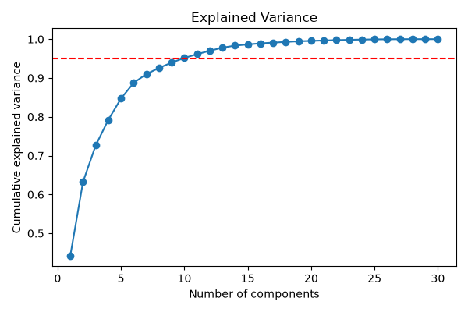
Figure 3.1: Cumulative explained variance (red line marks 95%)
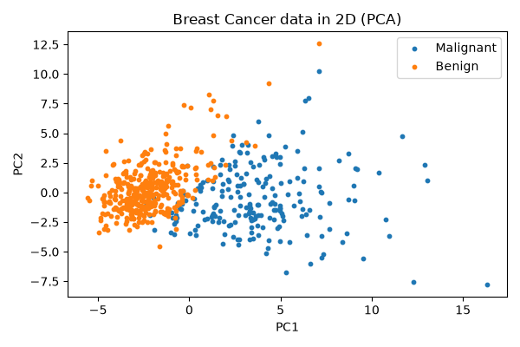
Figure 3.2: The 30-feature data projected into 2 dimensions

Observations
- PC1 explains 44.3% of the variance and PC2 a further 19%, so two components hold 63.2% of what was spread across 30 columns.
- Retaining 95% of the variance needs 10 components, one third of the original count.
- In the 2D plot, malignant and benign samples form two fairly distinct groups with only slight overlap in the middle.
- Logistic regression scored 0.979 on the full 30 features and on the 2 components alike, so a 15-fold cut in columns cost no accuracy.

Conclusion
PCA brought the breast cancer data down from 30 features to 2. Some variance was sacrificed, yet the two classes remained clearly visible and the model's accuracy did not change at all. For data with many columns, PCA offers an easy way to make it smaller, faster to handle and plottable.
ASSIGNMENT NO. 4
Naïve Bayes Classification

Aim
Classify data with the Naïve Bayes algorithm and assess how well it performs.

Objectives
- Understand Bayes' theorem and how it is used for classification.
- See why the algorithm is described as 'naïve'.
- Apply Gaussian Naïve Bayes to numeric data.
- Apply Multinomial Naïve Bayes to a small spam-detection example.
- Evaluate the model with accuracy, a confusion matrix and a classification report.

Software and tools
Everything was coded in Python 3 using Jupyter Notebook (VS Code also works) on a Windows machine. Library: scikit-learn.

Theory

1. Bayes' theorem
Naïve Bayes rests on Bayes' theorem, which describes how a belief should be revised after new evidence is observed:
P(A | B) = P(B | A) × P(A) / P(B)
For classification, A is the class and B is the set of observed features:
P(Class | Features) = P(Features | Class) × P(Class) / P(Features)
P(Class) is the prior, i.e. how common the class is before looking at any data. P(Features | Class) is the likelihood, i.e. how probable these features are if the class is true. P(Class | Features) is the posterior, the quantity we are actually after. P(Features) is identical for every class, so it can be ignored when comparing classes.
The model calculates the posterior for each class and chooses the largest.

2. Why 'naïve'?
To keep the mathematics manageable, the algorithm assumes that features are independent of each other once the class is known, which lets it simply multiply individual probabilities:
P(Class | x₁, x₂, …, xₙ) ∝ P(Class) × P(x₁|Class) × P(x₂|Class) × … × P(xₙ|Class)
This is rarely true in reality; in emails, for example, 'free' and 'offer' often occur together. Even so, the model performs well in practice, which is a large part of its popularity.

3. Worked example
Suppose 40% of emails are spam and 60% are ham (not spam). The word 'free' occurs in 60% of spam emails but only 5% of ham emails. A new email contains 'free'. Is it spam?
- Spam score = P(free | spam) × P(spam) = 0.60 × 0.40 = 0.24
- Ham score = P(free | ham) × P(ham) = 0.05 × 0.60 = 0.03
- Probability of spam = 0.24 / (0.24 + 0.03) = 0.89
The email is about 89% likely to be spam, so the model labels it spam.

4. Variants of Naïve Bayes
Variant | Suited to | Example
Gaussian NB | Continuous values (assumes a bell-shaped normal distribution) | Height, weight, chemical readings
Multinomial NB | Counts of occurrences | Word counts in text
Bernoulli NB | Yes/no features | Whether a word is present or absent

5. Evaluation measures
Accuracy is the proportion of predictions that were correct. A confusion matrix lists actual classes along the rows and predicted classes along the columns, so the diagonal contains the correct predictions. Precision asks: of everything predicted as a class, how much truly belonged to it? Recall asks the opposite: of everything that truly belongs to a class, how much did the model find? The F1-score balances the two.

6. Strengths and limitations
Naïve Bayes is fast, copes with small datasets, handles many classes and is particularly good on text. Its weak point is the independence assumption. It also suffers from the zero-frequency problem: if a feature value never appears with a class in training, its probability becomes zero and wipes out the whole product. Laplace smoothing remedies this by adding a small count to every value.

Dataset used
Part A uses scikit-learn's wine dataset: 178 wines described by 13 chemical measurements such as alcohol, malic acid, magnesium and colour intensity. Each wine comes from one of three growers, giving three classes.
Part B uses eight short messages written by us, four spam and four normal, simply to show Naïve Bayes working on text.

Procedure
- Import the libraries and load the wine dataset.
- Split the data into 75% training and 25% testing portions.
- Train a GaussianNB model on the training data.
- Predict the classes of the test data.
- Print the accuracy, confusion matrix and classification report.
- For the text part, convert the messages into word counts with CountVectorizer.
- Train a MultinomialNB model on the counts and predict two new messages.

Program
# Assignment 4 - Naive Bayes classification
from sklearn.datasets import load_wine
from sklearn.model_selection import train_test_split
from sklearn.naive_bayes import GaussianNB, MultinomialNB
from sklearn.feature_extraction.text import CountVectorizer
from sklearn.metrics import accuracy_score, confusion_matrix, classification_report

# ---------- Part A: Gaussian Naive Bayes on the wine dataset ----------
wine = load_wine()
X, y = wine.data, wine.target
X_train, X_test, y_train, y_test = train_test_split(
X, y, test_size=0.25, random_state=4, stratify=y)

gnb = GaussianNB()
gnb.fit(X_train, y_train)
y_pred = gnb.predict(X_test)

print("Accuracy:", round(accuracy_score(y_test, y_pred), 3))
print("\nConfusion Matrix:")
print(confusion_matrix(y_test, y_pred))
print("\nClassification Report:")
print(classification_report(y_test, y_pred, target_names=wine.target_names))

# ---------- Part B: Multinomial Naive Bayes on small text messages ----------
messages = ["win a free phone now", "call now to claim your prize",
"free entry in a cash contest", "you won a lottery reply now",
"are we meeting for lunch today", "please send me the notes",
"see you at college tomorrow", "can you call me after class"]
labels = ["spam", "spam", "spam", "spam", "ham", "ham", "ham", "ham"]

vec = CountVectorizer()
X_text = vec.fit_transform(messages)
mnb = MultinomialNB().fit(X_text, labels)

new_msgs = ["claim your free prize now", "send the notes after lunch"]
print("Predictions for new messages:")
for msg, pred in zip(new_msgs, mnb.predict(vec.transform(new_msgs))):
print(f" '{msg}' -> {pred}")

Output
Accuracy: 0.978

Confusion Matrix:
[[15 0 0]
[ 0 17 1]
[ 0 0 12]]

Classification Report:
precision recall f1-score support

class_0 1.00 1.00 1.00 15
class_1 1.00 0.94 0.97 18
class_2 0.92 1.00 0.96 12

accuracy 0.98 45
macro avg 0.97 0.98 0.98 45
weighted avg 0.98 0.98 0.98 45

Predictions for new messages:
'claim your free prize now' -> spam
'send the notes after lunch' -> ham

Observations
- Gaussian Naïve Bayes classified 97.8% of the 45 test wines correctly.
- Only one wine was misclassified: a class_1 wine predicted as class_2. All class_0 and class_2 wines were right.
- That single error lowers the recall of class_1 to 0.94 and the precision of class_2 to 0.92; all other values are 1.00.
- In the text part, 'claim your free prize now' was labelled spam and 'send the notes after lunch' was labelled ham. Words such as 'free', 'claim' and 'prize' pushed the first message towards spam.

Conclusion
Gaussian Naïve Bayes classified the wines with high accuracy, and Multinomial Naïve Bayes separated spam from normal messages using nothing but word counts. The independence assumption is unrealistic, yet the model is quick, simple to build and accurate enough that it is often the first choice for a classification problem, particularly with text.
ASSIGNMENT NO. 5
K-Nearest Neighbours (KNN) Classification

Aim
Classify data with the K-Nearest Neighbours (KNN) algorithm and identify the best value of k.

Objectives
- Understand how KNN decides the class of a new point.
- Learn the distance measures KNN can use.
- Observe how changing k affects accuracy.
- Evaluate the final model with a confusion matrix and classification report.

Software and tools
Everything was coded in Python 3 using Jupyter Notebook (VS Code also works) on a Windows machine. Libraries: matplotlib, scikit-learn.

Theory

1. Idea behind KNN
KNN is among the easiest algorithms to follow. Since similar things tend to lie close together, a new point is classified by inspecting the k nearest training points and going with the majority. It resembles moving to a new neighbourhood and guessing the local language by asking the people living closest to you.

2. A lazy learner
Most algorithms build a model during training. KNN does not: it simply stores the training data and performs all its work at prediction time. This is why it is called a lazy or instance-based learner.

3. Algorithm steps
- Decide the number of neighbours, k.
- Compute the distance from the new point to every training point.
- Sort the distances and pick the k smallest.
- Tally the classes of these k neighbours.
- Assign the new point whichever class appears most often.

4. Distance measures
Euclidean distance, the ordinary straight-line distance, is the default:
d = √[ Σ (xᵢ − yᵢ)² ]
Manhattan distance moves only along grid lines, like walking city blocks:
d = Σ | xᵢ − yᵢ |
Minkowski distance generalises both: p = 1 gives Manhattan and p = 2 gives Euclidean.

5. Choosing k
With a tiny k such as 1, one noisy point can flip the result and the model overfits. With a very large k, distant points also get a say and the model underfits. For two classes an odd k avoids tied votes. In practice a range of values is tried and the one scoring best on the test data is kept.

6. Why scaling matters
KNN works purely on distance. If area is measured in thousands and smoothness lies between 0 and 1, area almost single-handedly decides the outcome. Features are therefore always scaled first.

7. Pros and cons
Advantages | Disadvantages
Very simple to understand and code | Prediction is slow on large datasets
No training phase | Must keep the whole training set in memory
Handles more than two classes | Sensitive to feature scale and noisy points
Can also be used for regression | Struggles when there are too many features

Dataset used
The Breast Cancer Wisconsin dataset from scikit-learn was used again: 569 samples with 30 numeric features measured from images of cell nuclei, each labelled malignant (212 samples) or benign (357 samples). 75% of the data was used for training and the remaining 25%, i.e. 143 samples, for testing.

Procedure
- Import the libraries and load the dataset.
- Split the data into training and testing sets.
- Scale the features with StandardScaler, fitting it on the training data only.
- Train KNN for every k from 1 to 20 and record the test accuracy.
- Plot accuracy against k and select the best k.
- Train the final model with that k and predict the test data.
- Print the accuracy, confusion matrix and classification report.

Program
# Assignment 5 - KNN classification
import matplotlib.pyplot as plt
from sklearn.datasets import load_breast_cancer
from sklearn.model_selection import train_test_split
from sklearn.preprocessing import StandardScaler
from sklearn.neighbors import KNeighborsClassifier
from sklearn.metrics import accuracy_score, confusion_matrix, classification_report

data = load_breast_cancer()
X_train, X_test, y_train, y_test = train_test_split(
data.data, data.target, test_size=0.25, random_state=42, stratify=data.target)

# KNN works on distance, so scaling is a must
scaler = StandardScaler()
X_train = scaler.fit_transform(X_train)
X_test = scaler.transform(X_test)

# try k from 1 to 20 and note the accuracy
scores = []
for k in range(1, 21):
knn = KNeighborsClassifier(n_neighbors=k)
knn.fit(X_train, y_train)
scores.append(knn.score(X_test, y_test))

best_k = scores.index(max(scores)) + 1
print("Accuracy for k = 1 to 20:")
print([round(s, 3) for s in scores])
print("Best k:", best_k)

plt.figure(figsize=(6, 4))
plt.plot(range(1, 21), scores, marker='o')
plt.xlabel('k (number of neighbours)')
plt.ylabel('Test accuracy')
plt.title('Accuracy vs k')
plt.xticks(range(1, 21))
plt.tight_layout()
plt.savefig('a5_k.png')
plt.show()

# final model with the best k
knn = KNeighborsClassifier(n_neighbors=best_k)
knn.fit(X_train, y_train)
y_pred = knn.predict(X_test)

print("\nFinal accuracy:", round(accuracy_score(y_test, y_pred), 3))
print("\nConfusion Matrix:")
print(confusion_matrix(y_test, y_pred))
print("\nClassification Report:")
print(classification_report(y_test, y_pred, target_names=data.target_names))

Output
Accuracy for k = 1 to 20:
[0.951, 0.937, 0.972, 0.958, 0.979, 0.972, 0.979, 0.972, 0.965, 0.965, 0.972, 0.979, 0.958, 0.965, 0.958, 0.958, 0.951, 0.951, 0.951, 0.951]
Best k: 5

Final accuracy: 0.979

Confusion Matrix:
[[50 3]
[ 0 90]]

Classification Report:
precision recall f1-score support

malignant 1.00 0.94 0.97 53
benign 0.97 1.00 0.98 90

accuracy 0.98 143
macro avg 0.98 0.97 0.98 143
weighted avg 0.98 0.98 0.98 143

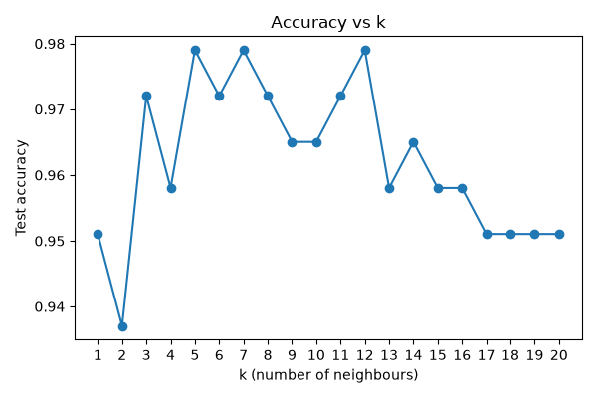
Figure 5.1: Test accuracy for every value of k

Observations
- Accuracy remained between 0.937 and 0.979 for every k, so KNN suits this data well overall.
- The lowest score came at k = 2 (0.937); even values of k can produce tied votes, which may partly explain this.
- The best score, 0.979, first appeared at k = 5 and recurred at k = 7 and k = 12.
- Beyond k = 12 accuracy declines slowly because the model becomes too general.
- The confusion matrix shows all 90 benign samples correct; of the 53 malignant samples, 50 were correct and 3 were labelled benign.
- In medicine a missed cancer is worse than a false alarm, so the malignant recall of 0.94 is the figure most worth improving.

Conclusion
After scaling the data and testing k from 1 to 20, k = 5 gave the best accuracy of roughly 98%. Very small and very large k both performed worse. KNN needs no training and is easy to grasp, but it works well only when the features are scaled and k is chosen with some care.
ASSIGNMENT NO. 6
Implementation of Linear Regression

Aim
Implement linear regression to predict a continuous value and judge the quality of its predictions.

Objectives
- Understand how linear regression fits a straight line through data.
- Obtain the slope and intercept of the best-fit line.
- Predict values for new inputs.
- Evaluate the model with MSE and the R² score.

Software and tools
Everything was coded in Python 3 using Jupyter Notebook (VS Code also works) on a Windows machine. Libraries: numpy, matplotlib, scikit-learn.

Theory

1. What regression is
Classification predicts a category, such as spam or not spam. Regression predicts a number: a house price, a temperature or a mark out of 100. Linear regression is the simplest form and assumes the output changes along a straight line as the input changes.

2. Simple linear regression
With a single input, the model is the familiar straight-line equation:
y = m·x + c
y is the output and x the input. The slope m tells how much y changes when x rises by 1, and the intercept c is the value of y at x = 0.

3. Multiple linear regression
With several inputs the idea is unchanged:
y = b₀ + b₁x₁ + b₂x₂ + … + bₙxₙ
Each input has its own coefficient (b₁, b₂, …) and b₀ is the intercept.

4. Finding the best line
Many lines could pass through the data, so a rule is needed to choose one. Linear regression applies least squares: the error of a point is the gap between its actual value and the line, and the best line is the one with the smallest sum of squared errors. For one input, slope and intercept follow directly from:
m = Σ (x − x̄)(y − ȳ) / Σ (x − x̄)² c = ȳ − m·x̄

5. Measuring the fit
Metric | Formula | Meaning
MAE | Σ |y − ŷ| / n | Average size of the error
MSE | Σ (y − ŷ)² / n | Average squared error; punishes large errors more
RMSE | √MSE | Error expressed in the unit of y
R² score | 1 − Σ(y − ŷ)² / Σ(y − ȳ)² | Share of the variation explained by the model (1 is perfect)

6. Assumptions
- The input–output relationship is a straight line.
- The errors are independent of one another.
- The errors have roughly equal spread at every value of x (homoscedasticity).
- The errors are approximately normally distributed.
- With several inputs, the inputs are not strongly correlated with each other (no multicollinearity).

Dataset used
To keep things easy to follow, a small made-up dataset of 20 students was used, with two columns: hours studied and marks out of 100. Hours is the independent variable and marks the dependent one. Sixteen students went into training and 4 into testing.

Procedure
- Import numpy, matplotlib and the required scikit-learn modules.
- Create the hours and marks arrays and reshape hours into a 2D array.
- Divide the data into 80% training and 20% testing.
- Fit a LinearRegression model on the training data.
- Print the slope, the intercept and the resulting equation.
- Predict marks for the test data and compare them with the actual marks.
- Calculate the MSE and the R² score.
- Predict the marks of a new student and plot the best-fit line.

Program
# Assignment 6 - Linear Regression
import numpy as np
import matplotlib.pyplot as plt
from sklearn.linear_model import LinearRegression
from sklearn.model_selection import train_test_split
from sklearn.metrics import mean_squared_error, r2_score

# small dataset: hours studied vs marks scored (20 students)
hours = np.array([1.1, 2.0, 2.5, 3.2, 3.5, 4.0, 4.5, 5.1, 5.5, 6.0,
6.5, 6.9, 7.4, 7.8, 8.3, 8.9, 9.2, 9.6, 2.7, 5.8])
marks = np.array([21, 30, 28, 40, 38, 45, 48, 55, 60, 62,
66, 72, 75, 80, 82, 88, 91, 95, 33, 61])

X = hours.reshape(-1, 1) # sklearn wants a 2D input
y = marks

X_train, X_test, y_train, y_test = train_test_split(X, y, test_size=0.2, random_state=0)

model = LinearRegression()
model.fit(X_train, y_train)

print("Slope (m):", round(model.coef_[0], 3))
print("Intercept (c):", round(model.intercept_, 3))
print(f"Equation: marks = {model.coef_[0]:.2f} * hours + {model.intercept_:.2f}")

y_pred = model.predict(X_test)
print("\nActual vs Predicted on test data:")
for a, p in zip(y_test, y_pred):
print(f" actual = {a:3d} predicted = {p:.1f}")

print("\nMSE:", round(mean_squared_error(y_test, y_pred), 3))
print("R2 score:", round(r2_score(y_test, y_pred), 3))

# predict for a new student
print("\nPredicted marks for 7.5 hours of study:",
round(model.predict([[7.5]])[0], 1))

plt.figure(figsize=(6, 4))
plt.scatter(X, y, label='Actual data')
line_x = np.linspace(0, 10, 50).reshape(-1, 1)
plt.plot(line_x, model.predict(line_x), color='red', label='Best fit line')
plt.xlabel('Hours studied')
plt.ylabel('Marks')
plt.title('Hours vs Marks (Linear Regression)')
plt.legend()
plt.tight_layout()
plt.savefig('a6_line.png')
plt.show()

Output
Slope (m): 8.93
Intercept (c): 8.882
Equation: marks = 8.93 * hours + 8.88

Actual vs Predicted on test data:
actual = 33 predicted = 33.0
actual = 30 predicted = 26.7
actual = 61 predicted = 60.7
actual = 60 predicted = 58.0

MSE: 3.683
R2 score: 0.983

Predicted marks for 7.5 hours of study: 75.9

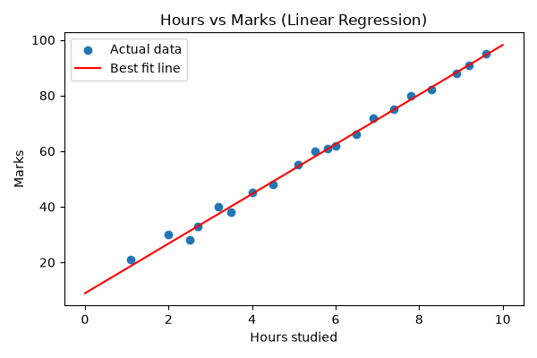
Figure 6.1: Data points with the best-fit line

Observations
- The model found the relationship marks = 8.93 × hours + 8.88.
- A slope of 8.93 means each additional hour of study adds about 9 marks on average.
- The intercept of 8.88 is the predicted mark at zero hours; it is just the starting point of the line and should not be over-interpreted.
- Test predictions landed close to the actual marks, with the largest miss at about 3.3 marks.
- R² is 0.983, so the line explains roughly 98% of the variation in marks, and MSE is only 3.683.
- A student who studies for 7.5 hours is predicted to score about 75.9.

Conclusion
Linear regression revealed a clear positive link between study hours and marks, and the high R² shows the straight line fits this data very well. It is quick to build and easy to explain, which is why it is usually the first model tried when the output is a number.
ASSIGNMENT NO. 7
Support Vector Machine (SVM) for Regression

Aim
Implement Support Vector Regression (SVR) and compare how different kernels cope with curved data.

Objectives
- Understand how SVM ideas carry over from classification to regression.
- Learn what the epsilon tube and support vectors are.
- Know what kernels and the parameters C, epsilon and gamma control.
- Compare linear, polynomial and RBF kernels on the same data.

Software and tools
Everything was coded in Python 3 using Jupyter Notebook (VS Code also works) on a Windows machine. Libraries: numpy, matplotlib, scikit-learn.

Theory

1. SVM in brief
SVM is best known as a classifier. It draws a separating line (a hyperplane in higher dimensions) between two classes so that the gap to the nearest points on either side, the margin, is as wide as possible. Those nearest points are the support vectors, because they hold the line in position.

2. Support Vector Regression
SVR applies the same idea to predicting numbers. Ordinary linear regression tries to shrink the error of every point. SVR is more relaxed: it draws a tube of width ε (epsilon) around its line, and any point inside the tube counts as close enough and carries no penalty. Only points outside the tube are treated as errors.
In SVR the support vectors are the points on the tube's edge or outside it. They alone determine the line. Points inside the tube could be deleted without changing the model.

3. What SVR minimises
SVR keeps the line as flat as possible while fitting most points inside the tube:
Minimise ½‖w‖² + C · Σ (ξᵢ + ξᵢ*)
such that | yᵢ − f(xᵢ) | ≤ ε + ξᵢ
Here w is the weight of the line, and the ξ (xi) values are slack terms measuring how far a point lies outside the tube.

4. Main parameters
Parameter | What it controls
C | How strongly points outside the tube are penalised. High C hugs the data; low C gives a smoother model.
epsilon (ε) | Width of the tube. A wider tube ignores more small errors.
kernel | The kind of shape the model can fit (linear, poly, rbf).
gamma | Used by the RBF kernel. High gamma gives a wiggly curve; low gamma a smoother one.

5. The kernel trick
A straight line cannot follow curved data. Kernels get around this by acting as if the data had been moved into a higher dimension where a straight fit works, without ever computing that dimension. The common kernels are:
- Linear: K(x, x′) = x · x′, producing a straight line.
- Polynomial: K(x, x′) = (x · x′ + 1)ᵈ, producing a curve of degree d.
- RBF (Gaussian): K(x, x′) = exp(−γ ‖x − x′‖²), able to fit almost any smooth shape.

6. Strengths and weaknesses
SVR works well on small and medium datasets, models curves through kernels and is not thrown off much by a few outliers, since small errors inside the tube are ignored. It is slow on very large datasets, needs C, epsilon and gamma to be tuned, and is harder to explain than linear regression. Features should normally be scaled first; our program has one feature between 0 and 5, so scaling was skipped.

Dataset used
One hundred points were generated with numpy. x is random between 0 and 5, and y equals sin(x) plus a little noise. The curved shape makes the difference between the straight-line kernel and the curved ones easy to see. Seventy-five points were used for training and 25 for testing.

Procedure
- Import numpy, matplotlib and the scikit-learn modules.
- Generate the sine-shaped data with some noise.
- Split it into training and testing sets.
- Create three SVR models with linear, polynomial and RBF kernels.
- Train each one, predict the test data and print MSE and R².
- Plot all three prediction curves over the data.
- Print how many support vectors the RBF model used.

Program
# Assignment 7 - Support Vector Regression (SVR)
import numpy as np
import matplotlib.pyplot as plt
from sklearn.svm import SVR
from sklearn.model_selection import train_test_split
from sklearn.metrics import mean_squared_error, r2_score

# make a curved (sine shaped) dataset with a little noise
rng = np.random.RandomState(0)
X = np.sort(5 * rng.rand(100, 1), axis=0)
y = np.sin(X).ravel() + rng.normal(0, 0.15, 100)

X_train, X_test, y_train, y_test = train_test_split(X, y, test_size=0.25, random_state=0)

models = {
'Linear': SVR(kernel='linear', C=10),
'Polynomial': SVR(kernel='poly', degree=3, C=10),
'RBF': SVR(kernel='rbf', C=10, gamma=0.5, epsilon=0.1),
}

plt.figure(figsize=(7, 4))
plt.scatter(X, y, s=12, color='gray', label='Data')
line_x = np.linspace(0, 5, 200).reshape(-1, 1)

print("Kernel MSE R2")
for name, model in models.items():
model.fit(X_train, y_train)
y_pred = model.predict(X_test)
print(f"{name:11s} {mean_squared_error(y_test, y_pred):7.4f} {r2_score(y_test, y_pred):6.3f}")
plt.plot(line_x, model.predict(line_x), label=f'{name} kernel')

print("\nSupport vectors used by RBF model:", len(models['RBF'].support_))

plt.xlabel('X')
plt.ylabel('y')
plt.title('SVR with different kernels')
plt.legend()
plt.tight_layout()
plt.savefig('a7_svr.png')
plt.show()

Output
Kernel MSE R2
Linear 0.3320 0.275
Polynomial 0.1468 0.680
RBF 0.0327 0.929

Support vectors used by RBF model: 43

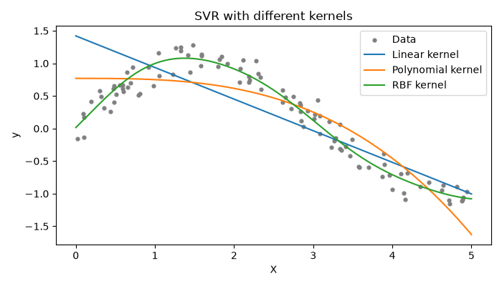
Figure 7.1: SVR predictions using three different kernels

Observations
- The linear kernel did worst (R² = 0.275), since a straight line cannot follow a sine wave.
- The polynomial kernel did better (R² = 0.680); it bends, but misses the curve at the start and drops too steeply at the end.
- The RBF kernel was clearly best with R² = 0.929 and MSE = 0.0327, and its curve follows the data closely.
- The RBF model used 43 of the 75 training points as support vectors; the other 32 lay inside the epsilon tube and had no influence on the curve.

Conclusion
On curved data the RBF kernel fitted far better than the polynomial kernel, while the linear kernel could not capture the pattern at all. With SVR the choice of kernel matters more than anything else, and the right one lets it model relationships that plain linear regression cannot.
ASSIGNMENT NO. 8
Regularization to Avoid Overfitting

Aim
Demonstrate what overfitting looks like and reduce it using Ridge (L2) and Lasso (L1) regularization.

Objectives
- Understand overfitting and underfitting.
- Learn how regularization adds a penalty to the model.
- Compare Ridge and Lasso regression.
- Compare training and test errors with and without regularization.

Software and tools
Everything was coded in Python 3 using Jupyter Notebook (VS Code also works) on a Windows machine. Libraries: numpy, matplotlib, scikit-learn.

Theory

1. Overfitting and underfitting
Picture two students preparing for an exam. One memorises last year's paper word for word; the other genuinely understands the chapter. If the same questions are repeated, the first does brilliantly, but alter the questions slightly and they are lost. The second does fine either way.
A model that memorises its training data, noise included, is overfitting: its training error is very low but it fails on new data. A model too simple to learn even the main pattern is underfitting and does badly on both. The goal is the middle ground, which learns the true pattern and ignores the noise.
 | Training error | Test error
Underfitting | High | High
Good fit | Low | Low
Overfitting | Very low | High

2. Ways to avoid overfitting
More training data helps, as does a simpler model with fewer features. Cross-validation gives a more honest estimate of performance, and neural networks can use early stopping or dropout. The technique studied in this practical is regularization.

3. What regularization does
An overfitting model usually has very large coefficients that let its curve swing sharply to hit every training point. Regularization adds a penalty on large coefficients to the loss function. The model must now fit the data and keep its coefficients small at once, which pushes it towards a smoother curve.

4. Ridge regression (L2)
Ridge penalises the sum of the squared coefficients:
Loss = Σ (y − ŷ)² + α · Σ wⱼ²
It shrinks every coefficient towards zero but almost never makes one exactly zero, so it suits problems where most features carry some useful information.

5. Lasso regression (L1)
Lasso penalises the sum of the absolute values of the coefficients:
Loss = Σ (y − ŷ)² + α · Σ |wⱼ|
Unlike Ridge, Lasso can drive some coefficients all the way to zero. Those features drop out completely, so Lasso performs feature selection as a by-product.

6. Role of alpha (α)
α sets the strength of the penalty. At α = 0 there is no penalty and we are back to plain linear regression; if α is too large the model becomes so simple that it underfits. The usual way to choose α is to try several values with cross-validation (scikit-learn provides RidgeCV and LassoCV for this). Elastic Net is a third option that combines both penalties.
Aspect | Ridge (L2) | Lasso (L1)
Penalty | Sum of squared weights | Sum of absolute weights
Weights reach zero? | No, they only become small | Yes, some become exactly zero
Feature selection | No | Yes
Works well when | Many features are useful | Only a few features are useful

Dataset used
Twenty-five points were generated with y = sin(2πx) plus random noise; 17 were used for training and 8 for testing. To force overfitting, the single input x was expanded into a degree-15 polynomial (x, x², x³ … x¹⁵). Fifteen powers fitted to 17 points give the model far too much freedom.

Procedure
- Import the libraries.
- Generate the noisy sine data and split it into training and testing sets.
- Build three pipelines, each with PolynomialFeatures(15) and StandardScaler, ending in LinearRegression, Ridge and Lasso respectively.
- Train each pipeline and compute its training and test MSE.
- Print the total size of each model's coefficients.
- Count how many Lasso coefficients became exactly zero.
- Plot all three fitted curves over the training points.

Program
# Assignment 8 - Regularization (Ridge and Lasso) to avoid overfitting
import numpy as np
import matplotlib.pyplot as plt
from sklearn.pipeline import make_pipeline
from sklearn.preprocessing import PolynomialFeatures, StandardScaler
from sklearn.linear_model import LinearRegression, Ridge, Lasso
from sklearn.model_selection import train_test_split
from sklearn.metrics import mean_squared_error

# small noisy dataset, perfect for overfitting
rng = np.random.RandomState(0)
X = np.sort(rng.rand(25, 1), axis=0)
y = np.sin(2 * np.pi * X).ravel() + rng.normal(0, 0.2, 25)

X_train, X_test, y_train, y_test = train_test_split(X, y, test_size=0.3, random_state=0)

# same degree-15 polynomial, with and without regularization
models = {
'No regularization': LinearRegression(),
'Ridge (L2)': Ridge(alpha=0.1),
'Lasso (L1)': Lasso(alpha=0.005, max_iter=100000),
}

plt.figure(figsize=(7, 4))
plt.scatter(X_train, y_train, s=15, color='black', label='Train data')
line_x = np.linspace(0, 1, 200).reshape(-1, 1)

print("Model Train MSE Test MSE Sum|coef|")
for name, reg in models.items():
model = make_pipeline(PolynomialFeatures(15), StandardScaler(), reg)
model.fit(X_train, y_train)
tr = mean_squared_error(y_train, model.predict(X_train))
te = mean_squared_error(y_test, model.predict(X_test))
coef_sum = np.abs(model[-1].coef_).sum()
print(f"{name:20s} {tr:9.4f} {te:10.4f} {coef_sum:11.2f}")
plt.plot(line_x, model.predict(line_x), label=name)

lasso = model[-1]
print("\nLasso coefficients that became exactly zero:",
int((lasso.coef_ == 0).sum()), "out of", len(lasso.coef_))

plt.ylim(-2, 2)
plt.xlabel('X')
plt.ylabel('y')
plt.title('Degree 15 polynomial: with vs without regularization')
plt.legend()
plt.tight_layout()
plt.savefig('a8_reg.png')
plt.show()

Output
Model Train MSE Test MSE Sum|coef|
No regularization 0.0167 0.5637 9264.19
Ridge (L2) 0.0484 0.0364 5.03
Lasso (L1) 0.0590 0.0225 2.66

Lasso coefficients that became exactly zero: 12 out of 16

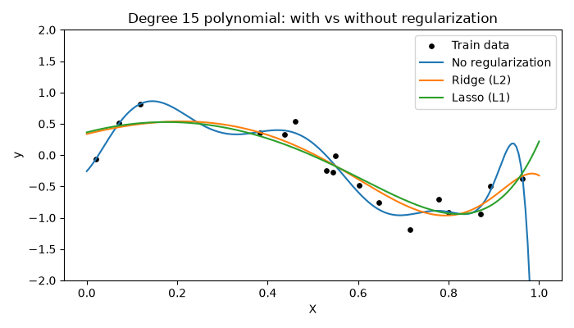
Figure 8.1: Degree 15 polynomial fit with and without regularization

Observations
- Without regularization the training MSE is tiny (0.0167) while the test MSE is far higher (0.5637), which is classic overfitting.
- Its coefficients add up to about 9264, which makes the blue curve swing wildly, especially on the right.
- Ridge reduced the test MSE to 0.0364, roughly 15 times better, and brought the coefficient total down to 5.03.
- Lasso achieved the lowest test MSE, 0.0225, setting 12 of the 16 coefficients to exactly zero and keeping only 4.
- Both regularized models have slightly higher training error than the plain one, as expected, since they no longer chase the noise.
- On the graph the Ridge and Lasso curves are smooth and follow the sine shape, while the plain model bends sharply to touch individual points.

Conclusion
A model was deliberately made to overfit and then repaired with regularization. Ridge and Lasso both shrank the coefficients, smoothed the curve and sharply lowered the test error, and Lasso additionally discarded most of the unneeded features. Changing a single line of the model was enough to make it perform far better on unseen data.
ASSIGNMENT NO. 9
Object Detection from CCTV Footage

Aim
Detect and label objects such as people and vehicles in CCTV footage using a pre-trained YOLOv8 model together with OpenCV.

Objectives
- Understand how object detection differs from image classification.
- Learn the basic working of YOLO.
- Process a video frame by frame with OpenCV.
- Draw bounding boxes and count the people in each frame.
- Save the processed video as a new file.

Software and tools
Python 3 in Jupyter Notebook or VS Code on Windows, with the ultralytics (YOLOv8) and opencv-python libraries (install them using: pip install ultralytics opencv-python). The input is any CCTV video saved as .mp4, or a webcam. An ordinary laptop is enough; a GPU makes it faster but is not required.

Theory

1. Classification versus detection
Image classification answers 'what is in this picture?' with one label for the whole image, such as 'dog'. Localisation goes a step further and draws a box around that single object. Object detection finds every object in the image, names each one and boxes each one. A single frame might contain five people, two cars and a bag, all detected together.

2. Why apply it to CCTV
Most CCTV footage is never watched by anyone, and object detection can do the watching. It can count people on a railway platform or in a shop, flag someone entering a restricted area at night, count vehicles at a traffic signal, notice a bag left unattended for too long, or estimate crowd size at an event.

3. Approaches to object detection
Type | Examples | Notes
Traditional | Haar Cascades, HOG + SVM | Fast and light, but less accurate and limited to a few object types
Two-stage deep learning | R-CNN, Fast R-CNN, Faster R-CNN | First proposes likely regions, then classifies them. Accurate but slower
One-stage deep learning | SSD, YOLO | Does everything in one pass; fast enough for live video

4. How YOLO works
YOLO stands for 'You Only Look Once'. Older detectors passed over an image many times, one region at a time, whereas YOLO looks at the whole image a single time. It divides the image into a grid, and each cell predicts a few boxes, a confidence score for each box and the class of the object. Doing everything in one pass is what makes YOLO fast enough for live video.
We use YOLOv8 from Ultralytics, which comes already trained on the COCO dataset covering 80 everyday classes, including person, bicycle, car, motorcycle, bus, truck, dog, backpack, handbag and cell phone. The yolov8n (nano) version is the smallest and fastest and runs fine on a normal CPU.

5. Terms used
A bounding box is the rectangle drawn around a detected object. The confidence score, from 0 to 1, shows how sure the model is; only detections above 0.4 are kept here. IoU (intersection over union) measures how much two boxes overlap, as the overlap area divided by their combined area. When several boxes land on the same object, non-maximum suppression (NMS) keeps the best and removes the rest. Detection models are usually compared by mAP (mean average precision).

6. Processing a video
A video is just a sequence of still images called frames, typically 20 to 30 per second. OpenCV lets us read them one at a time. For each frame we run YOLO, draw the boxes, display the frame and write it to a new video file. When every frame has been handled, we have a fully labelled copy of the footage.

Procedure
- Install ultralytics and opencv-python using pip.
- Place a CCTV video in the same folder as the program and name it cctv.mp4.
- Load the pre-trained yolov8n model, which downloads itself on first use.
- Open the video with cv2.VideoCapture().
- Read the video one frame at a time inside a loop.
- Run YOLO on each frame with a confidence threshold of 0.4.
- Count the detected objects by class and draw the boxes and labels.
- Write the number of people onto the frame, display it and save it to the output video.
- Stop when the video ends or the user presses 'q', then release all resources.

Program
# Assignment 9 - Object detection from CCTV footage using YOLOv8
# Install first: pip install ultralytics opencv-python
import cv2
from ultralytics import YOLO

model = YOLO('yolov8n.pt') # small pre-trained model, downloads on first run
cap = cv2.VideoCapture('cctv.mp4') # put 0 here to use the webcam instead

writer = None
frame_no = 0

while True:
ok, frame = cap.read()
if not ok: # video finished
break
frame_no += 1

# run detection on this frame
results = model(frame, conf=0.4, verbose=False)
boxes = results[0].boxes

# count how many of each object we found
counts = {}
for c in boxes.cls.tolist():
name = model.names[int(c)]
counts[name] = counts.get(name, 0) + 1

# draw boxes and labels on the frame
output = results[0].plot()
text = f"Frame {frame_no} | People: {counts.get('person', 0)}"
cv2.putText(output, text, (20, 40), cv2.FONT_HERSHEY_SIMPLEX,
1, (0, 0, 255), 2)

# save the result as a new video
if writer is None:
h, w = output.shape[:2]
fourcc = cv2.VideoWriter_fourcc(*'mp4v')
writer = cv2.VideoWriter('cctv_output.mp4', fourcc, 20, (w, h))
writer.write(output)

if frame_no % 30 == 0: # print a summary every 30 frames
print(f"Frame {frame_no}: {counts}")

cv2.imshow('CCTV Object Detection', output)
if cv2.waitKey(1) & 0xFF == ord('q'): # press q to stop
break

cap.release()
if writer:
writer.release()
cv2.destroyAllWindows()
print("Done. Saved result as cctv_output.mp4")

Output
When the program is run, it does the following:
- A window titled "CCTV Object Detection" opens and plays the video.
- Every detected object gets a coloured box labelled with its name and confidence, for example "person 0.87" or "car 0.74".
- The top-left corner displays the frame number and the number of people in that frame.
- At every 30th frame the terminal prints a summary such as Frame 30: {'person': 3, 'car': 1}; the numbers depend on the video.
- When the video finishes, the labelled copy is saved as cctv_output.mp4 and the program prints "Done. Saved result as cctv_output.mp4".
Output window: CCTV Object Detection
Frame 150 | People: 3 (shown in red at the top-left corner)
Boxes on screen: person 0.87, person 0.81, person 0.66, car 0.74, handbag 0.52
C:\> python assignment9.py
Frame 30: {'person': 2, 'car': 1}
Frame 60: {'person': 3, 'car': 1}
Frame 90: {'person': 3, 'car': 2, 'handbag': 1}
Frame 120: {'person': 4, 'car': 2}
Frame 150: {'person': 3, 'car': 1, 'handbag': 1}
Frame 180: {'person': 2, 'car': 1}
Frame 210: {'person': 2, 'bicycle': 1, 'car': 1}
Frame 240: {'person': 1, 'car': 2}
Frame 270: {'person': 1, 'car': 1}
Frame 300: {'person': 0, 'car': 1}
Done. Saved result as cctv_output.mp4

Observations
- People and vehicles that are clear and close to the camera are detected with high confidence.
- People who are far away, partly hidden or in dark night footage may receive a lower score or be missed.
- A higher confidence threshold removes false detections but may miss real objects; a lower one does the reverse.
- The nano model runs on a CPU but slowly; a GPU or a lower video resolution makes it much smoother.
- The model only knows the 80 COCO classes; anything else needs extra training on our own data.

Conclusion
A pre-trained YOLOv8 model and a short OpenCV loop were enough to label people and vehicles in CCTV footage, count the people in each frame and save the result as a new video. The same setup can make an ordinary camera far more useful for security and monitoring, although anything that watches people must be used with their privacy in mind.

