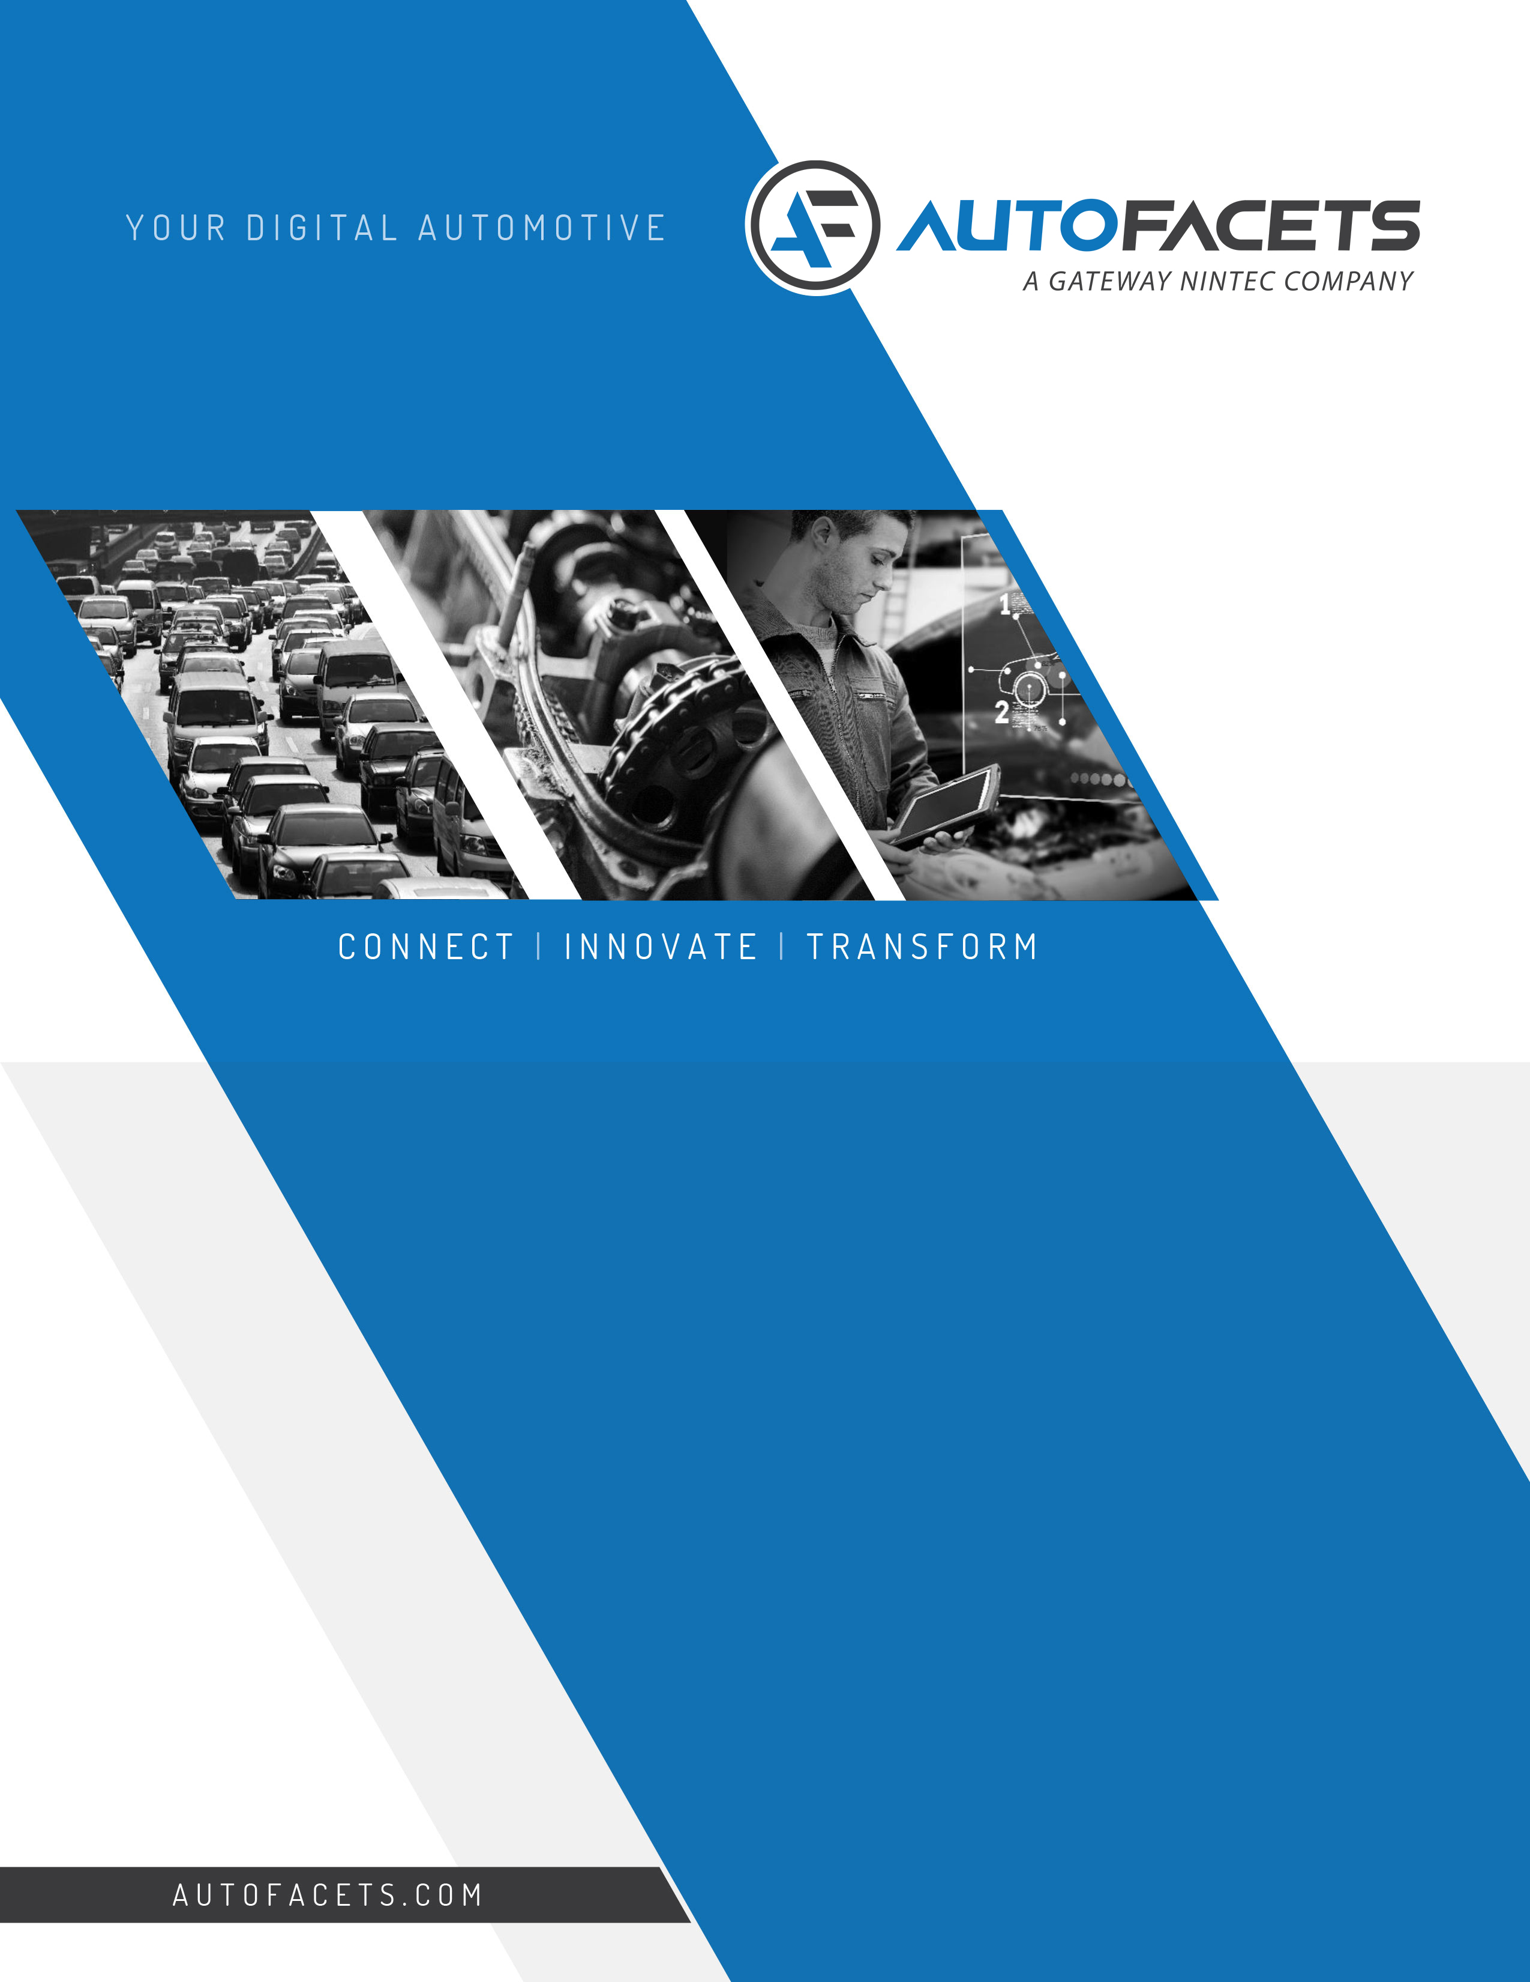

YOUR DIGITAL AUTOMOTIVE PARTNER

Report for 14th April, 2021

By: Shubham Lunker

I had the following activities planned with Mohanish Sir as a part of induction to STC.

* AutoFacets - GEM Automotive:

- Automotive Industry Eco-system Overview

- Our Experience & expertise

- Key showcases

* AutoFacets Capabilities:

- Walk-through of major project showcases in the capability PPT

* Workshop Activities

Due to time constraints and some other factors we covered the first topics and it’s sub – topics. Here on, I have tried my best to document my understanding regarding the same.

**1. AutoFacets:**



* AutoFacets provides IT based solution to organizations working in the automotive domain.
* AutoFacets is a European major in digital automotive products and solutions for over 23 years. With 16 offices worldwide and more than 350 European success stories, they facilitate the entire automotive ecosystem with digital innovation and disruptive technologies.
* The major segments that are catered by AutoFacets are as follows:

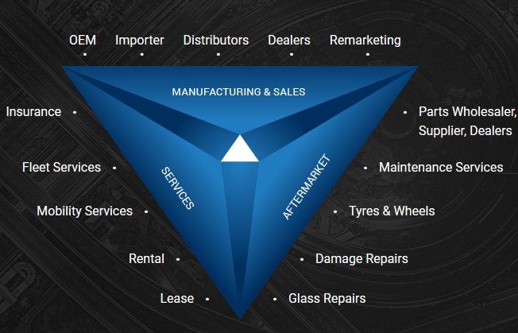

* **Manufacturing and Sales:**
  + - OEM – Original Equipment Manufacturer
    - Importer
    - Distributors
    - Dealers
    - Remarketing
* **Aftermarket**:
  + - Parts Wholesaler, Suppliers, Dealers
    - Maintenance Services
    - Tyres and Wheels
    - Damage Repairs
    - Glass Repairs
* **Services:**
  + - Insurance
    - Fleet Services
    - Mobility Services
    - Rental
    - Lease

**1. Manufacturing and Sales:**

* OEM’s and Distributors:
  + OEM stands for Original Equipment Manufacturer.
  + An Original Equipment Manufacturer or OEM is a company that manufactures and sells products or parts of a product that their buyer, another company, sells to its own customers while putting the products under its own [branding](https://corporatefinanceinstitute.com/resources/knowledge/other/brand-equity/). OEM’s commonly operate in the auto and computer industries.
  + For example, in a manufacturing plant of Tata motors, different parts like tyres, glass, etc may be brought in from different OEM and they are assembled under the same roof to make a car.
* Importers:
  + - Considering India, car maybe brought in from different parts of the world. So, basically we are importing the car or a part from another region. AF provides solutions for it’s management.
* Distributors:
  + - India as a country may have many distributors for any car as a part of supply chain. It is supplied down to different states like Gujarat, Maharastra, etc. Than further it may be distributed city wise and so on