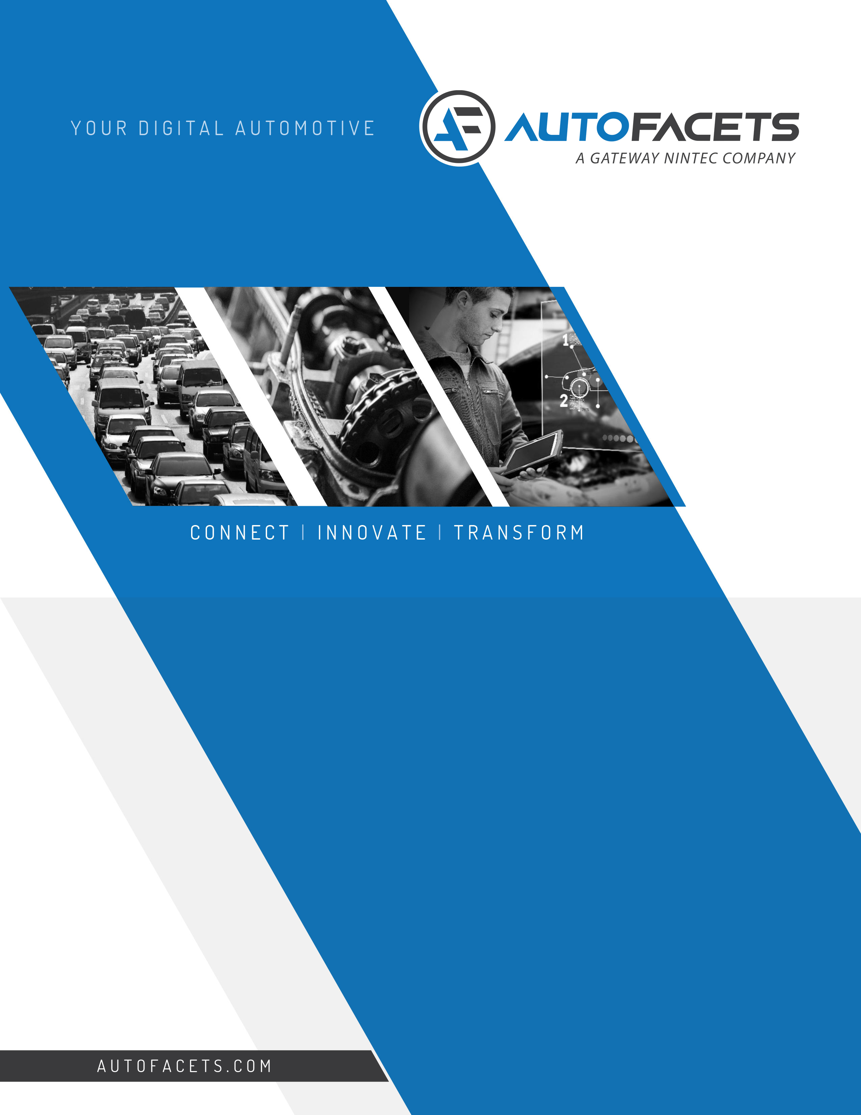

YOUR DIGITAL AUTOMOTIVE PARTNER

http://www.aldautomotive.be/Portals/belgium/ald_automotive_logo.png?ver=2015-10-02-163739-570

**Pricing Tool**

**Analysis Phase**

Proposal Document

Date: 11th October, 2017 | Version V0.1  
  
***“Digital Transformation and  
 Technology is in our DNA”***

TABLE OF CONTENTS

1. Introduction 3

1.1 Background to this Proposal 3

1.2 Overall Objective 3

1.3 Purpose of this proposal 3

2 AutoFacets’s Proposition 4

3 Approach – Analysis Phase 4

4 Solution Overview 5

4.1 Functional Components & Flow 5

4.2 BI Engine – Prediction 6

5 Engagement Overview 6

5.1 Engagement Model 6

5.2 Team Composition 7

5.3 Organizational Roles & Responsibilities 7

6 Delivery Overview 8

6.1 Deliverables 8

6.2 Timeline 8

7 Commercials 8

7.1 Payment Schedule 8

7.2 Payment Terms 9

8 Appendix 10

8.1 Autofacets Visualization 10

# Introduction

**ALD Automotive** (Henceforth referred to as “ALD”) is a multi-brand car leasing and fleet management company independent of any car manufacturer and is ranked among the top 3 major players worldwide. ALD principally offers two car leasing products: full service vehicle leasing and fleet management.

**AutoFacets** is a Gateway Group Company and an Automotive strategic business unit (SBU) of **NINtec B.V.** (Henceforth referred to as “NINtec”), based in Zoetermeer, The Netherlands. AutoFacets is the Digital Automotive Partner for companies in the Automotive industry. With its rich portfolio of services, solutions and products, we collaborate with automotive businesses for digital innovations that drive competitive edge.

## Background to this Proposal

## Overall Objective

The automotive industry is changing rapidly, as new technologies, offerings and players emerge. To remain competitive, the most progressive automotive companies are working hard to get ahead of the digital disruptions, master the developments in technology, and adjust to the new, tech-based business models. Winners will be companies that create new customer experiences, innovate new services & processes and build & new capabilities to seize market opportunities.

Automotive market has globally shifted focus towards customer centricity. With increasing competition in the market, it is extremely important to continuously engage the customers and ensure their stickiness and loyalty. The ambition of ALD is to implement Smart Pricing solutions.

In order to achieve this, Autofacets will perform analysis phase for the below points

* Problem Statement
* Pain Areas
* Improvement in Pricing
* Who will be the users?
* Future plan

Hence, AutoFacets and ALD can jointly leverage this prior experience and take this to the next level.

## Purpose of this proposal

In order to achieve the overall objective, AutoFacets is submitting this RA and PoC Phase proposal which explains the proposition, Solution overview, Engagement, deliverables, timeline, and commercials for the proposed project.

# AutoFacets’s Proposition

AutoFacets has over two decades of experience across various segment and strong expertise in delivering multiple complex & innovative across verticals like Automotive, Logistics & Transportation, Retail & Distribution domains. As such, AutoFacets understands the criticality and complexity that such a project would involve and can visualize the touch-points and impact this solution would have on the business of ALD.

AutoFacets proposes a fixed price - time boxed model for this Analysis Phase.

# Approach – Analysis Phase

AutoFacets will conduct the Analysis phase of 3 workshops for implementation of Pricing Engine, jointly with ALD and relevant stakeholders from ALD.

Autofacets will deploy a project manager (PM) and a team of SME/BA for Analysis Phase. Project Manager (PM) will lead and supervise the deliveries.

* During Analysis Phase workshops will be planned to facilitate discussions and decision making. ALD subject matter experts will participate along with Autofacets staff in these workshops.
* First 2 workshop will include the analysis, requirements gathering, updating and documentation and last 1 workshop will be finalization and approval. This will be executed in a time-boxed manner from both ALD and AutoFacets side to ensure timely delivery.

Following area will be explore during the workshops:

* Problem Statement
* Pain Areas
* Improvement in Pricing
* Who will be the users?
* Future plan

*Note: Final workshop agenda will be published at the start of Analysis Phase.*

# Solution Overview

AutoFacets has visualized the overall solution and approach that is required for the required pricing engine. Below diagram gives a holistic idea on how the tool will process.

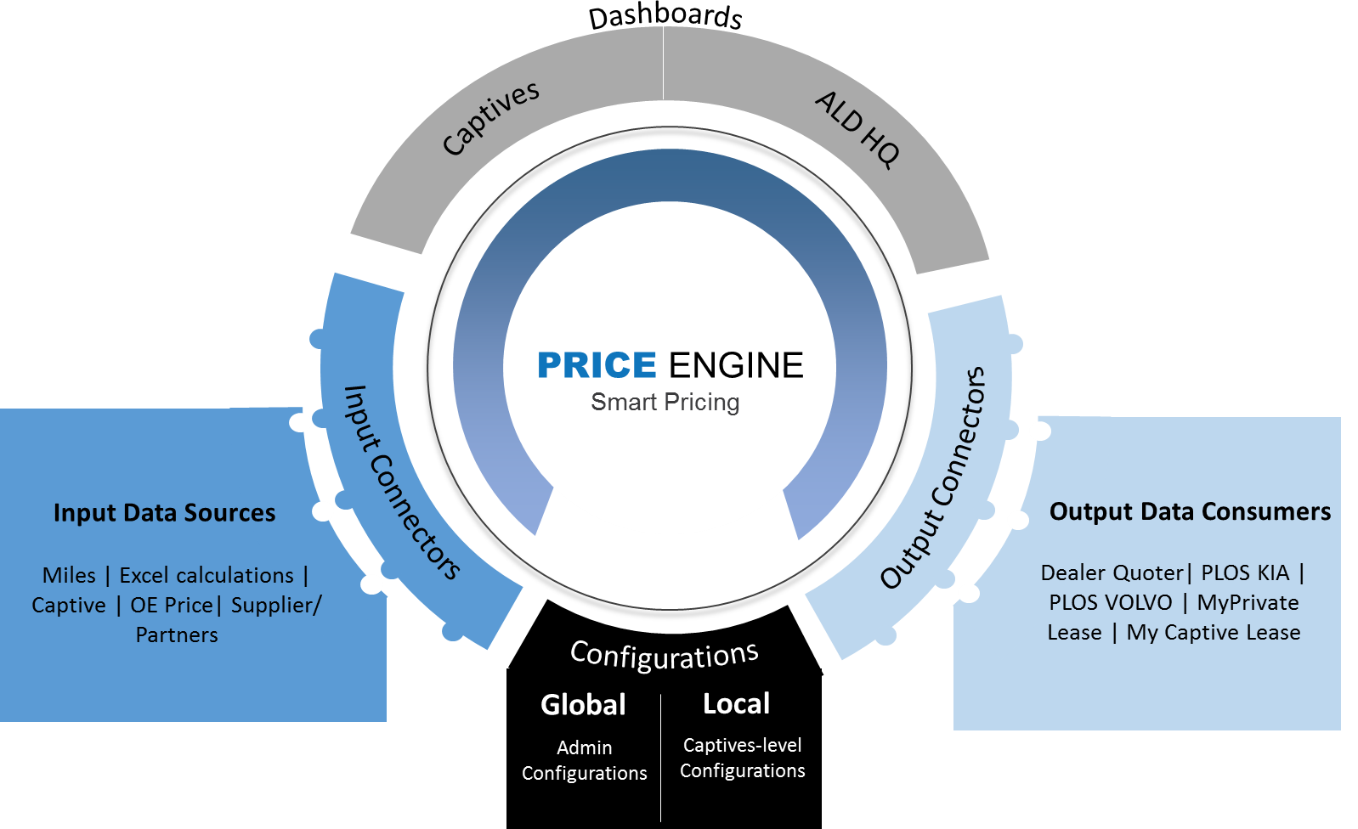

## Functional Components & Flow

Autofacets has visualized the high-level functional solution of the Pricing Engine from the point of view of Captives and ALD HQ. The below diagram provides a high-level visualization of functional components & flow for the Pricing Engine.

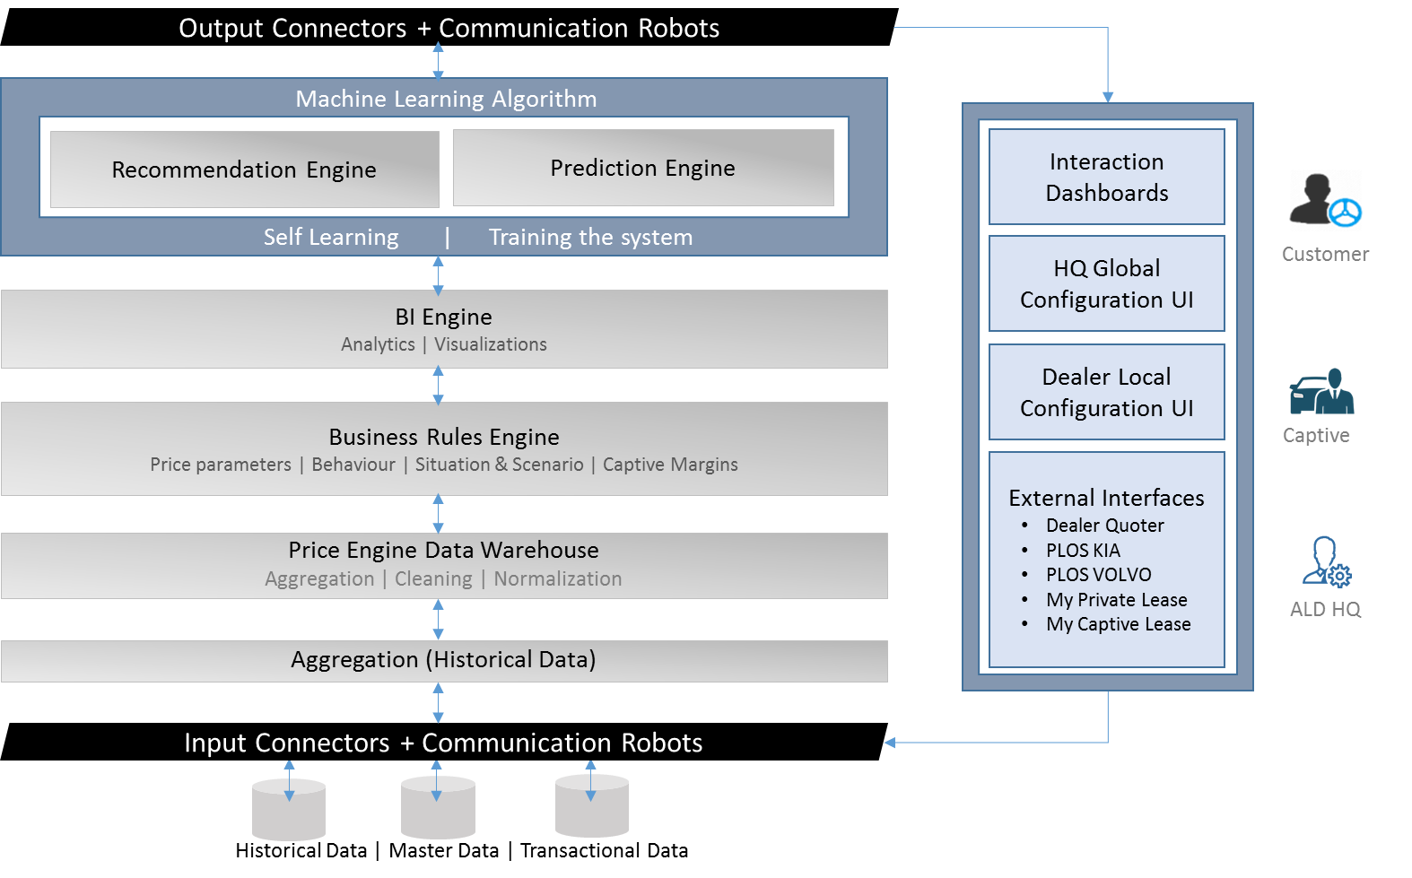

## BI Engine – Prediction

Autofacets has visualized and consolidate, price modeling and prediction with BI engine; below diagram is a overall view of self-learning and adapting model.

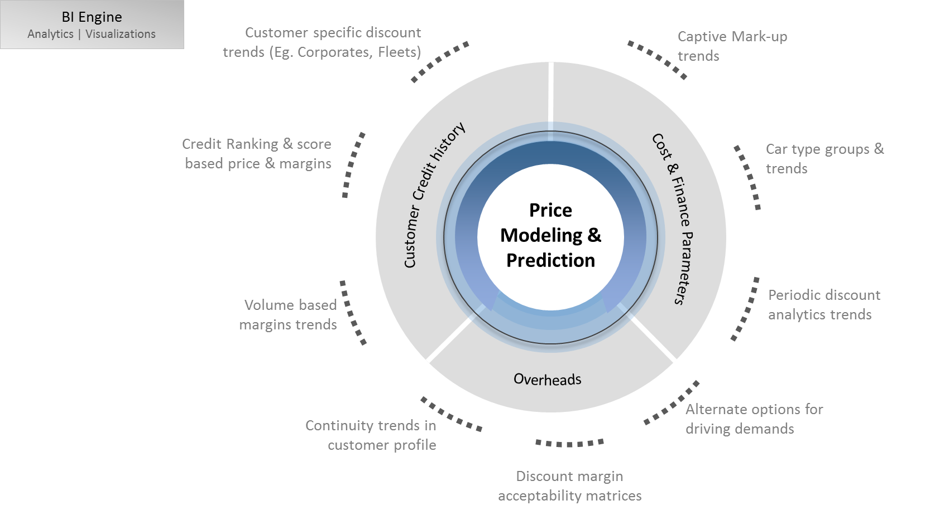

# Engagement Overview

## Engagement Model

AutoFacets believes in a balanced onsite & offshore service offerings approach and executes software development and innovation projects through its onsite & offshore software development centres.

AutoFacets will deploy an onsite Business project manager (BPM) based in The Netherlands, who has the required knowledge and expertise, has understanding of local culture, business and language. He will manage, monitor and control the project and will formally report to the ALD team on a regular basis about the project status. He will be responsible for highest level project management and delivery.

AutoFacets will deploy a team of technical resources from offshore locations with the expertise and domain knowledge to work on long term onsite-offshore engagement in a similar capacity, ensuring adherence to the business and project objectives.

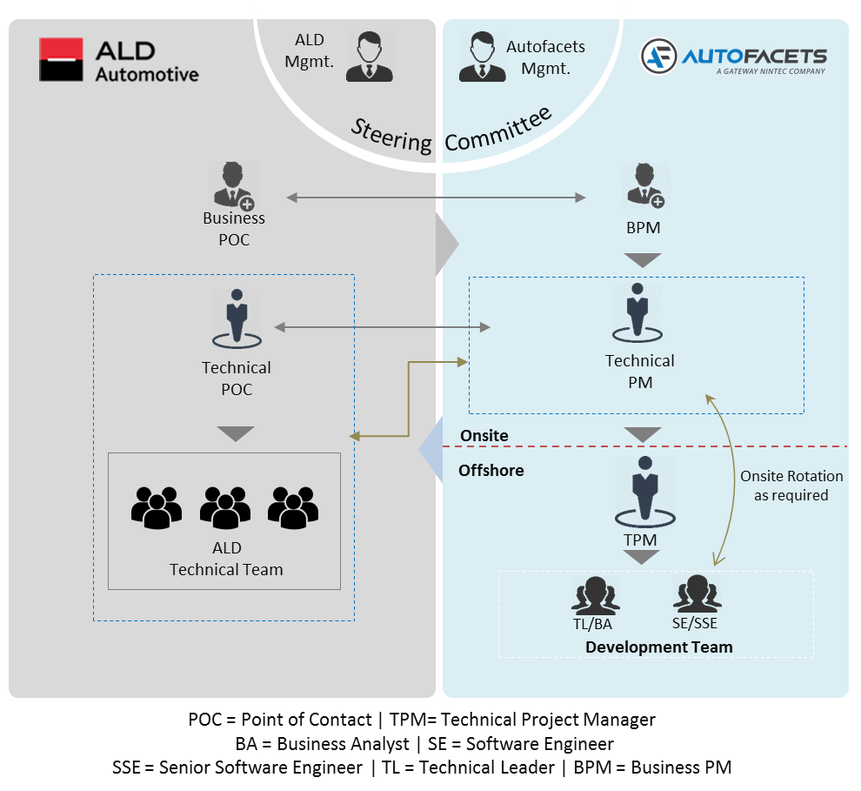

## Team Composition

Following table explains the team roles/composition for Analysis Phase:

|  |  |  |
| --- | --- | --- |
| **#** | **Resource Type** | **Code** |
| 1 | Technical Lead/Business Analyst | TL/ BA |
| 2 | Senior Software Engineer | SSE |
| 4 | Senior Test Engineer | STE |
| 6 | Onsite – Business Project Manager | Onsite – BPM |

## Organizational Roles & Responsibilities

**AutoFacets**

* AutoFacets will deliver the necessary standard document drafts, which need to be reviewed and approved by ALD.
* AutoFacets will provide detailed project plan before the start of Implementation to ALD for review and approval.
* AutoFacets shall be responsible for testing of the functionality of the delivery as per the functional scope that will be agreed upon between both the parties.
* AutoFacets will be responsible for providing skilled resources.

**ALD Automotive**

In order to ensure the success of Analysis phase, the following will be the major expectations from ALD Automotive:

* Identify and involve right people corresponding to the workshop sessions and Agenda, to participate effectively during the workshop.
* Jointly define clear expectations with AutoFacets and provide required support for Autofacets to meet the expectations.
* ALD will provide timely inputs on the information requested by Autofacets before, during and after the workshop sessions.
* ALD will be responsible for both making decisions and providing information in a timely manner.
* ALD will be responsible for providing related support documents related to the Analysis phase.
* Ensure consolidation of collective inputs from the other important stakeholders of ALD.
* The approval/feedback should take place within 3-5 working days from the day AF presents any material for approval/feedback. Any delay in the approval will result in delay of the Analysis Phase.

# Delivery Overview

* 1. Deliverables

## Timeline

The total duration of the Analysis Phase is 6 weeks including the 3 workshops for 4 hours each.

# Commercials

## Payment Schedule

|  |  |  |  |
| --- | --- | --- | --- |
| **Milestone** | **Deliverable Task** | **%** | **Amount** |
| 1 | Payment towards start of Analysis Phase | 50% | X.XXX,- |
| 2 | Payment towards end of Analysis Phase | 50% | X.XXX,- |
|  | **Total Cost (€)** | 100% | XX.XXX,- |

*\* Note: Any onsite travel of offshore resources, if required, will be additional to the above pricing.*

The overall investment budget for the Analysis Phase based on the current understanding is **€ XX.XXX,- ex BTW** (if applicable).

## Payment Terms

* All amounts are ex BTW.
* Invoices will be raised as per the payment schedule.
* Invoices are payable to AutoFacets (NINtec B.V.) within 14 days of the date of the invoice.
* The general terms & conditions of AutoFacets (NINtec B.V.), filed at the chamber of commerce, Zoetermeer under number 27192319 are applicable to all our offerings, correspondence and this contract/proposal. The same is attached herewith in the proposal.
* The proposal is valid for 15 days from the date of submission.

We hope that by means of this proposal, we have met the expectations of ALD and look forward to a mutually beneficial business cooperation. We kindly request you to sign on set of documents and return these back to us.

Best regards,

**Vipin Moharir**

CEO, NINtec B.V.

Date:

Signature: …………………………….

Signed on Behalf of ALD Automotive for Acceptance:

**Mr. Stefan Kamp**

Manager ICT, ALD Automotive

Date: .........................

Signature: …………………………….

# Appendix

## Autofacets Visualization

**The Concept**

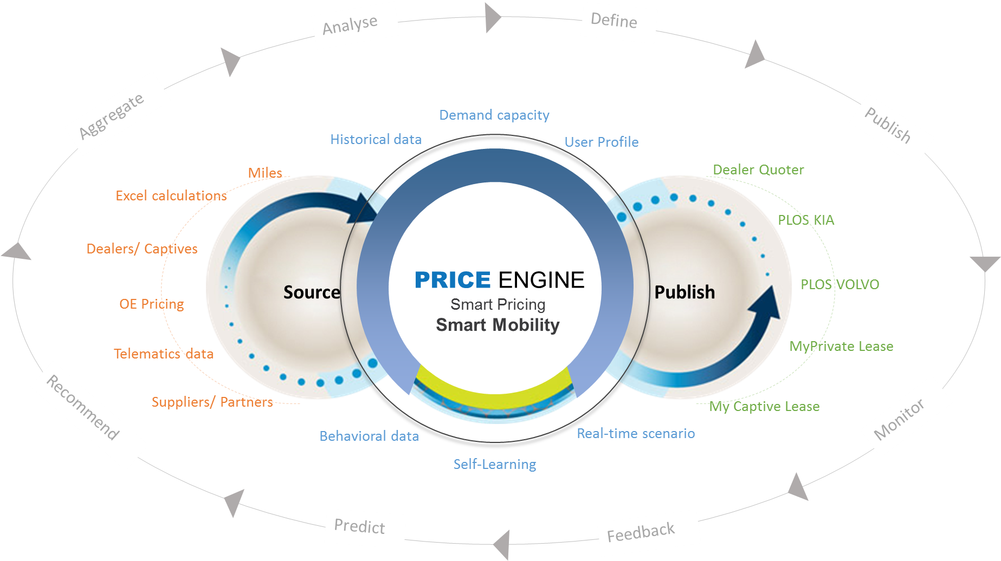

**Price Engine – Characteristics**

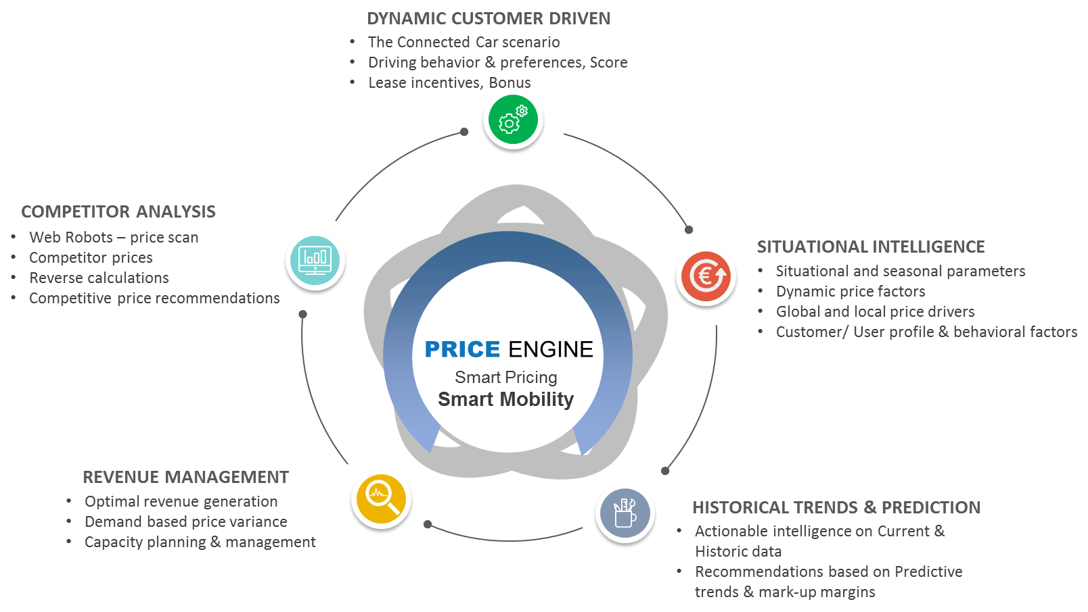

**What it brings to Stakeholders**

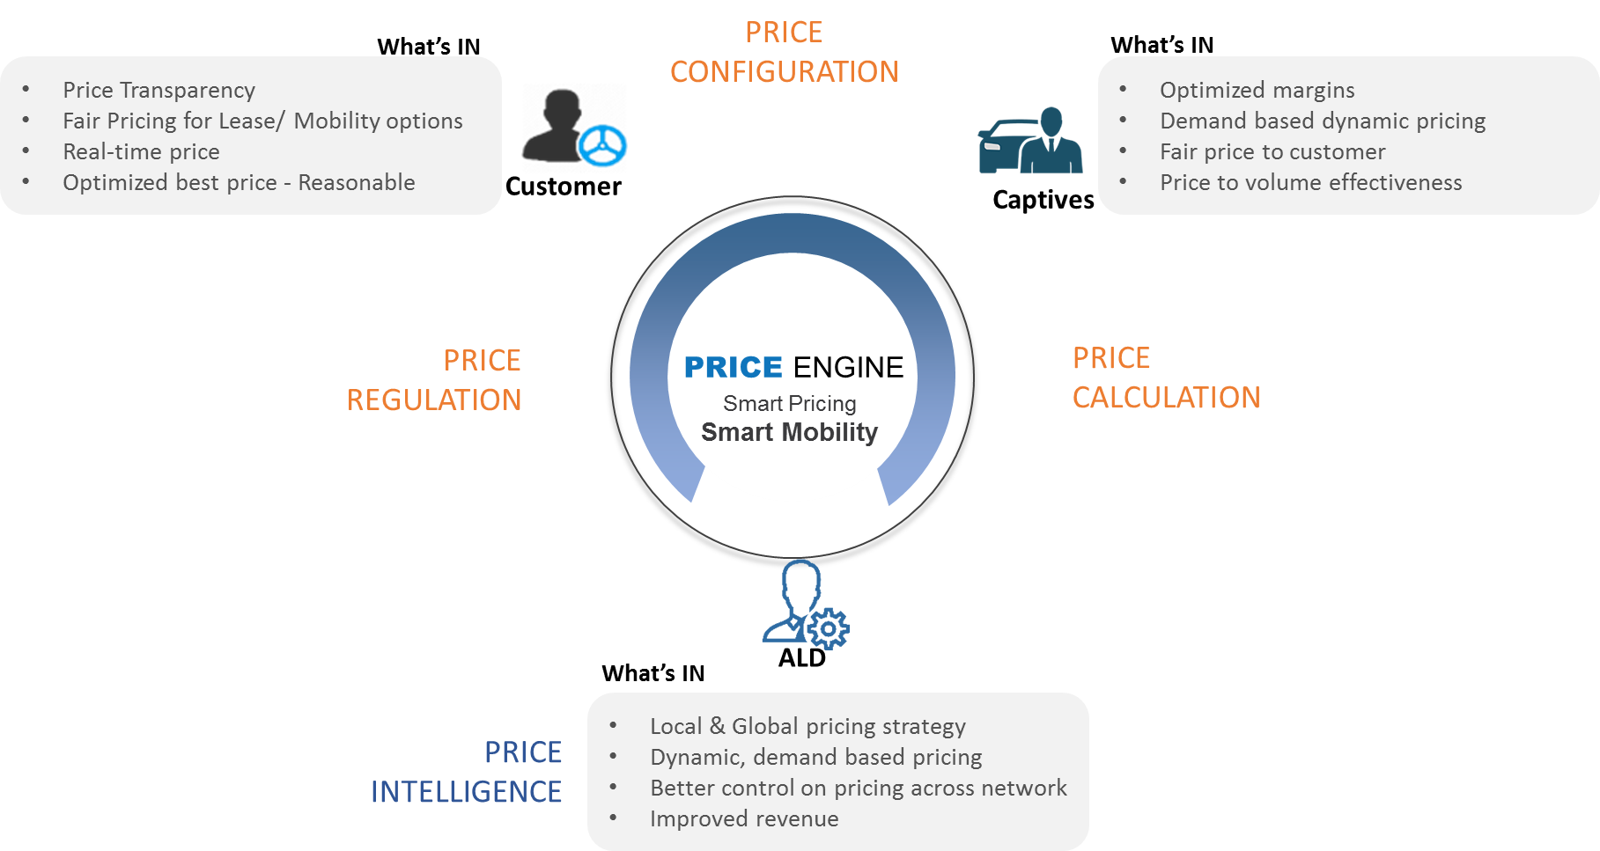



**Europe**Willem Dreeslaan 434, 2729 NK Zoetermeer,

The Netherlands   
Phone: [+31 (0) 79 3200 980](tel:+310793200980)  
Email: [info@autofacets.com](mailto:info@autofacets.com)

****Confidentiality****

**This document and any files with it are for the sole use of the intended recipient(s) and may contain confidential and privileged information. If you are not the intended recipient, please destroy all copies of the document. Any unauthorized review, use, disclosure, dissemination, forwarding, printing or copying of this document or any action taken in reliance on this document is strictly prohibited and may be unlawful. Visit us at** <http://www.autofacets.com>

YOUR DIGITAL AUTOMOTIVE PARTNER