ELECTRONIC VEHICLE HEALTH CHECK

Below given is the method followed by car-maker Jaguar for an eVHC:

CHECK: The Jaguar Technician carries out the complimentary Electronic Vehicle Health Check and films any issues identified as red or amber.

NOTIFY: We'll receive an email containing a link and unique access code to view the video.

REVIEW: We'll be directed to a personalized web page with the footage, audio explanations and annotated imagery.

AUTHORIZE: Along with their findings, we’ll receive a fully priced quote. Simply click to authorise work or request a call back.

Jaguar has a methodology of 30 POINT ELECTRONIC VEHICLE HEALTH CHECK:

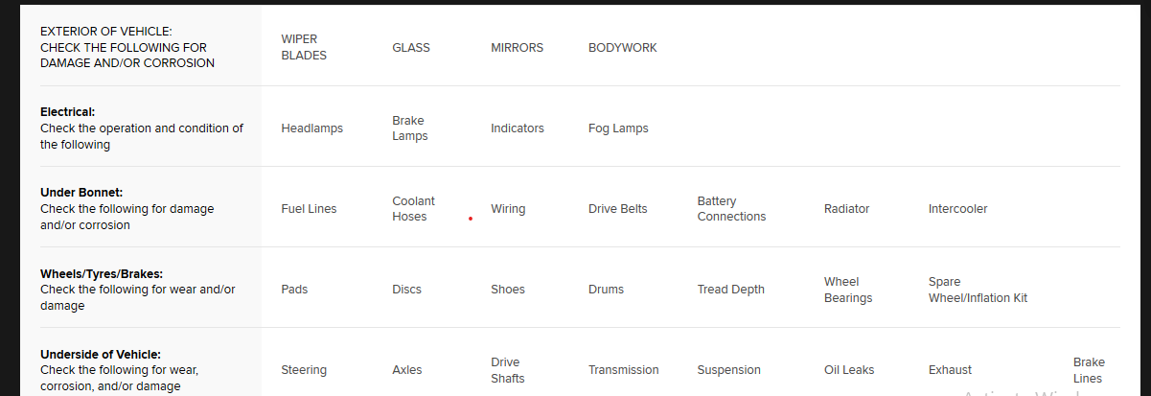

What is an intercooler and what does it do?
The intercoolers (Charge Air Coolers) are designed to reduce fuel consumption while increasing the engine power and efficiency. The intercooler's task is to reduce the temperature of the inlet gas and thus densify the air required which optimises the combustion.

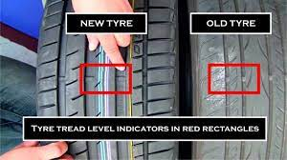
Tread Depth:

Wheel bearing:
A wheel bearing is a crucial part of the wheel assembly that connects the wheel and the axle. It is a set of steel balls (ball bearings) or tapers (tapered bearings), held together by a metal ring. It enables the wheel to rotate smoothly with a minimum of friction.
