Electronic Vehicle Health Checkup (eVHC)

What is an Electronic Vehicle Health Check?

– An Electronic Vehicle Health Check (eVHC) (also referred to visual health check) is a complimentary check of one's car’s components, carried out by a skilled technician.

– A ‘traffic light system’ is used on each of the different check points to report whether your vehicle is:

Green: Safe and good to go

Amber: Recommended work is required but not urgent

Red: Requires urgent attention

– No work will be done on your vehicle without first asking for your permission – the VHC is there to simply check the state of your car and provide you with relevant advice. It’s completely up to you whether you use us for any maintenance or repairs that are needed. In most cases, our customers choose for us to do so as while the vehicle is in our care this is the most convenient option.
What’s included in a Vehicle Health Check?

– A VHC includes checks on the following things:
• Brakes
• Tyre
• Lights
• Fluid Levels
• Exhaust
• Steering
• Suspension
• Electrical

– The check points will be listed in a report, as well as a short video which will be sent to you explaining what has been checked during the VHC. If any amber or red components have been identified, this will also include the technician’s recommendations for what to do next.

What are the benefits of using an eVHC system?

– When a vehicle is brought into a dealership for its routine service work, it pays to do a thorough vehicle health check! Using an electronic Vehicle Health Check (eVHC) system helps technicians identify additional repair issues. It can also generate a complete vehicle inspection report that can be sent to the customer in an easy-to-understand format. The whole eVHC process is transparent, creating goodwill between the service provider and customer, and leading to more opportunities to up-sell.

– With more and more dealerships across the world using an eVHC system to turn their after-sales operations around, it seems that it’s not just a question of adopting the system, but how far it can improve your performance.

CASE STUDY: SUPER-SERVICE TRIAGE

– It is a service provided by Infomedia.
– Infomedia is a leading global provider of SaaS solutions to the parts and service sector of the automotive industry.

Superservice Triage:
An online, mobile-friendly Vehicle Health Check (VHC) system, enabling service staff to identify, price and recommend additional repair work.
Superservice Triage empowers Service Advisors to deliver an easy-to-understand, fully priced vehicle inspection report with transparency and efficiency.

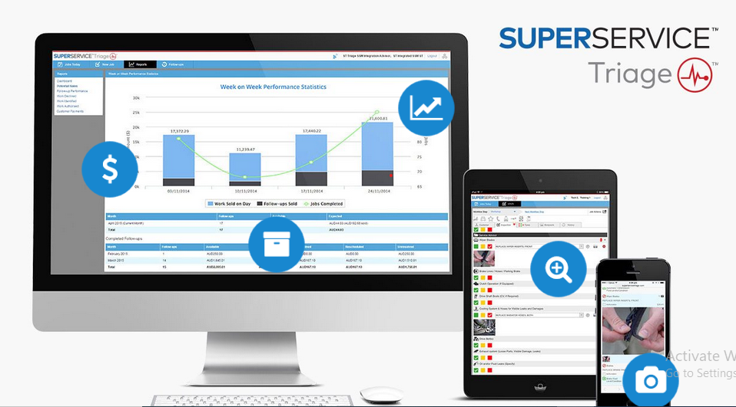

It's Features:

Photo & Video Capture:
– Build Trust through Transparency. Providing photo and video evidence of repair recommendations makes it easier for staff to explain the extent of the repair, required parts, labour and price. Your customers will feel more informed and engaged in their vehicle’s servicing, leading to higher service conversion rates.

Instant Price Quoting:
– VIN-Precise and Accurate. With full integration to Superservice Menus™ VIN-precise quoting; parts, labor, shop supplies, quantities and pricing are instantly available. Staff are empowered to quote quickly and accurately for complex repairs, reducing the time spent researching parts information and labor times. This delivers the critical price transparency that maximizes on-the-spot authorizations.

Real-time Reporting:
– Better Decision Making. Comprehensive real-time analytic give you the key insights to increase staff performance, sales closure and profits.
– Identify, track and report on VHC sales metrics with point and click simplicity:
- Number of Inspection Reports Created
- Averages Sold per Advisor/Tech
- Service Advisor Performance
- Technician Performance
- Sales and Conversion Rates
- Percentages Sold/Declined
- Reasons for Deferred/Declined Work
- Jobs Sold on Follow-up
- Tyre Sales

Customer Engagement:
– Improve Customer Experience and Retention. Build trust by providing customers with an informative, easy-to-understand and professionally presented vehicle inspection report, complete with visual evidence and accurate pricing. The report can also be emailed to customers, giving them the flexibility to view the report and authorize work online.

Job Status Alerts:
– Visual Status Tracking and Real-time Alerts. Superservice Triage tracks the status of the vehicle and alerts staff to changes in the vehicle status. This allows Service Advisors and Technicians to know where a vehicle is at any time, maximizing the efficiency of the dealership’s service process.

Working:

– https://www.youtube.com/watch?v=RNDxuP8YT7U&list=PLD1l_xbylNTGuOJ1xZplbeb6Z68Ej_PcY

