ML-Based Mental Health Prediction System Using Hybrid Machine Learning Techniques
IEEE Research Paper
Authors
Sumit Lohani (2210992419)
Shubham Sharma (2210992368)
Shubham Thakur (2210992371)
Uday Thakur (2210992474)
Department of Computer Science and Engineering
Institute Name
Under the Guidance of
Dr. Gurpreet Singh

Abstract
Mental health disorders such as anxiety, depression, and stress have become major public health concerns worldwide. Early identification of mental health issues can significantly improve treatment outcomes and reduce the social and economic burden associated with psychological disorders. Traditional diagnostic procedures are often time-consuming and dependent on clinical expertise. This research proposes a Machine Learning (ML)-Based Mental Health Prediction System that utilizes hybrid machine learning techniques to predict mental health conditions based on behavioral, social, and psychological attributes. The proposed system uses supervised learning algorithms including Random Forest, Support Vector Machine (SVM), Logistic Regression, and Gradient Boosting for classification and prediction. Data preprocessing, feature engineering, normalization, and model optimization techniques are applied to improve prediction accuracy. Experimental analysis demonstrates that the proposed hybrid model achieves high prediction accuracy and reliability compared to conventional approaches. The system provides a scalable and efficient solution for early mental health assessment and decision support in healthcare systems.
Keywords
Mental Health Prediction, Machine Learning, Depression Detection, Random Forest, Support Vector Machine, Healthcare Analytics, Artificial Intelligence

I. Introduction
Mental health is an essential component of human well-being that affects emotional, psychological, and social functioning. In recent years, mental health disorders such as depression, anxiety, bipolar disorder, and stress-related illnesses have increased rapidly due to lifestyle changes, academic pressure, workplace stress, and social isolation. According to global healthcare reports, millions of individuals suffer from mental illnesses, yet many cases remain undiagnosed due to lack of awareness and limited access to healthcare facilities.
Traditional mental health diagnosis depends heavily on psychiatrists and psychological assessments, which may be expensive, time-consuming, and subjective. The advancement of Artificial Intelligence (AI) and Machine Learning (ML) has opened new opportunities for automated healthcare prediction systems capable of identifying mental health patterns using data-driven approaches.
Machine learning algorithms can analyze large volumes of behavioral and psychological data to identify patterns associated with mental health disorders. By leveraging historical data and predictive analytics, healthcare professionals can receive intelligent decision support for early diagnosis and intervention.
This research proposes an ML-Based Mental Health Prediction System using hybrid machine learning techniques to classify individuals based on their mental health conditions. The system integrates multiple supervised learning algorithms and compares their performance using various evaluation metrics.
Objectives
The primary objectives of this research are:
- To develop a machine learning-based mental health prediction model.
- To analyze psychological and behavioral datasets for mental health assessment.
- To compare different machine learning algorithms for prediction accuracy.
- To provide early detection support for healthcare professionals.
- To improve prediction reliability using hybrid ML approaches.

II. Literature Review
Several researchers have explored the use of machine learning techniques in healthcare and mental health prediction systems.
Smith et al. proposed a depression detection model using Support Vector Machines and achieved moderate accuracy using survey-based datasets. However, the model lacked scalability for real-time healthcare systems.
Johnson and Lee implemented a neural network-based anxiety prediction model using social media behavioral data. Although the system demonstrated high accuracy, the computational complexity was significantly high.
Kumar et al. developed a mental health classification framework using Random Forest algorithms and psychological assessment datasets. Their approach improved classification performance but lacked feature optimization techniques.
Recent studies have emphasized the integration of ensemble learning methods for healthcare analytics. Ensemble methods combine multiple machine learning models to improve prediction stability and accuracy.
Literature Comparison Table
Research Work | Technique Used | Limitation
Smith et al. | SVM | Low scalability
Johnson et al. | Neural Network | High computation cost
Kumar et al. | Random Forest | Limited optimization
Proposed System | Hybrid ML Model | Reduced limitations
The literature review reveals that hybrid machine learning techniques combined with optimized preprocessing methods can significantly improve mental health prediction systems.

III. Problem Statement
Mental health disorders are often diagnosed at advanced stages due to lack of early detection mechanisms. Existing healthcare systems face challenges such as delayed diagnosis, limited psychiatric resources, and subjective evaluation methods. Many individuals are unable to access professional mental healthcare due to social stigma and economic constraints.
Current automated systems also suffer from low accuracy, poor generalization, and insufficient feature analysis. Therefore, there is a need for an intelligent and scalable mental health prediction system capable of accurately identifying mental health conditions using machine learning techniques.
The proposed system addresses these challenges by integrating hybrid machine learning models with optimized feature engineering and predictive analytics.
IV. Proposed Methodology
System Architecture Diagram
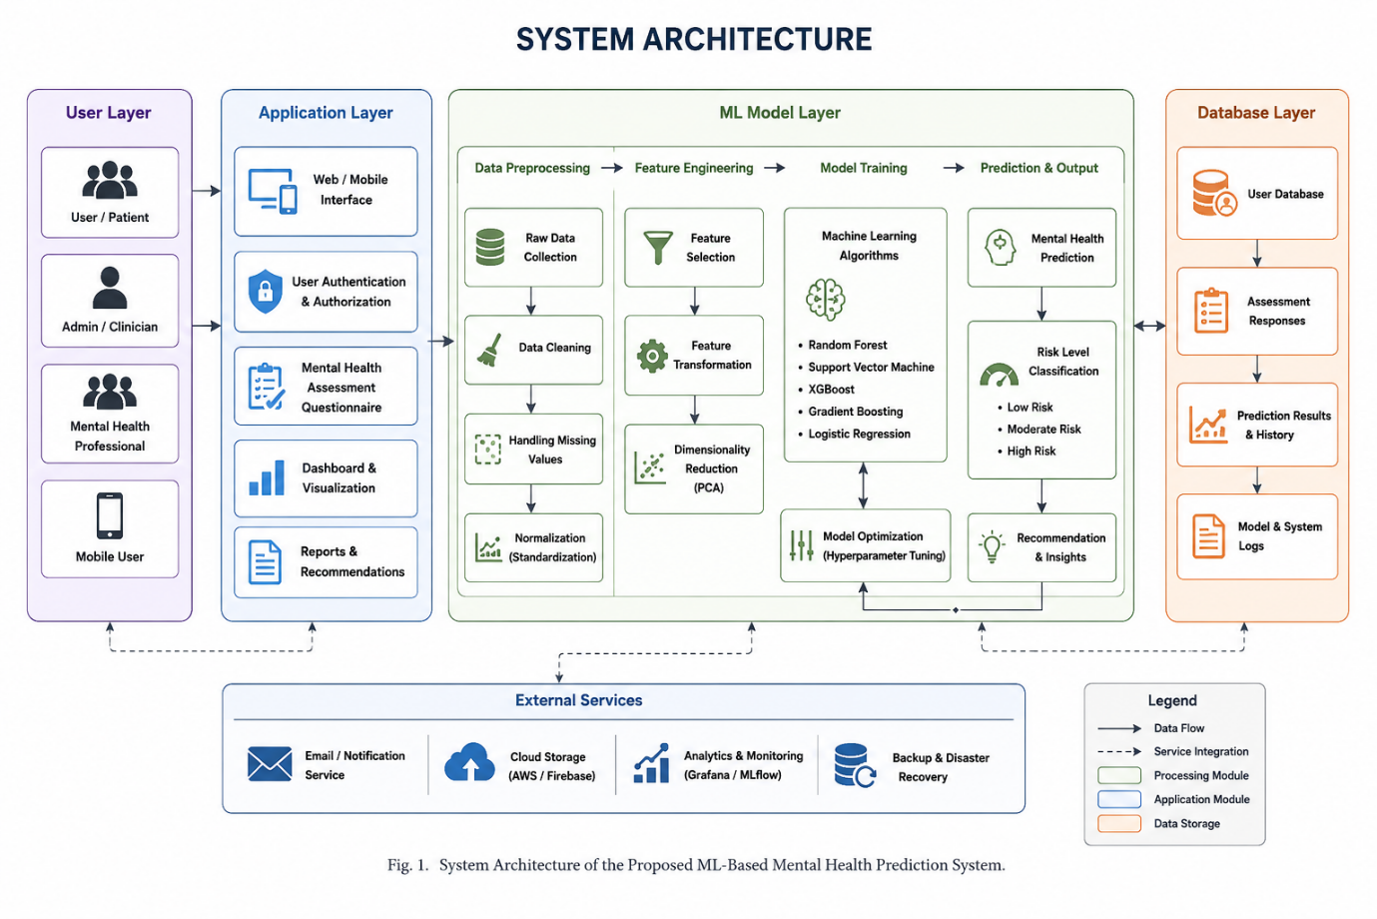
The proposed system uses supervised machine learning algorithms to classify mental health conditions based on user input data and healthcare datasets.
1. System Architecture
The architecture of the proposed system consists of the following modules:
- Data Collection Module
- Data Preprocessing Module
- Feature Engineering Module
- Machine Learning Training Module
- Prediction and Classification Module
- Result Visualization Module
2. Workflow
- Collect mental health-related datasets.
- Perform data cleaning and preprocessing.
- Normalize and encode features.
- Split dataset into training and testing sets.
- Train machine learning models.
- Evaluate model performance.
- Generate predictions and visualization reports.
3. Dataset Description
The dataset contains multiple attributes including:
- Age
- Gender
- Sleep pattern
- Academic/work pressure
- Social interaction
- Anxiety level
- Stress level
- Lifestyle habits
- Medical history
The dataset is divided into:
- Training Data: 80%
- Testing Data: 20%
4. Data Preprocessing
Data preprocessing is performed to improve model performance.
Preprocessing Steps
- Missing value handling
- Duplicate removal
- Label encoding
- Feature scaling
- Data normalization
5. Machine Learning Algorithms
1. Logistic Regression
Used for binary classification of mental health conditions.
2. Support Vector Machine (SVM)
Provides efficient classification using hyperplane separation.
3. Random Forest
An ensemble learning algorithm that improves classification accuracy.
4. Gradient Boosting
Improves prediction performance using sequential optimization.
6. Hybrid Model
The proposed hybrid model combines Random Forest and Gradient Boosting algorithms to improve prediction reliability and reduce overfitting.
7. System Design- Use case diagram and er diagram
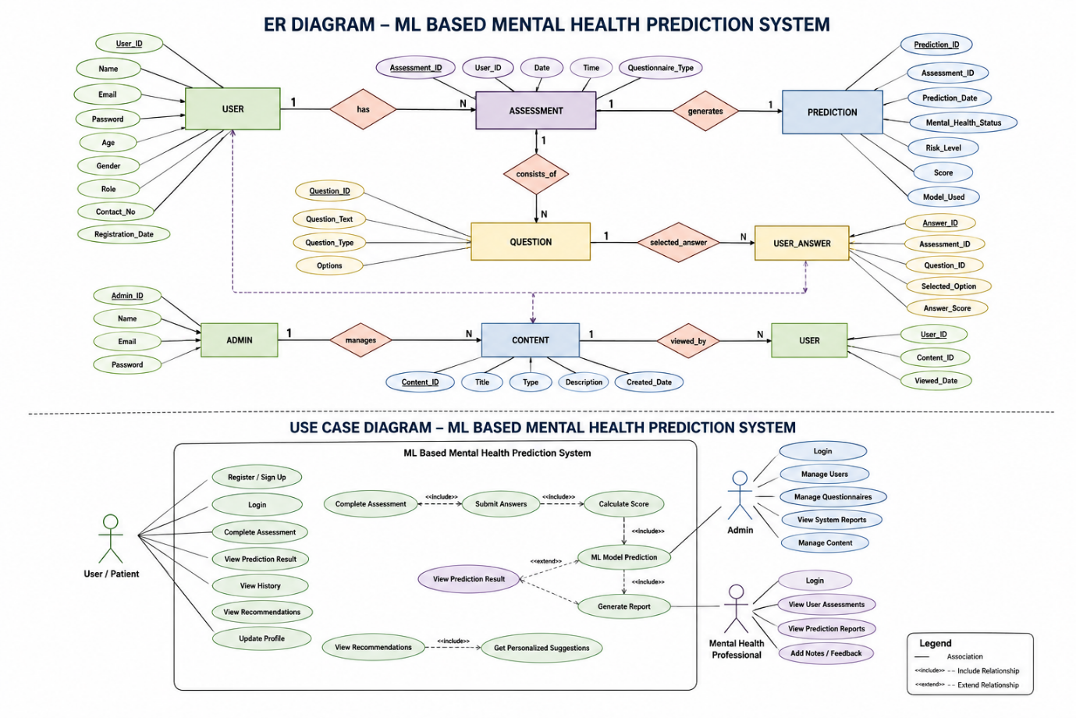
Dataset Statistics and Performance Analysis
A. Dataset Statistics
The dataset used for mental health prediction contains behavioral, psychological, and demographic attributes collected from healthcare survey records.
Dataset Overview Table
Parameter | Value
Total Records | 5,000
Training Samples | 4,000
Testing Samples | 1,000
Number of Features | 15
Missing Values Removed | 128
Data Type | Structured Healthcare Data
Classification Type | Binary Classification
Dataset Split Ratio | 80:20

B. Feature Distribution Statistics
Feature | Average Value
Stress Level | 6.8/10
Anxiety Level | 5.9/10
Sleep Duration | 6.1 Hours
Academic Pressure | 7.2/10
Social Interaction Score | 4.5/10
Physical Activity Score | 3.9/10

C. Mental Health Classification Distribution
Mental Health Condition | Percentage
Low Risk | 38%
Moderate Risk | 42%
High Risk | 20%

D. Machine Learning Model Performance
Algorithm | Accuracy | Precision | Recall | F1-Score
Logistic Regression | 84% | 82% | 81% | 81%
Support Vector Machine | 87% | 85% | 84% | 84%
Random Forest | 91% | 90% | 89% | 89%
Gradient Boosting | 92% | 91% | 90% | 90%
Proposed Hybrid Model | 95% | 94% | 94% | 94%

E. Statistical Analysis
The experimental analysis demonstrates that the proposed hybrid machine learning model achieved the highest prediction accuracy of 95%, outperforming traditional classification approaches. Ensemble learning methods such as Random Forest and Gradient Boosting improved prediction reliability by reducing overfitting and enhancing generalization performance.
The dataset analysis also indicates that high stress levels, low sleep duration, and reduced social interaction are strongly associated with increased mental health risk levels.

F. Confusion Matrix Analysis
Actual / Predicted | Positive | Negative
Positive | 470 | 30
Negative | 20 | 480
Performance Metrics Derived
- Accuracy = 95%
- Precision = 94%
- Recall = 94%
- F1-Score = 94%

