INSTALLING TOMCAT SERVER

STEP 1:
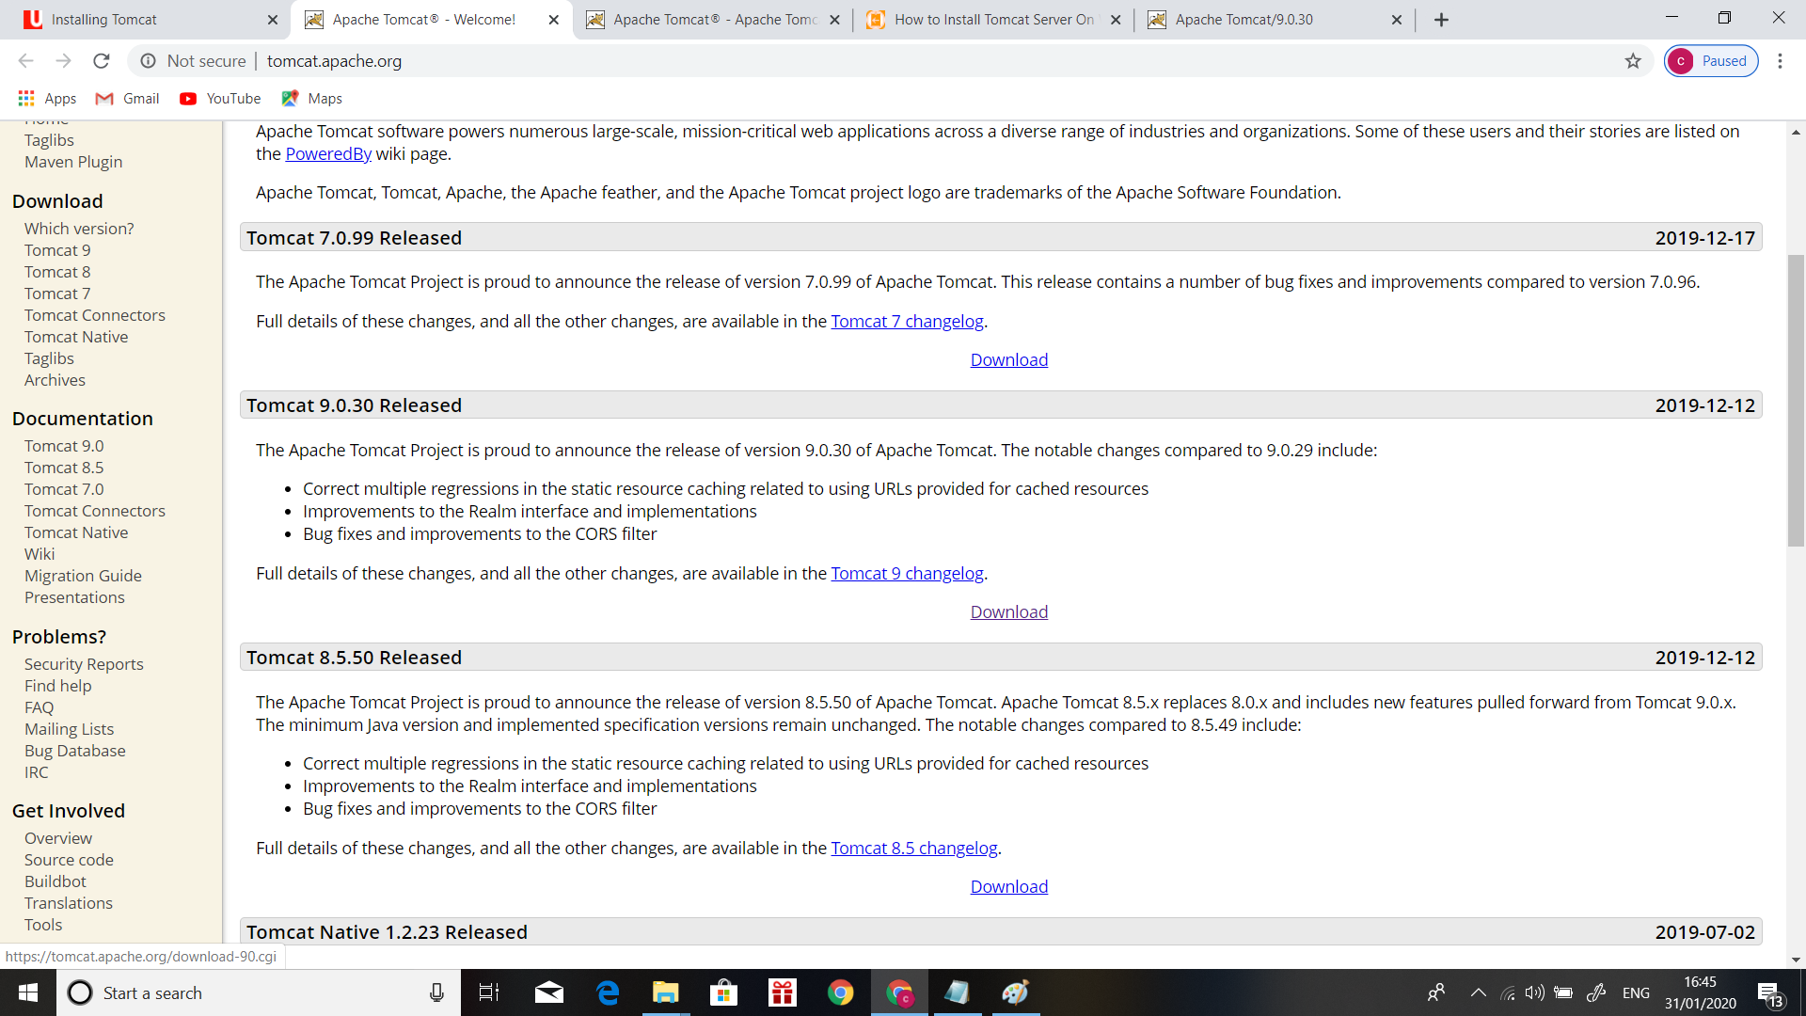
Downloading Tomcat.exe from the Webpage.

STEP 2:
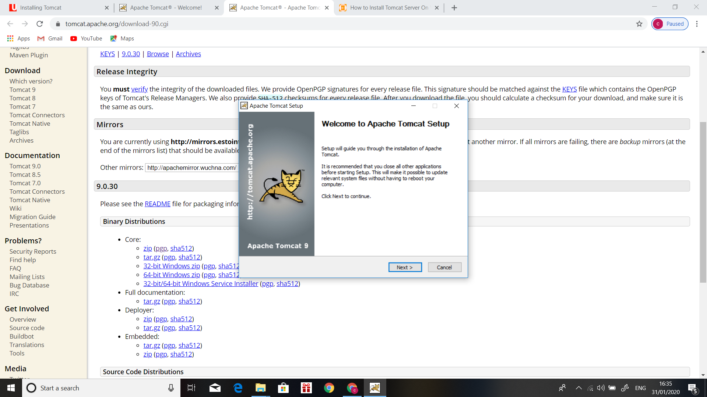
Configure the Tomcat.exe

STEP 3:
while configuring provide the autherization. Once we completed our tomcat is get installed.
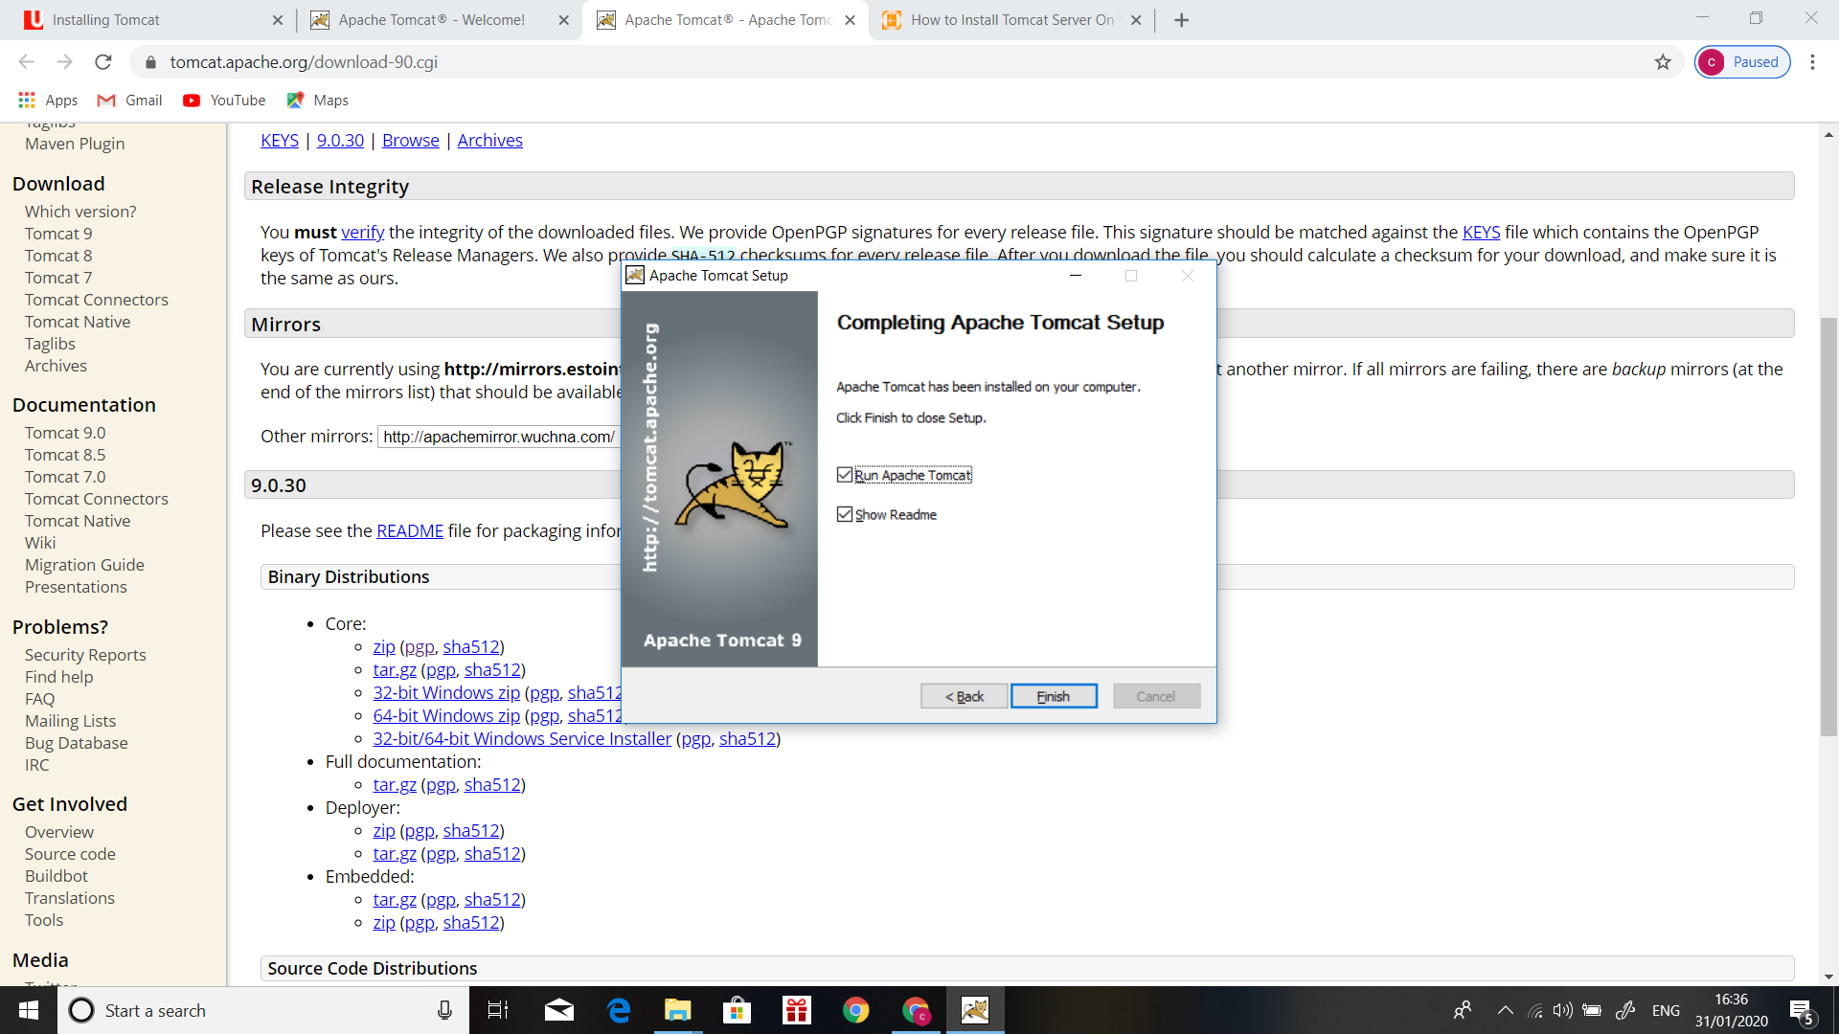
STEP 4:
For confirming https://localhost:8080
