Hair Care Assortment Optimization Platform
Technical Architecture & Data Flow — Executive Overview
From raw retail data to AI-powered assortment decisions

1. Purpose of This Document
This document summarizes the technical architecture of the AI-Led Category Growth & Transformation Platform (Hair Care MVP) for a leadership audience. It explains, at a high level, how raw retail data is transformed into assortment decisions — Keep, Expand, Watch, or Delist — along with demand forecasts and AI-generated category insights.
The platform is built around a simple idea: connect existing retail data sources to a set of proven analytics and machine learning techniques, add a layer of AI-generated narrative and alerts on top, and deliver all of it through a single, easy-to-use dashboard for category managers.

2. End-to-End Technical Flow
The diagram below shows the seven layers of the platform, from the underlying database through to the dashboard used by category managers and business leaders.
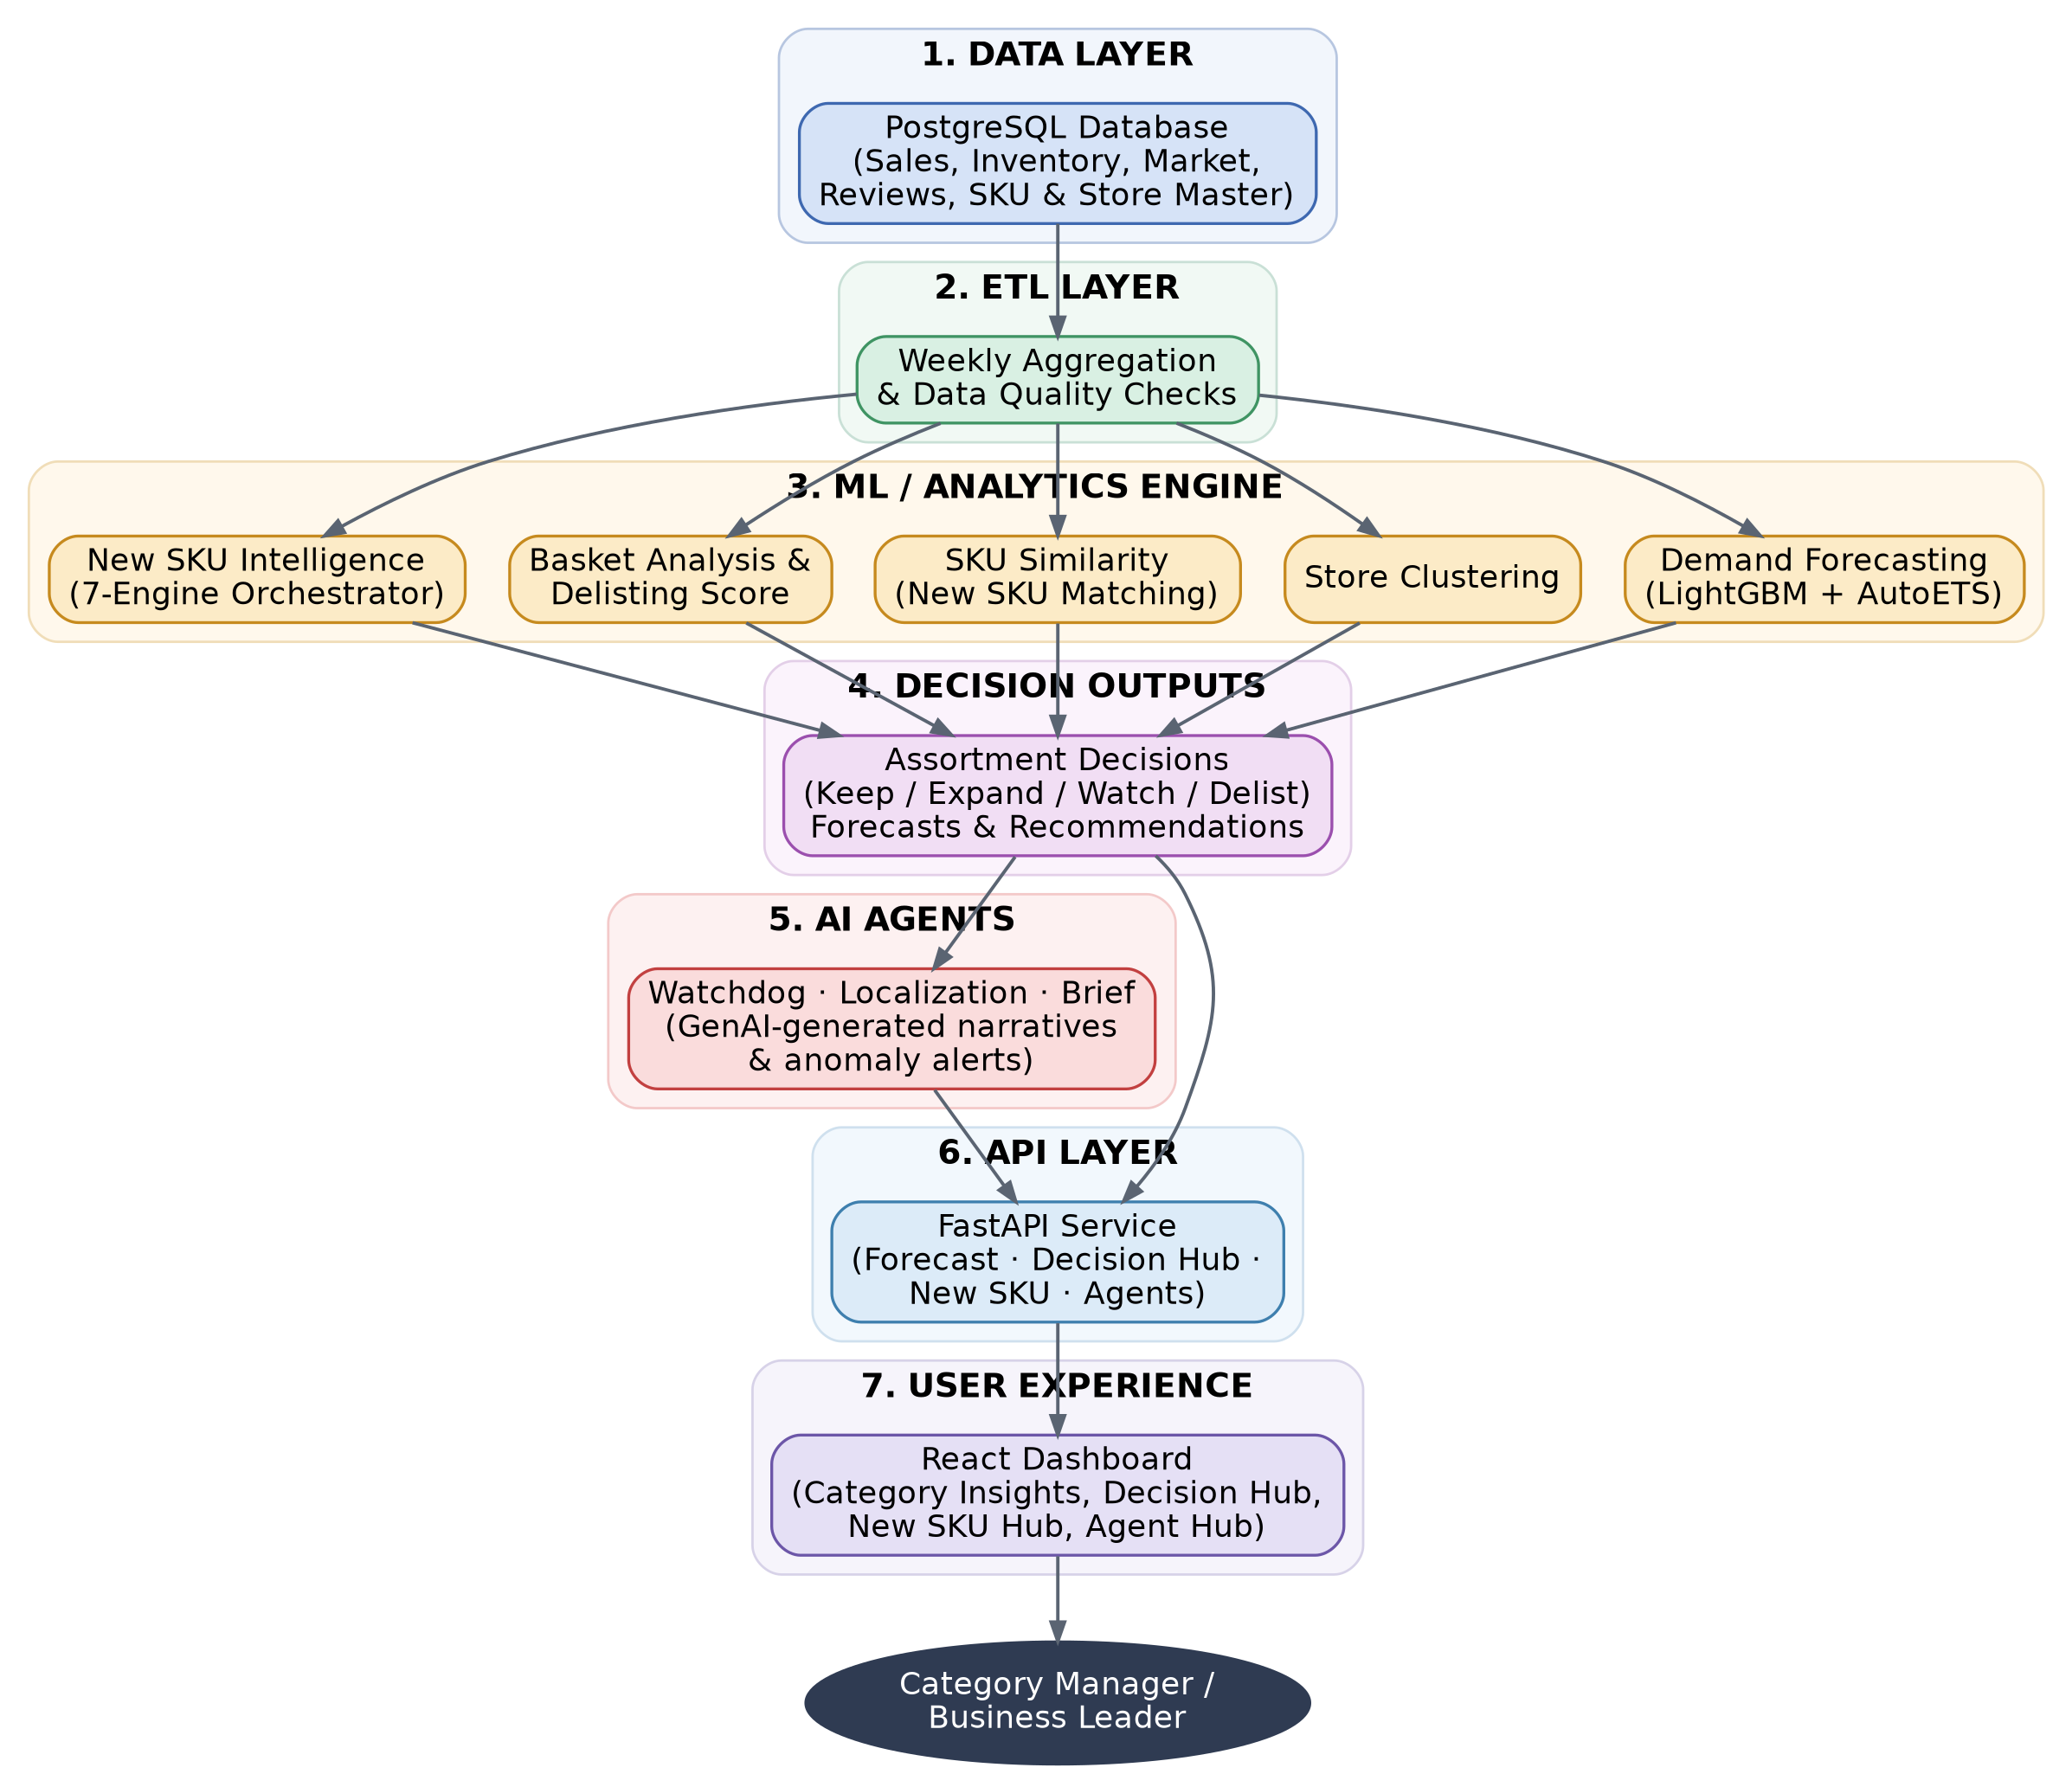
Figure 1: Platform data flow, from raw data to business decision

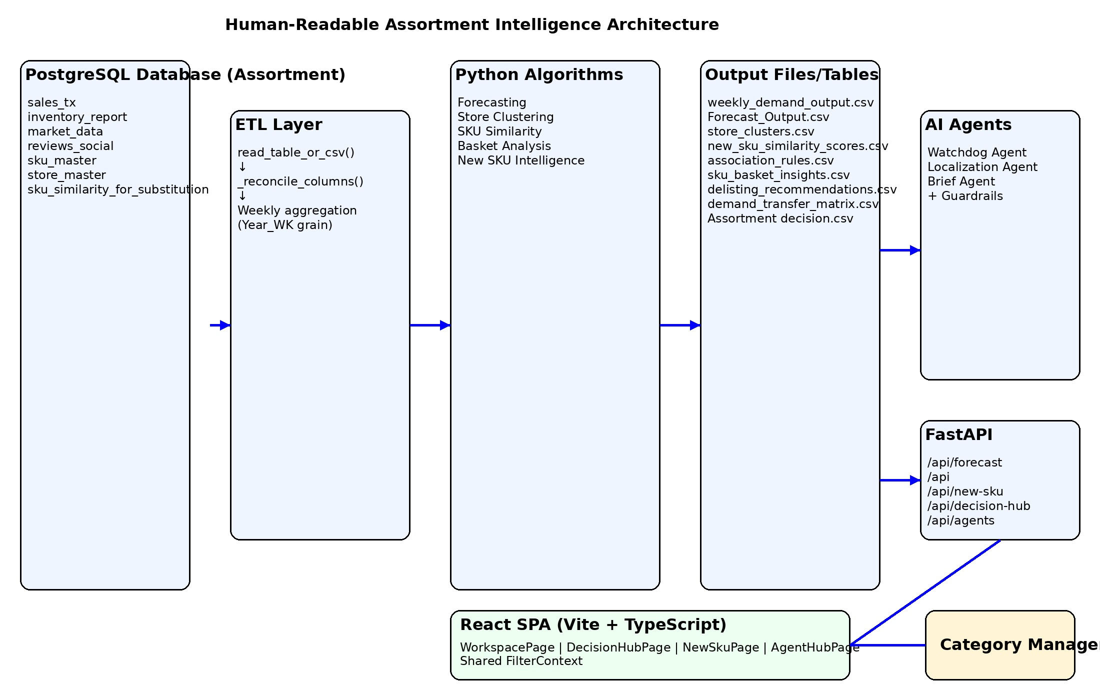

3. What Happens at Each Layer
1. Data Layer | All source data — sales transactions, inventory, market data, customer reviews, and SKU/store reference data — is centralized in a single PostgreSQL database. This is the single source of truth for the entire platform.
2. ETL Layer | Raw, transaction-level data is cleaned and aggregated to a weekly view per store and SKU, with automated checks for data quality and completeness. This weekly view feeds every downstream model.
3. ML / Analytics Engine | Five purpose-built models run on the weekly data: demand forecasting, store clustering, new-SKU similarity matching, basket/delisting analysis, and a new-SKU intelligence engine that evaluates launch candidates.
4. Decision Outputs | Model outputs are consolidated into clear, actionable recommendations — which SKUs to keep, expand, watch, or delist — along with demand forecasts and supporting evidence.
5. AI Agents | Three GenAI-powered agents sit on top of the decision outputs: one flags anomalies, one highlights where local recommendations diverge from the overall category view, and one writes plain-language category briefs.
6. API Layer | A single service layer exposes all decisions, forecasts, and agent outputs through a consistent set of endpoints, keeping the dashboard and the underlying data cleanly separated.
7. User Experience | Category managers interact with everything through one web dashboard: category performance insights, the assortment decision hub, a new-SKU intelligence hub, and an AI agent hub — no technical knowledge required.

4. Technology Stack at a Glance
Component | Technology
Database | PostgreSQL
Data Processing | Python (pandas, numpy, scikit-learn)
Machine Learning | LightGBM, Nixtla AutoETS for demand forecasting
AI Agents | GenAI (LLM)-powered narrative and anomaly-detection agents
Backend API | FastAPI
Frontend Dashboard | React (with interactive charts and data grids)

5. Why This Architecture Matters
- Single source of truth: all data flows through one governed database, reducing inconsistency across reports.
- Modular design: each analytics engine (forecasting, clustering, basket analysis) can be improved independently without disrupting the rest of the platform.
- Explainable decisions: assortment recommendations are backed by transparent, auditable model outputs — not a black box.
- AI-augmented, human-led: GenAI agents surface insights and anomalies, but category managers retain the final decision.
- Built to scale: the same architecture can extend to additional categories beyond Hair Care in future phases.

6. Current Status & Near-Term Roadmap
Implemented today:
- Weekly ETL pipeline with data quality gates
- Demand forecasting, store clustering, SKU similarity, and basket/delisting analysis
- New SKU Intelligence engine (7-engine orchestrator)
- Three GenAI agents (Watchdog, Localization, Brief)
- FastAPI service layer and React dashboard (Category Insights, Decision Hub, New SKU Hub, Agent Hub)
Planned next:
- MILP-based assortment optimization (OR-Tools) for cross-lever recommendations
- Formal audit logging for all agent-driven actions
- Category health scoring module

