Indian institute of Technology Hyderabad

IoT for Enviromental Monitoring & Smart Homes

~By Shubham Jain

(SM20MTECH12007)

Part-1 IoT for Environment Monitoring

2

Contents

◆ Used Cases of IoT for Environment Monitoring.  Essential Components of IoT

◆ Answers to Fundamental Questions.  Working

◆ Sensors

◆ Conclusion

3

8 IoT Environment Monitoring Use Cases

● Monitoring air for quality, CO2, smog-like gasses, CO in confined areas, and indoor O3 levels.

● Monitoring water for quality, pollutants, thermal contaminants, chemical leakages, the presence of lead, and flood water levels.

● Monitoring soil for moisture and vibration levels in order to detect and prevent landslides.

● Monitoring forests and protected land for forest fires.  Monitoring for earthquake and tsunami warnings.

● Monitoring fisheries for both animal health and poaching.

● Monitoring snowfall levels for weather tracking and avalanche prevention.

● Monitoring data centers for air temperature and humidity.

4

4 Essential Components IoT Enviromental Monitoring

1. Monitoring The Building Environment

2. Measuring The Data

3. Cataloging The Data

4. Performing Data Analysis For Insights

5

Air Quality Monitoring

WHY ?

One of the most alarming issues in modern cities is the air quality level, where air pollution has caused 120 deaths out of 100,000 per year based on a worldwide study (Green Car Congress, 2019)

The WHO emphasized that 97% of cities in low- and middle- income countries with more than 100000 inhabitants do not meet WHO air quality guidelines.

Poor air quality will increase potential health risks such as risk of stroke, heart disease, lung cancer, asthma and others as well (citation).

6

Air Quality Monitoring

What problems to solve?

● In Industries, Health of workers can be Improved By monitoring levels of harmfull gases.

● IoT can help conserve energy and other natural resources  For Improving Health of people in Highly polluted City.  For helping government to take decisive action and not just monitor.

● With Huge data from IoT based monitoring of environment, Researches can be carried out and we can find the roots of Many diseases Caused by pollution.

7

Air Quality Monitoring

HOW ?

Monitor dust particles, CO2, CO, NO2 and SO2 levels by sensors and this information can be shared with the authority and then we can use AI and ML tools, among others to anlyse the data. The refined information can be shared public through smartphones, which allows people to monitor real-time data of the current air quality level in the area.

8

Working Flow Chart

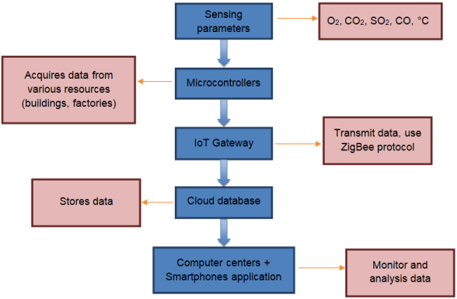9

Air quality sensors are installed in the targeted area on top of buildings, industrial areas, traffic and residential areas. These sensors are connected to microcontroller to control the sensors network. The data collected by the microcontroller is transmitted to the cloud for analysis. The analyzed data is shared to the public through a smartphone app.

10

Wireless sensors 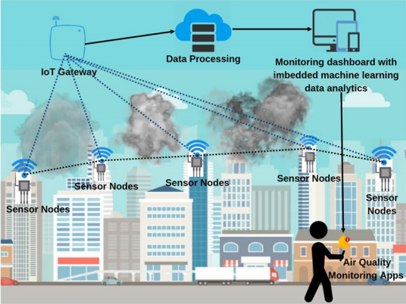

placed at strategic

locations sense the

level of dust particles,

carbon dioxide, carbon

monoxide, nitrogen

dioxide and sulfur

dioxide in the air. This

information is

transmitted to a

gateway which

forwards it to a cloud

database by means of

cellular or WiFi

communication. In the

cloud, the data are

analyzed to provide

information on the air

quality.

The information on the air quality is shared through a smartphone app. This allows the relevant authority to take remedial action and the community to take precautionary measures.

11

Some Air Quality measuring Sensor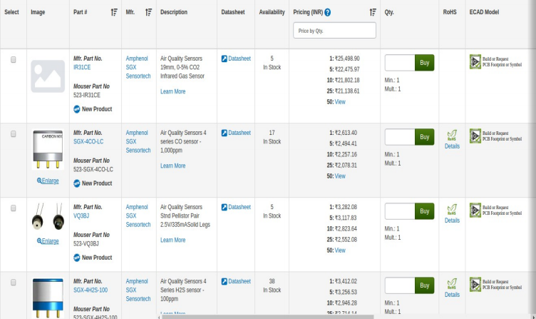12

Sensors That are In development phase

● Alphasense OPC N2 sensor is for PM 10 and PM 2.5 monitoring. This was tested through GRIMM.

● AQMesh, CairClip and CitySense are gas phase sensors (Detect air quality conditions). These are being evaluated by USEPA, and are internationally funded projects.

(These are low cost sensors being developed for Indian needs)

13

Challenges in deploying IoT-based sensors

● The current technology is expensive, provides only a snapshot of data, requires expertise to use and takes time in lab analysis.

● A sensor’s lifetime is only two or three years. Sensitivity, stability and longevity of the sensor need to be improved for its operation.

● Lack of research in this area in our country.

● Basic testing by manufacturers is lagging.

● National Environmental Engineering Research Institute is developing a new technology that includes the IoT, and will be low-cost, easy to use and provide continuous data. However, such technology needs to have a QA/QC approval, and there is no common agency for approving these techniques.

14

Conclusion

With the help of Internet of Things (IoT) in environment monitoring, we will be able to conserve energy, air, water and other natural resources, which are being contaminated every second.

15

Part 2 : Smart Homes

~ Shubham Jain

(SM20MTECH12007)

16

Contents

● Answers to fundamental questions.

● Used Cases.

(Smart Window, Lighting, Thermostat, Refrigerator, Bed, TV, Lock)  Microcontrolers Used.

● Sensors.

● Conclusion.

17

**What is a “Smart**

**Home”?**

• An intelligent network capable of 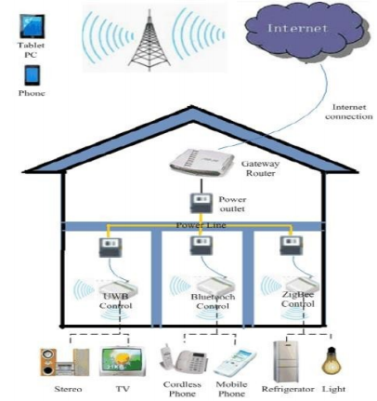

connecting and controlling

various appliances throughout

your home.

• Can be controlled and monitored

remotely (e.g. with your

smartphone)

• Uses sensors to detect movements

and changes in the physical state

of your home.

• Utilize the ***“Internet of things”***

**Why do we want Smart**

**Homes?**

• Improve energy efficiency

➢ Automatic lighting based on presence

➢ Automatically regulated thermostats based on daily routine

• Improved accessibility and controllability

➢ Voice, gesture and motion controlled lights, TVs, etc.

• Improved convenience

➢ Automatically or remotely controlled thermostats, lights, multimedia systems and other electrical appliances

• Enhanced security

➢ Intelligent and programmable looking systems

5

**What makes a “Smart Device” smart?**

• Generally includes…

➢ Transceivers

• Allows for the device to communicate wirelessly ➢ Sensors

• Can sense changes in the physical state of its surrounding ➢ Motors and other actuators

• Can change the state of its surrounding

➢ Communication Interfaces

• Touch screens, Voice command, Gesture control • Requires enabling technologies such as…

➢ ICs, telecommunications and other sensor technologies

**Smart Windows**

What is a “Smart Window”? 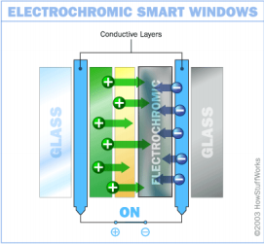

• Control the flow of light through the window • Can replace traditional blinds and curtains • Programmed to auto-tint based on temperature • Automatically open/close on command

• Remotely controlled (e.g. with your smartphone) • Saves energy by lessen the need for heating/cooling

**Smart Lighting**

What is “Smart Lighting”? 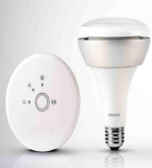

• Amount of light emitted to be controlled • Automatically regulates the amount of light emitted

➢ Sensors for natural daylight, movements and presence

➢ Programmed based on daily routine

➢ Light up specific parts of a room individually • Remotely controlled (e.g. with your smartphone) 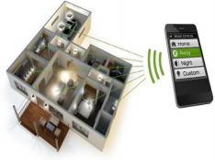

• Uses up to 80% less energy than a traditional light bulb

• Can change color (through LEDs with different colors)

**Smart Thermostat**

What is a “Smart Thermostat”? • Automatic regulation of your AC system 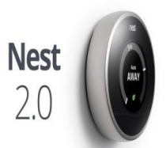

• Self-programmable, i.e. “learns” form its surrounding

➢ Using sensors for temperature, humidity, far/ near-field activity

➢ Auto schedule and tweak temperatures to fit your daily routine 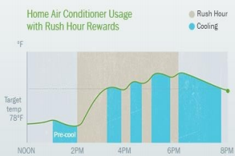

• Remotely controlled (e.g. with your smartphone)

• Lower energy consumption by up to 20 %

**Smart Refrigerators**

What is a “Smart Refrigerator”? • Allows for more efficient food management • Monitoring inventory and expiry dates ➢ RFID to keep track of food 

➢ Scan grocery receipts or item barcodes ➢ Image and voice recognition 

➢ LCD panel for information display and interaction 

• Remotely monitored and controlled (e.g. with your smartphone)

• Recipe suggestion and communications to other cooking devices.

**Smart Bed**

What is a “Smart Bed”? 

• Can measure average breathing and heart rate and movements

➢ Create and present (e.g. in your smartphone) a sleeping profile

• Adjust firmness and elevation of any part of the bed 

➢ Change the shape of the bed to prevent snoring ➢ Can be programmed with several profiles

• Remotely controlled

➢ Using remote control, smartphone, voice commands • Perform massage 

• Advice on optimum firmness levels and how to improve sleeping patterns

**Smart TV**

What is a “Smart TV”? 

• More advanced computing ability and connectivity

• Allows your TV to act as a computer ➢ Browse websites

➢ Use internet-based services (VOD, VOIP, social networking etc.)

➢ Interact with other multimedia devices 

• Remotely controlled (e.g. with your smartphone)

• Can support voice, motion and face recognition

**Smart Lock**

What is a “Smart Lock”?

• Remotely controlled and monitored (e.g. with your smartphone)

• Can be programmed to allow access to outsiders during a certain times

• Connected to and control other Smart Devices (e.g. Smart Lights)

• Sense if someone is knocking on the door and alerts residents

• Take and send photos of what/who is at front of the door

• Monitor lock/unlock activity

• LED indication of lock status

**Smart Household Appliances**

What are “Smart Household Appliances”? 

• “Smart Cookware” includes appliances such as…

➢ Ovens

➢ Coffee/tea makers

➢ Vacuum cleaners

➢ Washing machines

• Can be programmed to start automatically • Remotely controlled and monitored (e.g. with your smartphone) 

• Alert the user when the program is finished ➢ Food/drink is ready

➢ Cleaning/washing program is finished

**Raspberry Pi For Smart Homes**

• Credit card sized single-board computer

➢ Initial intention to promote teaching of basic computer science in schools

• Can be used as a controller for Smart Devices ➢ Wirelessly connect with 

• Sensors

• Motors

• Servers

• Etc.

**Wunderbar For Smart**

**Homes**

• Bundle including a central controller and six sensors ➢ WiFi and Bluetooth connections

➢ Can easily be programmed to do anything you want Add additional sensors

• Light, proximity, humidity, temperature, 

accelerometer, gyroscope, infrared transmitter

**Arduino For Smart Homes**

• Single-board computer (preassembled or disaggregated) ➢ Can be connected with a wide variety of sensors, motor and other actuators to sense and control the environment ➢ Control lights, screens and basically anything that you plug into a wall socket

➢ Hundreds of clone and innovation freely available to download

**Sensors**

• There is a wide array of sensors available for these Open Source systems

➢ Temperature ➢ Gyroscopes ➢ Hall sensors ➢ Termistors ➢ Tilt sensors ➢ Touch sensors ➢ Joysticks

➢ Displays

➢ Static color

identification

sensors

➢ Heart rate sensors, ➢ Buzzers,

➢ Vibrating sensors ➢ Gas sensors

➢ Ethanol sensors ➢ Photosensitive sensors 

➢ Ultrasound sensors

➢ Soil moisture

sensors

➢ Leds modules

• Increased freedom to customize your own Smart Home 

➢ Possibility to create devices and features not currently offered in existing solutions

**Conclusion**

Automation at home is one of the best used case of IoT in today’s generation. In this fast paced lifestyle it is very important that some of the burden is taken off from human shoulders. But with techonology there are always some risks of security and health, which must never be ignored.

**THANKYOU**

Shubham Jain