Minor Project

HireSense: AI-Powered Recruitment and Placement Intelligence Platform
Submitted by

Shubham Kumar Nigam  236301197 | Ayush Aryan  236301063
Course
Bachelor of Technology in Computer Science Engineering
Instructor

Department
Department of Computer Science and Engineering
Faculty of Engineering and Technology
Gurukula Kangri (Deemed to be University)
Haridwar, Uttarakhand

Table of Contents
Abstract 3
1. Introduction 3
Background 3
Problem Statement 3
Objectives 4
Scope 4
2. Literature Review 4
3. System Design & Methodology 5
Development Approach 5
System Modules 5
System Architecture 5
Tools & Technologies 5
4. Project Plan & Timeline 6
5. Expected Outcomes 7
Deliverables 7
Impact 7
6. Resources Required 7
Development Tools 7
Other Resources 8
7. References 8

Abstract
Recruitment and university placement processes generate large volumes of unstructured information — resumes, job descriptions, eligibility criteria, and application records — that traditional keyword-based portals are poorly equipped to interpret. HireSense is proposed as an AI-powered recruitment and placement intelligence platform that applies Natural Language Processing and Machine Learning to understand candidates and opportunities beyond surface-level keywords. The system produces an explainable compatibility score for every match, highlights specific skill gaps, and consolidates application tracking and placement analytics into a single dashboard. By replacing opaque recommendations with transparent, data-driven reasoning, HireSense aims to help candidates make better career decisions and help placement teams operate more efficiently.

1. Introduction

Background
The recruitment and university placement process involves a large amount of information related to job opportunities, candidate profiles, skills, eligibility requirements, applications, and placement statistics. Students and job seekers often find it difficult to determine which opportunities are most suitable for their skills and qualifications. Similarly, recruiters and placement administrators need efficient methods to analyze candidate profiles and job requirements.
With the advancement of Artificial Intelligence, Natural Language Processing, and Machine Learning, recruitment systems can be made more intelligent by automatically analyzing candidate information and job descriptions. Such systems can provide meaningful recommendations instead of relying only on traditional keyword-based searching.
HireSense is proposed as an AI-powered recruitment and university placement intelligence platform that helps candidates discover suitable opportunities, understand their compatibility with job requirements, identify skill gaps, and make data-driven career decisions.

Problem Statement
Traditional job and placement platforms primarily depend on manual searching, basic filtering, and keyword matching. These approaches may fail to understand the actual relationship between a candidate's skills, education, experience, and a job's requirements. Candidates may also apply to positions without knowing their level of suitability or which skills they are missing. At the same time, placement and recruitment processes can involve large datasets that are difficult to analyze manually.
Therefore, there is a need for an intelligent platform that can:
- Analyze candidate profiles and job descriptions.
- Provide explainable job-candidate matching.
- Identify missing or insufficient skills.
- Recommend relevant opportunities.
- Track and analyze applications.
- Provide useful recruitment and placement analytics.

Objectives
- To develop an AI-powered platform for recruitment and university placement intelligence.
- To implement intelligent matching between candidates and job opportunities.
- To provide an explainable matching score instead of only showing a recommendation.
- To identify skill gaps between a candidate's profile and job requirements.
- To allow candidates to manage and track their job applications.
- To provide analytics related to jobs, candidates, applications, and placement trends.
- To use Natural Language Processing for extracting and comparing relevant information from job descriptions and candidate profiles.
- To develop a scalable web-based architecture that can be extended for real-world recruitment and university placement use cases.

Scope
The initial scope of HireSense covers candidate and job-profile management, AI-based matching with explainability, skill-gap analysis, application tracking, and a placement analytics dashboard for a single institution or organization. Multi-tenant support, mobile applications, and integration with third-party job boards are treated as future extensions beyond the current project timeline.

2. Literature Review
Conventional Applicant Tracking Systems (ATS) and campus placement portals typically rank candidates using exact or fuzzy keyword overlap between a resume and a job description. This approach is fast but brittle: it penalizes candidates who describe equivalent skills in different words and gives recruiters little insight into why a candidate was ranked highly or filtered out.
Advances in Natural Language Processing — from vector-based word representations to transformer-based language models — have made it possible to compare text on the basis of meaning rather than exact wording, enabling semantic similarity between a candidate's stated experience and a job's requirements. Parallel progress in classical Machine Learning libraries has made similarity scoring, classification, and ranking techniques readily accessible for applied systems such as recruitment platforms.
HireSense builds on these two threads — semantic text understanding and similarity-based ranking — while adding an explainability layer that surfaces the specific factors behind a match, an emphasis largely absent from keyword-driven placement portals in common use today.

3. System Design & Methodology

Development Approach
The development of HireSense will follow a modular and iterative approach. First, candidate and job-related information will be collected and structured; relevant attributes such as skills, education, experience, job requirements, and eligibility criteria will then be processed.
Natural Language Processing techniques will be used to extract meaningful information from unstructured text such as resumes and job descriptions. Machine Learning-based similarity and matching techniques will then be applied to calculate compatibility between candidates and opportunities.
The system will generate an explainable match result, showing not only the compatibility score but also the factors contributing to the recommendation, and will compare required skills with candidate skills to identify skill gaps.

System Modules
- Candidate Profile Management
- Job / Opportunity Management
- AI-Based Job-Candidate Matching
- Explainable Match Analysis
- Skill-Gap Analysis
- Application Tracking
- Recruitment / Placement Analytics
- Dashboard and Visualization

System Architecture
The architecture separates the frontend, backend/API layer, AI/ML processing, and database components into independent layers, making the system easier to maintain, test, and extend.
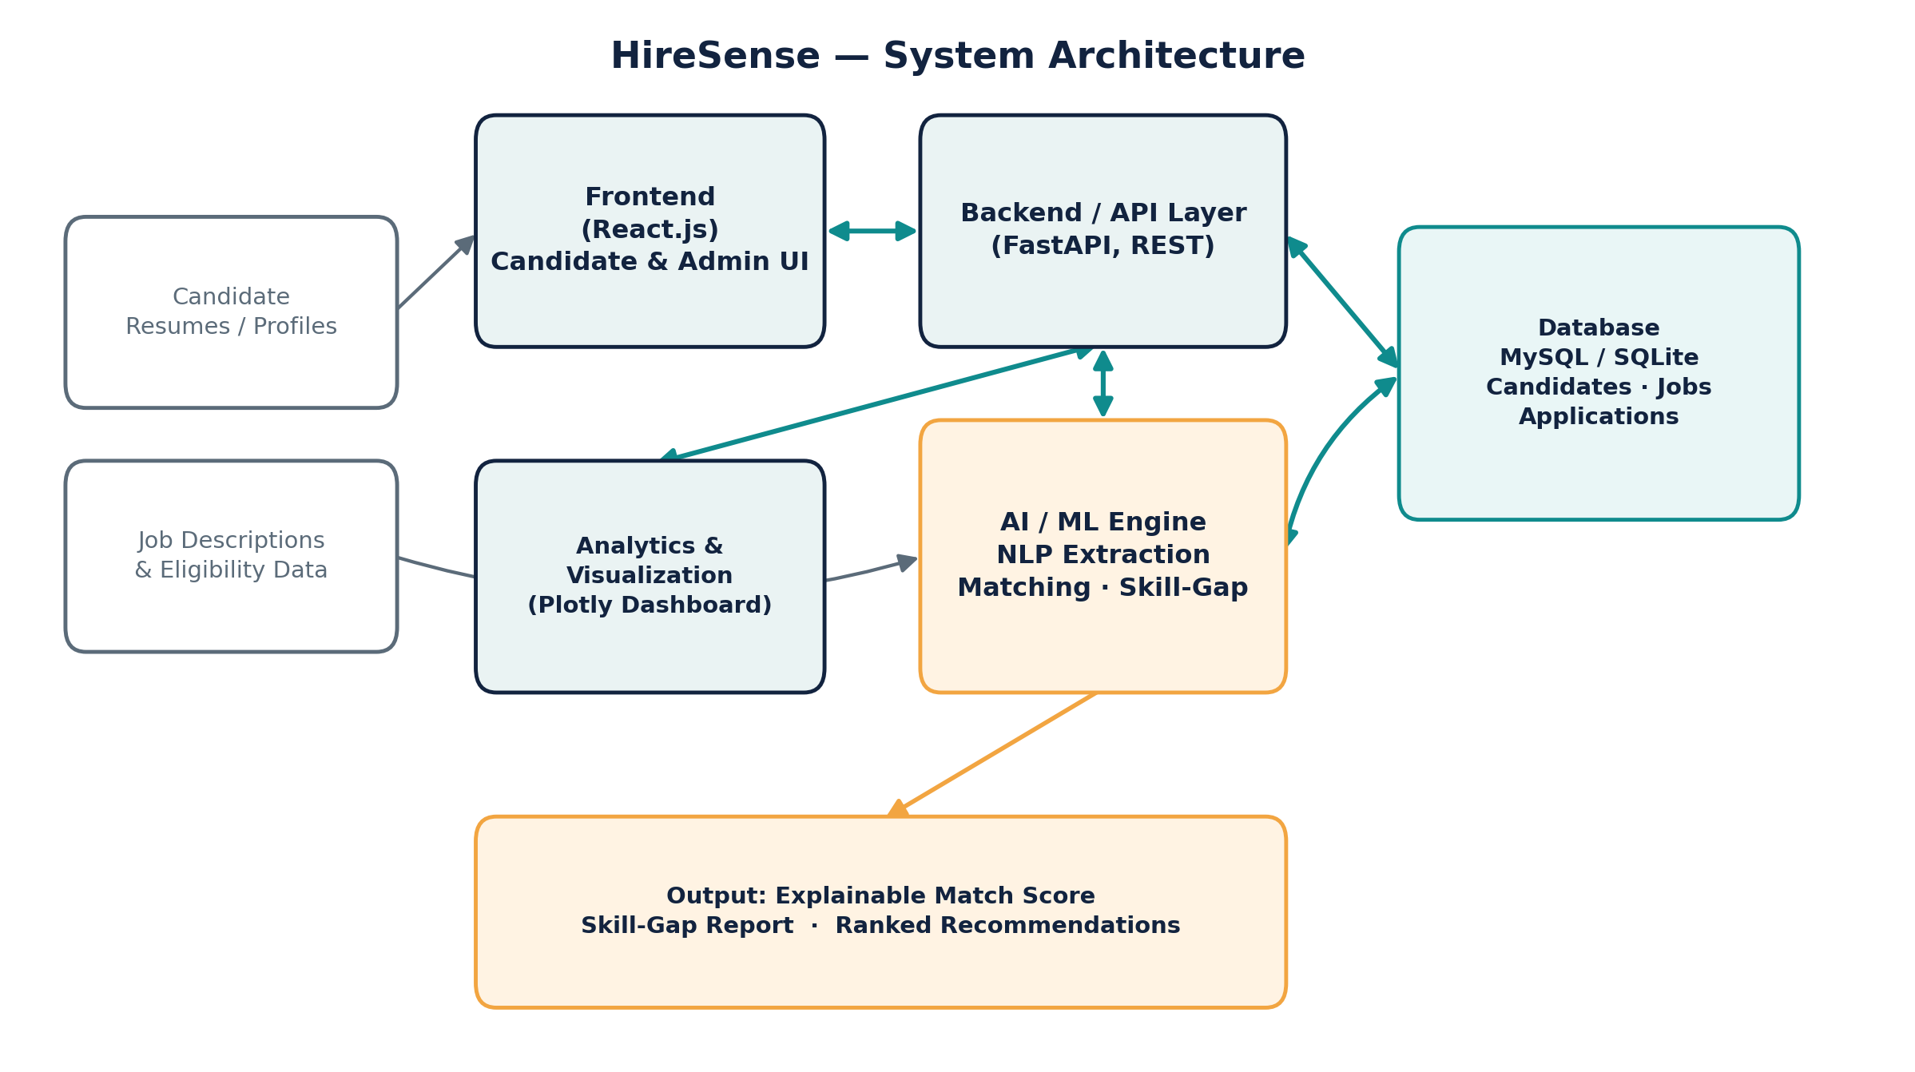
Figure 1. HireSense high-level system architecture

Tools & Technologies
Component | Technology
Frontend | React.js
Backend | FastAPI
Programming Language | Python
Database | MySQL (target) / SQLite (local development)
Machine Learning | Scikit-learn
NLP | Python NLP techniques / libraries
Data Processing | Pandas
Data Visualization | Plotly
API Communication | REST APIs
Development Environment | VS Code / Python virtual environment

4. Project Plan & Timeline
The project is planned over a six-week schedule, organized into four phases with two key milestones.
Phase | Focus | Key Activities | Milestone
Week 1-2 | Requirement Analysis & System Design | Analyze recruitment/placement requirements; define candidate, job, application & analytics workflows; design database, architecture, API structure and initial frontend. | —
Week 3-4 | AI Matching & Core Development | Build candidate/job profile modules; implement data processing and NLP-based extraction; develop initial matching model, skill-gap analysis and dashboard interface. | Initial AI matching prototype
Week 5 | Integration & Application Management | Integrate frontend with FastAPI backend; implement application tracking; improve match explainability; add analytics & visualization; module-level testing. | —
Week 6 | Testing, Refinement & Final System | Integration and functional testing; improve model performance and UX; fix bugs; validate matching/skill-gap results; complete documentation. | Final HireSense system

5. Expected Outcomes

Deliverables
- A functional web-based HireSense recruitment and placement intelligence platform.
- Candidate profile management module.
- Job / opportunity management module.
- AI-based candidate-job matching system.
- Explainable matching results.
- Skill-gap analysis and recommendations.
- Application tracking functionality.
- Recruitment and placement analytics dashboard.
- REST APIs for communication between frontend and backend.
- Database for storing candidate, job, and application information.
- Project documentation and final project report.

Impact
HireSense is expected to make the recruitment and university placement process more intelligent, personalized, and data-driven.
For students and job seekers, the system can help them discover relevant opportunities, understand their suitability, identify missing skills, and make better application decisions.
For recruiters and placement administrators, the platform can reduce manual analysis and provide useful insights into candidates, job requirements, applications, and placement trends.
The explainable matching approach will also improve transparency by showing why a particular job is considered suitable for a candidate, rather than presenting an unexplained recommendation.

6. Resources Required

Development Tools
- Computer / laptop with development environment.
- Python development environment.
- Node.js and React development environment.
- FastAPI framework.
- MySQL database for the target deployment environment.
- SQLite for local development and testing.
- Scikit-learn.
- NLP libraries and techniques.
- Pandas.
- Plotly.
- VS Code or equivalent IDE.
- Git / GitHub for version control.

Other Resources
- Sample resumes / candidate profiles for testing.
- Sample job descriptions and placement opportunities.
- Publicly available datasets related to jobs, skills, and recruitment, where appropriate.
- Internet connection for development resources and documentation.
- Academic papers and technical documentation related to NLP, Machine Learning, recommender systems, and recruitment intelligence.

7. References
- Devlin, J., Chang, M.-W., Lee, K., & Toutanova, K. (2019). BERT: Pre-training of Deep Bidirectional Transformers for Language Understanding. Proceedings of NAACL-HLT.
- Mikolov, T., Chen, K., Corrado, G., & Dean, J. (2013). Efficient Estimation of Word Representations in Vector Space. arXiv:1301.3781.
- Pedregosa, F., et al. (2011). Scikit-learn: Machine Learning in Python. Journal of Machine Learning Research, 12, 2825-2830.
- McKinney, W. (2010). Data Structures for Statistical Computing in Python. Proceedings of the 9th Python in Science Conference.
- React documentation. Retrieved from https://react.dev
- FastAPI documentation. Retrieved from https://fastapi.tiangolo.com

