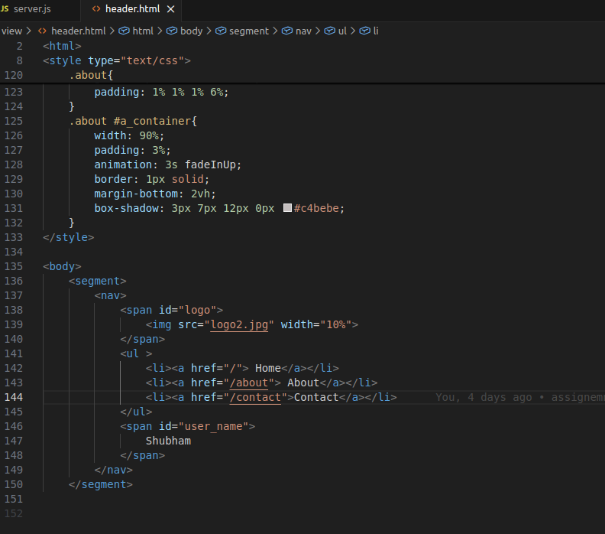

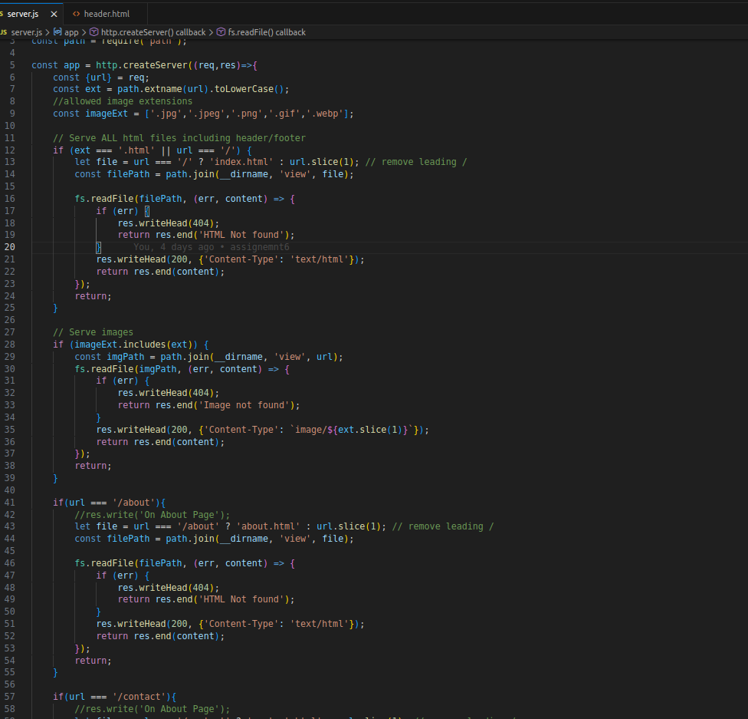

Routing match url text or url from request variable and match. Matched if statement excute. If url is not matched then It will show Page not found.

If url is /about then about case excute.

If image load then imageExt code excute.

