MAD1 Project Report

Author:

Name: Atkal Shubham Sheshnarayan

Roll number: 23f1002838

Student email: [23f1002838@ds.study.iitm.ac.in](mailto:23f1002838@ds.study.iitm.ac.in)

About me: Passionate about Computer Science and fascinated by its uses in various fields, currently pursuing Online BS degree from IITM.

Description:

In this project one should create a website which is capable of Hosting E-library and can moderate various aspects of this E-library at ease, and also students can register themselves on this website and can read various books provided by this Library and can also download the books by paying small amount. Basically, one has to create Library Management System.

Technologies used:

* Python: The programming language used for developing the project.
* Flask: A micro web framework for Python used for building this web applications.
* render_template: Flask function for rendering HTML templates.
* request: Flask module for handling HTTP requests.
* flash: Flask module for flashing messages to the user.
* redirect: Flask module for redirecting requests to another endpoint.
* url_for: Flask function for generating URLs for endpoint functions.
* session: Flask module for managing user sessions.
* generate_password_hash: Function from Werkzeug library for securely hashing passwords.
* check_password_hash: Function from Werkzeug library for checking password hashes.
* os: Python module for interacting with the operating system
* SQLAlchemy: Python SQL toolkit and Object-Relational Mapper (ORM) used for database interactions.
* date: Python module for working with dates.
* HTML: Markup language used for structuring the content of web pages.
* CSS: Styling language used for defining the presentation of HTML elements.
* Bootstrap: Front-end framework used for building responsive and mobile-first website.

DB Schema Design:

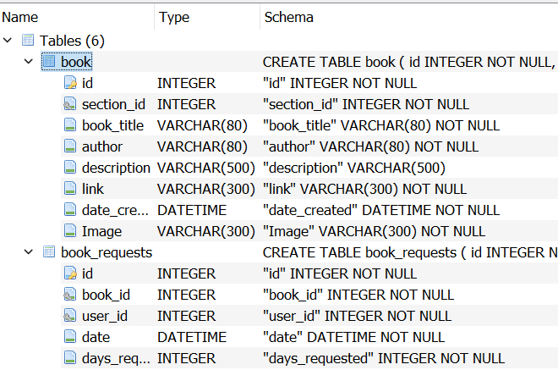 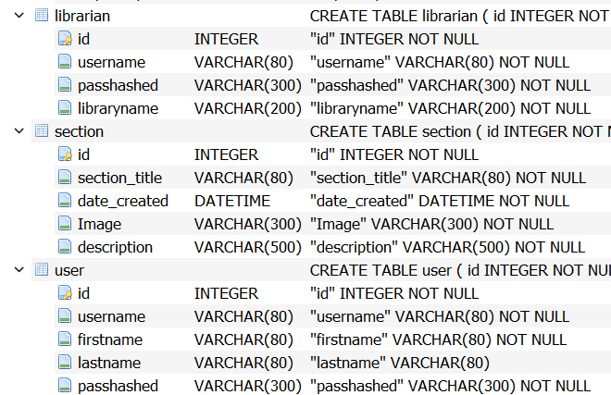 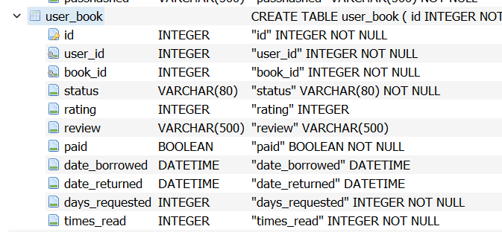

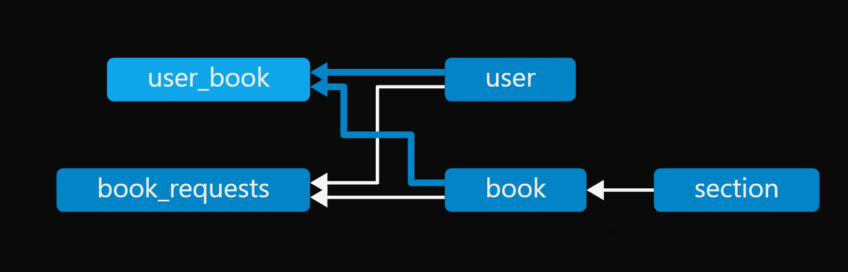

API Design:

This project contains a RESTful API designed for a library management system using Flask, a Python web framework.

* API Design

The API follows RESTful principles with clear endpoints for each functionality:

User Management: Register, login, and logout for users.

Librarian Management: Register, login, and logout for librarians.

Book Management: View available books, request books, rate books, and view book statistics.

Section Management: Manage book sections, create, delete sections

Request Management: Handle book borrowing requests.

Statistics: Provide statistics for users and librarians.

* Endpoints:
* User Endpoints:

/user/register, /user/login, /user/logout, /user/requestbook, /user/books, /user/return_book, /user/ratebook, /user/stats , /user/cancelbook , /user/viewbook . /user/downloadbook

* Librarian Endpoints:

/library/register, /library/login, /library/logout, /library/home, /library/add_section , /library/view_book_details, /library/deletebook, /library/grantboooks, /library/rejectbooks, /library/delete_section, /library/revoke_access, /library/stats , /library/viewbooks , /library/current_books

* Other Endpoints: /, /forgot_password , /about

Video:

External Links:

Books stored on cloud (one drive): <https://1drv.ms/f/s!AoAgZ_o5skAEiCHzCe7c6XoV8N32?e=wCGfTR>