### Creation of a RedShift Cluster

**Screenshots of the configuration of the RedShift cluster that you have created:**

<Screenshot of the type of machine used along with number of nodes>

1. Cluster Image

1. Configuration Details

1. Additional Details

### Setting up a database in the RedShift cluster and running queries to create the dimension and fact tables

**Queries to create the various dimension and fact tables with appropriate primary and foriegn keys:**

<Queries>

1. Create Schema

create schema redshift_etlcasestudy;

1. Create DIM_LOCATION Table

create table redshift_etlcasestudy.DIM_LOCATION(

atm_location varchar(50),

atm_streetname varchar(255),

atm_street_number integer not null,

atm_zipcode integer not null,

atm_lat decimal(10,3),

atm_lon decimal(10,3),

location_id varchar(100) not null PRIMARY KEY);

1. Create DIM_CARD_TYPE Table

create table redshift_etlcasestudy.DIM_CARD_TYPE(

card_type varchar(50),

card_type_id varchar(100) not null PRIMARY KEY);

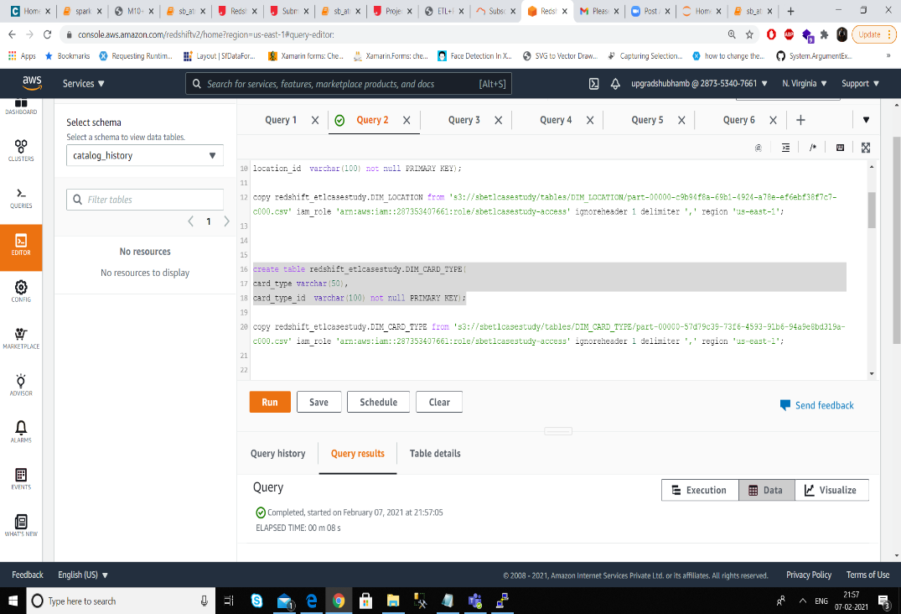

1. Create DIM_ATM Table

create table redshift_etlcasestudy.DIM_ATM(

atm_id varchar(100) not null PRIMARY KEY,

atm_manufacturer varchar(50),

atm_number integer not null,

atm_location_id varchar(100) not null references redshift_etlcasestudy.DIM_LOCATION(location_id));

1. Create DIM_DATE Table

create table redshift_etlcasestudy.DIM_DATE(

year integer not null,

month varchar(20),

day integer not null,

hour integer not null,

weekday varchar(20),

full_date_time timestamp,

date_id varchar(100) not null PRIMARY KEY);

1. Create FACT_ATM_TRANS Table

create table redshift_etlcasestudy.FACT_ATM_TRANS(

trans_id varchar(100) not null PRIMARY KEY,

atm_id varchar(100) not null references redshift_etlcasestudy.DIM_ATM(atm_id),

weather_loc_id varchar(100) not null references redshift_etlcasestudy.DIM_LOCATION(location_id),

date_id varchar(100) not null references redshift_etlcasestudy.DIM_DATE(date_id),

card_type_id varchar(100) not null references redshift_etlcasestudy.DIM_CARD_TYPE(card_type_id),

atm_status varchar(20),

currency varchar(10),

service varchar(20),

transaction_amount integer,

message_code varchar(255),

message_text varchar(255),

rain_3h decimal(10,3),

clouds_all decimal(10,3),

weather_id integer,

weather_main varchar(50),

weather_description varchar(255));

### 

### Loading data into a RedShift cluster from Amazon S3 bucket

**Queries to copy the data from S3 buckets to the RedShift cluster in the appropriate tables**

<Queries>

1. Copy DIM_LOCATION

copy redshift_etlcasestudy.DIM_LOCATION from 's3://sbetlcasestudy/tables/DIM_LOCATION/part-00000-c9b94f8a-69b1-4924-a78e-ef6ebf38f7c7-c000.csv' iam_role 'arn:aws:iam::287353407661:role/sbetlcasestudy-access' ignoreheader 1 delimiter ',' region 'us-east-1';

1. Copy DIM_CARD_TYPE

copy redshift_etlcasestudy.DIM_CARD_TYPE from 's3://sbetlcasestudy/tables/DIM_CARD_TYPE/part-00000-57d79c39-73f6-4593-91b6-94a9e8bd319a-c000.csv' iam_role 'arn:aws:iam::287353407661:role/sbetlcasestudy-access' ignoreheader 1 delimiter ',' region 'us-east-1';

1. Copy DIM_ATM

copy redshift_etlcasestudy.DIM_ATM from 's3://sbetlcasestudy/tables/DIM_ATM/part-00000-2d3acbd6-9eea-41bb-8a94-d3516436da37-c000.csv' iam_role 'arn:aws:iam::287353407661:role/sbetlcasestudy-access' ignoreheader 1 delimiter ',' region 'us-east-1';

1. Copy DIM_DATE

copy redshift_etlcasestudy.DIM_DATE from 's3://sbetlcasestudy/tables/DIM_DATE/part-00000-80eaf1a4-a776-4047-9589-25daf08b8810-c000.csv' iam_role 'arn:aws:iam::287353407661:role/sbetlcasestudy-access' ignoreheader 1 delimiter ',' region 'us-east-1' timeformat 'YYYY-MM-DDTHH:MI:SS';

1. Copy FACT_ATM_TRANS

copy redshift_etlcasestudy.FACT_ATM_TRANS from 's3://sbetlcasestudy/tables/FACT_ATM_TRANS/part-00000-7307f0b5-7942-4531-9582-67a51436f509-c000.csv' iam_role 'arn:aws:iam::287353407661:role/sbetlcasestudy-access' ignoreheader 1 delimiter ',' region 'us-east-1' removequotes

emptyasnull

blanksasnull

maxerror 5

