A PROJECT REPORT ON

CAN IMPLEMENTATION FOR VEHICLE SAFETY

SUBMITTED IN PARTIAL FULFILLMENT OF

DIPLOMA IN EMBEDDED SYSTEM DESIGN (PG-DESD)


BY
SAMADHAN WAGHMODE
RUSHIKESH CHIKANE
VIVEK BANSODE
SHUBHAM BHADKE

AT
SUNBEAM INSTITUTE OF INFORMATION TECHNOLOGY, HINJEWADI, PUNE

ACKNOWLEDGEMENT

It is indeed a matter of great pleasure and proud privilege to be able to present this project on “CAN Implementation for Vehicle Safety”. The completion of this project work is great
experience in student’s life and its execution is inevitable in hands of guide. We are highly indebted to the Project Guide Mr. Vrushabh Patil sir for his invaluable guidance and appreciation for giving form and substance to this project. It is
due to his enduring efforts, patience and enthusiasm which has given sense of direction and purposefulness to this project and alternately made it a success.
I also wish to express my sincere thanks to the CEO of Sunbeam Institute of Information Technology Pune Mr. Nitin Kudale for their immense planning, continuous guidance and talk-shows which kept us involved even in this remote
learning batch. Also, I am grateful to all the faculty members specially Mr. Devendra Dhande, Mr. Nilesh Ghule, for their consistent support and assistance.
Thanks for all your encouragement!

ABSTRACT
General Secured Systems abbreviated as GeSS_CAN is a basic security and safety systems based on CAN Protocol. CAN Protocol being a excellent communicating protocol with robust features and highly noise immune abilities makes it best choice for implementation of systems which requires extreme reliability.
The CAN protocol is a standard designed to allow the microcontroller and other devices to communicate with each other without any host computer. The feature that makes the CAN protocol unique among other communication protocols is the broadcast type of bus. Here, broadcast means that the information is transmitted to all the nodes. The node can be a sensor, microcontrollers. The CAN is a message-based protocol, which means that message carries the message identifier, and based on the identifier, priority is decided. There is no need for node identification in the CAN network, so it becomes very easy to insert or delete it from the network. It is a serial half- duplex and asynchronous type of communication protocol.
This System is implemented with various sensors interfaced with ARM Cortex based STM32F407G Discovery-1 Board. Includes sensors like
- LM35 – Temperature Sensors for temperature measurement.
- LDR – It detects the ambient light level .
- Ultrasonic Sensor – It measures the distance to obstacle in front of vehicle.
System is implemented in such a way multiple sensors can be added easily. This project will help to learn the concept of CAN protocol and to implement CAN protocol.

INDEX

1.
INTRODUCTION
BLOCK DIAGRAM
PROJECT DESIGN & EXPLANATION
HARDWARE DESCRIPTION
SOFTWARE REQUIREMENTS & SPECIFICATION
SOURCE CODE
FUTURE SCOPE
CONCLUSION
REFERENCES

2.
3.
4.
5.
6.
7.
8.
9.

1. INTRODUCTION

Nowadays industrial automation systems have become popular in many of the industries and play a crucial role in controlling several process-related operations. Due to the implementation of a wide variety of industrial networks with their geographical distribution over factory or industry, the floor data transferring and controlling capability has become more sophisticated and easy ranging from low-level to high-level control. These industrial networks are routed through various field buses that use various communication standards like CAN protocol, Profibus, Modbus, Device net, etc.
A Controller Area Network (CAN) is Main heart of our project. A Controller Area Network (CAN bus) is a robust vehicle bus standard designed to allow microcontrollers and devices to communicate with each other's applications without a host computer. It is a message-based protocol, designed originally for multiplex electrical wiring within automobiles to save on copper, but it can also be used in many other contexts. For each device, the data in a frame is transmitted sequentially but in such a way that if more than one device transmits at the same time, the highest priority device can continue while the others back off. Frames are received by all devices, including by the transmitting device. CAN protocol is not an address-based protocol, but message-oriented protocol, wherein the embedded message in CAN has the contents and priority of data being transferred. Up on the reception of data on the bus, each node decides whether to discard or to process the data – and then depending on the system, the network message is destined to single node or many other nodes.
The STM32 have inbuilt CAN controller so we are use MCP2551 (CAN trans-receiver) to establish CAN communication. The sensors are interfaced with STM32 board. In that we use two stm32 board one is master controller and other is slave board. Sensors are connected to the master board. The sensors data is transferred from controller through CAN bus towards the receiver side. Here data is compared and appropriate measure are carried out.
2. BLOCK DIAGRAM

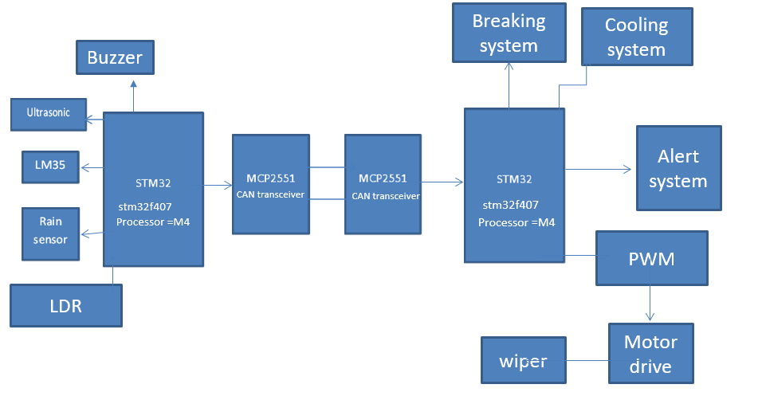

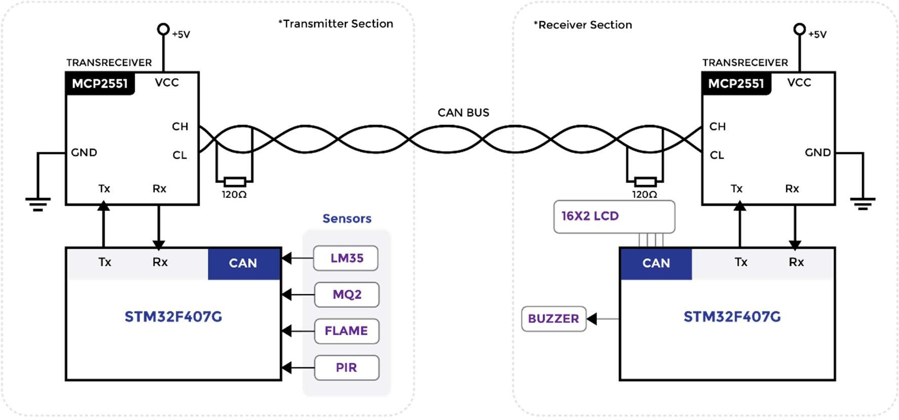
2.1: Figure shows block diagram of system.

The above block diagram shows that General Secured System uses two trans-receivers and two STM32 Boards with CAN hardware inbuilt. Sensors like
- LM35 – Temperature Sensors for temperature measurement.
- LDR – It detects the ambient light level .
- Ultrasonic Sensor – It measures the distance to obstacle in front of vehicle.
Are connected over the transmitter section, while the Buzzer and 16X2 LCD Display is connected over receiver side. The block diagram is been distributed
as transmitter and receiver sections so as to indicate that the communication takes place only in one direction. Receiver section is implemented in such a way that it receives data over CAN bus and carries out preventive measures, while the transmitter section is connected with sensors and transmits data towards receiver side.
CAN TRANS-RECEIVER (MCP2551):
It is implemented by twisting wires and connecting 120-ohm resistors at the end to bus as shown in block diagram. CAN High (CANH) & CAN Low (CANL) pins of Trans-receivers be connected to each other respectively. VCC is connected to
+5V and GND pin of both trans-receivers are connected to ground. Make sure
both trans-receivers are connected to common ground if has different power sources for either STM32 boards. CTX & CRX pins of trans-receivers is connected to Tx & Rx of STM32 bo
3. PROJECT DESIGN & EXPLANATION

General Secured System is designed with four different sensors. Sensor interfacing is as follows: -
- LM35 (Temperature Sensor)
This sensor is an analog sensor so the output of this sensor is connected to ADC and the digital output is stored in a variable. This data is transmitted to receiver side through CAN bus. Over receiver side the data is fetched into a variable and displayed over LCD.
Connected to Pin – PA1 of STM32F407G Board. PA1 – Configured as ADC input.
- LDR

- Ultrsonic Sensor

A long-distance relationship (LDR) or long-distance romantic relationship is an intimate relationship between partners who are geographically separated from one another. Partners in LDRs face geographic separation and lack of face-to-face contact. LDRs are commonly used in light-sensitive circuits such as streetlights, photographic light meters, solar cells, and automatic lighting systems. They are also used in some electronic musical instruments, where they can be used to control the pitch or volume of the sound.

PROCEDURE
Transmitter Node Configurations: -
- Open STM32 IDE and create new stm32 project.
- Select board and select ‘NO’ for default configurations.
- System Core tab -> RCC and select High Speed Clock -> Crystal/Ceramic Resonator to clock config. & Change clock to 72MHz.
- Connectivity tab -> Activate CAN1 -> Parameters -> Prescalar = 18.
- System Core tab -> NVIC -> enable RX0 Interrup and capture compare interrupt.
- Now Select PA0 pin and configure as GPIO_EXTI0 -> Under GPIO tab -> NVIC -> Enable PA0 external interrupt.
- Configure pin PA1 as ADC_IN.
- Configure pins PD12, PD13, PD14, PD15 as GPIO_Output (Onboard LEDs).

Receiver Node Configurations: -
- Perform steps 1- 4 of transmitter node configurations.
- Perform step 5 if receiver node is resending data over transmitter.
- Connectivity tab -> I2C -> Select I2C from drop down menu.
- Keep default I2C settings.
- Configure pins PD12, PD13, PD14, PD15 as GPIO_Output (Onboard LEDs)

4. HARDWARE DESCRIPTION

1. STM32F407F Discovery Board
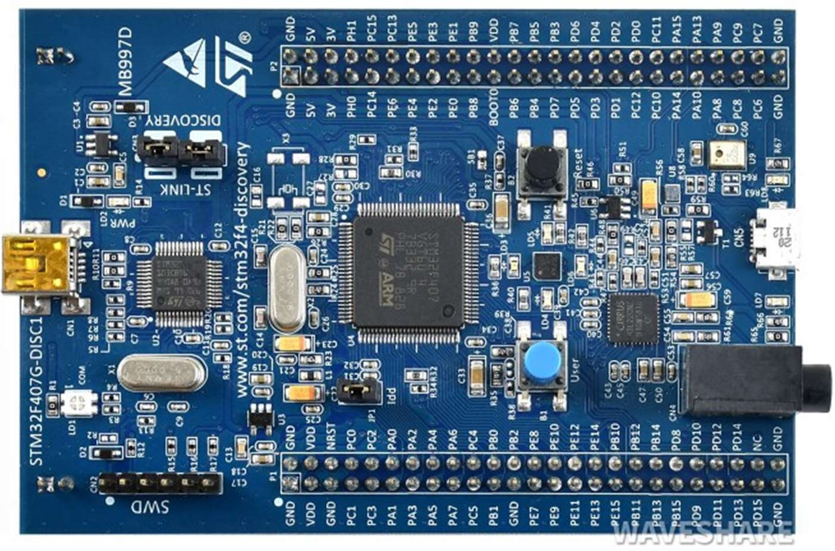

The STM32F4 Discovery board is small devices based on STMF407 ARM microcontroller, which is a high-performance microcontroller. This board allows users to develop and design applications. It has multiple modules within itself which allows the user to communicate and design the interface of different kinds without relying on any third device. The board has all the modern system modules peripherals like DAC, ADC, audio port, UART etc. which makes it one of the best-developing devices.
The STM32F407lines are designed for medical, industrial and consumer applications where the high level of integration and performance, embedded memories and rich peripheral set inside packages as small as 10 x 10 mm are required. The STM32F407 offers the performance of the Cortex™-M4 core (with floating point unit) running at 168MHz.
Performance: At 168 MHz, the STM32F407 delivers 210 DMIPS/566 CoreMark performance executing from Flash memory, with 0-wait states using ST’s ART Accelerator. The DSP instructions and the floating-point unit enlarge the range of addressable applications.
- 2x USB OTG (one with HS support).
- Audio: dedicated audio PLL and 2 full-duplex I²S.
- Up to 15 communication interfaces (including 6x USARTs running at up to 11.25 Mbit/s, 3x SPI running at up to 45 Mbit/s, 3x I²C, 2x CAN, SDIO)
- Analog: two 12-bit DACs, three 12-bit ADCs reaching 2.4 MSPS or 7.2 MSPS in interleaved mode.
- Up to 17 timers: 16- and 32-bit running at up to 168MHz.
- Easily extendable memory range using the flexible static memory controller supporting Compact Flash, SRAM, PSRAM, NOR and NAND memories
- Analog true random number generator The STM32F407 product lines provide from 512 Kbytes to 1 Mega Byte of Flash, 192 Kbytes of SRAM, and from 100 to 176 pins in packages as small as 10 x 10 mm.

2. MCP2551 CAN Trans-Receivers
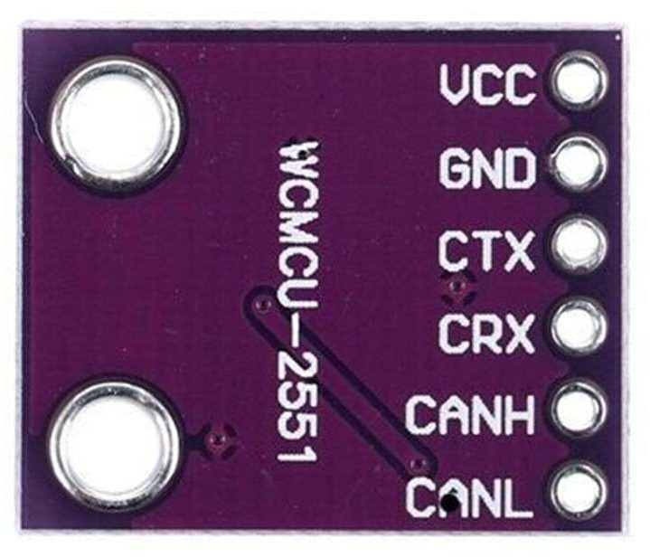

The MCP2551 is a high-speed CAN, fault-tolerant device that serves as the interface between a CAN protocol controller and the physical bus. The MCP2551 provides differential transmit and receive capability for the CAN protocol controller and is fully compatible with the ISO-11898 standard, including 24V requirements. It will operate at speeds of up to 1 Mb/s.
TRANSMITTER FUNCTION
The CAN bus has two states: Dominant and Recessive. A dominant state occurs when the differential voltage between CANH and CANL is greater than a defined voltage (e.g.,1.2V). A recessive state occurs when the differential voltage is less than a defined voltage (typically 0V).
RECEIVER FUNCTION
The RXD output pin reflects the differential bus voltage between CANH and CANL. The low and high states of the RXD output pin correspond to the dominant and recessive states of the CAN bus, respectively.
OPERATING MODES
The RS pin allows three modes of operation to be selected:
- High-Speed
- Slope-Control
- Standby
When in High-speed or Slope-control mode, the drivers for the CANH and CANL signals are internally regulated to provide controlled symmetry in order to minimize EMI emissions. Additionally, the slope of the signal transitions on CANH and CANL can be controlled with a resistor connected from pin 8 (RS) to ground, with the slope proportional to the current output at RS, further reducing EMI emissions.
FEATURES
  - Supports 1 Mb/s operation.
  - b) Implements ISO-11898 standard physical layer requirements.
  - c) Suitable for 12V and 24V systems.
  - d) Externally-controlled slope for reduced RFI emissions.
  - e) Detection of ground fault (permanent dominant) on TXD input.
  - f) Power-on reset and voltage brown-out protection.

3. LM35 (Temperature Sensor)
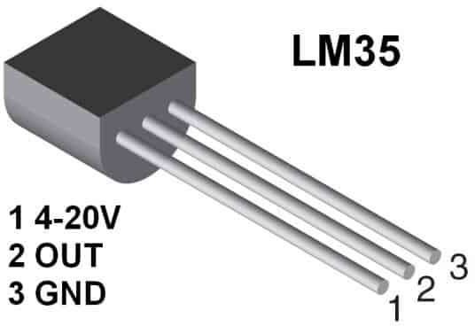
LM35 is a temperature sensor that outputs an analog signal which is proportional to the instantaneous temperature. The output voltage can easily be interpreted to obtain a temperature reading in Celsius. The advantage of lm35 over thermistor is it does not require any external calibration. The coating also protects it from self-heating.
Temperature sensor Specifications
- Calibrated Directly in Celsius (Centigrade).
- Linear + 10-mV/°C Scale Factor.
- 0.5°C Ensured Accuracy (at 25°C).
- Rated for Full −55°C to 150°C Range.
- Suitable for Remote Applications.
4. LDR
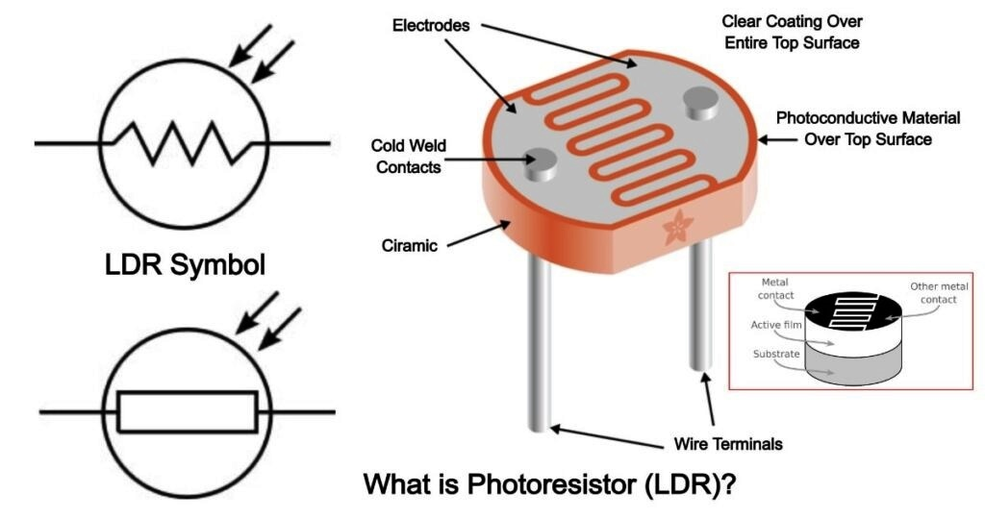
LDR (Light Dependent Resistor) as the name states is a special type of resistor that works on the photoconductivity principle means that resistance changes according to the intensity of light. Its resistance decreases with an increase in the intensity of light.
It is often used as a light sensor, light meter, Automatic street light, and in areas where we need to have light sensitivity. LDR is also known as a Light Sensor. LDR are usually available in 5mm, 8mm, 12mm, and 25mm dimensions.

5. Ultrasonic Sensor
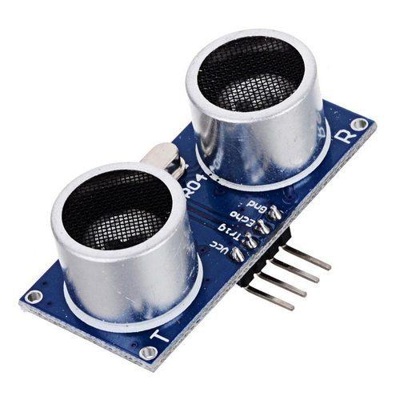

An ultrasonic sensor is an instrument that measures the distance to an object using ultrasonic sound waves. An ultrasonic sensor uses a transducer to send and receive ultrasonic pulses that relay back information about an object's proximity. Ultrasonic sensors emit a chirp usually between 23 kHz and 40 kHz, much higher than the typical audible range of human hearing at 20 kHz, hence the term ultrasonic. Using this chirp, they measure the amount of time it takes for the sound to bounce off an object.

6. Buzzer

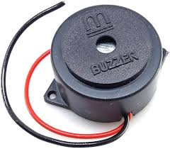

The buzzer is an electronic device that makes an audible sound when an external voltage is applied. The outcome of such a buzzer circuit results in a beeping or a buzzing sound. You must have come across a buzzer in different quiz competitions or game shows. Its primary function is to provide an audible alert or notification and typically operates within a voltage range of 5V to 12V.

7. LED

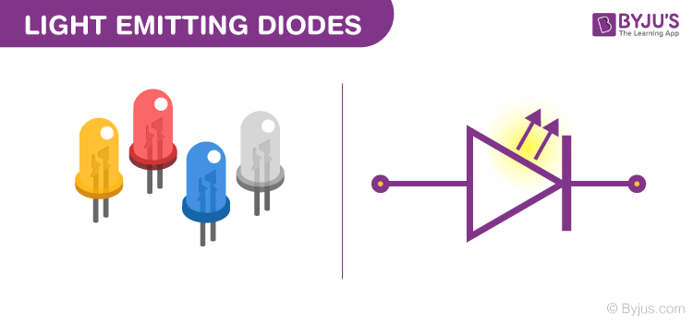
LEDs allow the current to flow in the forward direction and blocks the current in the reverse direction. Light-emitting diodes are heavily doped p-n junctions. Based on the semiconductor material used and the amount of doping, an LED will emit coloured light at a particular spectral wavelength when forward biased. It is today's most energy-efficient and rapidly developing lighting technology. Quality LED light bulbs last longer, are more durable, and offer comparable or better light quality than other types of lighting.

8. 16 x 2 LCD Display
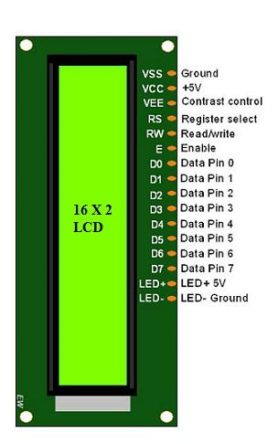

An LCD screen is an electronic display module that uses liquid crystal to produce a visible image. The 16×2 LCD display is a very basic module commonly used in DIYs and circuits. The 16×2 translates a display of 16 characters per line in 2 such lines. In this LCD, each character is displayed in a 5×7 pixel matrix.
LCDs have several advantages over older display technologies like CRT. LCDs are thinner, lighter, and more energy efficient. They also produce less heat, have better image quality, and offer a wider viewing angle.
Features of LCD16x2
The features of this LCD mainly include the following.

The operating voltage of this LCD is 4.7V-5.3V
It includes two rows where each row can produce 16-characters.
The utilization of current is 1mA with no backlight
Every character can be built with a 5×8 pixel box
The alphanumeric LCDs alphabets & numbers
Is display can work on two modes like 4-bit & 8-bit
These are obtainable in Blue & Green Backlight
It displays a few custom generated characters

9. CAN (Controlled Area Network) Protocol
CAN stands for controller area network. They are designed specially to meet the Automobile Industry needs. Before CAN was introduced, each electronic device is connected to other devices using many wires to enable communication. But when the functions in the automobile system increased, it was difficult to maintain because of the tedious wiring system. With the help of the CAN bus system, which allows ECUs to communicate with each other without much complexity by just connecting each ECU to the common serial bus. Hence when compared with the other protocols used in automotive systems i.e., CAN vs LIN, CAN is robust due to less complexity.
CAN Protocol can be defined as a set of rules for transmitting and receiving messages in a network of electronic devices connected through a serial bus. Each electronic device in a CAN network is called a node. Each node must have hardware and software embedded in them for data exchange. Every node of a CAN bus system has a host microcontroller unit, CAN controller and, CAN transceiver in it. CAN controller is a chip that can be embedded inside the host controller or added separately, which is needed to manage the data and sends data via transceiver over the serial bus and vice versa.
CAN Transceiver chip is used to adapt signals to CAN bus levels. CAN is a message-based protocol where every message is identified by a predefined unique ID. The transmitted data packet is received by all nodes in a CAN bus network, but depending on the ID, CAN node decides whether to accept it or not. CAN bus follows the arbitration process when multiple nodes try to send data at the same time.
CAN BUS ELECTRICAL SPECIFICATION
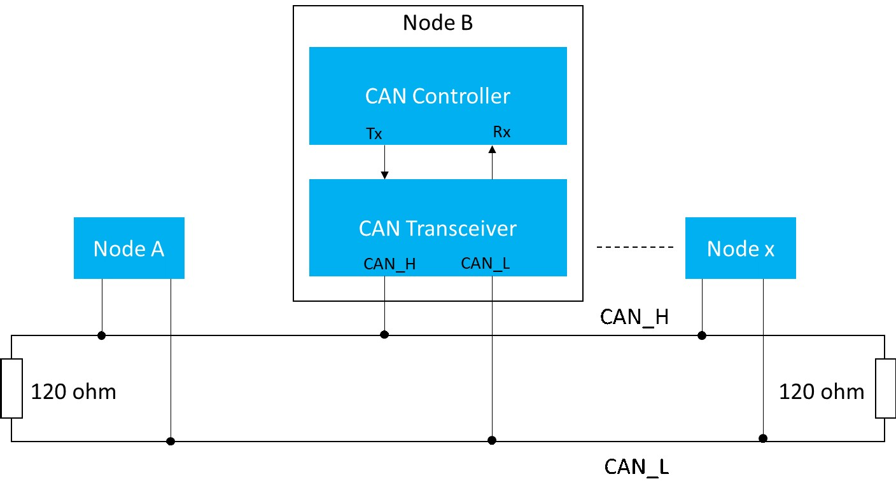

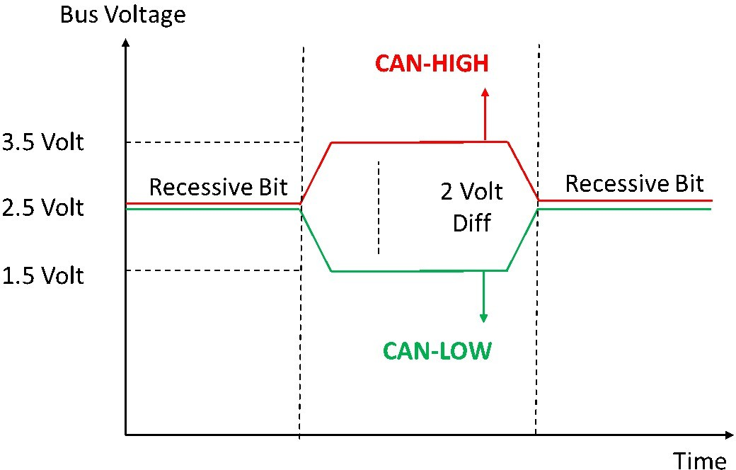
processed by CAN transceiver are single-ended signals and differential signals (CANH and CANL). CAN High and CAN Low lines be at 2.5v in ideal condition. CAN defines logic “zero” as the dominant bit and logic “one” as the recessive bit. When the dominant bit is transmitted, CAN High goes to 3.5v, and CAN low goes to 1.5v i.e., the differential voltage of the dominant bit is 2v. When the recessive bit is transmitted CAN High and CAN Low lines are driven to 2.5v, indicating the differential voltage of the recessive bit is 0v.CAN bus terminal resistor of 120 ohms should be added at the physical end of CANH and CANL lines to avoid any signal reflections.

FRAME TYPES OF CAN:
Frame is a defined structure or format that carries meaningful data(bytes) within the network. CAN has four frame types:
- Data Frame
- Remote Frame
- Error Frame
- Overload Frame
Data Frame
Data Frame contains the actual data for transmission. Data Frames consist of fields that provide additional information about the message i.e., Arbitration Field, Control Field, Data Field, CRC Field, a 2-bit Acknowledge Field, and an End of Frame. There are two types of Data frames.
  - Standard Frame or Base Frame Format
  - Extended Frame Format.
The only difference between the two formats is standard frame supports an 11-bit identifier, and the extended frame supports a 29-bit identifier made up of an 11-bit identifier and extended 18-bit identifier. IDE bit is dominant in a standard frame and recessive in an extended frame.
STANDARD FRAME FORMAT
Standard CAN protocol is also known as the Base frame format. The standard frame is mainly used to send data.
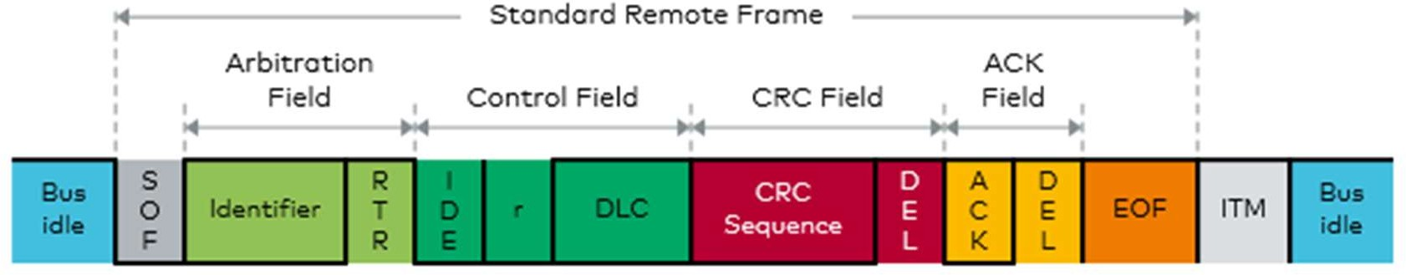

- SOF - Start of Frame. Denotes the start of frame transmission.
- Identifier - 11-bit unique id and also represents message priority Lower the value, higher is the priority.
- RTR - Remote Transmission Request. It is dominant for data frames and recessive for remote frames.
- IDE - Single Identification Extension. It is dominant for standard frames and recessive for extended frames.
- R0 - reserved bit.
- DLC - Data Length Code. Defines the length of the data being sent. It is of 4- bit size.
- Data - Data to be transmitted and length is decided by DLC.
- CRC– Cyclic Redundancy Check. It contains the checksum of the preceding application data for error detection.
- ACK– Acknowledge. It is 2 bits in length. It is dominant if an accurate message is received.
- EOF– end of the frame and must be recessive.
- IFS– Inter Frame Space. It contains the time required by the controller to move a correctly received frame to its proper position.

EXTENDED FRAME FORMAT

It is the same as the Standard Frame with some additional fields.
  - SRR- Substitute Reverse Request. The SRR bit is always transmitted as a recessive bit to ensure that the standard Data frame has high priority when compared to the extended Data frame if both messages have the same 11-bit identifier. It also contains an 18-bit identifier other than an 11-bit identifier.
  - r1- Reserved bit.

Advantages of CAN Protocol
  - Low cost because of reduced wiring.
  - Saves time due to simple wiring.
  - Auto retransmission of Lost messages.
  - Supports Error Detection.
  - Flexible Data transmission rates.
Disadvantages of CAN Protocol
  - CAN Bus Hacking
CAN bus Hacking is a threat to consumers. Many wireless technologies are adopted in CAN bus vehicles like Bluetooth for attending calls or playing music. When onboard system access CAN bus in a car and are capable of Wi-Fi connectivity, it is easy for the hackers to get CAN bus access and be able to control the car. Wi-Fi hotspots are popular in cars, this allows people who know cars’ IP address to track the car. This leads the Car manufacturers to secure transmitted data on the CAN bus network.
5. SOFTWARE REQUIREMENTS

  - STM32CubeIDE
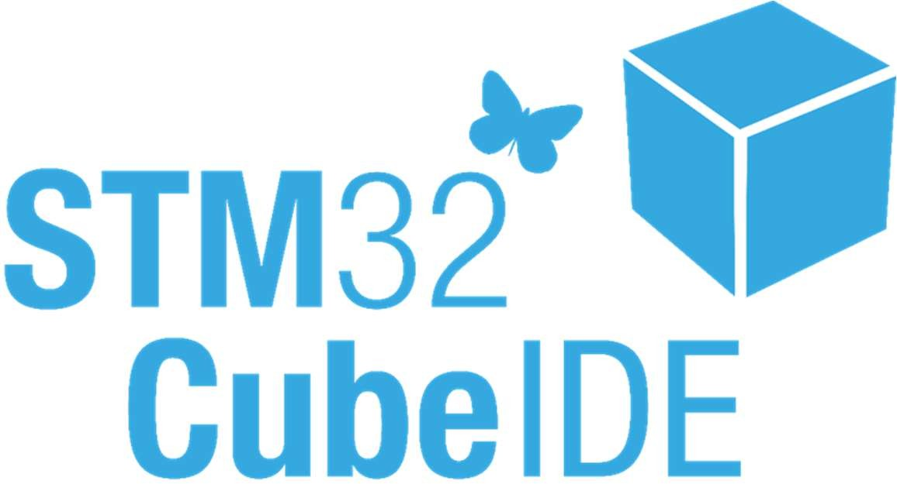

STM32CubeIDE is an all-in-one multi-OS development tool, which is part of the STM32Cube software ecosystem. STM32CubeIDE is an advanced C/C++ development platform with peripheral configuration, code generation, code compilation, and debug features for STM32 microcontrollers and microprocessors. It is based on the Eclipse®/CDT™ framework and GCC tool chain for the development, and GDB for the debugging. It allows the integration of the hundreds of existing plugins that complete the features of the Eclipse.

7. FUTURE SCOPE

- General Secured System can be developed further by adding more sensors and implementing IoT system so as it can be controlled over internet.
- System can be implemented with multiple CAN nodes for vast infrastructure.

8. CONCLUSION
Thus, implementing this project enhanced the understanding about CAN Protocol and similar other protocols such as I2C, as well as interfacing different types of sensors to STM32 board gave us basic idea for best possible implementation.

9. REFRENCES
  - Robert Bosch GmbH, “CAN Specification”, Version 2.0, 1991
  - https://www.rpi.edu/dept/ecse/mps/CAN_Theory&Case_Study.pdf
  - https://controllerstech.com/
  - https://lastminuteengineers.com

