1. **What are the requirements a tenant must fulfill under the Punjab Security of Land Tenures Act, 1953, to be eligible to purchase the land they occupy?**

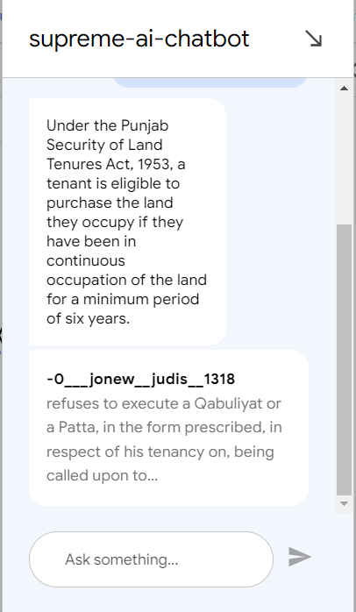

1. **How does the tenant's right to purchase land under the Punjab Security of Land Tenures Act, 1953, affect ongoing ejectment proceedings?**

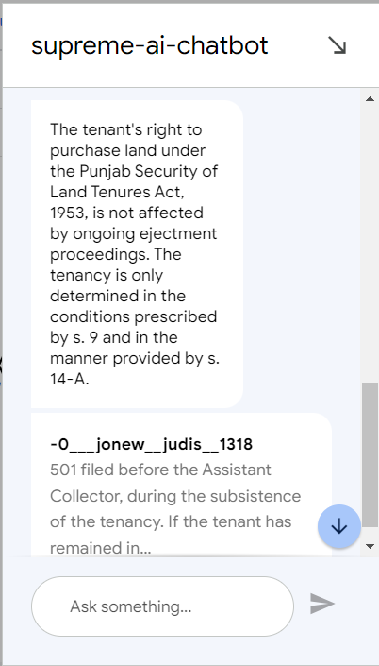

1. **What is the principle of waiver in the law of preemption?**

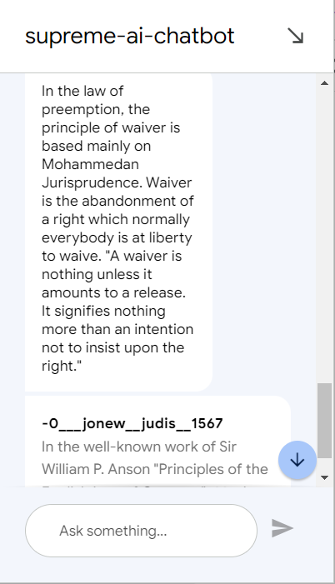

1. How is the concept of waiver applied in preemption law?

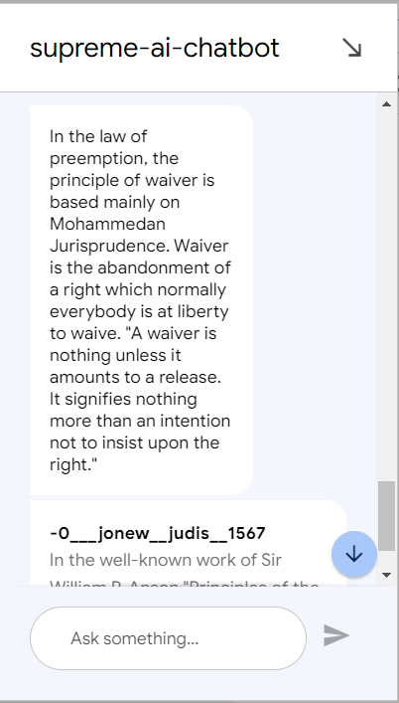

1. How is the concept of waiver applied in preemption law?

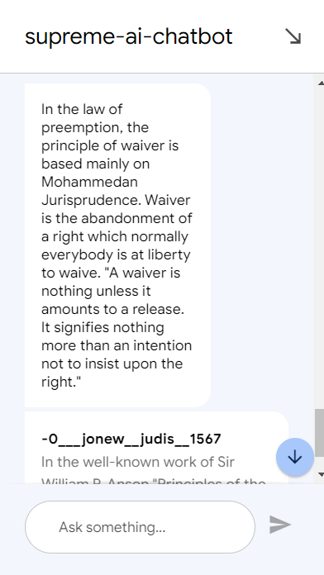

1. In the law of preemption, what role does the principle of waiver play?

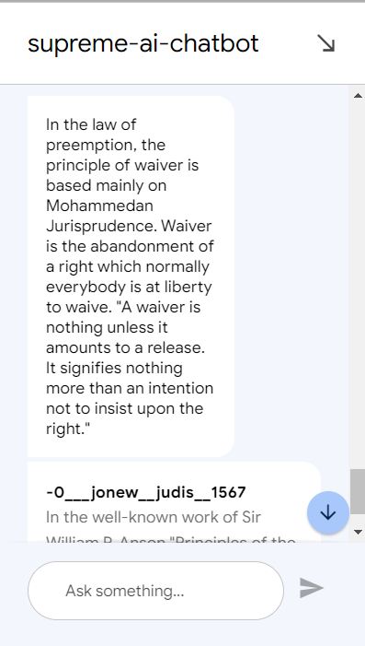

1. How does Article 235 of the Constitution empower the High Courts in matters of administrative control over subordinate courts?

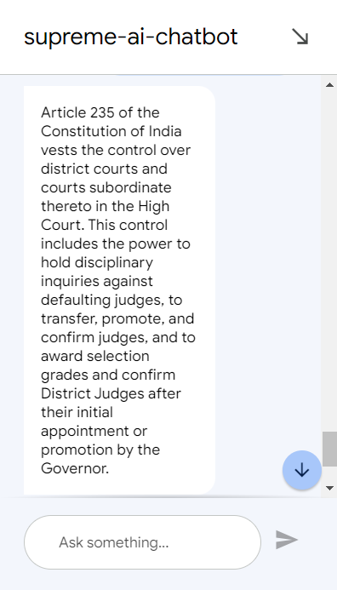

1. What authority does Article 235 of the Constitution grant to High Courts regarding administrative control over subordinate courts?

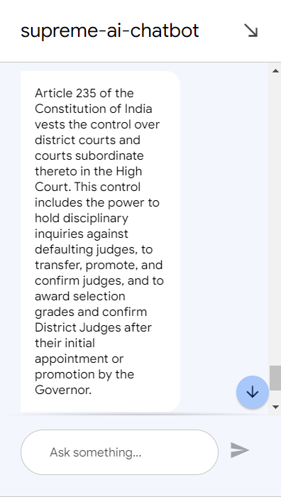

1. In what ways does Article 235 of the Constitution empower High Courts to oversee and manage subordinate courts?

